Leonardo Ibarra López  
 **GET:**  
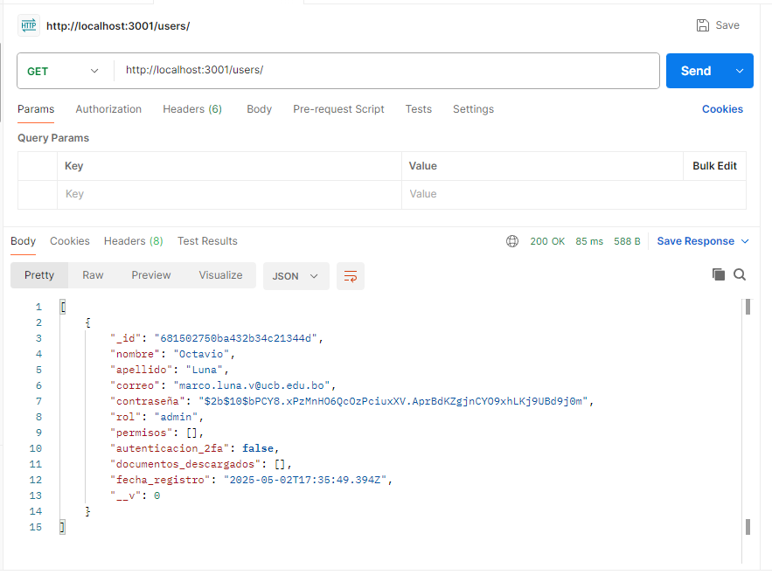  
  
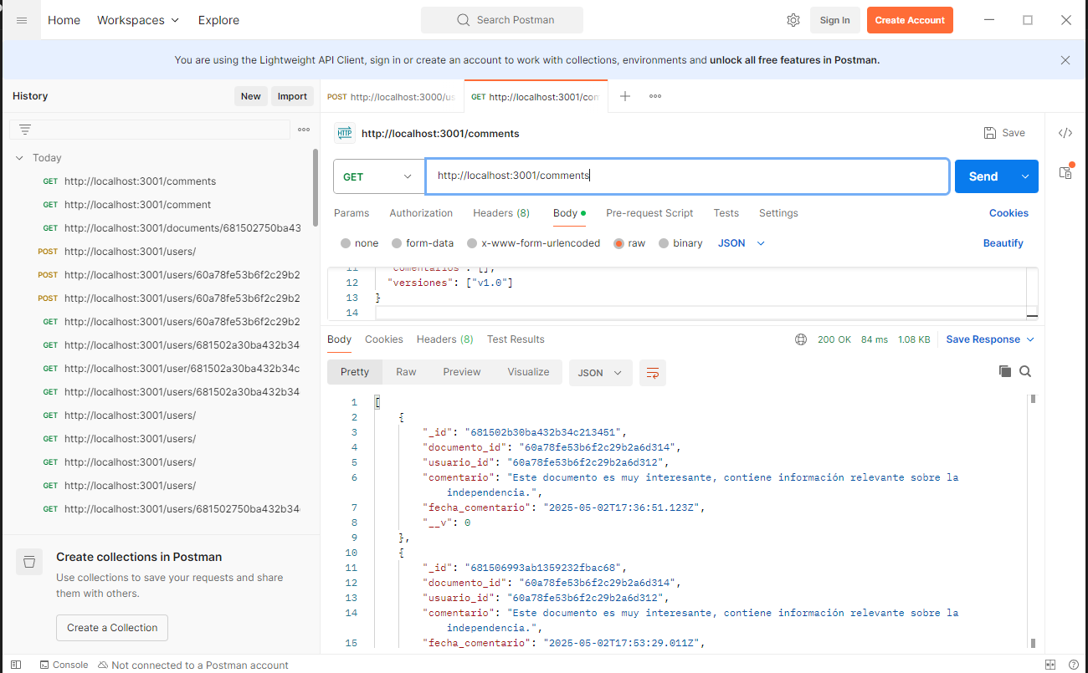  
  
  
**POST:**  
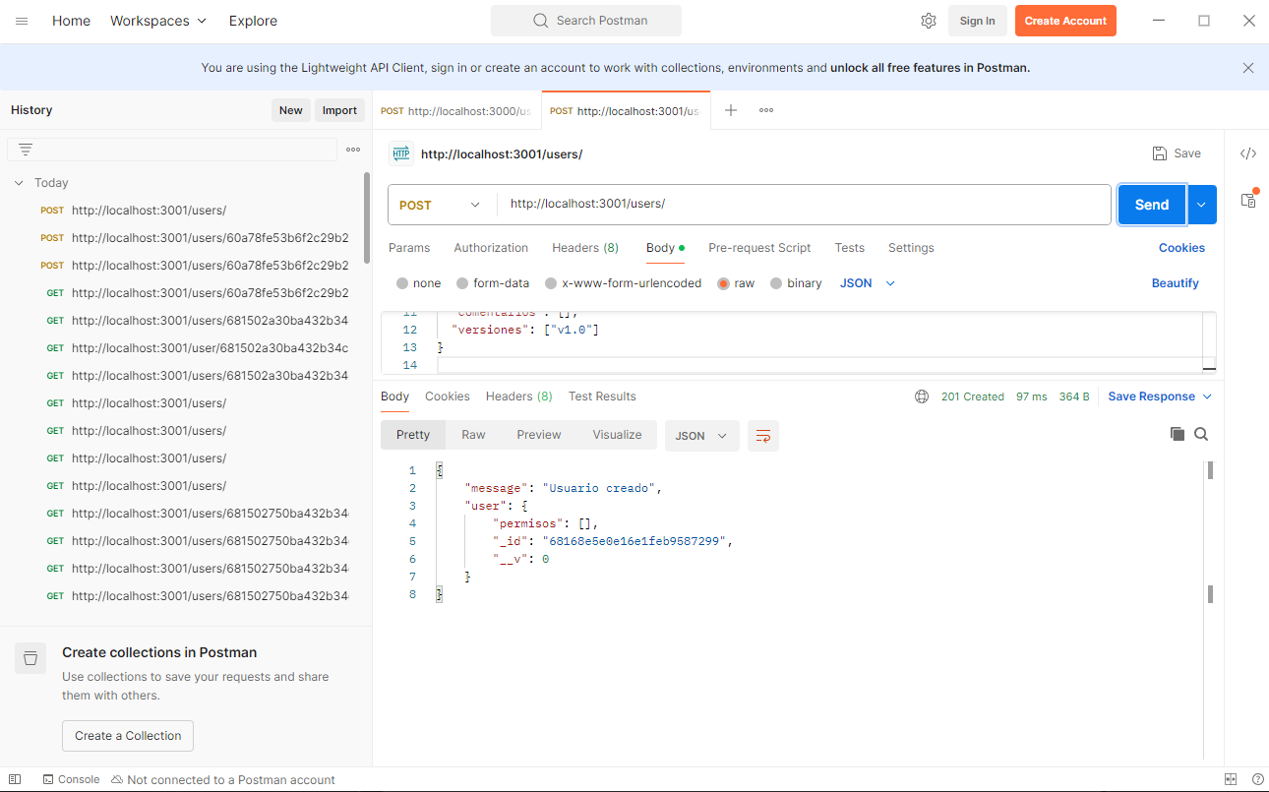  
 **PUT:**  
  
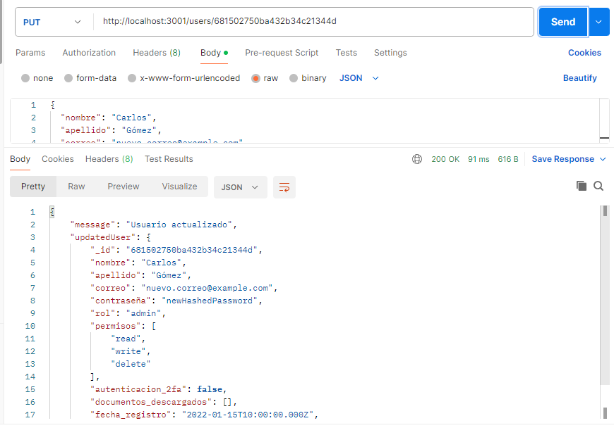  
  
  
  
**DELETE:**  
  
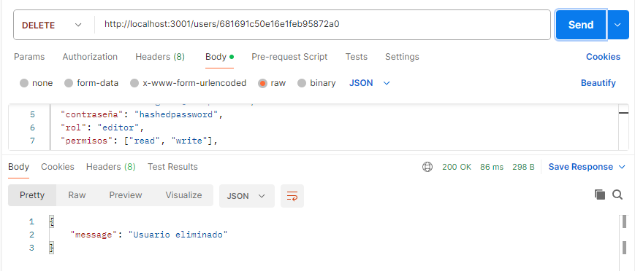  
  
  
 **LocalHost:**  
  
