INTRODUCTION
Once I tried to use an improperly maintained SAP system. There I opened the Process pMRP simulation app. While opening it I had an issue like the app below could not be opened because the SAP UI5 component of the application could not be loaded.
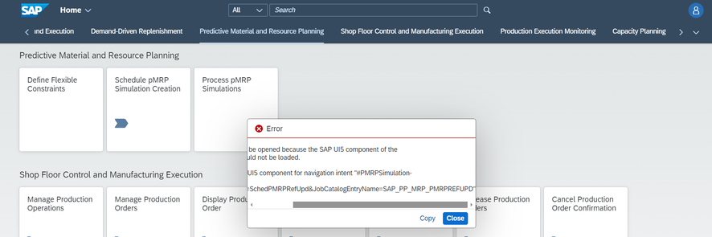
So, I checked online and found a solution. I would like to share the same.
Main Part - Solution:
I copied the error message from the popup and pasted it into a notepad. Where I found the service name like this
- /sap/bc/ui5_ui5/sap/pp_pmrp_psims1
-/sap/bc/ui5_ui5/sap/pp_pmrp_pcomps1
-/sap/bc/ui5_ui5/sap/pp_pmrp_pcaps1
-/sap/bc/ui5_ui5/sap/pp_pmrp_pwlsts1
-/sap/bc/ui5_ui5/sap/pp_pmrp_pboms1
Note: Activate all these to get the pMRP working fine
Then went to SICF Tcode. Pasted the service path and clicked execute.
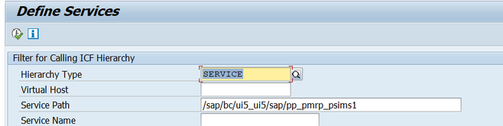
Then activated the service.
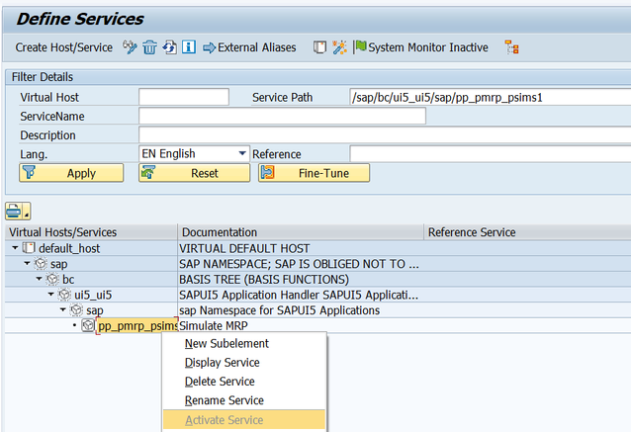
You can have a look in to this 2808615 I dont know why SAP having different methods and tcoded to activate services. Please explain if you have idea. Later tried to open the app. But got another issue like below.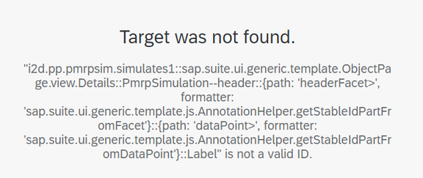
Then again searched for solution. Later found some service were not maintained in SAP ODATA. So maintained it via the tcodes
- /IWFND/ERROR_LOG - SAP Gateway Error Log - to find the missing ODATA service
- /IWBEP/REG_VOCAN - Maintain Vocabulary Annotations - To get the service name from vocabulary annot
- /IWFND/MAINT_SERVICE - Activate and Maintain Services - To maintain the service.
This is another way of maintaining the ODATA Services for FIORI apps. After doing all clear the cache in SAP and browser
Transaction:
/IWFND/CACHE_CLEANUP
/IWBEP/CACHE_CLEANUP
Run Report in SE38
- /UI2/CHIP_SYNCHRONIZE_CACHE
- /UI2/DELETE_CACHE_AFTER_IMP
- /UI2/DELETE_CACHE
- /UI5/UPDATE_CACHEBUSTER
- /UI2/INVALIDATE_GLOBAL_CACHES
Have look to Cache clear . At last got the app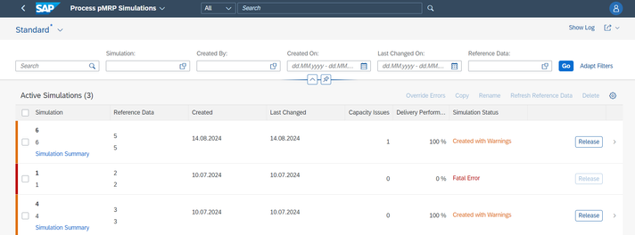
Conclusion:
I hope this will support on on getting the fiori app to work. Please comment your thoughts.

