OCTMARK TECHNOLOGIES
Dr. Chandrashekar P — Portfolio Website
UI/UX Structure & Design Specification
Prepared by Octmark Technologies • Design & Build
Version 1.0 • July 2026
1. Design Direction
The site is a personal brand for a senior surgeon known for precision. The design language is minimal and editorial, with generous whitespace, a single confident accent, and premium typography — authoritative, calm, and human. It should feel meticulous, the way robotic surgery is meticulous, while remaining warm and reassuring for anxious patients.
Positioning in one line
A pioneer of robotic and computer-assisted knee replacement — precise technology, delivered with a patient-first, human touch.
Style
- Approach: Minimal / editorial medical. Clean grids, thin rules, rounded cards, plenty of air.
- Motif: Precision — fine geometric accents, a single teal highlight used deliberately, exact alignment.
- Tone: Trustworthy, precise, premium, human. Never clinical-cold, never salesy.
- Anti-patterns avoided: No hero carousels, no autoplay media, no clutter — these erode trust and engagement.
2. Design System
2.1 Colour
Navy anchors the brand (shared DNA with IKOC), while a precision teal replaces IKOC's gold as the personal accent — it signals medical-technology and keeps the doctor's site distinct from the hospital's identity. Warm sand adds humanity; white and mist keep it clean.
Swatch | Token | Hex | Usage
 | Ink Navy | #0C2233 | Primary — headers, nav, footer, dark bands
 | Slate Navy | #16394F | Secondary surfaces, stat band
 | Precision Teal | #0F8B84 | Accent — primary CTAs, links, highlights
 | Teal (deep) | #0B6E68 | Hover / pressed; small-text links (contrast)
 | Warm Sand | #F5EFE7 | Soft section backgrounds (humanity)
 | Mist | #E9F1F1 | Alternate section backgrounds, cards
 | Ink | #1E2E39 | Body text
 | Slate Grey | #5E7180 | Muted text, captions
 | Line | #D2DBE1 | Borders, dividers

Contrast note: use the deep teal (#0B6E68) for small text links and body-size accent text on white to meet WCAG AA; the brighter teal is reserved for large text, buttons and UI fills.
2.2 Typography
Recommended pairing: Fraunces for headings (a warm, premium serif — human and authoritative) with Inter for body (clean, highly legible, accessible). Alternatives: Playfair Display + Lato (more editorial), or Space Grotesk + Inter (more tech-forward).
@import url('https://fonts.googleapis.com/css2?family=Fraunces:opsz,wght@9..144,400;9..144,600&family=Inter:wght@400;500;600;700&display=swap');

--font-heading: 'Fraunces', Georgia, serif;
--font-body: 'Inter', system-ui, sans-serif;

Element | Typeface | Size | Weight | Usage
Display / Hero H1 | Fraunces | 56–64px | 600 | Doctor's name, hero
Section H2 | Fraunces | 32–40px | 600 | Section titles
Sub-head H3 | Inter | 22–24px | 600 | Card & subsection titles
Lead / intro | Inter | 18–20px | 400 | Section intros
Body | Inter | 16px | 400 | Paragraphs
Small / label | Inter | 14px | 500 | Chips, nav, labels
Caption | Inter | 12–13px | 400 | Captions, disclaimers
2.3 Spacing, grid & shape
- Grid: 12-column, max content width 1200px, 24px gutters, 24px side padding on mobile.
- Spacing: 8px base scale (8 / 16 / 24 / 32 / 48 / 64 / 96). Section padding 96px desktop, 56px mobile.
- Corner radius: Cards 14px, buttons pill (full), inputs 10px.
- Elevation: Soft and low — y-offset 8–16px, blur 24–32px, ~8–12% opacity. No hard drop shadows.
2.4 Core components
- Buttons: Primary = teal fill / white text / pill; Secondary = teal outline; Tertiary = teal text link. Minimum 44px tap height; hover → deep teal.
- Cards: White, 1px line border, 14px radius, subtle shadow, gentle lift on hover.
- Nav: Transparent over hero, condenses to solid navy on scroll; mobile → hamburger drawer. Persistent Book button.
- Patterns: Stat counter, testimonial card (with disclaimer slot), press card, FAQ accordion, media-embed card, and a sticky mobile CTA bar (Book + Call).
- Icons: Line icons (Lucide), teal inside a soft circle for section accents. Consistent 24px grid.

3. Information Architecture
A single-page scroll with anchor navigation — the fastest path for a patient to build trust and book. Navigation is capped at five items (Hick's Law), with the booking action always visible.
- Primary nav: About · Robotic Surgery · Expertise · Media · Contact — plus a persistent Book button.
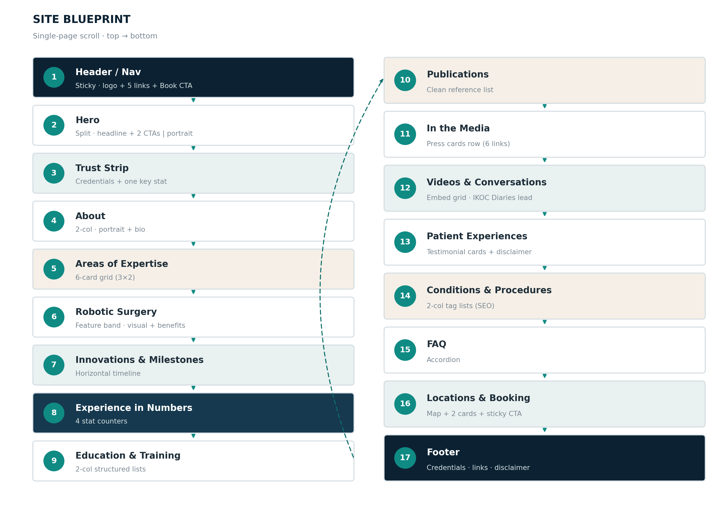
Figure 1 — Full-page blueprint: 17 sections in scroll order.

4. Page Structure — Section by Section
Each section below maps directly to the content document. Layout patterns and components are specified for build.
# | Section | Layout pattern | Key components | Primary CTA
1 | Header / Nav | Sticky bar; transparent → solid on scroll | Logo mark, 5 links, phone, Book button | Book
2 | Hero | Split 55/45; text left, portrait right | H1 name, positioning subhead, 2 CTAs, trust strip | Book / Robotic
3 | Trust Strip | Full-width band, inline items | Credential chips + one key stat | —
4 | About | 2-column: portrait + prose | Short + extended bio, signature line | Read profile
5 | Areas of Expertise | 3×2 card grid | 6 expertise cards (icon, title, line) | (cards link)
6 | Robotic Surgery | Feature band; media + benefits (alternating) | Explainer, benefit list, variability disclaimer | Ask about robotic
7 | Innovations & Milestones | Timeline (horizontal → vertical on mobile) | Milestone nodes (MISSO, AI-first, portal) + sources | —
8 | Experience in Numbers | Dark band, 4 counters | Animated stat counters + micro-disclaimer | —
9 | Education & Training | 2-column structured lists | Roles, qualifications, fellowships | —
10 | Publications | Clean reference list | Paper entries + “full list on request” | —
11 | In the Media | Card row / logo strip | 6 press cards (outlet, headline, link) | Read coverage
12 | Videos & Conversations | Embed grid; 1 featured + row | IKOC Diaries lead, Sakra RX, explainers | Subscribe
13 | Patient Experiences | Testimonial cards / slider | Consented stories + mandatory disclaimer | —
14 | Conditions & Procedures | 2-column tag lists | Conditions + procedures (SEO inner links) | —
15 | FAQ | Accordion (one open by default) | 7 Q&A pairs | —
16 | Locations & Booking | Map + 2 location cards | IKOC + Sakra, Practo, phone/WhatsApp | Book
17 | Footer | Multi-column | Credential line, quick links, socials, disclaimer | Book (repeat)
4.1 Hero anatomy
The only section a visitor is guaranteed to see. Headline states who + what; subhead adds the differentiator (robotics / MISSO); two CTAs (Book primary, Explore Robotic secondary); a slim trust strip carries one credential and one number. Portrait is warm and direct. No carousel.
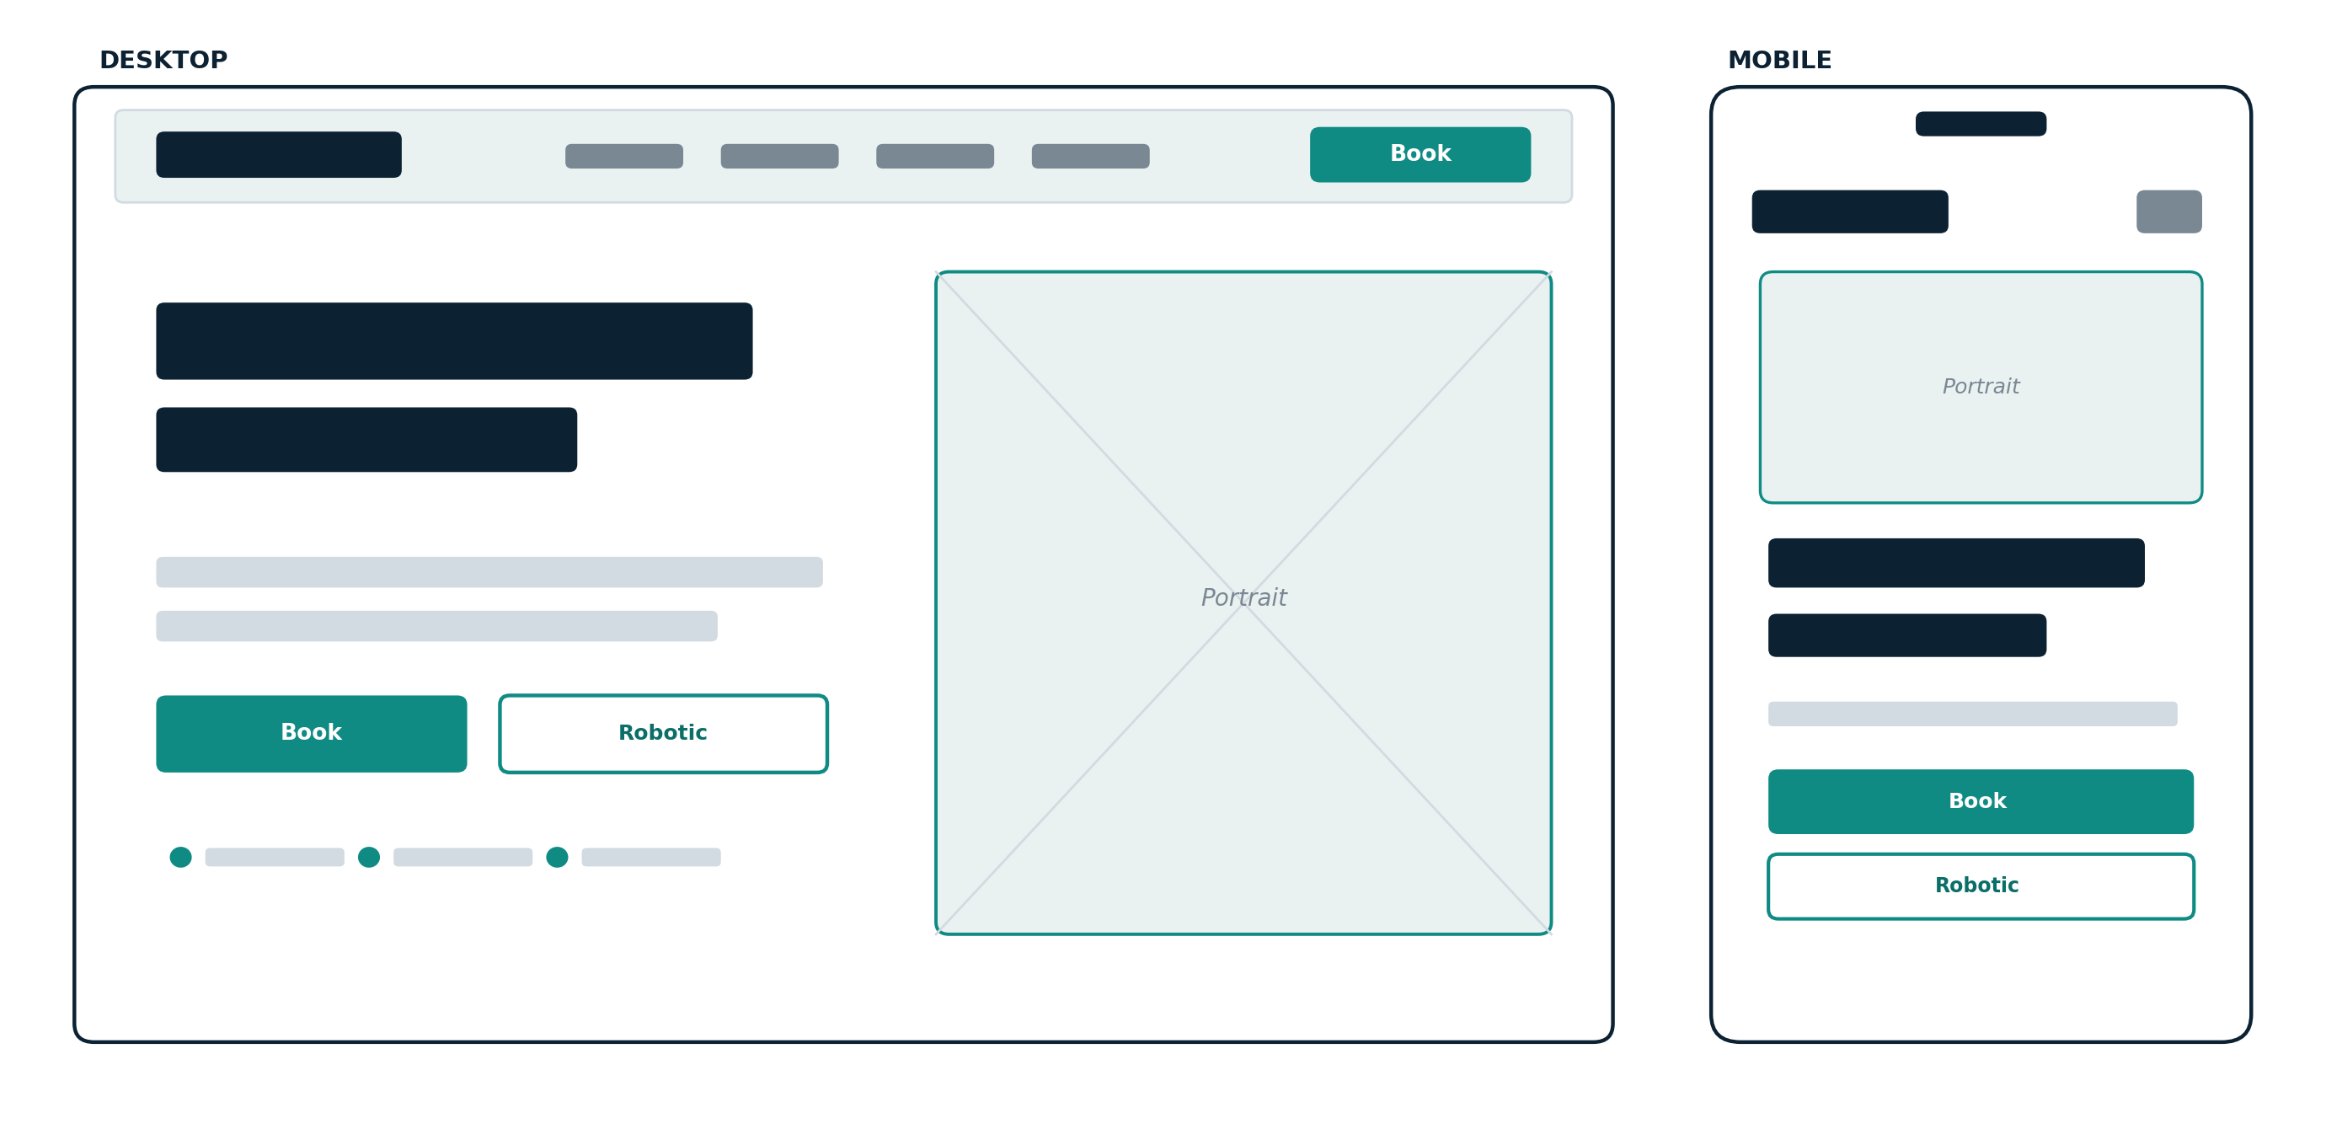
Figure 2 — Hero layout, desktop and mobile.

5. Responsive Behaviour
- Breakpoints: Mobile < 640px · Tablet 640–1024px · Desktop > 1024px.
- Reflow: Hero stacks (portrait above headline); expertise grid 3→2→1; timeline goes vertical; media grid 3→2→1.
- Mobile CTA: Sticky bottom CTA bar on mobile with Book + Call — the two highest-intent actions, always a thumb away.
- Touch: All tap targets ≥ 44px; nav collapses to a drawer; font sizes step down one level.
6. Accessibility & Compliance
- Accessibility: WCAG 2.1 AA contrast; deep teal for small text on white; visible focus states; full keyboard navigation; semantic landmarks.
- Media: Descriptive alt text on every image; captions/transcripts on videos where possible.
- Motion: Respect prefers-reduced-motion — disable scroll and counter animation for those users.
- Medical (NMC/ASCI): No outcome-guarantee language; testimonial and footer disclaimers present; no unverified “best / record” claims; patient stories require written consent.
7. Motion & Interaction
- Use: Fade / slide-up on scroll-in (subtle, 300–400ms), number counters, gentle card lift on hover, smooth anchor scrolling.
- Avoid: Hero carousels, autoplay video/audio, parallax overload, motion without a reduced-motion fallback.
8. Recommended Build
Static, fast, and GitHub Pages–friendly — matching the existing Octmark toolchain.
- Stack: Static HTML + Tailwind CSS, with Alpine.js for the accordion and mobile drawer; or Astro / Next.js static export.
- Assets: Google Fonts (Fraunces + Inter), Lucide icons, WebP images (lazy-loaded), Practo booking link/embed.
- SEO: Semantic headings, meta title/description, Open Graph, and Physician / MedicalBusiness JSON-LD schema for rich results.

Design tokens (drop into CSS / Tailwind config)
:root{
--navy:#0C2233; --navy-2:#16394F;
--teal:#0F8B84; --teal-deep:#0B6E68;
--sand:#F5EFE7; --mist:#E9F1F1;
--ink:#1E2E39; --muted:#5E7180; --line:#D2DBE1;
--radius-card:14px; --radius-btn:999px;
--pad-section:96px; --maxw:1200px;
}
9. Handoff Checklist
- Content: Lock one canonical, dated set of surgical figures (they differ across his current profiles).
- Assets: High-resolution portrait(s) with usage rights; professional domain email; social handles; clinic/tracked phone.
- Tokens: Implement the tokens above as CSS variables / Tailwind theme before building components.
- Compliance: Copy sign-off against NMC/ASCI guardrails before publish; add paid-context disclosures where relevant.

Prepared by Octmark Technologies • Dr. Chandrashekar P Portfolio • Confidential

