**Performetrics User Guide**

Objective : Performetrics Utility is a tool to test the load and performance of the rest endpoints

Internally it uses Gatling Opensource framework to generate the reports. The tool stores the information in H2 database and it persists to a file.

Here are the instructions to setup the application to run the load/performance tests

* Clone the performetrics back-end and front-end applications from git repository
* Do the clean build for back-end application using mvn clean install and run the application using following command

Command to run the back end : mvn spring-boot:run

* Open the front-end application using Visual Studio Code and run the Angular application using following command in terminal window

Command to run : npm start

* Fill the following fields before you submit for load test report generation

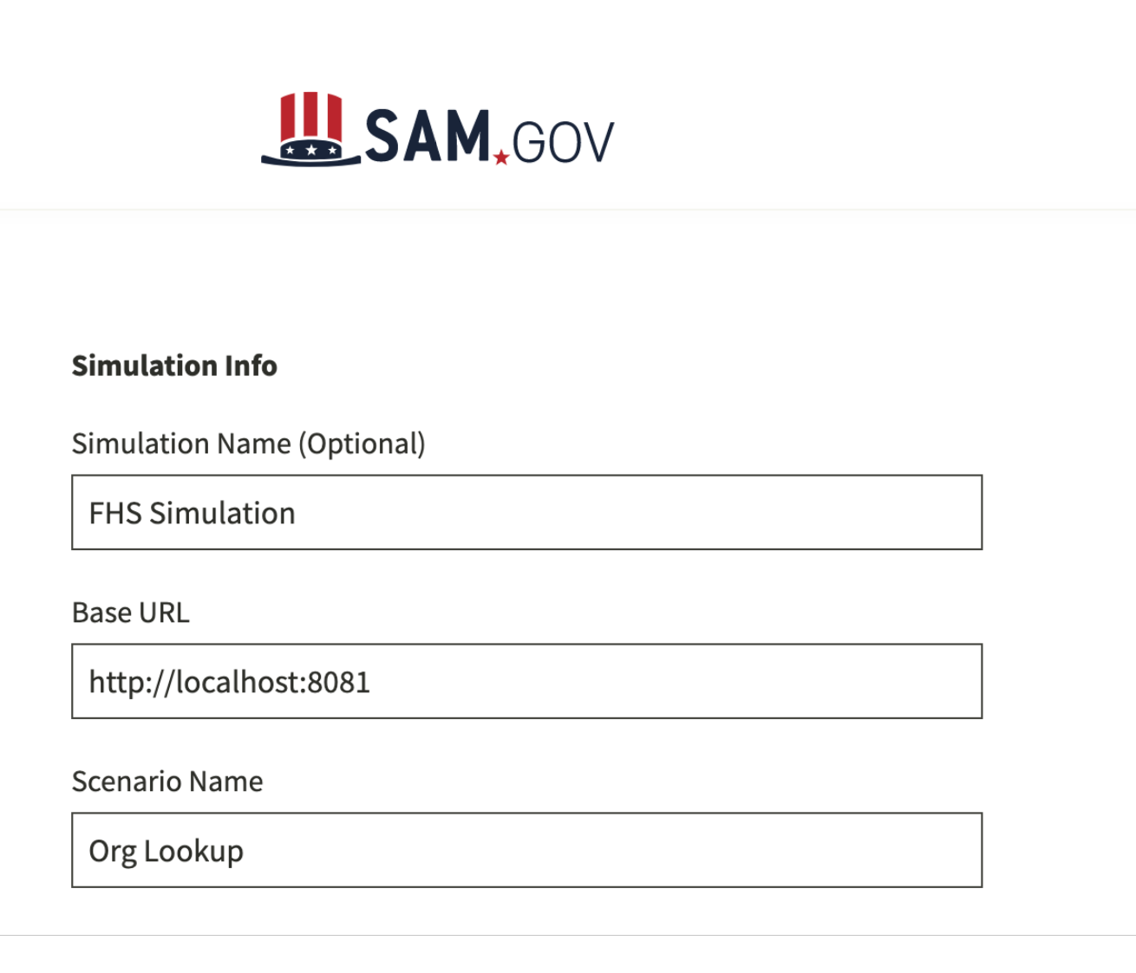

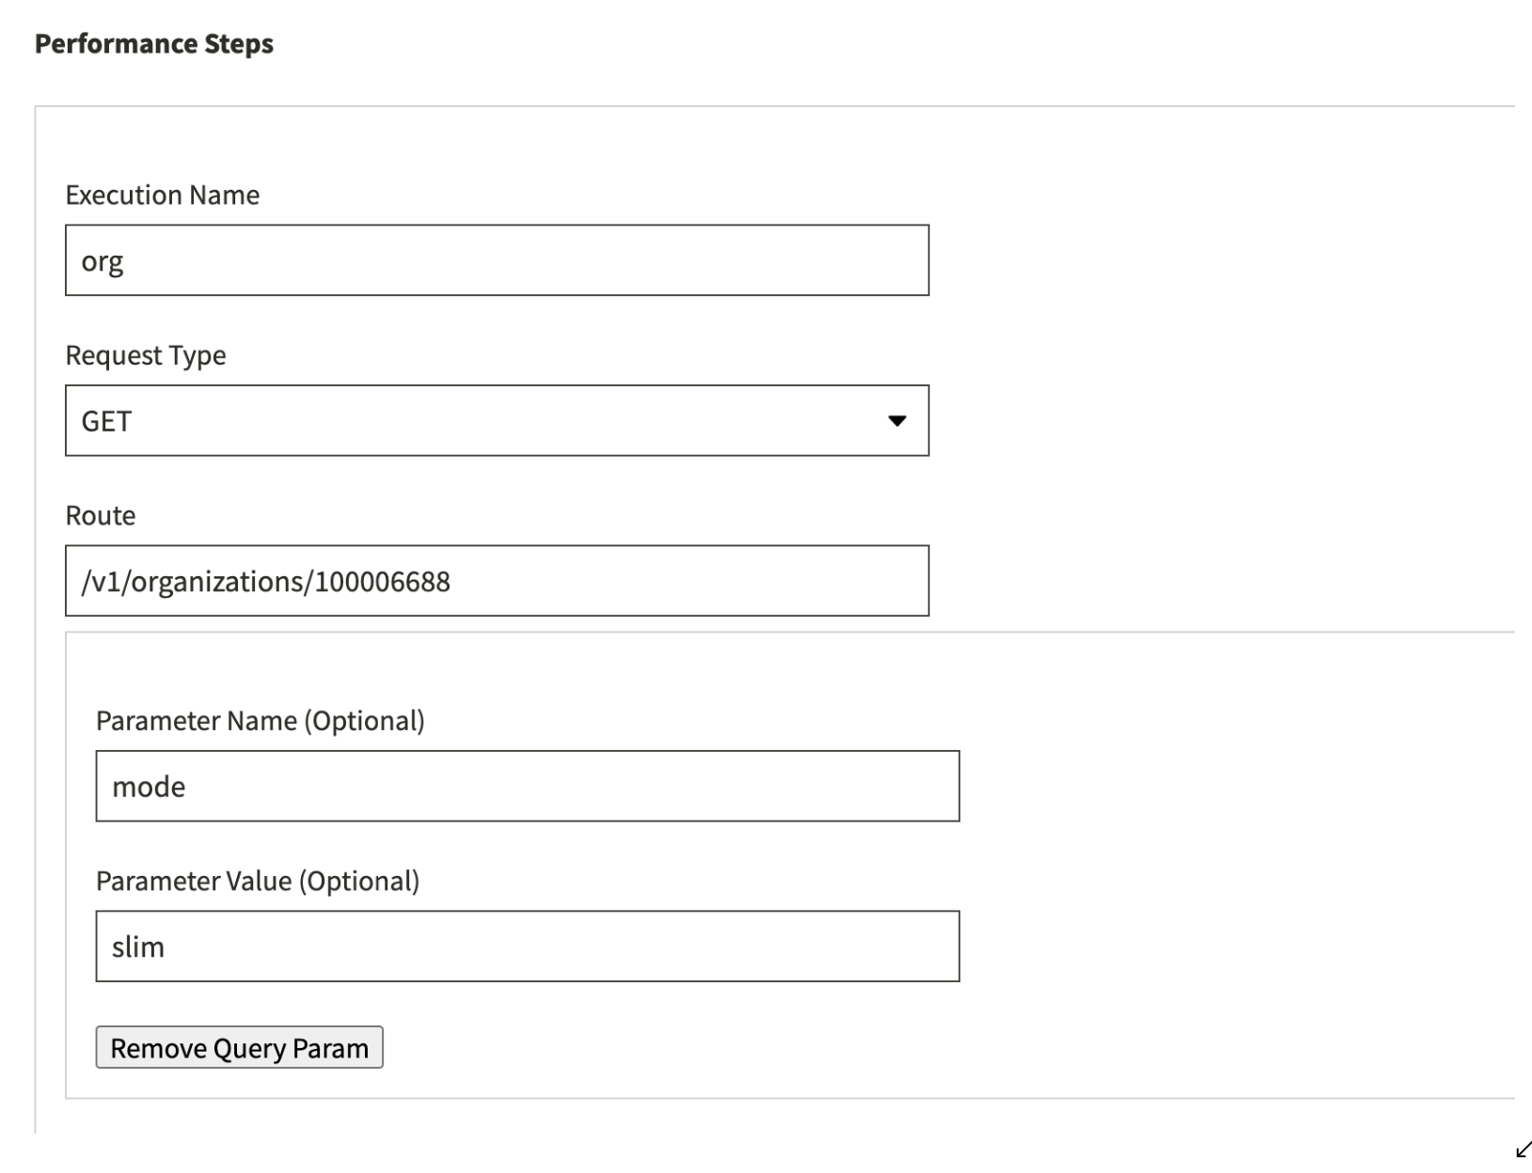

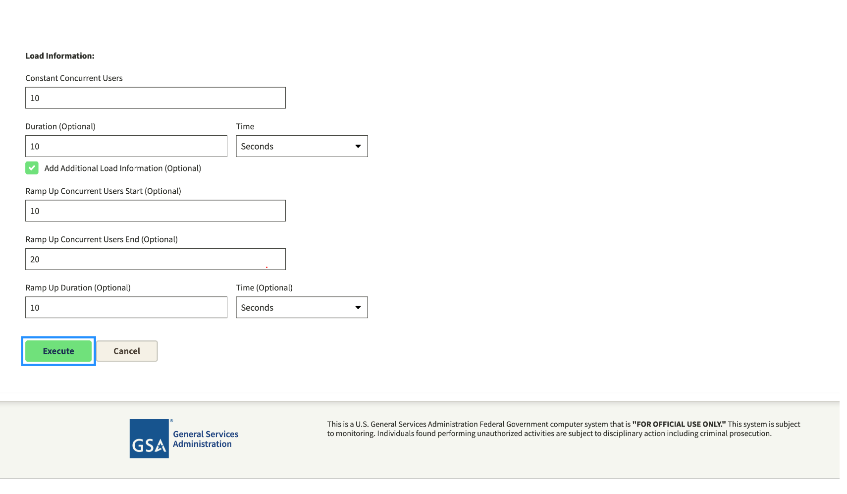

* Reports will be displayed on details page.

here are the sample reports

