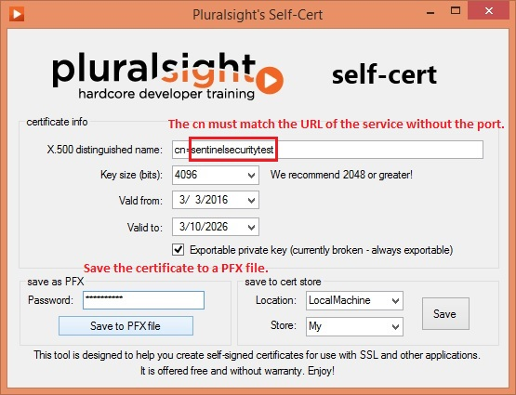Open the Self-Cert application. Enter the name of the service url after “cn=”. The common name must match the url of the service.

Save the certificate as a PFX file.

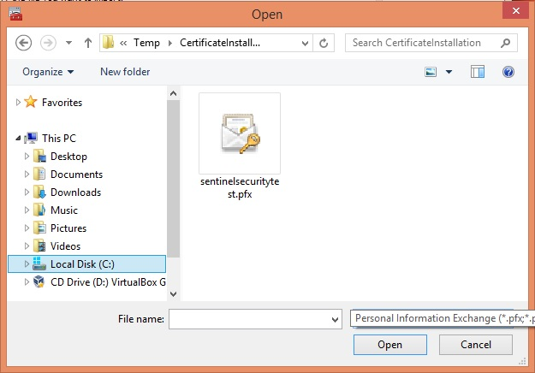

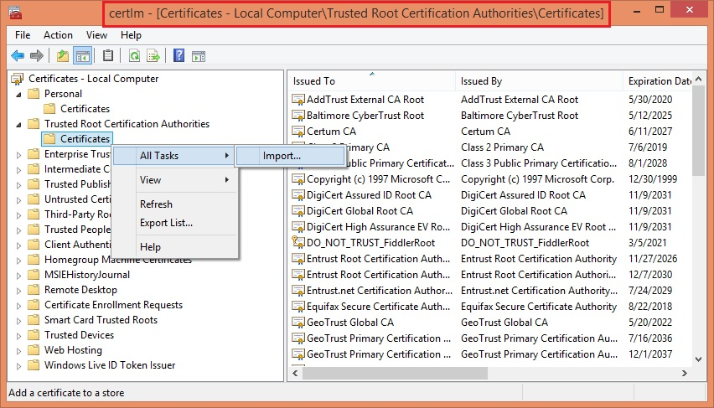Open the CERTLM.MSC Certificate Management Console.

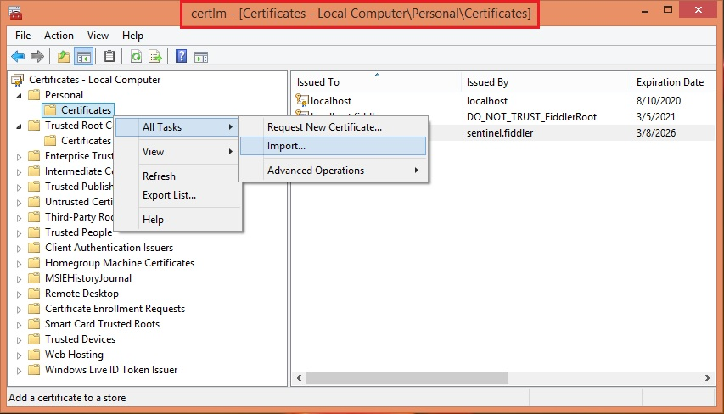Import the certificate to the Personal and Trusted Root Certification Authorities stores.

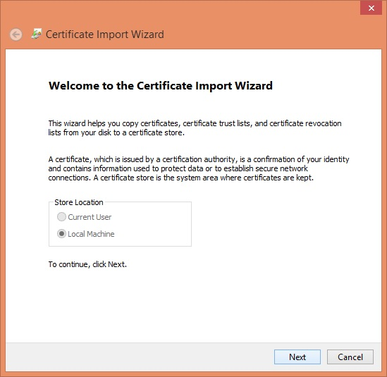

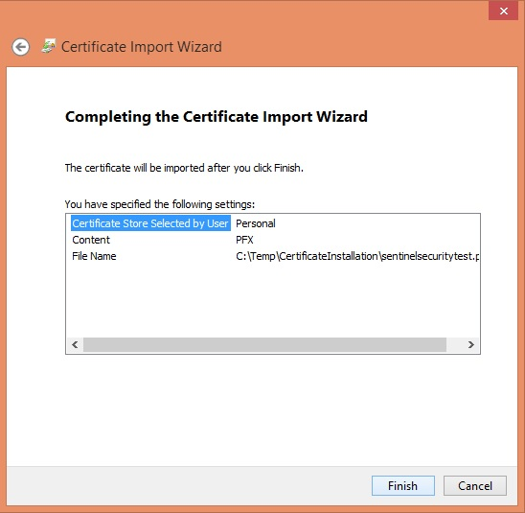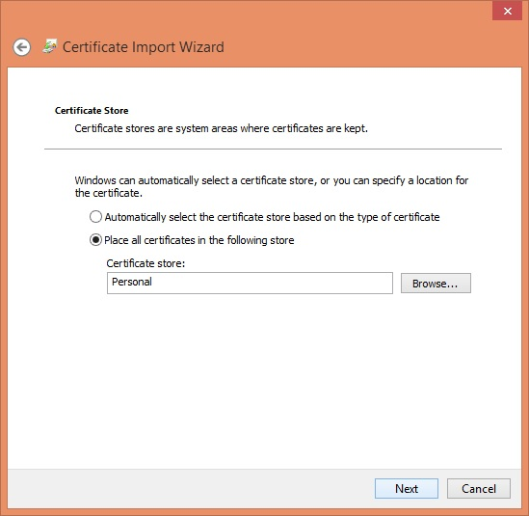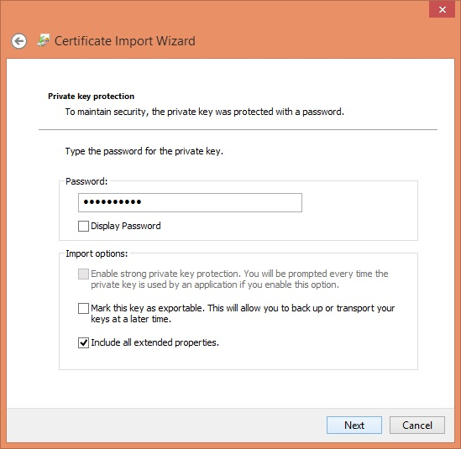

Once the certificate has been imported into both stores, open the certificate details.

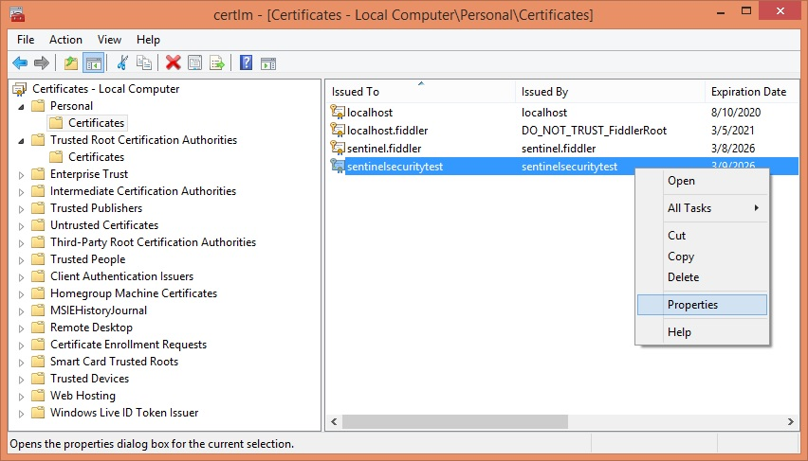

Copy the certificate thumbprint from the Details tab.

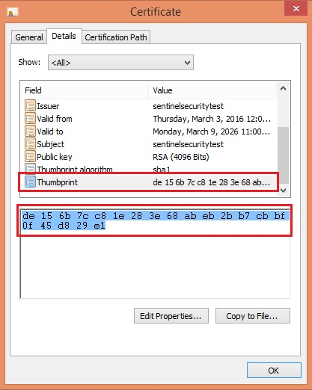

Use the thumbprint in the **netsh http add sslcert** command.

The test application id will always be: **b4996e50-9894-446a-888c-997cd532c37b**

The port should reflect the port that the service has been configured to run on.

The certhash is the certificate thumbprint with the spaces removed.

netsh http add sslcert ipport=0.0.0.0:8733 certhash=bba07e55e81251465d5d1c4dd2ff7c1f13879668 appid={b4996e50-9894-446a-888c-997cd532c37b}

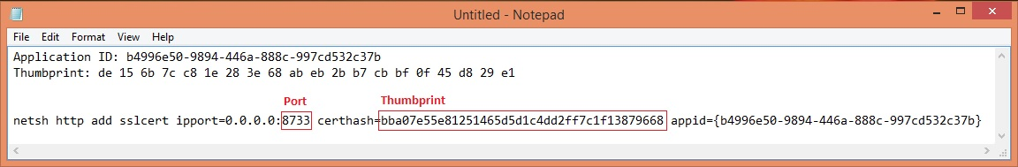

It may also be necessary to run the **netsh http add urlacl** *url=https://+:ServicePort/ServiceName* command for any service that may run as a non-administrative account.