Energy-Feasible UAV Exploration over an Online Registry of Safe Landing Zones
Capstone B Final Report
Dorian Veloso
Student ID 25773615
Supervisor: Dr Graeme Best
University of Technology Sydney
October 2026
Abstract
A battery-powered rotorcraft exploring unknown terrain must be able to land safely before its energy runs out, yet the places where it could land are not known in advance: they have to be discovered during the flight, and a later, closer observation may withdraw them. This report presents an exploration planner that detects geometrically safe landing zones online from a downward 3D LiDAR, holds them in a dynamic registry, and enforces an energy-feasibility invariant: whenever a confirmed zone exists, the energy left covers the flight to one of them and the landing, plus a fixed reserve. Two mechanisms are proposed. C1 filters every candidate frontier against this invariant and re-evaluates it whenever the registry changes, including when it shrinks. C2 ranks the admissible frontiers by a convex combination of information gain and energy margin, weighted by a parameter α. Both rest on an energy model calibrated on rotor shaft power in simulation, E = P_{hover} t + k_{move} d + c_{leg} n_{legs}, whose transit predictions fall within 0.16 % of the measurement. In 210 PX4 software-in-the-loop missions over three worlds, no mission with C1 violated the invariant (0/150), against 30/30 for nearest-frontier exploration and 11/30 for a classical explorer returning at a fixed 30 % battery threshold. The energy-margin utility shows an interior optimum: α = 0.75 gives the highest coverage on all three worlds, significantly above both pure margin and pure gain. A deliberately provoked loss of the zone in use during a return was detected within 3.1 to 4.1 s and answered at the same decision cycle; it also exposes the limit of the guarantee, which holds as long as the registry does not shrink under the zone it relies on.
Keywords: UAV exploration, safe landing zone detection, energy constraints, reachability, frontier-based exploration, LiDAR terrain mapping

1 Introduction
Rotary-wing UAVs are increasingly sent where no prepared landing pad exists: post-disaster assessment, coastal and environmental monitoring, inspection of remote infrastructure. In these missions the terrain is unknown at launch and endurance is measured in tens of minutes. The vision behind this work is a UAV that can be released over unknown terrain, explore it autonomously, and at every moment still know where it can put itself down safely with the energy it has left. Manned aviation offers a structural analogue: a pilot must always keep a reachable alternate aerodrome given fuel, weather and runway constraints. For a UAV over unknown terrain the alternate is not filed before departure. It must be discovered during the flight, and its reachability must be re-verified as the battery drains and as the map, and therefore the alternate itself, is revised.
The capabilities this requires have so far been developed separately. Frontier-based and next-best-view exploration planners maximise coverage or information gain without reasoning about where the vehicle could land (Yamauchi, 1997; Bircher et al., 2016). Landing site detectors assess slope, roughness and obstacles on a given map, but do not steer the exploration that produces the map (Shah Alam & Oluoch, 2021; Takahashi et al., 2013). Energy-aware planners either trigger a return to a predefined base when the battery crosses a threshold (Gramajo & Shankar, 2017; Gasche et al., 2025), or reduce consumption without checking that any safe state remains reachable (Elskamp et al., 2026); work that does provide formal reachability guarantees assumes that the safe sets are known in advance or found incidentally (Cherenson et al., 2025). None addresses the case in which safe landing sites are initially absent, are discovered online by terrain assessment, and may later be withdrawn when a closer observation contradicts the first one. This leads to the research question of this work:
How can a UAV autonomously search an unknown environment for safe landing zones, while ensuring continuous reachability of a geometrically confirmed safe site whenever one has been identified?
The final clause is not a stylistic precaution. At take-off no safe site is known, so an unconditional guarantee could not be stated and the mission could never begin; the problem must therefore define what is guaranteed before the first confirmation and how the guarantee behaves when the set of confirmed sites changes (Section 3).
We address the question with a planner that adds two mechanisms to a conventional perception and exploration pipeline (Figure 1). LiDAR returns are fused into a 2.5D elevation map; slope, roughness and step height are computed separately and tested against thresholds derived from the measured map noise; landable cells are grouped into zones held in a dynamic registry, in which a zone becomes usable only after every cell of a landing footprint has been observed on two distinct passes. The first contribution, C1, is an energy-feasibility invariant over this registry: a frontier is admissible only if the energy to reach it, plus the energy to return from it to the nearest confirmed zone and land, fits within the energy left minus a reserve. The invariant is also monitored at every map update, so that the loss of a zone triggers an immediate re-evaluation rather than waiting for the next frontier selection. The second contribution, C2, ranks the admissible frontiers by U = αG + (1 − α)M, a convex combination of information gain and energy margin, both rescaled over the candidates of each decision so that α keeps the same meaning throughout a mission. Both mechanisms rest on an energy model calibrated against rotor shaft power, after the distance-proportional model of the original proposal was refuted by measurement.
The system was evaluated in PX4 software-in-the-loop simulation with Gazebo Harmonic on three worlds of increasing size and difficulty, 210 missions in total, against nearest-frontier exploration without energy reasoning (B0) and a gain-driven explorer that returns at a fixed 30 % battery threshold (B1), the common practice in the literature. No mission with C1 violated the invariant (0 of 150), while B0 violated it in all 30 of its missions and B1 in 11 of 30: all ten on the tightest budget and none on the world where its threshold happens to exceed the return cost. The energy-margin utility has an interior optimum: α = 0.75 gives the highest coverage on all three worlds, significantly above both pure margin and pure gain. A deliberately provoked loss of the landing zone in use was detected 3.1 to 4.1 s after the obstruction appeared and answered at the same decision cycle; it also exposed the limit of the guarantee, since in three of four cases no other zone remained within the margin and the reserve covered the shortfall, at most 0.30 kJ.
The contributions of this report are therefore: (i) an energy-feasibility invariant enforced over a registry of landing zones that is built online and can shrink, with an explicit treatment of the bootstrap case and of zone loss; (ii) an energy-margin utility whose per-decision normalisation makes the trade-off parameter act over its whole range; and (iii) an empirical characterisation: a calibrated and validated energy model, a 210-mission evaluation with criteria fixed before the flights, a deliberately provoked registry shrink, and a set of documented negative results. Section 2 reviews related work, Section 3 states the problem formally, Section 4 describes the method and Section 5 its implementation, Section 6 reports the experiments, and Section 7 concludes with short and long-term future work.

2 Related Work
This work draws on four bodies of literature: autonomous exploration, landing site detection, terrain mapping, and energy-constrained planning. Each is mature on its own; the gap lies in how they are coupled.

2.1 Autonomous Exploration of Unknown Environments
Frontier-based exploration (Yamauchi, 1997) reduces exploration to repeatedly travelling to the boundary between known free space and unknown space. Its appeal lies in its simplicity and in the fact that its candidates are explicit places on the map. Sampling-based next-best-view planners extend the idea to three-dimensional volumetric maps (Bircher et al., 2016), usually stored as octrees (Hornung et al., 2013), with an information gain estimated by ray casting from each candidate view. Later work made the exploration objective aware of localisation uncertainty, steering the robot away from regions where the map would be unreliable (Papachristos et al., 2017), and of risk under stochastic dynamics (Han, 2023). These developments reflect a broader shift, articulated in the SLAM literature (Cadena et al., 2016), from map building as an end in itself towards perception in the service of a task.
The common thread is that the exploration objective remains information: where to look next in order to learn the most. Energy enters, when it does, as a path-length cost added to the utility, and the availability of a place to land, which is what actually bounds a battery-powered rotorcraft, plays no role in the decision. This work keeps the frontier paradigm precisely because its candidates are discrete and explicit: each one can be checked against an energy constraint before it is ranked, which is the structure C1 and C2 require.

2.2 Safe Landing Site Detection
Shah Alam and Oluoch (2021) classify landing zone detection into geometry-based, vision-based and hybrid learning-based methods, and note that geometric methods offer the most reliable metric assessment outdoors. They also have the longest history in safety-critical settings: LiDAR hazard detection for planetary landing fitted local planes to an elevation map and thresholded their slope and the residual roughness (Johnson et al., 2002), the same descriptors used in this work. On rotorcraft, Scherer et al. (2012) demonstrated autonomous landing at unprepared sites with a full-scale helicopter that evaluated candidate sites from LiDAR during the approach, and Takahashi et al. (2013) benchmarked safe landing area determination algorithms against surveyed field sites, finding geometric hazard scores more dependable than texture-based ones. Visual SLAM such as ORB-SLAM3 (Campos et al., 2021) can now produce dense maps from cameras, but the absolute height accuracy needed for slope and step tests still favours ranging sensors.
Two conclusions follow. First, geometric tests on a 2.5D map are mature enough to be used as a building block rather than a research object, and this work treats them as such. Second, the literature treats landing detection as a perception problem: sites are assessed on a map built for another purpose, during a final approach, or offline. The result neither steers the exploration that builds the map nor is checked against the energy needed to reach the site. A third observation, which this work makes explicit in Section 6.2, is that detectors are usually evaluated on a single map, whereas the absence of dangerous false accepts is a joint property of the map and the detector, and must be measured over many maps.

2.3 Terrain Mapping and Traversability
Elevation mapping with per-cell uncertainty is the standard representation for this purpose: each cell holds a height estimate and its variance, updated by a scalar Kalman filter (Kalman, 1960) as new returns arrive, with pose uncertainty propagated into the map (Fankhauser et al., 2014, 2018). Traversability analysis then derives local descriptors from the map. Beycimen et al. (2026) show that slope, roughness and step height discriminate safe from hazardous terrain in real time under field conditions, and Brubaker et al. (2013) established that surface roughness can be recovered from LiDAR returns. These techniques are reused here without modification. They matter to the contribution for a different reason: their error characteristics set the thresholds, the landing footprint and hence the safety margin of everything built on top. One known representational limit, a single height per cell that cannot represent two surfaces, turns out to be the dominant source of false refusals near obstacles in our largest world (Section 6.6).

2.4 Energy-Constrained Planning and Reachability
Empirical studies of multirotor consumption show that power is dominated by the cost of staying airborne rather than by the distance flown (Liu et al., 2017; Abeywickrama et al., 2018). A distance-proportional cost is therefore a poor model for missions that include hovering, decision pauses and frequent stops, a point this work confirms by measurement (Section 4.5). Planning under a battery budget has mostly taken the form of a return-to-base problem. Gramajo and Shankar (2017) redirect a coverage mission towards a known exit state when the remaining energy falls below a threshold; Cesare et al. (2015) coordinate multi-UAV exploration with vehicles returning to a base under battery and communication limits; Gasche et al. (2025) trigger a model-predictive return to base on the depth of discharge. Elskamp et al. (2026) integrate trajectory-level energy prediction into exploration and reduce total consumption, but do not verify that a safe state remains reachable.
Formal guarantees exist in a different line of work. Cherenson et al. (2025) maintain backup trajectories to renewal sets under budget constraints and thereby guarantee that a safe state stays reachable, but the renewal sets are either known a priori or discovered incidentally rather than being an objective of the mission. Control barrier functions express safety as the forward invariance of a safe set (Ames et al., 2019); C1 can be read as a discrete-time, set-valued analogue in which the safe set is defined by an energy inequality over a registry that itself changes with perception. In all of these works the place to return to is fixed, given or incidental, and none considers that it may disappear.

2.5 Synthesis and Research Gap
Table 1 summarises the positioning. Three gaps emerge. First, the availability of landing sites does not influence where an exploring vehicle goes next. Second, energy guarantees, when they exist, are stated relative to a static and predefined return target. Third, no work treats the case where the safe set shrinks because perception revises an earlier assessment while the vehicle relies on it. This work addresses the three gaps for a single vehicle in simulation. It deliberately contributes nothing to mapping, terrain analysis, frontier detection or path planning, which are taken from the works above; the contribution is the coupling between a registry of safe zones discovered online and a continuous energy guarantee, and the selection policy that follows from it.
Table 1. Positioning of this work against representative prior work.
Work | Exploration objective | Landing assessment | Return target | Energy guarantee
Yamauchi (1997); Bircher et al. (2016) | coverage, information | none | none | none
Johnson et al. (2002); Scherer et al. (2012); Takahashi et al. (2013) | none (given map or final approach) | geometric, LiDAR | not applicable | none
Gramajo & Shankar (2017); Cesare et al. (2015); Gasche et al. (2025) | coverage | none | predefined base | threshold or predictive return trigger
Elskamp et al. (2026) | information per unit energy | none | not verified | none (consumption reduced)
Cherenson et al. (2025) | budget-constrained tasks | none | renewal sets, known or incidental | formal, backup trajectories
This work | coverage, traded against margin (C2) | geometric, online registry | nearest confirmed zone; may shrink | invariant checked at every decision (C1)

3 Problem Statement

3.1 Setting and Assumptions
A multirotor UAV takes off from a known point into terrain that is unknown, static and contained in a square exploration area A. It carries a single downward-facing 3D LiDAR and is localised by GPS through the autopilot estimator; no SLAM is used, following the supervisor's advice in the first semester. It flies at a fixed cruise altitude h above the take-off point (8 m in all experiments) and has an energy budget B₀. The energy left at time t is B_{t}, and a fixed reserve R = 0.1 B₀ is withheld from planning. There is no wind. The energy budget is a logical budget measured by integrating rotor shaft power in simulation (Section 4.5), not the autopilot's simulated battery.

3.2 Map, Landable Cells and Registry
The terrain is represented by a 2.5D grid M_{t} with 1 m cells, each holding a height estimate, its variance and an observation count. A cell is landable when it is observed, its slope, roughness and step height are below fixed thresholds, and every cell under a landing footprint centred on it passes the same tests (Section 4.3). Connected landable cells form zones. The registry Z_{t} is the set of zones whose state is CONFIRMED, that is, zones whose footprint cells have each been observed on at least two distinct passes (invariant I4, Section 4.4). Z_{t} grows when a zone is confirmed and shrinks when new observations refuse its cells. The frontier set F_{t} contains the clusters of observed cells that border unknown cells, each with a reachable viewpoint f and an information gain G(f).

3.3 The Energy-Feasibility Invariant
Let E_{ret}(p, z) be the predicted energy to fly from position p to zone z along a collision-free path, and E_{land} the energy of a controlled descent and landing. The margin of the vehicle at position p_{t} is
m_{t} = B_{t} − R − E_{land} − min_{z∈Z} E_{ret}(p_{t}, z), (1)
where Z denotes the registry at the time of evaluation. The invariant I1 required by the research question is
I1: Z_{t} ≠ ∅ ⇒ m_{t} ≥ 0 for all t. (2)
A cycle in which Z_{t} is non-empty and m_{t} < 0 is a violation: the vehicle can no longer reach any confirmed zone and land with its reserve intact. The decision rule that keeps I1 true by construction is the admissibility condition on frontiers,
E_{go}(p_{t}, f) + min_{z∈Z} E_{ret}(f, z) + E_{land} ≤ B_{t} − R, (3)
which requires that after flying to f the vehicle could still return to a confirmed zone and land. If the predictions are accurate and the registry does not change during the transit, choosing only admissible frontiers implies m ≥ 0 on arrival. Neither condition holds exactly in practice: predictions err, decisions take time, and the registry can shrink while the vehicle relies on it. The method therefore also monitors (2) at every map update (Section 4.6) and treats a shrink explicitly (Section 4.4).

3.4 Objective, Bootstrap and Outputs
The objective is to maximise the fraction of A that is observed, subject to I1 whenever Z_{t} is non-empty, and to end every mission by landing on a confirmed zone, never wherever the vehicle happens to be. The bootstrap case, t = 0 with no confirmed zone, is resolved by registering the take-off point as a provisional zone: the vehicle has just left it, so it can land there. This makes I1 meaningful from the first cycle without a special case, and the flag lets the analysis distinguish missions that end on a discovered zone from those that end at the start. It departs from the proposal, which excluded the launch point by assumption; the consequence, that the take-off point is assumed to stay free for the whole mission, is declared as a limitation (Section 7). The outputs of a mission are the trajectory, the registry history, the per-cycle record of every candidate with its energy terms, and the landing site.

4 Method

4.1 Overview and Changes from the Proposal
Figure 1 shows the method as concepts. The perception chain (top row) turns LiDAR scans into an elevation map, terrain descriptors, landable cells and finally a registry of confirmed zones. The decision chain (bottom row) extracts frontiers from the same map, filters them with C1, ranks the survivors with C2, and hands the choice to a mission state machine that also decides when to return and land. The energy model feeds both C1 and C2. A single component holds the decision authority, so that C1 and C2 sit in one place and can be disabled cleanly for the baselines.
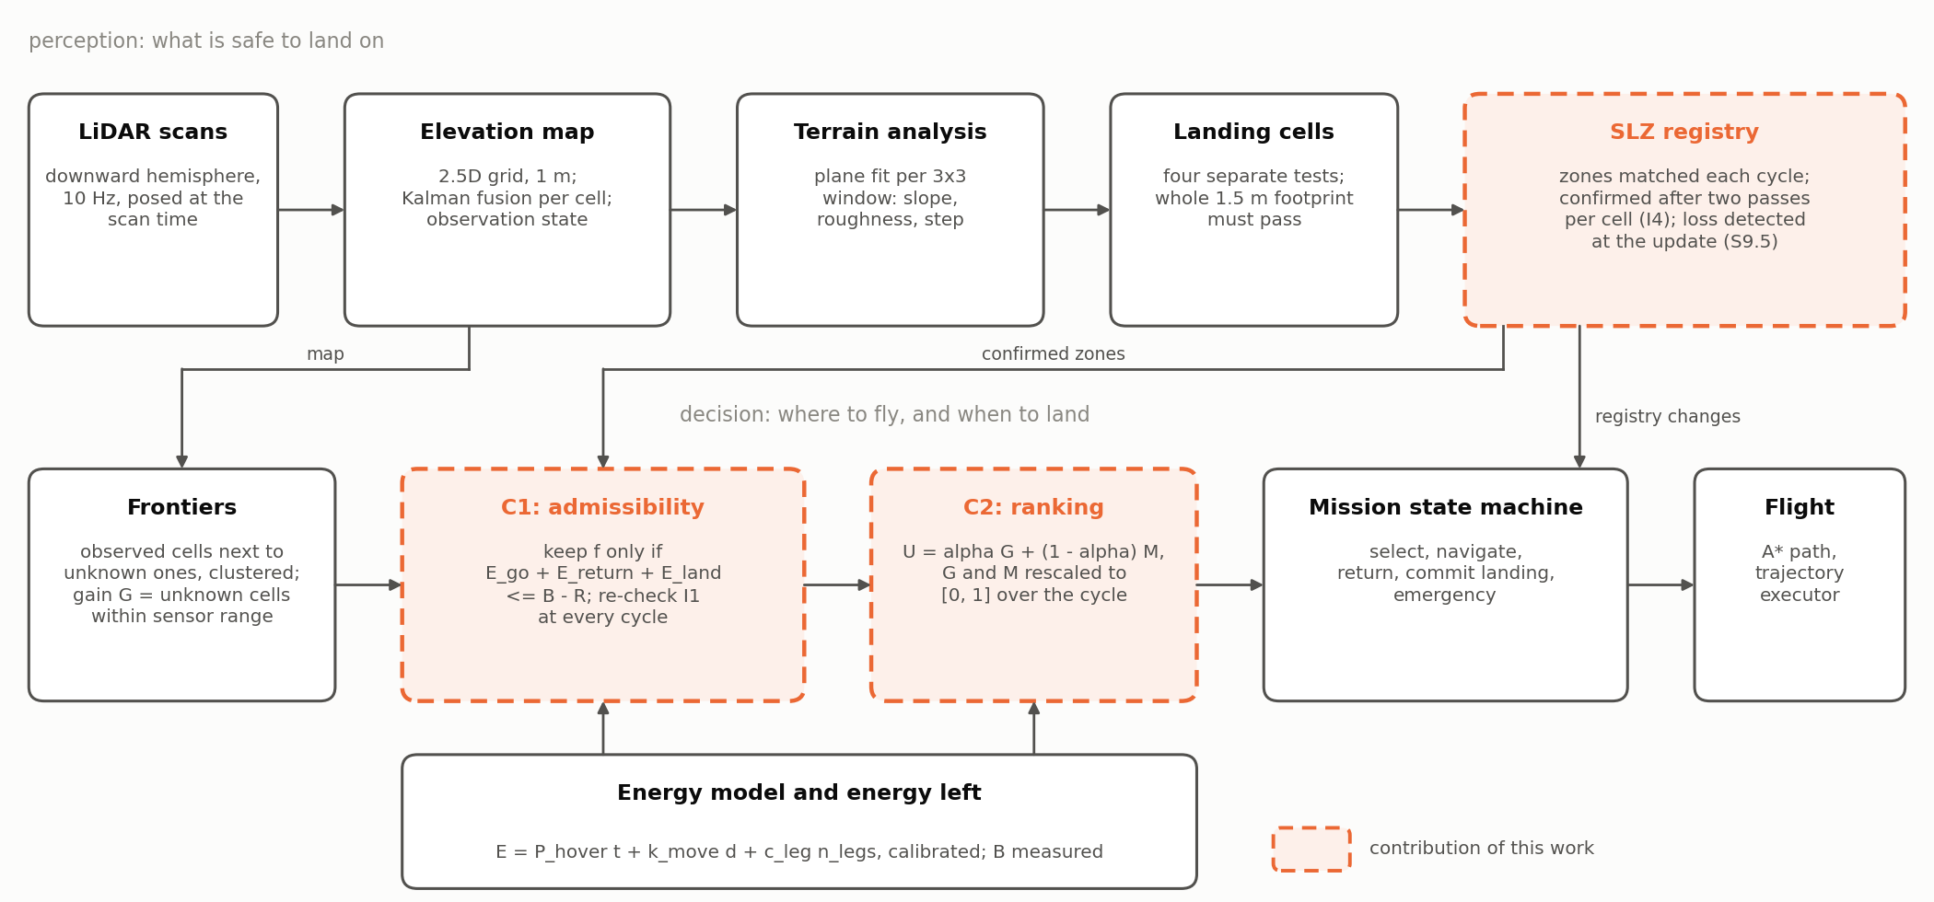
Figure 1. Method overview. Top: the perception chain from LiDAR scans to the registry of confirmed landing zones. Bottom: the decision chain from frontiers to flight. Dashed boxes are the contributions of this work (the dynamic registry, C1 and C2); solid boxes are established techniques reused as building blocks. The registry feeds C1 with the confirmed zones and the state machine with every change, which triggers the re-evaluation of the invariant described in Section 4.4.
Almost every technical choice of the proposal was changed during the project, each time because a measurement showed that the proposed choice would not support the guarantee. Table 2 lists the changes and the evidence for each. The research question, the two contributions and the evaluation logic are unchanged.
Table 2. Design changes from the research proposal and the measurement that motivated each.
Component | Proposal | Final design | Reason
Energy model | E = k d, calibrated on PX4 battery telemetry | E = P_{hover} t + k_{move} d + c_{leg} n_{legs}, calibrated on rotor shaft power | SITL telemetry depends only on armed time; k d predicts 77 J for a 60 s hover costing over 17 kJ (Section 4.5)
Terrain scoring | weighted composite score; slope 10°, roughness 0.3 m, step 0.5 m; 0.5 m grid | four separate tests; slope 6°, roughness 0.05 m, step 0.24 m; 1 m grid | thresholds set by the measured map noise; a weighted sum lets one good descriptor mask a failing one (Section 4.3)
Exploration map | ray-cast occupancy grid | frontiers on the observation state of the elevation map | one map for exploring and for judging terrain, so both agree on what is known
Return cost | bounded Dijkstra on a roadmap | A* on the inflated obstacle grid; one return field per cycle | the same planner serves flight and C1
Launch point | never assumed safe | provisional zone in the registry | gives I1 a meaning from t = 0 (Section 3.4)
Zone confirmation | safe cluster larger than the footprint | whole footprint seen on two passes per cell (I4) | single oblique views confirmed zones that later vanished (Section 4.4)
Configurations | (a) no filter, (b) C1 only, (c) C1 + C2 with α by 0.2 | B0, B1 (30 % threshold), B3 with α ∈ {0, 0.25, 0.5, 0.75, 1} | B1 is the practice to beat; (b) equals B3 at α = 1 by construction
Statistics | means with 95 % confidence intervals | medians, interquartile ranges, Mann-Whitney U, Spearman | bounded distributions with many zeros; runs not seed-repeatable

4.2 Elevation Mapping and Observation State
Each LiDAR return is transformed into the world frame (Section 5.2) and fused into the cell it falls in by a scalar Kalman filter, k = p / (p + r), with the measurement variance growing with range as σ = 0.02 + 0.009 d metres. The cell variance is floored at (0.02 m)². The floor is not cosmetic: without it the variance of a cell decays as 1/n, and after a few hundred observations the gain is so small that the cell is effectively frozen and cannot be corrected even by a much better observation taken from close range. In early versions this produced phantom trenches several metres deep at ramp edges, under cells that had accumulated tens of thousands of observations with an absurd confidence.
Every cell is assigned an observation state: UNKNOWN when it has no return, OBSERVED when it has at least 10 returns and a variance below 2 × 10⁻³ m² (the median fused variance at that count), and SPARSE otherwise. Frontiers and coverage are defined on this state, and the terrain analysis refuses any window that contains an unknown cell (invariant I2: nothing is declared safe that has not been seen).

4.3 Terrain Analysis and Landing Cells
For each cell a plane is fitted by least squares to the 3 × 3 window around it. Slope is the inclination of that plane, roughness the standard deviation of the residuals to it, and step the largest height difference between the cell and its neighbours. The plane fit matters: with 5 cm of noise between neighbouring cells a finite difference produces about 6° of spurious slope, which the fit reduces roughly threefold. Because the plane is removed before roughness is measured, roughness is independent of slope by construction: a smooth ramp reads as slope and not as roughness, and a rubble field as roughness and not as slope. Section 6.2 verifies this separation against ground truth.
A cell passes when its slope is at most 6°, its roughness at most 0.05 m and its step at most 0.24 m, and its window is fully observed. The four tests are applied separately rather than combined into a weighted score as in the proposal: a weighted sum allows a very flat but stepped cell to compensate its step with its flatness, whereas each descriptor captures a distinct way of damaging a landing gear. The slope threshold is not a convention. It sits between the 95th percentile of the slope measured on truly flat ground (4.34°) and the 1st percentile measured on the 10° ramp of the validation world (8.25°), both on the reference map (Section 6.2).
A cell is landable only if every cell covered by a landing footprint of 1.5 m centred on it passes. The footprint element is an over-approximation of the disc: every cell the disc touches, even partially, must pass, which at 1 m resolution is the 3 × 3 square. An earlier element kept only the cells contained in the disc, a single cell for a 1.5 m footprint, and therefore accepted cells it had never tested; correcting it reduced the dangerous false accepts on the reference map from 25 to 0. The footprint was then checked against the measured landing precision (Section 6.3): the vehicle needs 1.13 m, but a 1.2 m footprint, whose element loses the diagonal cells, reintroduced 2 dangerous false accepts on the reference map. The diagonal cells are a margin that the map error requires, and 1.5 m was kept. With an analysis radius r_{a} and a footprint radius r_{f} in cells, an isolated zone must be at least 2(r_{a} + r_{f}) + 1 cells wide to be detected, 5 m in this configuration. The real lever for detecting smaller zones is therefore the map error, which costs energy to reduce (flying lower, passing more often); this is exactly the trade-off that C2 formalises.

4.4 Dynamic Landing Zone Registry
Landable cells are grouped into zones by 8-connected flood fill at every map cycle. Because zones are re-detected from a map that changes, each new zone is matched to the zones of the previous cycle by cell overlap, so that a zone keeps its identity and its history. A zone enters as CANDIDATE and is not usable by C1. It becomes CONFIRMED when a whole footprint of its landable cells has been observed on at least two distinct passes, cell by cell (invariant I4). A pass of a cell begins when the vehicle comes within r_{in} = 14.4 m of it and ends when it moves beyond r_{out} = 18 m, the radius of the sensor footprint at cruise altitude; the hysteresis prevents a vehicle hovering near the boundary from counting many passes. The rule replaced an earlier one that counted passes over the zone's centroid: offline on the validation world, that rule confirmed zones of which only 538 m² out of 2465 m² had in fact been seen twice. A single view from one angle confirms nothing; a second pass from another position is what removes the artefacts of oblique observation. Once confirmed, a zone is demoted or retired when an update refuses enough of its cells that no whole footprint remains.
The registry is what makes the safe set dynamic, and its shrinking is the case that no prior work on energy-constrained exploration treats. When an update removes a confirmed zone, the system (1) detects the event at the registry update rather than at the next frontier selection; (2) re-evaluates I1 immediately against the reduced registry; (3) if I1 still holds through another zone, continues and logs the event; (4) if it no longer holds, interrupts the current navigation and returns to the nearest reachable zone; and (5) if no zone is reachable within the guarantee, logs a violation and still flies to the nearest reachable zone, the reserve covering the shortfall. Section 6.6 provokes this sequence deliberately.

4.5 Energy Model
The proposal planned a model E = k d, calibrated from the battery telemetry of the PX4 simulator. Both parts were refuted. The simulated battery reports a current of −1 A, a discharged capacity of zero, and a remaining fraction that decreases linearly with the time the vehicle has been armed: regressing it on distance would only measure flight duration. The signal used instead is the mechanical shaft power of the four rotors, computed from the motor speed commands that PX4 sends to the simulator. The instrument was validated in hover, where the analytic prediction from weight and thrust coefficients (806.0 rad/s, 286.5 W) falls within 0.2 % of the measurement (805.5 rad/s, 285.9 W). Fitted to a survey flight, the distance model gives k = 48 J/m and predicts 77 J for a 60 s hover that costs over 17 kJ: flight time explains 87 % of the survey energy. A multirotor spends most of its energy staying in the air, which had to be measured rather than assumed.
The adopted model charges time, distance and each straight leg of a path:
E = P_{hover} t + k_{move} d + c_{leg} n_{legs}, t_{leg} = L/v + v/a + 0.06 s, (4)
where every leg of length L is flown on a trapezoidal profile from rest to rest at v = 5 m/s and a = 3 m/s², and 0.06 s of settling is measured at each arrival. The time of a path is thus known exactly from the plan, which is what allows C1 to predict an energy before flying. The model was calibrated on 16 flights on fresh simulator instances: squares of 10, 20, 40 and 60 m flown three times each, with a hover of 10, 20 or 30 s before each lap to decorrelate time from distance, and four validation flights never used in the fit, including an eight-leg zigzag. Table 3 gives the parameters. Without the leg term the model already passes the 10 % acceptance bar by a factor of ten, but its error is structured and optimistic, up to 4.2 % on 10 m legs, because every leg pays the same two accelerations; with it the transit errors fall within ±0.16 %. The zigzag, with twice as many legs per metre as the squares, confirms that the cost is per leg. E_{land} is calibrated separately from twelve descents from 8 m (3199 J, standard deviation 15 J); the planner uses 3387 J, the 95th percentile of the landings commanded by the mission manager, which include its own pauses.
Table 3. Energy model parameters, least-squares fit on 36 segments of 12 calibration flights, with 95 % confidence intervals.
Parameter | Value | Interpretation
P_{hover} | 285.64 ± 0.12 W | power to stay airborne; 285.9 W in a pure hover
k_{move} | −0.400 ± 0.042 J/m | cruise at 5 m/s costs about 2 W less than hover
c_{leg} | 65.2 ± 1.3 J | the two accelerations of each leg
E_{land} (calibrated) | 3199 J, s.d. 15 J | descent from 8 m and touchdown, 12 descents
E_{land} (planning) | 3387 J | 95th percentile of the landings commanded in missions

Three caveats bound the claims. The intervals measure the model's lack of fit rather than noise, since the simulation repeats to 0.02 %. The negative k_{move}, cruise slightly cheaper than hover, is measured but its origin in the rotor model was not established. And the model is valid only for the calibrated profile, which the trajectory executor therefore flies by construction: stop at every vertex, constant speed and acceleration, constant altitude.

4.6 C1: Energy-Feasibility Filter and Monitor
C1 evaluates (3) for every frontier at every selection, and the margin (1) at every map cycle, about once per second. Figure 2 illustrates one decision. The terms are computed as follows. E_{go} is the energy of the planned path from the vehicle to the frontier viewpoint by (4), plus a hover of duration τ for everything the plan does not contain: the computation before the path starts, the settling, and the wait and computation at the frontier before the next command. E_{ret} is the energy of the path from the viewpoint to the nearest landable cell of any confirmed zone, the provisional take-off point included, plus another τ, since the return also starts one decision after the energy is read. A single return field, a distance transform seeded on every landable cell of every confirmed zone, gives the return cost from all frontiers in one pass.
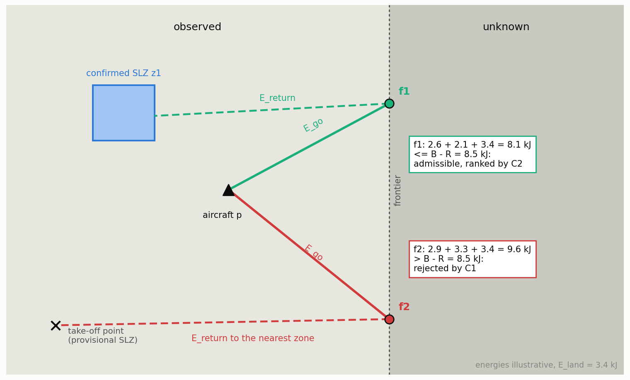
Figure 2. The admissibility rule of C1 on one decision, seen from above, with illustrative energies. Frontier f1 can be reached and the vehicle can still return from it to the confirmed zone z1 and land within B − R: it is admissible and passed to C2. Frontier f2 costs about as much to reach, but its nearest zone is the provisional take-off point, far behind the vehicle, and the sum exceeds the budget: C1 rejects it before any ranking, whatever its information gain.
The latency τ was first a constant of 2 s, which sufficed while decisions took under a second. On a 190 m area the decision time grew with the map up to 21.5 s, 301 s of hover went uncounted, and I1 was violated seven times with C1 active. τ is now measured at every decision and C1 charges the maximum of the last five latencies plus the largest recent increase; with 5 s of latency injected on purpose, the violations fell from 2, 2 and 1 per mission to 0, 0 and 0. A guarantee is no stronger than the worst term it omits.
Two approximations remain. The return from f is planned on the current map, whereas the map at f is unknowable; this is optimistic, and the reserve R covers it. And the registry may change during the transit, which the monitor addresses: Algorithm 1 shows how the filter, the monitor and the shrink handling of Section 4.4 fit into one decision cycle. When no frontier is admissible, exploration is over for energy reasons, which is a legitimate end of mission rather than an error, and the vehicle returns.
Algorithm 1. One decision cycle of the exploration manager, run on every new map (about 1 Hz).
1 input: map M, registry Z, energy left B, position p, reserve R, α
2 W ← analyse(M) ▷ landable cells, frontiers F, obstacles
3 Z, lost ← update_registry(Z, W, passes) ▷ match, confirm (I4), demote
4 D ← return_field(W, Z) ▷ cost to the nearest confirmed zone
5 m ← B − R − E_land − D(p) ▷ margin (1), logged every cycle
6 if lost ≠ ∅ and m < 0 then ▷ registry shrank under the guarantee
7 log violation; RETURN to argmin_z E_ret(p, z)
8 if state = SELECTING then
9 A ← {f ∈ F : E_go(p, f) + D(f) + E_land ≤ B − R} ▷ C1, (3)
10 if A = ∅ then RETURN to argmin_z E_ret(p, z)
11 else rescale G, M over A; f* ← argmax_A αG + (1 − α)M ▷ C2
12 NAVIGATE to f*
13 if state = RETURNING and a zone is cheaper by > 541 J
14 and I1 holds without it then switch target ▷ ≤ 3 per return
15 if arrived over a landable cell of the target then COMMIT landing

4.7 C2: Energy-Margin Utility
C1 is a filter and treats all admissible frontiers as equal. C2 ranks them by trading information against margin. For each admissible frontier the share of the usable budget it would leave is
share(f) = clip((B − R − E_{tot}(f)) / (B − R), 0, 1), E_{tot} = E_{go} + E_{ret} + E_{land}, (5)
and the utility is
U(f) = α G̃(f) + (1 − α) M̃(f), x̃ = (x − min_{A} x) / (max_{A} x − min_{A} x), (6)
where G is the number of unknown cells within the sensor radius of the viewpoint, M is the share, and both are rescaled to [0, 1] over the admissible set A of the current cycle. The rescaling of both terms is essential and was established by measurement. In the first version G was divided by its maximum and M was the share itself. Over 2225 decisions of 60 missions, G spread by 0.88 between candidates and M by only 0.12 (medians), so G dominated from α = 0.10 and 92 % of the decisions at α = 0.5 were already the pure-gain choice: α acted only on [0, 0.2]. With both terms rescaled per cycle, the choice leaves the pure-margin one at α = 0.35 and joins the pure-gain one at α = 0.55 (medians), and 52 % of the decisions at α = 0.5 differ from pure gain. The cost is that when all margins are nearly equal a small difference is magnified, but only among frontiers that C1 has already judged safe. At α = 1 the ranking is pure information gain among admissible frontiers, which is exactly configuration (b) of the proposal; at α = 0 the vehicle always takes the frontier that leaves the most energy, which in practice keeps it close to its landing zones.

4.8 Mission State Machine and Returns
The exploration manager is a state machine: INIT, TAKEOFF, SELECTING (frontiers, C1, C2), NAVIGATING (following the path while the margin is monitored), RETURNING (transit to the chosen zone), COMMIT_LANDING (descent engaged), LANDED and EMERGENCY. A mission ends in one of three ways, each logged separately: complete coverage (no valid frontier), budget exhausted (no admissible frontier), or an external stop. In all three the vehicle lands on a registry zone, never where it stands. Once the descent is engaged the decision is irreversible, since oscillating between zones at the end of a mission is the worst behaviour energetically.
Two refinements of the return were found necessary in flight. First, during a return the target may be switched to a confirmed zone that has become cheaper to reach by more than the cost of one stop and restart, c_{leg} + P_{hover} v/a = 541 J, at most three times per return. The first version of this rule switched to zones confirmed in the same cycle that vanished one or two seconds later, and one mission ended in its reserve; a switch is therefore taken only if I1 would still hold should the new zone be lost on arrival. Second, a frontier whose target cell turns out to be unreachable on approach (for instance a roof measured higher up close) is blacklisted for 30 s, and for 300 s after three failures, and a new frontier is selected. Finally, when the inflated obstacles of the nominal map enclose the vehicle, which happened over the rooftop units of the largest world, the return may use an escape map with a 1 m vertical margin instead of 2 m; the escape map is never used to explore.

5 Implementation

5.1 Software Architecture
The system runs on ROS 2 Jazzy with PX4 SITL (v1.17.0-alpha1) and Gazebo Harmonic (8.11.0) under Ubuntu 24.04 on WSL2 (Macenski et al., 2022; Meier et al., 2015; Koenig & Howard, 2004). Figure 3 shows what runs and the topics between the components. The code separates pure Python modules, which contain every algorithm of Section 4 and import no ROS, from four thin ROS nodes that only move messages: cloud_world (scan to map), energy_monitor (rotor power to energy), exploration_manager (the state machine and the only decision authority) and trajectory_executor (path to PX4 setpoints). The separation is what makes the decision logic testable without a simulator: 120 unit tests cover the map fusion, the terrain analysis, the registry, the energy model, C1, C2 and the state machine, and every rule added after a flight came with its test.
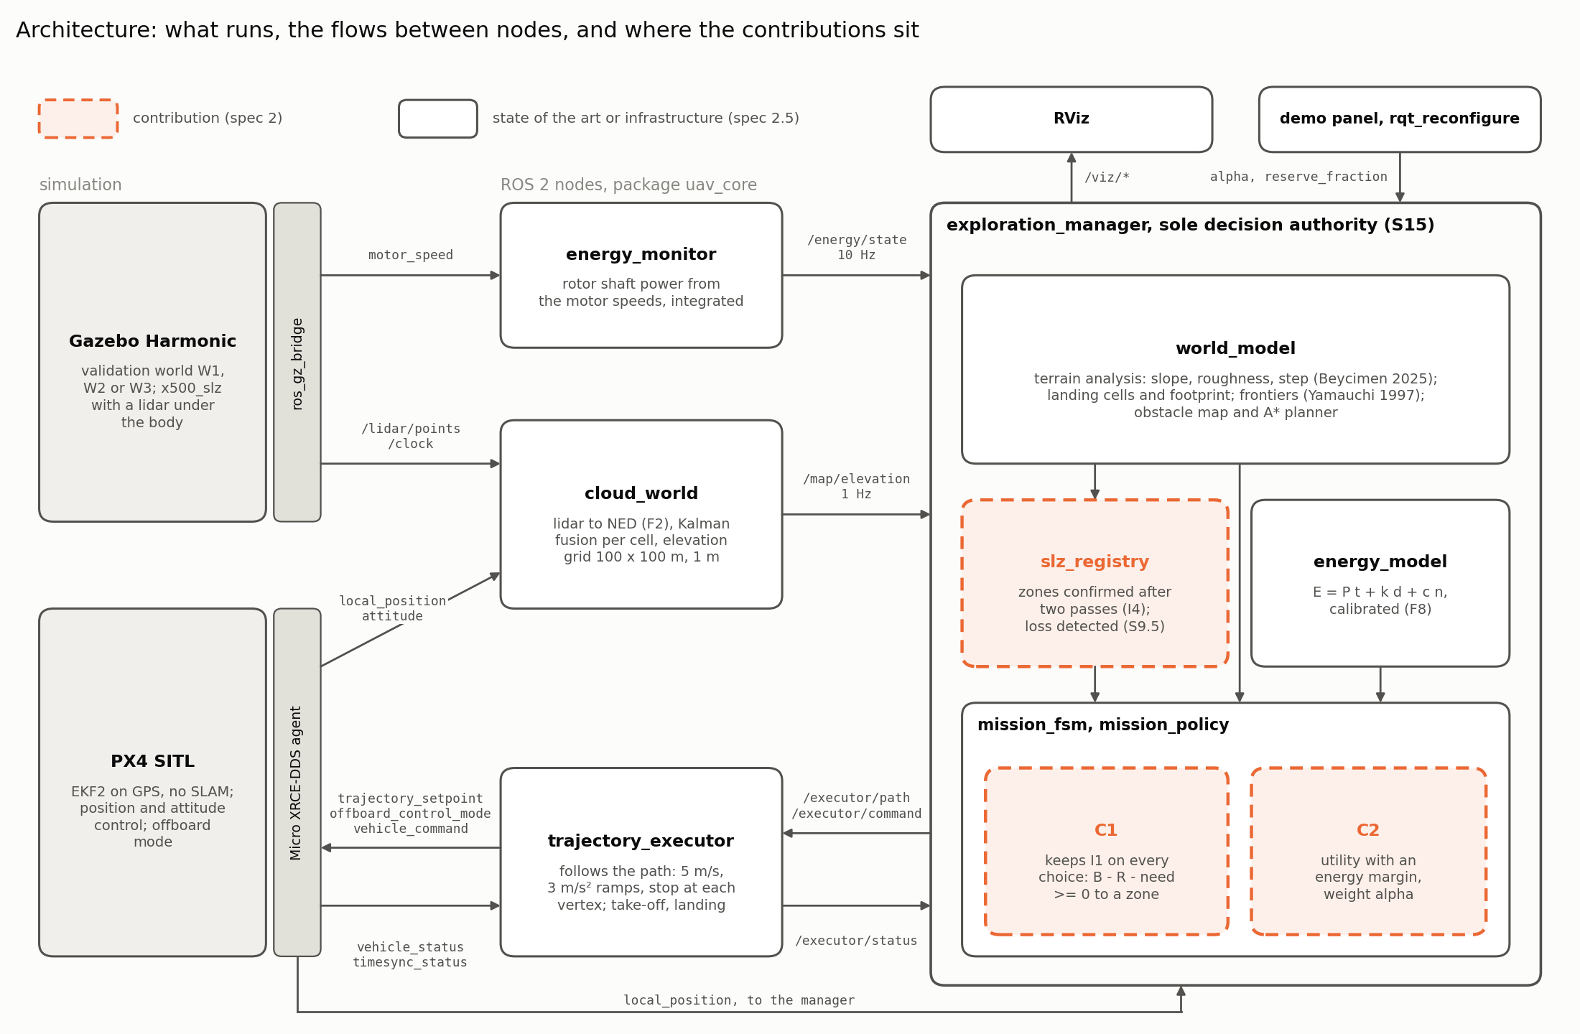
Figure 3. Software architecture as it runs: Gazebo and PX4 SITL with their two bridges (left), the four ROS 2 nodes of the package (middle), and the exploration manager with the pure modules it calls (right). Arrows carry the real topic names; PX4 topics are shortened (the /fmu/in and /fmu/out prefixes and version suffixes are omitted). Dashed boxes are the contributions; solid ones are reused techniques or infrastructure.

5.2 Frames and Timing
Four frames are involved (Figure 4). LiDAR points arrive in the sensor frame (forward, left, up) and are converted to the body frame (forward, right, down) by inverting the y and z axes and adding the 0.15 m sensor offset. They are then rotated into the local north-east-down frame by the attitude quaternion and translated by the vehicle position. Without this rotation a point 15 m ahead is placed at the wrong height as soon as the vehicle tilts, which in an earlier version of the project turned the whole terrain unsafe. The simulator world, in which the ground truth is drawn, is east-north-up and is converted by swapping the horizontal axes and negating the height.
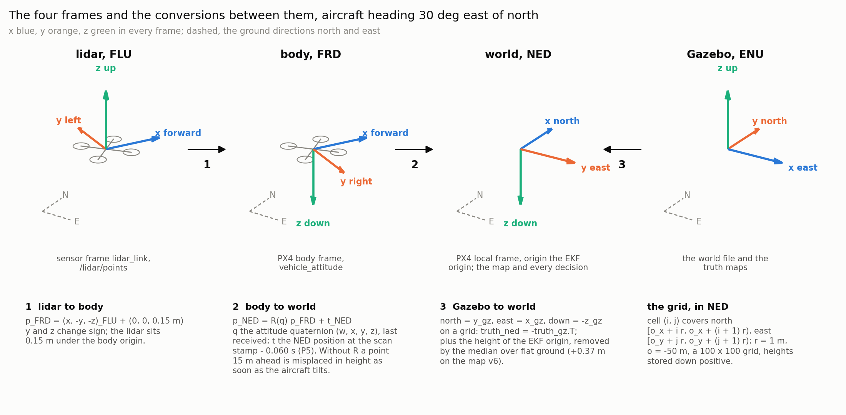
Figure 4. The four frames and the conversions applied by the code, drawn for a heading 30° east of north so that the body and world frames visibly differ. (1) LiDAR to body; (2) body to world, with the position taken at the scan time; (3) simulator to world, used for the ground truth; the grid indexing in the world frame is given on the right.
Timing turned out to matter as much as geometry. On the ramps of the validation world the map was offset by one cell from the truth along the direction of flight. The cause was measured: the pose used to place a scan was 0.11 to 0.12 s ahead of the scene the LiDAR had seen, which at 5 m/s smears the map by half a cell. The fix takes the position at the scan timestamp minus a calibrated 0.060 s, through the simulation clock, and the attitude last received; taking the attitude back in time as well destroyed the recall offline and was rejected. On six fresh surveys the offset vanished, the ramp error fell from 0.34 to 0.16 m RMS, and the dangerous false accepts of fresh surveys fell from 3 or 4 to 0, while the recall was kept (93.7 % before, 94.4 to 95.7 % after). Several silent failure modes of the PX4 interface had to be resolved as well; the most costly was that offboard setpoints must be stamped in microseconds since the autopilot booted, extrapolated from a time offset updated at 1 Hz, and copying the 1 Hz stamp itself caused 177 failsafes in one test series, none after the fix.

5.3 Vehicle, Sensor and Flight
The vehicle is the PX4 x500 quadrotor with a LiDAR mounted 0.15 m below the body, a placement chosen so that the sensor does not see the arms. Table 4 lists the parameters used in all experiments. The trajectory executor follows a path of straight legs on the calibrated profile and declares arrival on separate horizontal and vertical tolerances. Paths are planned by A* (Hart et al., 1968) on an obstacle grid in which a cell is blocked when its height exceeds the cruise altitude minus a 2 m vertical margin, inflated by 1.25 m (half the span plus the measured tracking error).
Table 4. Parameters of the implementation used in every experiment.
Group | Parameter | Value
LiDAR | beams; rate; range; noise | 360 × 32, downward hemisphere; 10 Hz; 0.3 to 25 m (20 m used); σ = 0.02 m
Flight | altitude; speed; acceleration | 8 m; 5 m/s; 3 m/s², stop at every vertex
Map | cell; fusion; variance floor | 1 m; scalar Kalman, σ = 0.02 + 0.009 d; (0.02 m)²
Observation | OBSERVED | ≥ 10 returns and variance ≤ 2 × 10⁻³ m²
Terrain | slope; roughness; step; window | 6°; 0.05 m; 0.24 m; 3 × 3 plane fit
Landing | footprint; confirmation | 1.5 m (3 × 3 cells); two passes per cell (r_{in} 14.4 m, r_{out} 18 m)
Planning | inflation; vertical margin; escape | 1.25 m; 2 m; 1 m (returns only)
Energy | reserve; E_{land}; latency τ | 10 % of the budget; 3387 J; measured, max of last five plus largest rise
Frontiers | minimum cluster; viewpoint radius; blacklist | 3 cells; 5 m; 30 s, then 300 s after three failures
Returns | switch threshold; switches | 541 J; at most 3 per return

5.4 Energy Measurement, Logging and Reproducibility
The energy_monitor node integrates the rotor shaft power at 10 Hz and publishes the energy left against the logical budget of the mission. Every mission writes one directory containing its full configuration and git commit, the trajectory, the registry history with every state transition, map snapshots, every evaluation of the invariant with its margin, every event, and, for every selection cycle, all candidates with G, M, E_{go}, E_{ret}, U and their admissibility, not only the winner. Every figure of Section 6 is regenerated by a script from these logs alone, without running the simulation again. Campaigns are run headless: rendering a large map slows the simulation, and because the energy is integrated on the system clock a slower simulation is charged more energy for the same flight, which is conservative but would bias the comparisons.

6 Experiments and Results

6.1 Experimental Setup
Worlds. Three worlds were built, each with a ground truth rasterised from the same geometry as the simulated world, so that map and truth cannot diverge (Figure 5, Table 5). W1, the validation world, holds flat ground and four test zones: a 3° ramp that must be accepted, a 10° ramp that must be refused, a rough patch that must be refused on roughness rather than slope, and a 4 m cube that must be refused on step. W2 is a 176 m field sloped at 20° with only three flat pads of 16 m, two of them 62.5 m from the centre, so that safe zones are far apart and the margin is consumed quickly. W3 is a mixed 240 m world with a road, a town with flat and gabled roofs, cars, a forest, scrub, rocks and hills, in which landable ground lies between obstacles. The budget of each world was set so that it binds: about half of what complete coverage requires (97 kJ on W2), since if a full exploration fits comfortably in the budget no configuration can fail and the experiment proves nothing. On W1 the budget of 16 kJ was chosen from a budget sweep as the one at which α measurably changes the behaviour.
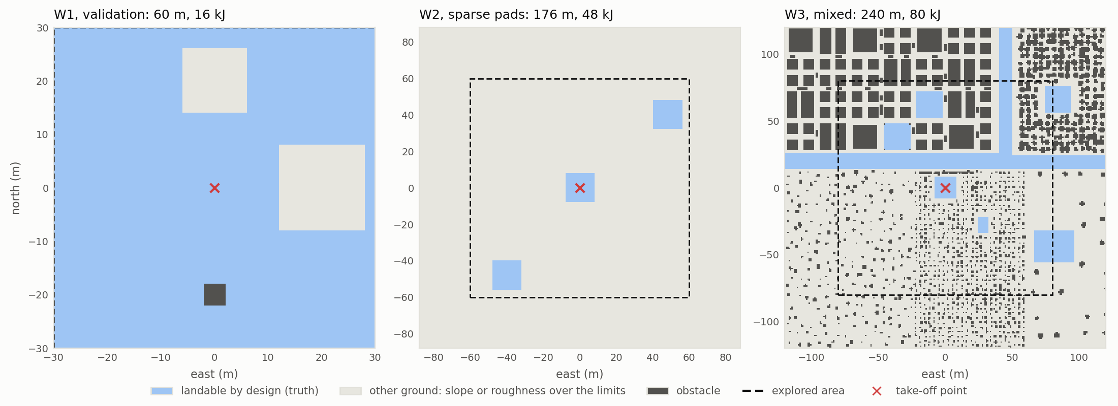
Figure 5. The three test worlds from above, from their ground truth: ground landable by design, other ground whose slope or roughness exceeds the limits, and obstacles. The dashed square is the explored area, the cross the take-off point. W2 offers three distant pads in a steep field; W3 mixes a town, a forest and open ground.
Table 5. Test worlds and budgets.
World | Map / explored area | Budget | Reserve | Character and purpose
W1, validation | 100 m / 60 m | 16 kJ | 1.6 kJ | known test zones; perception against exact truth; budget where α acts
W2, sparse pads | 200 m / 120 m | 48 kJ | 4.8 kJ | three flat pads in a 20° field; puts C1 under tension
W3, mixed | 240 m / 160 m | 80 kJ | 8.0 kJ | town, forest, hills; zones between obstacles; registry dynamics

Configurations. B0 explores the nearest frontier with no energy reasoning and lands where its budget ends. B1 explores the frontier of largest information gain and returns to the nearest zone when its energy falls below 30 % of the budget, the classical practice and the baseline that matters. B3 applies C1 and C2 with α swept over {0, 0.25, 0.5, 0.75, 1}; the configuration of the proposal with C1 and pure gain ranking is B3 at α = 1 by construction and was not flown separately. This gives seven configurations, ten missions each per world, 210 missions in all, instead of the 240 initially planned.
Protocol. Every mission starts on a fresh simulator instance with reset autopilot parameters, configurations are interleaved rather than run in blocks, and the host clock is checked before and watched during every mission, after a clock fault of the WSL2 virtual machine was found to corrupt some earlier flights. A mission that fails for a technical reason is flown again and reported, never discarded. All 210 missions of the final campaigns completed at the first attempt, with no technical failure, no autopilot failsafe and no clock step. The acceptance criteria and the statistical comparisons were written down before each campaign.
Metrics and statistics. Safety is measured by the number of cycles violating I1 and the minimum margin of each mission, by the use of the reserve, and by where the vehicle landed relative to the truth. Exploration is measured by coverage, the fraction of the explored area whose cells reached the OBSERVED state, and by cells observed per kilojoule. Perception is measured against the truth by the elevation error per zone, the recall of landable cells, and the number of dangerous false accepts, cells declared landable whose true slope or step exceeds twice its limit. Results are reported as medians with interquartile ranges. Because a simulated mission is not repeatable to the seed, configurations are compared with the unpaired Mann-Whitney U test (Mann & Whitney, 1947) with the rank-biserial correlation r as effect size, and trends in α with Spearman's rank correlation.

6.2 Perception Against Ground Truth
The perception results are measured on the reference map of W1, a survey map that every figure of this section uses and that was never regenerated (Figure 6). Figure 7 compares the map with the truth. On flat ground the elevation error is 0.240 m RMS with a bias of 0.014 m after removal of the constant offset of the estimator origin; the 3° ramp is mapped to 0.128 m RMS. Two zones stand out for opposite reasons. The 10° ramp has a larger error (0.466 m RMS), concentrated on its raised edges. The cube is mapped 1.67 m too low on average (2.11 m RMS): a single Gaussian per cell cannot represent both the top of a structure and the ground beside it, so the map shrinks raised structures by about 1.5 m at their edges. This limitation is inherent to the representation and is not corrected here; its consequences are bounded by the obstacle inflation and, as shown below, are conservative.
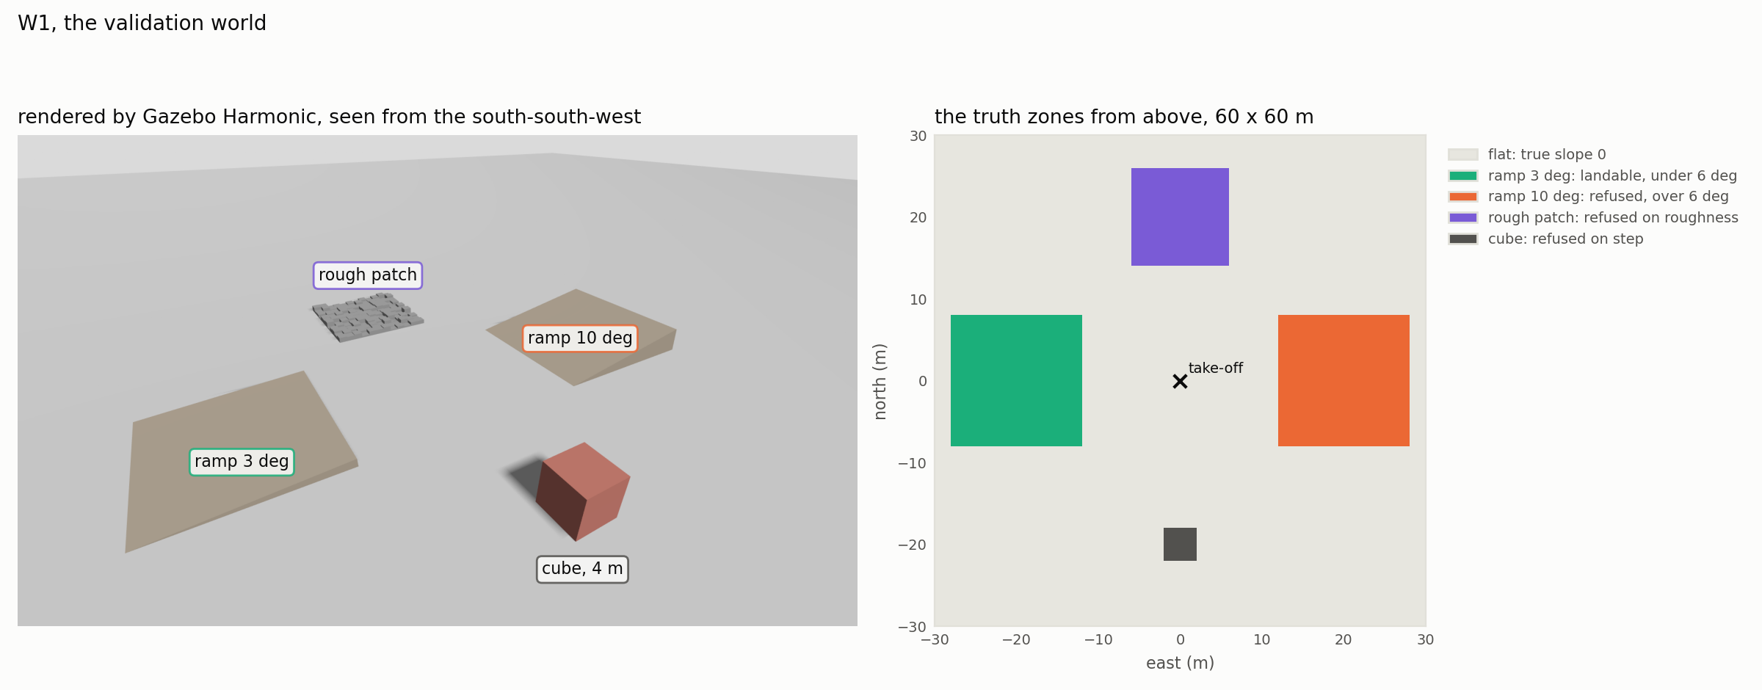
Figure 6. The validation world W1. Left: rendered by Gazebo Harmonic from the south-south-west. Right: the truth zones from above, with the geometric test each zone represents.
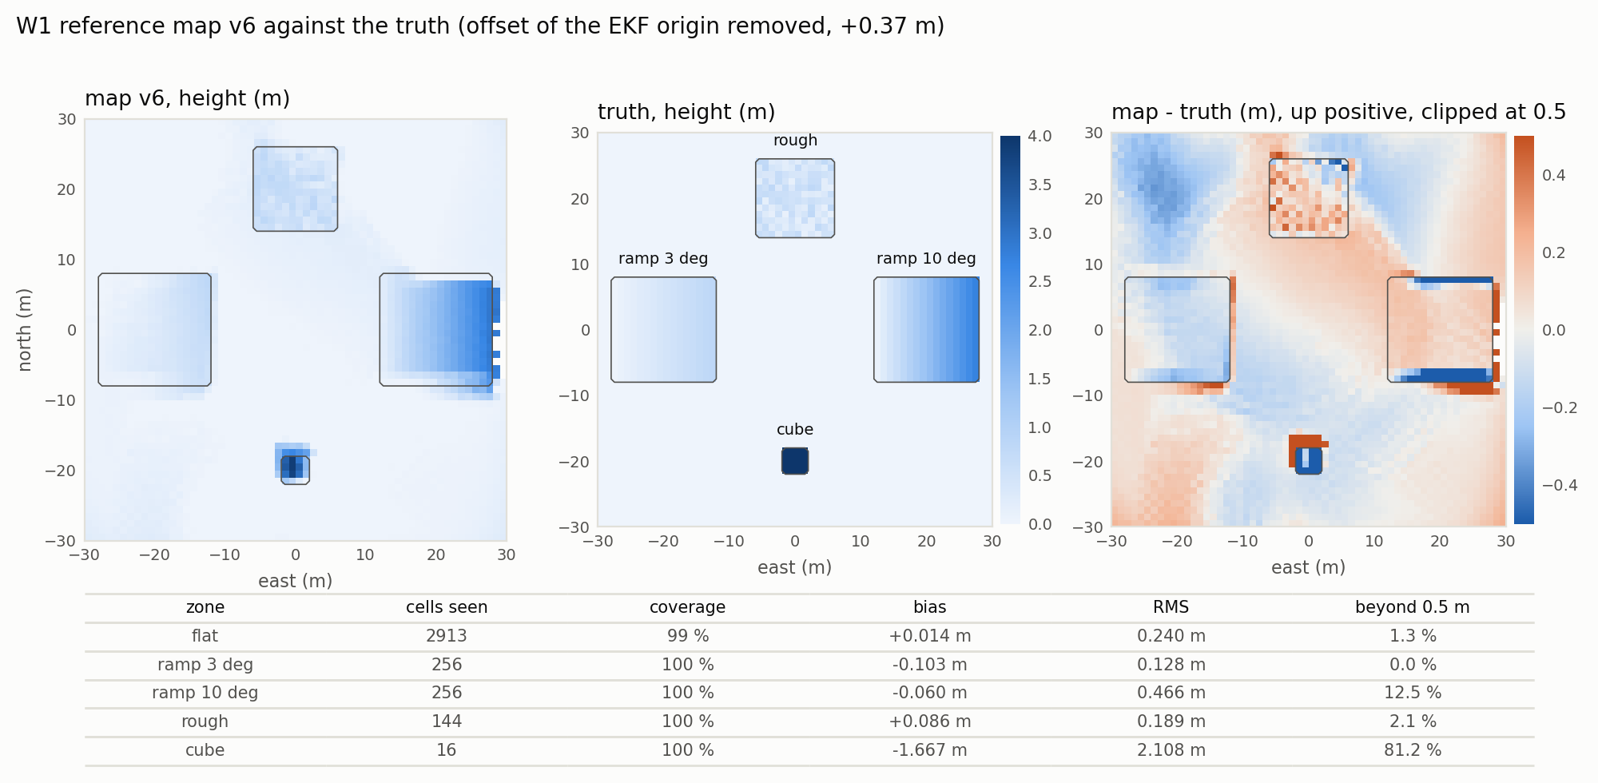
Figure 7. Reference map of W1 against the truth: map height, true height, and their difference (clipped at ±0.5 m), with the bias, RMS error and coverage per zone. The cube is read 1.67 m too low on average because one height per cell cannot represent both the top and the ground beside it.
Figure 8 justifies the slope threshold. On truly flat ground the slope read on the map has a 95th percentile of 4.34°; on the 10° ramp the 1st percentile is 8.25°; a threshold of 6° therefore separates the two for 95 % and 99 % of their cells respectively. The threshold is also not too strict in the other direction: about 1 % of the cells of the 3° ramp read above 6° (99th percentile 6.17°), a small and conservative loss. The tail of the flat distribution (99th percentile 21.66°) is not noise. Of the 88 flat cells (3.5 %) that read above 6°, 81 lie within 3 m of the edge of another zone, where the truth has a real step of up to 2.73 m (the side of the 10° ramp) or 4 m (the cube), while the truth under all 88 is flat: the representation smears these steps beyond the one-cell margin of the analysis window. Figure 9 verifies the separation of descriptors: the zone medians fall where they should, slope without roughness on the ramps (2.9° and 10.4° with roughness 0.013 and 0.014 m) and roughness without excessive slope on the rough patch (0.085 m against 0.150 m in the truth, 4.4°).
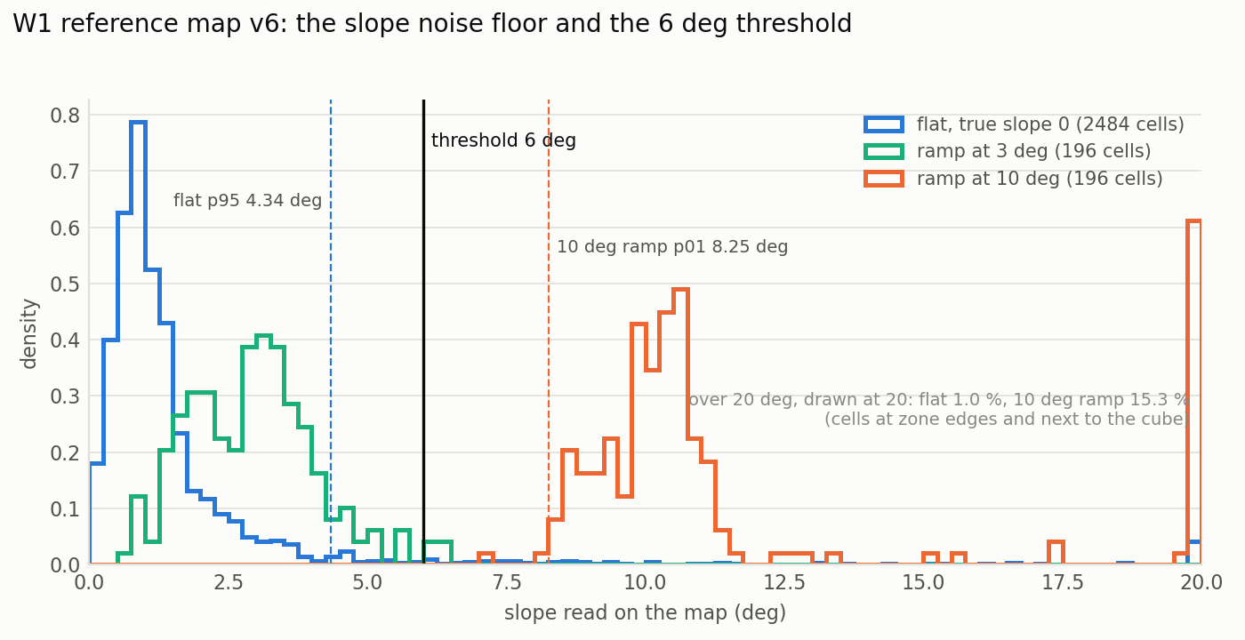
Figure 8. Distribution of the slope read on the map per zone of W1, with the 6° threshold. The threshold lies between the 95th percentile of flat ground (4.34°) and the 1st percentile of the 10° ramp (8.25°).
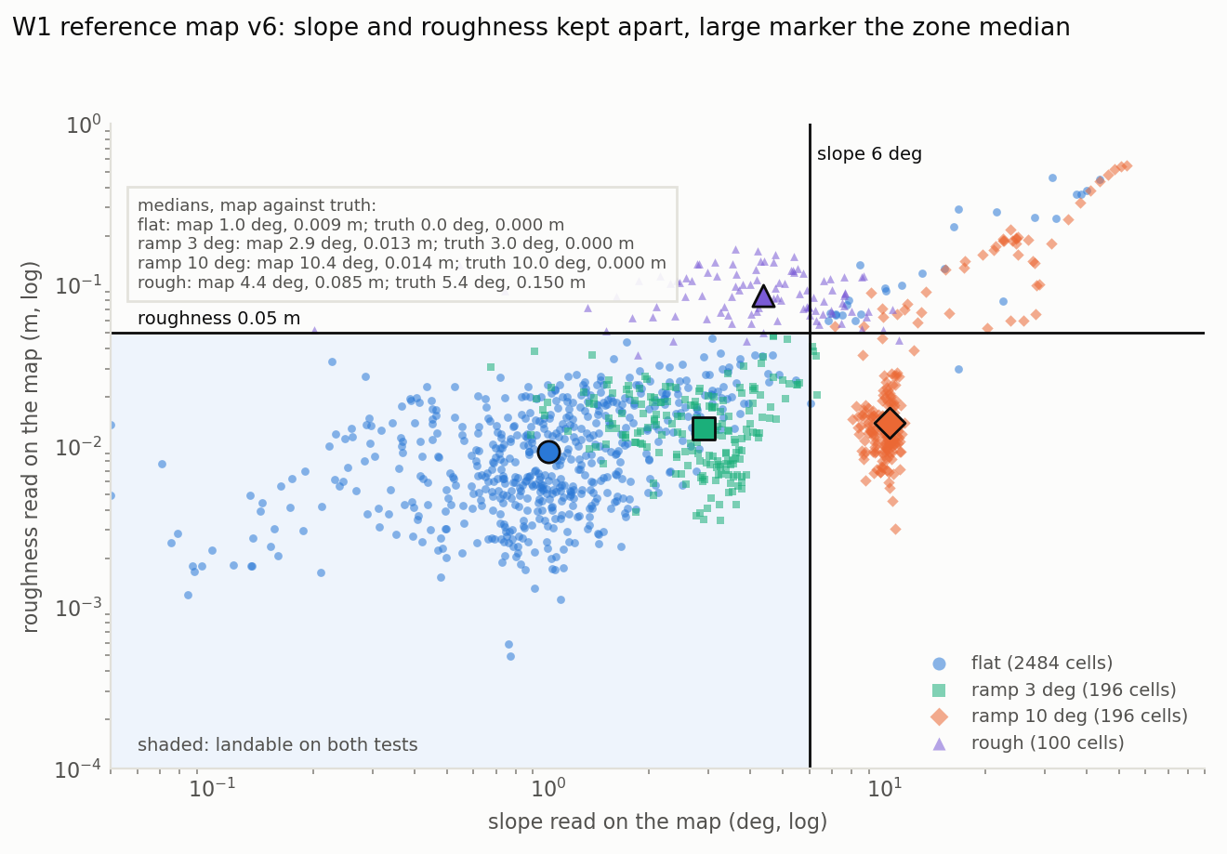
Figure 9. Slope against roughness read on the map, one point per cell, by zone (log scales), with the two thresholds and the landable quadrant shaded; the large markers are the zone medians. Ramps read as slope and the rough patch as roughness: the descriptors are separated.
Figure 10 brings the chain together. With the 1.5 m footprint the detector recovers 94.2 % of the truly landable cells. It produces 46 false accepts, all benign (cells slightly beyond a limit, such as a gentle slope just over 6°), and no dangerous one. Two qualifications are essential. First, the zero is a joint property of the map and the detector: on earlier maps the corrected footprint element reduced the dangerous false accepts without eliminating them. Second, a single map is an observation, not a result. Over the 80 final maps of an earlier W1 campaign, 14 carried a dangerous cell, always on the same two cells of the rough patch, where the map reads a 0.12 to 0.19 m step for a true 0.52 m; a guard added after that finding confirms a zone only if it contains a whole footprint of landable cells, and no mission of the final campaigns landed on a cell that is dangerous in the truth.
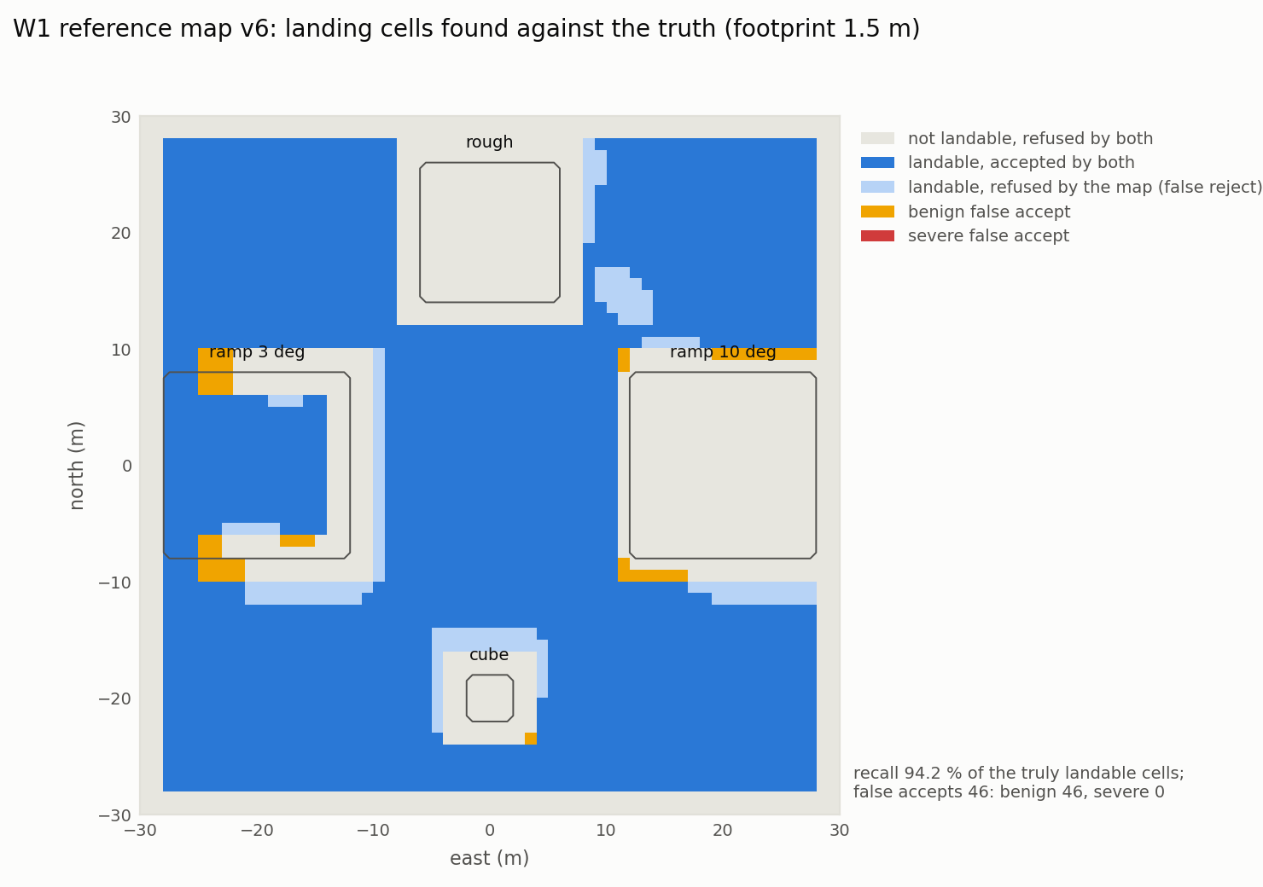
Figure 10. Landing cells detected on the reference map against those landable in the truth (footprint 1.5 m). Recall 94.2 %; 46 false accepts, all benign; no dangerous false accept.

6.3 Energy Prediction and Landing Precision
Figure 11 shows the calibration of Section 4.5. Predicted and measured energies lie on the identity line for hover segments, transits and the four validation flights. The right panel is the reason for the leg term: with two terms the transit error is structured by leg length, every leg paying the same two accelerations; with three it collapses to noise. Predicted from the plan alone, as C1 uses it, the validation flights fall within 0.13 to 0.26 % of the measurement, slightly below it; this residual optimism is two orders of magnitude smaller than the reserve.
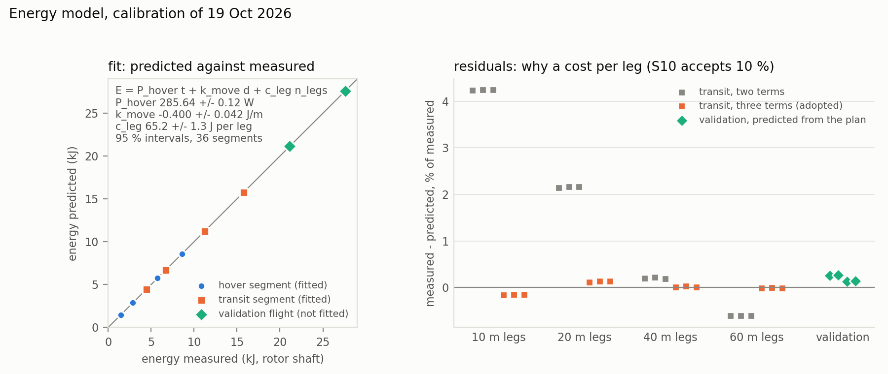
Figure 11. Energy model calibration. Left: predicted against measured energy for every hover and transit segment of the calibration flights and for the four validation flights never fitted, with the parameters and their 95 % intervals. Right: relative error of the transits by leg length, with two terms and with the adopted three, and of the validation flights predicted from the plan.
The footprint depends on how precisely the vehicle lands. Over 15 landings commanded on the same setpoint, the radial error of the touchdown was 0.124 m on average, 0.180 m at the 95th percentile and 0.195 m at most (Figure 12); most of it is already present when the land command is sent, the drift during the descent being 0.055 m on average. With the blade tips 0.386 m from the centre, the 1.5 m footprint leaves room for an error of 0.364 m, twice the measured 95th percentile.
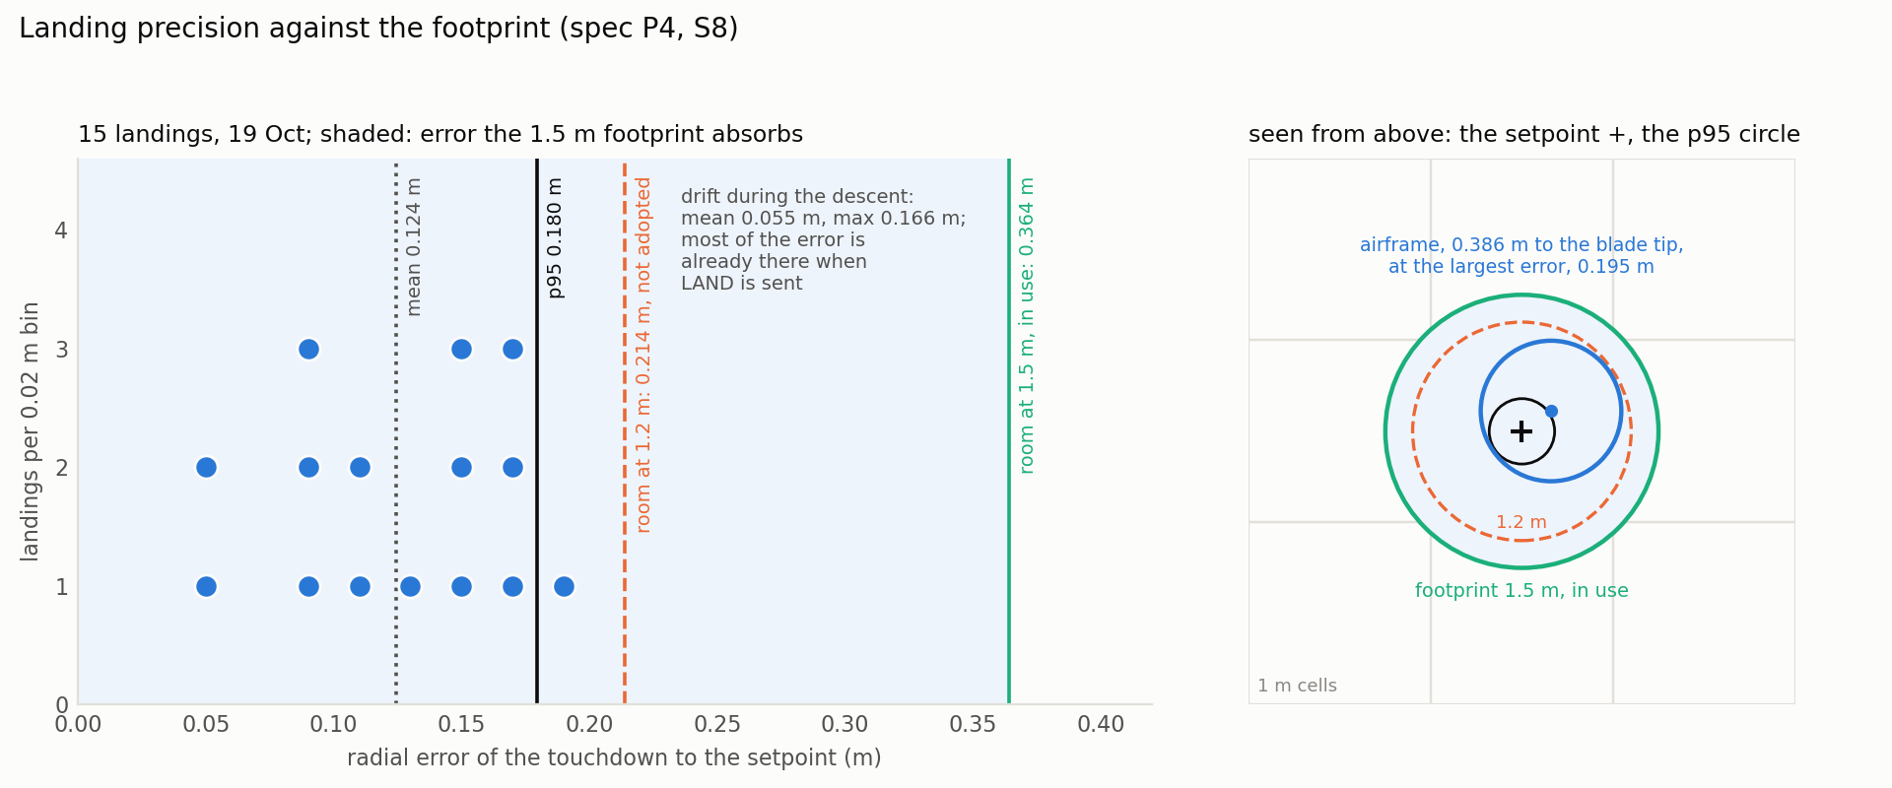
Figure 12. Landing precision against the footprint. Left: radial error of 15 landings, with the mean, the 95th percentile, and the error each footprint can absorb (0.364 m at the 1.5 m in use, 0.214 m at the 1.2 m computed from the precision alone). Right: the same seen from above, with the airframe drawn at the largest measured error.

6.4 Safety: the Invariant Against the Baselines
Table 6 gives the central result. No mission with C1 violated the invariant on any world, 0 of 150, and none used its reserve. B0, which ignores energy, violated it in every mission and ended in an emergency landing wherever its budget ran out, three times on W3 on a cell that is dangerous in the truth. Against B0 the difference in violations is significant on every world (p ≤ 0.0001, r = −1.00).
Table 6. Invariant I1 per world and configuration, ten missions per cell (B3 pools its five values of α, 50 missions).
World | Configuration | Missions violating I1 | Emergency landings | Energy left at landing (median)
W1, 16 kJ | B0 | 10/10 (median 24 cycles) | 10 | −4.17 kJ (budget overdrawn)
 | B1 | 10/10 (median 6 cycles) | 0 | 0.52 kJ (1.08 kJ into the 1.6 kJ reserve)
 | B3, all α | 0/50 | 0 | 3.1 to 3.9 kJ
W2, 48 kJ | B0 | 10/10 (median 44.5 cycles) | 10 | −4.05 kJ (budget overdrawn)
 | B1 | 0/10 | 0 | 8.7 kJ
 | B3, all α | 0/50 | 0 | 6.4 to 7.0 kJ
W3, 80 kJ | B0 | 10/10 (median 52.5 cycles) | 10 | −4.20 kJ (budget overdrawn)
 | B1 | 1/10 (9 cycles) | 0 | 17.6 kJ
 | B3, all α | 0/50 | 0 | 9.6 to 11.0 kJ

B1 is the more instructive comparison. Its outcome depends on the pairing of its threshold with the world and the budget, not on any property of the policy. On W1 at 16 kJ, 30 % of the budget is less than the return, the landing and the reserve together, and B1 violated I1 in every mission, landing 1.08 kJ into its reserve each time; Figure 13 shows one such mission next to a C1 mission of the same world. On W2 at 48 kJ the same threshold covers the return from anywhere in the area, and B1 held the invariant in all ten missions; on W3 it failed once. A fixed threshold can be made safe for one world by tuning it, but only a guarantee computed from the actual registry and position is safe without tuning, which is the property C1 provides.
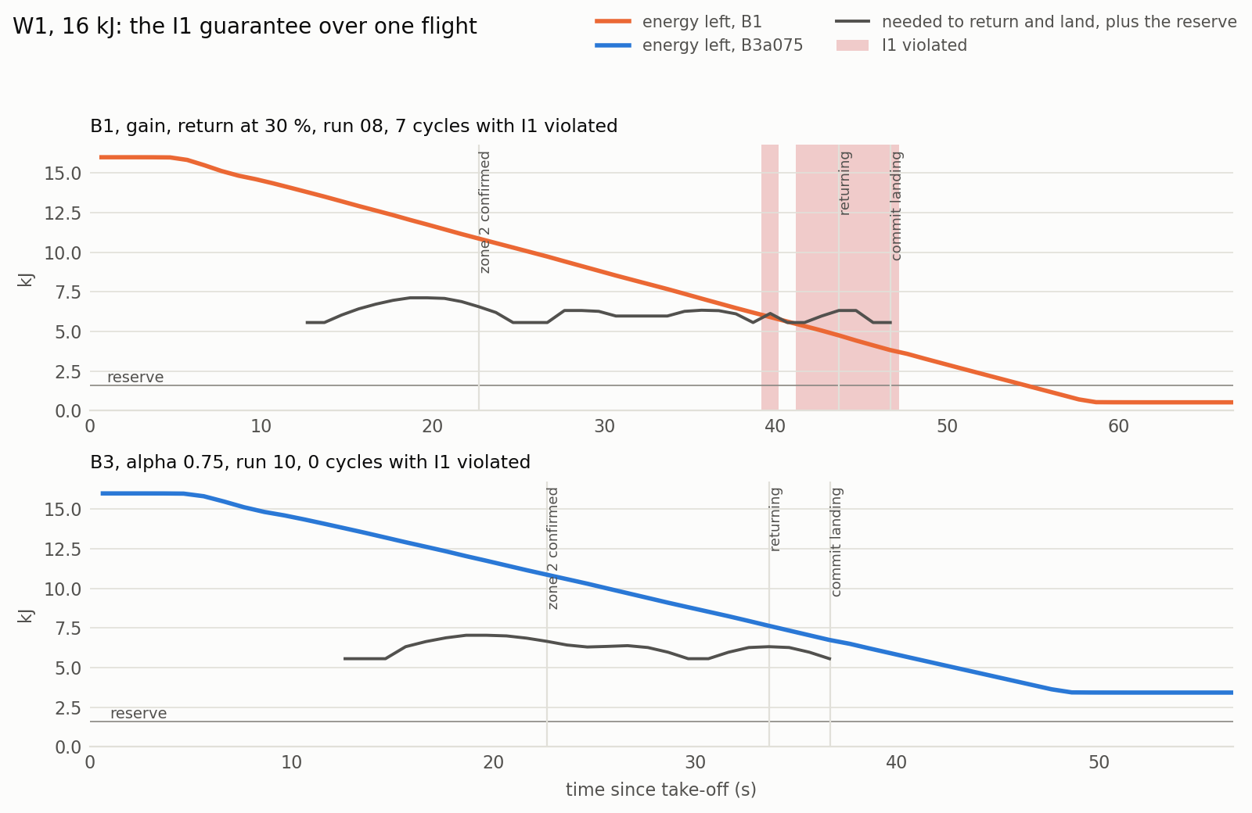
Figure 13. The guarantee over one flight on W1 at 16 kJ: energy left against the energy needed to return and land plus the reserve. Top: B1, which returns at 30 % of the budget; I1 is violated before the return starts (shaded) and the vehicle lands below its reserve. Bottom: B3 at α = 0.75, whose return is triggered by C1 when no frontier remains admissible; the margin stays positive throughout.
The guarantee costs coverage only relative to policies that break it. On W1, B1 covered 0.89 of the area against 0.69 for B3 at α = 0.5: the coverage B1 gains is the energy it takes from its reserve. On W2 and W3, where B1 does not overspend, C1 with C2 covered more than B1 (0.70 against 0.54 on W2, 0.63 against 0.50 coverage seen on W3 at α = 0.5; p = 0.0002, r = +1.00 on both), and landed with less energy left (6.4 to 7.0 kJ against 8.7 kJ on W2, 9.6 to 11.0 kJ against 17.6 kJ on W3): the margin that B1 wastes on a conservative threshold, C1 spends on exploration. B0 covers the most on every world, by consuming its reserve and landing wherever it stops.

6.5 The Coverage and Margin Trade-off
Table 7 and Figure 14 report the effect of α. On all three worlds the coverage peaks in the interior of the range, at α = 0.75 (within 0.01 of α = 0.5 on W2 and W3), and α = 0.75 covers significantly more than both ends: 0.77 against 0.65 (α = 0, p = 0.0002) and 0.76 (α = 1, p = 0.0091) on W1; 0.69 against 0.61 and 0.59 on W2 (p = 0.0002 and 0.0006); 0.60 against 0.48 and 0.52 on W3 (p = 0.0002 and 0.0006). Cells observed per kilojoule follow the same pattern. This comparison was fixed on W1 before the W2 and W3 campaigns, so its replication on the two other worlds is an out-of-sample test rather than a selection.
Table 7. Coverage (fraction of the explored area OBSERVED), median with interquartile range, ten missions each.
Configuration | W1, 16 kJ | W2, 48 kJ | W3, 80 kJ
B0, nearest frontier | 0.87 [0.86, 0.88] | 0.78 [0.73, 0.80] | 0.60 [0.56, 0.62]
B1, gain, 30 % return | 0.89 [0.89, 0.90] | 0.54 [0.48, 0.56] | 0.47 [0.43, 0.49]
B3, α = 0 | 0.65 [0.64, 0.66] | 0.61 [0.61, 0.62] | 0.48 [0.44, 0.49]
B3, α = 0.25 | 0.67 [0.66, 0.67] | 0.68 [0.67, 0.69] | 0.56 [0.53, 0.62]
B3, α = 0.5 | 0.69 [0.67, 0.71] | 0.70 [0.67, 0.72] | 0.60 [0.60, 0.63]
B3, α = 0.75 | 0.77 [0.77, 0.78] | 0.69 [0.67, 0.70] | 0.60 [0.58, 0.60]
B3, α = 1 | 0.76 [0.67, 0.77] | 0.59 [0.57, 0.61] | 0.52 [0.47, 0.56]

The mechanism behind the optimum is visible in the decisions. The number of frontiers chosen per mission falls monotonically with α (on W3: 40, 34.5, 27.5, 26 and 21; Spearman ρ = −0.96, p < 0.0001; on W2: 19, 19, 16, 15, 12), and the mean distance to the nearest confirmed zone rises with it (ρ = +0.48 on W3, p = 0.0004). At α = 0 the vehicle chooses the frontier that leaves the most energy, which keeps it near its zones in many short trips. At α = 1 it goes for the largest gain first, often far away, and C1 then finds no second admissible round trip; on W1 under the 20 Oct code, pure gain returned after two choices with 4.0 kJ unused. The intermediate weights explore far enough to see new ground while keeping the second and third trips admissible. On W1 the minimum margin of a mission also decreases with α (ρ = −0.36, p = 0.01), which is the trade-off C2 is designed to expose: more weight on information buys coverage with margin. Figure 15 shows the resulting trajectories on W2: B0 covers the field and lands where it stops, B1 makes long radial excursions, and B3 sweeps around the central pad in loops whose reach grows with α.
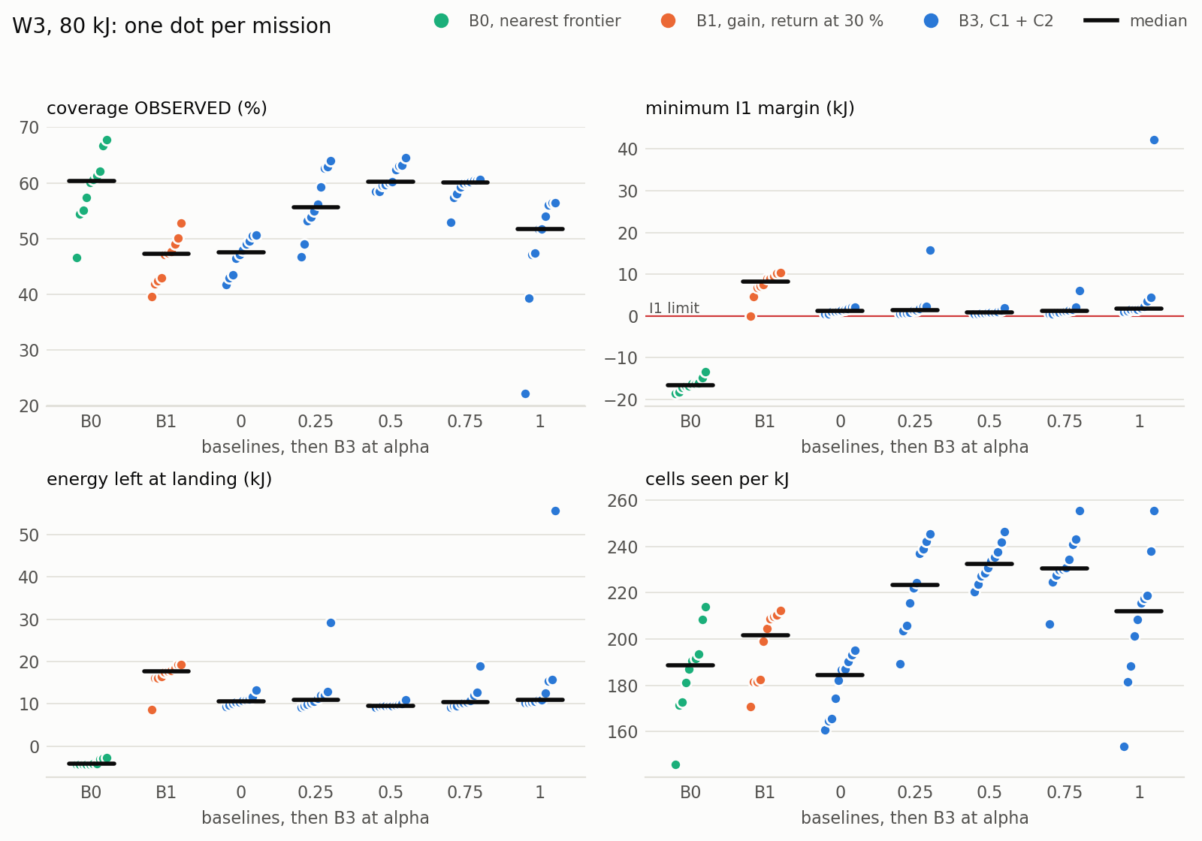
Figure 14. Mission metrics on W3 (80 kJ), one dot per mission, medians as bars: coverage, minimum I1 margin, energy left at landing and cells observed per kilojoule, for the baselines and B3 at each α. The lone α = 1 mission at 22 % coverage and 55 kJ left was ended early by the escape behaviour discussed in Section 7.
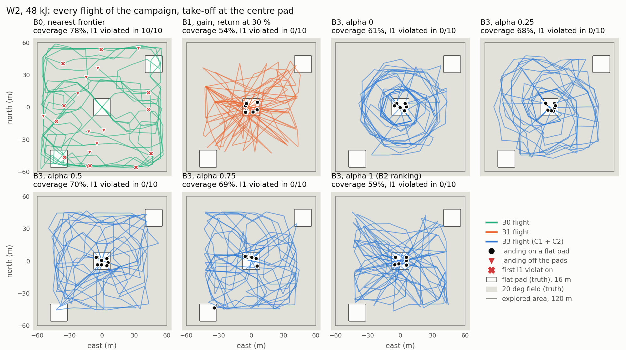
Figure 15. Every flight of the W2 campaign by configuration, over the truth (flat pads in white, 20° field shaded), with the landings and the first violation of I1 of each mission. Only B0 violates I1 and lands off the pads.

6.6 Registry Dynamics and the Loss of a Zone in Use
The registry is not static in practice. In the 50 C1 missions of W3 it shrank 90 times without any intervention; 35 of these removed the zone the vehicle was relying on and 8 the target of a return. Each was answered at the same cycle and none was followed by a violation. On W2, whose three pads are large and open, the registry shrank twice, and on W1 never. The demotions concentrate on W3 (49 in 70 missions, against 2 on W2 and 1 on W1), and their cause was reconstructed by replaying the perception code on the map snapshots around each event. Of the 637 cells newly refused in the examinable cases, 609 failed the roughness test, their roughness jumping from 0.013 to 0.066 m (median) while their own variance did not change; the truth under them is flat (only 4 are truly rough), and they lie a median 3 m from a building, tree, car or rock. The most probable mechanism is the single-height representation seen obliquely: as the vehicle flies past an obstacle, returns from its side fall into the cells at its foot and lift a neighbour by about 0.2 m, which raises the roughness of the adjacent windows above the threshold. The refusals are false and therefore conservative for safety; their cost is the demotions and the returns they divert. The oblique source of the points is inferred rather than observed, since point clouds are not logged.
To test the reaction of Section 4.4 deliberately, a field of 36 crates (2 m cubes on a 3.5 m pitch, covering a 20 m square, with gaps too narrow for a footprint) was placed by script over the target of a return while the vehicle was 35 to 20 m from it, on W3 at α = 1, the configuration that returns to small and distant zones most often. The 20 m lower bound keeps the event before the commitment to land, after which nothing is re-evaluated by design. An earlier scenario placing the obstacle at a frontier transit relying on a designated pad never fired in 26 missions: a frontier transit rarely relies on a single zone and flies away from it, whereas a return always flies towards the zone it relies on and does so with the least energy left, which makes it both the common and the hardest case.
Table 8. Registry shrink provoked during a return on W3: four missions in which the crate field was placed (13 flown).
Mission | Zone lost (area) | Lost after placement | Margin at re-evaluation | Branch | Landing | Above reserve
r05 | 16 (190 m²) | 3.1 s | −278 J | no zone within guarantee | zone 4 | +0.11 kJ
r08 | 26 (174 m²) | 3.1 s | +11 837 J | I1 holds via zone 25 | zone 4 | +12.21 kJ
r10 | 21 (209 m²) | 4.1 s | −461 J | no zone within guarantee | zone 9 | 0.00 kJ
r13 | 20 (49 m²) | 3.2 s | −914 J | no zone within guarantee | zone 3 | −0.30 kJ

Table 8 and Figure 16 give the outcome. In all four missions the crates were seen and the zone left the CONFIRMED state 3.1 to 4.1 s after placement, the assumed 2.5 s of detection plus at most one map cycle; I1 was re-evaluated at that very cycle against the reduced registry; the return turned to the nearest reachable zone within 0.5 s; and every landing was a committed landing on another registry zone, outside the field, on ground that is safe in the truth. The sequence specified in Section 4.4 is therefore executed as designed. The result also delimits the guarantee. In three of the four missions no zone remained within the guarantee after the loss: C1 returns precisely when no frontier is admissible any longer, so the margin it keeps at that point is smaller than the detour to the next zone. The violation was logged, and the vehicle still landed on the nearest zone using at most 0.30 kJ of its 8 kJ reserve. I1, as defined, holds as long as the registry does not shrink under the zone it relies on; when it does, the reserve absorbs the shortfall. Over all 188 C1 missions flown since the invariant was introduced, the reserve was touched twice (1.63 kJ before the final corrections and 0.30 kJ in this provoked case) and the lowest energy at landing was 2.8 kJ.
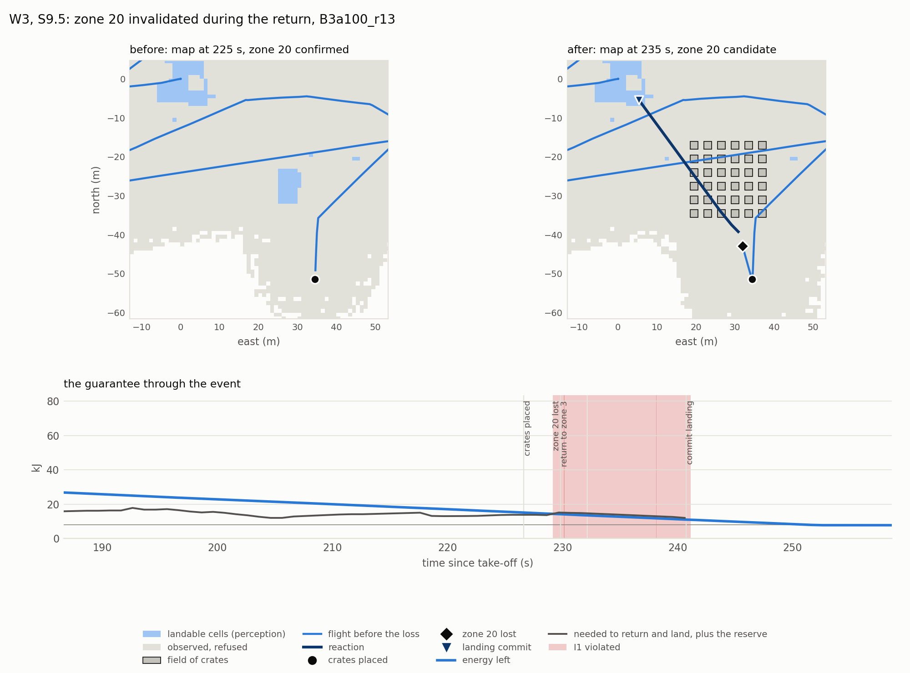
Figure 16. Provoked loss of the zone in use during a return on W3 (mission r13, the smallest zone and the hardest branch). Top: the map before and after the crate field is seen, with the flight, the reaction and the landing commit on zone 3. Bottom: energy left against the energy needed to return and land plus the reserve; I1 is violated from the loss until the landing commit (shaded), the reserve covering 0.30 kJ.

6.7 Negative Results and Discussion
Several results were negative, and each changed the design. The distance-proportional energy model of the proposal was refuted by a factor of two hundred on a hover, and the simulator's battery telemetry turned out to measure time rather than charge (Section 4.5). A measurement variance growing with range, σ = 0.02 + 0.009 d, degraded the flat-ground error from 0.121 to 0.143 m in an isolated test: the dominant error is an attitude error correlated across the points of a scan, which the independent-observation assumption of the filter cannot model, so angular diversity between passes matters more than per-point weighting. A Mahalanobis gate intended to handle discontinuities raised the dangerous false accepts from 26 to 138 and lowered the recall from 92.6 to 65.3 % on the map where it was tested, because it locked each cell to the first surface seen; any fix to P2 must keep two surface hypotheses per cell. C1 with a constant decision latency violated I1 seven times on the first large flight (Section 4.6). The invariant gate itself first failed as written on W3: two of 25 C1 missions violated I1, both after the loss of their return target; three corrections, each measured on its own (I1 at arrival charging the landing only, the robust return switch, and the timing fix of Section 5.2), brought the count to 0 of 50 on W3 and 0 of 150 overall. Finally, a well-tuned fixed threshold holds I1 (B1 on W2): the advantage of C1 is not to beat every threshold but to hold without tuning per world and budget.
Taken together, the results answer the sub-questions behind the research question. The map supports a classification with a recall near 94 % and no dangerous false accept on the reference map, as a joint property of map and detector. The calibrated model predicts energy within 0.3 % on unseen trajectories, far inside the 10 % acceptance bar. C1 prevents the vehicle from entering a state in which no confirmed zone is reachable, as long as the registry does not shrink under the zone in use, at no coverage cost relative to a baseline that respects the same reserve. And C2 exposes a monotone trade-off with an interior optimum near α = 0.75 that replicates on three worlds.

7 Conclusion and Future Work

7.1 Conclusion
This report addressed how a UAV can explore unknown terrain for safe landing zones while keeping a confirmed zone continuously reachable. The answer proposed is an energy-feasibility invariant over a registry of zones discovered online, enforced as a filter on every exploration decision and monitored at every map update, together with a utility that trades information against energy margin. Built on a conventional LiDAR mapping and terrain analysis chain and an energy model calibrated against rotor power, the system kept the invariant in all 150 missions in which it was active, across three worlds, where a coverage-only explorer broke it every time and a fixed-threshold return broke it whenever its threshold did not suit the world. The trade-off parameter has an interior optimum that replicates out of sample. The deliberate removal of a zone in use showed both the reaction working as designed and the precise scope of the guarantee: it rests on the zone the vehicle relies on, and the reserve covers the case where that zone disappears late in a mission.
The limitations must be stated with the same precision. All results are in simulation, without wind, with a static environment, GPS localisation and a single sensor. The energy is the mechanical rotor energy of the simulator, which excludes motor and battery losses, and the model is valid only for the calibrated flight profile. The take-off point is assumed free for the whole mission, and nothing is re-evaluated after the landing is committed; the specification foresaw an exception when an obstacle appears on the landing site, which is not implemented. The single-height map shrinks raised structures and produces false refusals near obstacles. And in two of 70 missions on W3 the escape behaviour, which lets the vehicle leave a region enclosed by inflated obstacles, ended the mission early with 21 and 48 kJ unused, because the machine returns and lands rather than resuming exploration once out.

7.2 Short-Term Future Work
With three more months, the first improvements would address these limits directly. (i) Resume exploration after an escape instead of landing, which would recover the coverage lost in those missions. (ii) Implement the landing abort when an obstacle is detected on the committed site, and remove the assumption that the take-off point stays free by letting observations retire it like any other zone. (iii) Replace the single Gaussian per cell by two surface hypotheses, or use a robust roughness such as the median of absolute residuals, to suppress the oblique false refusals that drive the demotions on W3. (iv) Integrate the energy on simulation time rather than system time, so that a slowed simulation is not charged extra energy. (v) Offer, as an option, a stricter guarantee that holds without the zone in use, at the price of a larger margin, and measure its coverage cost; the quantity it requires is already logged. (vi) Make missions repeatable to the seed so that configurations can be compared with paired tests.

7.3 Long-Term Research Directions
At the scale of a PhD, three directions stand out. The first is to make the guarantee robust to uncertainty: replace the deterministic energy prediction by a conservative bound, as the proposal anticipated, and state the invariant as a chance constraint over battery state, wind and map error, validated on real flights with an electrical energy model. The second is to treat landing safety as an object of active perception: confirming a zone requires a second view, so the planner could choose where to look not only for coverage but to confirm or reject candidate zones, with the value of a confirmation measured by the energy margin it unlocks. The third is to share and maintain the registry over time and across vehicles, which raises the question of how a guarantee should account for zones that other agents observed, and for a terrain that changes.

Declaration of Generative AI Usage
[To be completed by the author, following the instructions on the Canvas assignment page.]

References
Abeywickrama, H. V., Jayawickrama, B. A., He, Y., & Dutkiewicz, E. (2018). Comprehensive energy consumption model for unmanned aerial vehicles, based on empirical studies of battery performance. IEEE Access, 6, 58383–58394. https://doi.org/10.1109/ACCESS.2018.2875040
Ames, A. D., Coogan, S., Egerstedt, M., Notomista, G., Sreenath, K., & Tabuada, P. (2019). Control barrier functions: Theory and applications. 2019 18th European Control Conference (ECC), 3420–3431. https://doi.org/10.23919/ECC.2019.8796030
Beycimen, S., Ignatyev, D., & Zolotas, A. (2026). Real-time terrain traversability analysis and mapping for autonomous robotics in dynamic environments: Fusing appearance- and geometry-based approaches. Journal of Field Robotics, 43(3), 1719–1738. https://doi.org/10.1002/rob.70097
Bircher, A., Kamel, M., Alexis, K., Oleynikova, H., & Siegwart, R. (2016). Receding horizon "next-best-view" planner for 3D exploration. 2016 IEEE International Conference on Robotics and Automation (ICRA), 1462–1468. https://doi.org/10.1109/ICRA.2016.7487281
Brubaker, K. M., Myers, W. L., Drohan, P. J., Miller, D. A., & Boyer, E. W. (2013). The use of LiDAR terrain data in characterizing surface roughness and microtopography. Applied and Environmental Soil Science, 2013, 1–13. https://doi.org/10.1155/2013/891534
Cadena, C., Carlone, L., Carrillo, H., Latif, Y., Scaramuzza, D., Neira, J., Reid, I., & Leonard, J. J. (2016). Past, present, and future of simultaneous localization and mapping: Toward the robust-perception age. IEEE Transactions on Robotics, 32(6), 1309–1332. https://doi.org/10.1109/TRO.2016.2624754
Campos, C., Elvira, R., Rodríguez, J. J. G., Montiel, J. M. M., & Tardós, J. D. (2021). ORB-SLAM3: An accurate open-source library for visual, visual-inertial, and multimap SLAM. IEEE Transactions on Robotics, 37(6), 1874–1890. https://doi.org/10.1109/TRO.2021.3075644
Cesare, K., Skeele, R., Yoo, S.-H., Zhang, Y., & Hollinger, G. (2015). Multi-UAV exploration with limited communication and battery. 2015 IEEE International Conference on Robotics and Automation (ICRA), 2230–2235. https://doi.org/10.1109/ICRA.2015.7139494
Cherenson, D. M., Agrawal, D. R., & Panagou, D. (2025). Autonomy architectures for safe planning in unknown environments under budget constraints (arXiv:2504.03001). arXiv. https://doi.org/10.48550/arXiv.2504.03001
Elskamp, J., Shi, M., Bauersfeld, L., Scaramuzza, D., & Popović, M. (2026). EAAE: Energy-aware autonomous exploration for UAVs in unknown 3D environments (arXiv:2603.15604). arXiv. https://doi.org/10.48550/arXiv.2603.15604
Fankhauser, P., Bloesch, M., Gehring, C., Hutter, M., & Siegwart, R. (2014). Robot-centric elevation mapping with uncertainty estimates. In Mobile Service Robotics: Proceedings of the 17th International Conference on Climbing and Walking Robots (CLAWAR 2014) (pp. 433–440). World Scientific. https://doi.org/10.3929/ethz-a-010173654
Fankhauser, P., Bloesch, M., & Hutter, M. (2018). Probabilistic terrain mapping for mobile robots with uncertain localization. IEEE Robotics and Automation Letters, 3(4), 3019–3026. https://doi.org/10.1109/LRA.2018.2849506
Gasche, S., Kallies, C., Himmel, A., & Findeisen, R. (2025). Energy aware and safe path planning for unmanned aircraft systems (arXiv:2504.03271). arXiv. https://doi.org/10.48550/arXiv.2504.03271
Gramajo, G., & Shankar, P. (2017). An efficient energy constraint based UAV path planning for search and coverage. International Journal of Aerospace Engineering, 2017, 1–13. https://doi.org/10.1155/2017/8085623
Han, W. (2023). Risk aware planning and probabilistic prediction for autonomous systems under uncertain environments [Doctoral dissertation, Massachusetts Institute of Technology]. https://hdl.handle.net/1721.1/150099
Hart, P. E., Nilsson, N. J., & Raphael, B. (1968). A formal basis for the heuristic determination of minimum cost paths. IEEE Transactions on Systems Science and Cybernetics, 4(2), 100–107. https://doi.org/10.1109/TSSC.1968.300136
Hornung, A., Wurm, K. M., Bennewitz, M., Stachniss, C., & Burgard, W. (2013). OctoMap: An efficient probabilistic 3D mapping framework based on octrees. Autonomous Robots, 34(3), 189–206. https://doi.org/10.1007/s10514-012-9321-0
Johnson, A. E., Klumpp, A. R., Collier, J. B., & Wolf, A. A. (2002). Lidar-based hazard avoidance for safe landing on Mars. Journal of Guidance, Control, and Dynamics, 25(6), 1091–1099. https://doi.org/10.2514/2.4988
Kalman, R. E. (1960). A new approach to linear filtering and prediction problems. Journal of Basic Engineering, 82(1), 35–45. https://doi.org/10.1115/1.3662552
Koenig, N., & Howard, A. (2004). Design and use paradigms for Gazebo, an open-source multi-robot simulator. 2004 IEEE/RSJ International Conference on Intelligent Robots and Systems (IROS), 2149–2154. https://doi.org/10.1109/IROS.2004.1389727
Liu, Z., Sengupta, R., & Kurzhanskiy, A. (2017). A power consumption model for multi-rotor small unmanned aircraft systems. 2017 International Conference on Unmanned Aircraft Systems (ICUAS), 310–315. https://doi.org/10.1109/ICUAS.2017.7991310
Macenski, S., Foote, T., Gerkey, B., Lalancette, C., & Woodall, W. (2022). Robot Operating System 2: Design, architecture, and uses in the wild. Science Robotics, 7(66), eabm6074. https://doi.org/10.1126/scirobotics.abm6074
Mann, H. B., & Whitney, D. R. (1947). On a test of whether one of two random variables is stochastically larger than the other. The Annals of Mathematical Statistics, 18(1), 50–60. https://doi.org/10.1214/aoms/1177730491
Meier, L., Honegger, D., & Pollefeys, M. (2015). PX4: A node-based multithreaded open source robotics framework for deeply embedded platforms. 2015 IEEE International Conference on Robotics and Automation (ICRA), 6235–6240. https://doi.org/10.1109/ICRA.2015.7140074
Papachristos, C., Khattak, S., & Alexis, K. (2017). Uncertainty-aware receding horizon exploration and mapping using aerial robots. 2017 IEEE International Conference on Robotics and Automation (ICRA), 4568–4575. https://doi.org/10.1109/ICRA.2017.7989531
Scherer, S., Chamberlain, L., & Singh, S. (2012). Autonomous landing at unprepared sites by a full-scale helicopter. Robotics and Autonomous Systems, 60(12), 1545–1562. https://doi.org/10.1016/j.robot.2012.09.004
Shah Alam, M., & Oluoch, J. (2021). A survey of safe landing zone detection techniques for autonomous unmanned aerial vehicles (UAVs). Expert Systems with Applications, 179, 115091. https://doi.org/10.1016/j.eswa.2021.115091
Takahashi, M. D., Abershitz, A., Rubinets, R., & Whalley, M. S. (2013). Evaluation of safe landing area determination algorithms for autonomous rotorcraft using site benchmarking. Journal of the American Helicopter Society, 58(3), 1–13. https://doi.org/10.4050/JAHS.58.032007
Yamauchi, B. (1997). A frontier-based approach for autonomous exploration. Proceedings of the 1997 IEEE International Symposium on Computational Intelligence in Robotics and Automation (CIRA'97), 146–151. https://doi.org/10.1109/CIRA.1997.613851

Appendix A: Communication Log with Supervisor
Semester 2 communication log, to be added.

