Energy-Feasible UAV Exploration over an Online Registry of Safe Landing Zones
Capstone B Final Report
Dorian Veloso
Student ID 25773615
Supervisor: Dr Graeme Best
University of Technology Sydney
October 2026
Abstract
A battery-powered rotorcraft exploring unknown terrain must be able to land safely before its energy runs out, yet the places where it could land are not known in advance: they have to be discovered during the flight, and a later, closer observation may withdraw them. This report presents an exploration planner that detects geometrically safe landing zones online from a downward 3D LiDAR, holds them in a dynamic registry, and enforces an energy-feasibility invariant: whenever a confirmed zone exists, the energy left covers the flight to one of them and the landing, plus a fixed reserve. Two mechanisms are proposed. C1 filters every candidate frontier against this invariant and re-evaluates it whenever the registry changes, including when it shrinks. C2 ranks the admissible frontiers by a convex combination of information gain and energy margin, weighted by a parameter α. Both rest on an energy model calibrated on rotor shaft power in simulation, E = P_{hover} t + k_{move} d + c_{leg} n_{legs}, whose transit predictions fall within 0.16 % of the measurement. In 210 PX4 software-in-the-loop missions over three worlds, no mission with C1 violated the invariant (0/150), against 30/30 for nearest-frontier exploration and 11/30 for a classical explorer returning at a fixed 30 % battery threshold; in flight, the energy C1 charged exceeded the energy measured in 2530 of 2535 transits. For coverage the energy-margin utility has an interior optimum, α between 0.5 and 0.75, significantly above both pure margin and pure gain on all three worlds, whereas the confirmed landing area found keeps rising with α. A deliberately provoked loss of the zone in use during a return was detected within 3.1 to 4.1 s and answered at the same decision cycle; it also exposes the limit of the guarantee, which holds as long as the registry does not shrink under the zone it relies on.
Keywords: UAV exploration, safe landing zone detection, energy constraints, reachability, frontier-based exploration, LiDAR terrain mapping

1 Introduction
Rotary-wing UAVs are increasingly sent where no prepared landing pad exists: post-disaster assessment, coastal and environmental monitoring, inspection of remote infrastructure. In these missions the terrain is unknown at launch and endurance is measured in tens of minutes. The vision behind this work is a UAV that can be released over unknown terrain, explore it autonomously, and at every moment still know where it can put itself down safely with the energy it has left. Manned aviation offers a structural analogue: a pilot must always keep a reachable alternate aerodrome given fuel, weather and runway constraints. For a UAV over unknown terrain the alternate must instead be discovered in flight, and re-verified as the battery drains and as the map, and the alternate with it, is revised.
The capabilities this requires have so far been developed separately. Frontier-based and next-best-view exploration planners maximise coverage or information gain without reasoning about where the vehicle could land (Yamauchi, 1997; Bircher et al., 2016). Landing site detectors assess slope, roughness and obstacles on a given map, but do not steer the exploration that produces the map (Shah Alam & Oluoch, 2021; Takahashi et al., 2013). Energy-aware planners either trigger a return to a predefined base when the battery crosses a threshold (Gramajo & Shankar, 2017; Gasche et al., 2025), or reduce consumption without checking that any safe state remains reachable (Elskamp et al., 2026); work that does provide formal reachability guarantees assumes that the safe sets are known in advance or found incidentally (Cherenson et al., 2025). None addresses the case in which safe landing sites are initially absent, are discovered online by terrain assessment, and may later be withdrawn when a closer observation contradicts the first one. This leads to the research question of this work:
How can a UAV autonomously search an unknown environment for safe landing zones, while ensuring continuous reachability of a geometrically confirmed safe site whenever one has been identified?
The final clause is not a stylistic precaution. At take-off no safe site is known, so an unconditional guarantee could not be stated and the mission could never begin; the problem must therefore define what is guaranteed before the first confirmation and how the guarantee behaves when the set of confirmed sites changes (Section 3).
We address the question with a planner that adds two mechanisms to a conventional perception and exploration pipeline (Figure 1). LiDAR returns are fused into a 2.5D elevation map, tested for slope, roughness and step height, and grouped into landing zones held in a dynamic registry, where a zone becomes usable only once a whole landing footprint has been seen on two passes. The first contribution, C1, is an energy-feasibility invariant over this registry: a frontier is admissible only if the energy to reach it, return from it to the nearest confirmed zone and land fits within the energy left minus a reserve, and the invariant is re-checked at every map update so that the loss of a zone is answered at once. The second, C2, ranks the admissible frontiers by U = αG + (1 − α)M, a convex combination of information gain and energy margin rescaled at each decision. Both rest on an energy model calibrated against rotor shaft power.
The system was evaluated in PX4 software-in-the-loop simulation on three worlds, 210 missions in all, against nearest-frontier exploration (B0) and a gain-driven explorer returning at a fixed 30 % battery threshold (B1), the common practice. No mission with C1 violated the invariant (0 of 150), against 30 of 30 for B0 and 11 of 30 for B1, whose outcome depends on whether its threshold suits the world. For coverage, C2 has an interior optimum between α = 0.5 and 0.75 on all three worlds; for the landing area found, more weight on information is better. A deliberately provoked loss of the zone in use was answered at the cycle it was detected and exposed the limit of the guarantee, which the reserve then covered.
The contributions are: (i) an energy-feasibility invariant over a registry of landing zones that is built online and can shrink, with an explicit treatment of the bootstrap case and of zone loss; (ii) an energy-margin utility whose per-decision normalisation makes its parameter act over the whole range; and (iii) an empirical characterisation: an energy model checked against every leg flown, a 210-mission evaluation with criteria fixed in advance, an account of what the filter and the utility do at each decision, a provoked registry shrink, and documented negative results.

2 Related Work
This work draws on four bodies of literature: autonomous exploration, landing site detection, terrain mapping, and energy-constrained planning. Each is mature on its own; the gap lies in how they are coupled.

2.1 Autonomous Exploration of Unknown Environments
Frontier-based exploration (Yamauchi, 1997) reduces exploration to repeatedly travelling to the boundary between known free space and unknown space. Its appeal lies in its simplicity and in the fact that its candidates are explicit places on the map. Sampling-based next-best-view planners extend the idea to three-dimensional volumetric maps (Bircher et al., 2016), usually stored as octrees (Hornung et al., 2013), with an information gain estimated by ray casting from each candidate view. Later work made the exploration objective aware of localisation uncertainty (Papachristos et al., 2017) and of risk under stochastic dynamics (Han, 2023), part of a broader shift, articulated in the SLAM literature (Cadena et al., 2016), from map building as an end towards perception in the service of a task.
The common thread is that the exploration objective remains information. Energy enters, when it does, as a path-length cost, and the availability of a place to land, which is what actually bounds a battery-powered rotorcraft, plays no role in the decision. This work keeps the frontier paradigm because its candidates are discrete and explicit: each can be checked against an energy constraint before it is ranked, the structure C1 and C2 require.

2.2 Safe Landing Site Detection
Shah Alam and Oluoch (2021) classify landing zone detection into geometry-based, vision-based and hybrid learning-based methods, and note that geometric methods offer the most reliable metric assessment outdoors. They also have the longest history in safety-critical settings: LiDAR hazard detection for planetary landing fitted local planes to an elevation map and thresholded their slope and the residual roughness (Johnson et al., 2002), the same descriptors used in this work. On rotorcraft, Scherer et al. (2012) landed a full-scale helicopter at unprepared sites assessed from LiDAR during the approach, and Takahashi et al. (2013) benchmarked safe landing area determination against surveyed field sites. Visual SLAM such as ORB-SLAM3 (Campos et al., 2021) produces dense maps from cameras, but the height accuracy needed for slope and step tests still favours ranging sensors.
Two conclusions follow. Geometric tests on a 2.5D map are mature enough to be a building block rather than a research object. And the literature treats landing detection as a perception problem: sites are assessed on a map built for another purpose, during a final approach, or offline, so the result neither steers the exploration nor is checked against the energy needed to reach the site. Detectors are also usually evaluated on a single map, whereas Section 6.2 shows that their dangerous false accepts must be measured over many.

2.3 Terrain Mapping and Traversability
Elevation mapping with per-cell uncertainty is the standard representation for this purpose: each cell holds a height estimate and its variance, updated by a scalar Kalman filter (Kalman, 1960) as new returns arrive, with pose uncertainty propagated into the map (Fankhauser et al., 2014, 2018). Traversability analysis then derives local descriptors from the map. Beycimen et al. (2026) show that slope, roughness and step height discriminate safe from hazardous terrain in real time in the field, and Brubaker et al. (2013) that roughness can be recovered from LiDAR returns. These techniques are reused here unchanged; their error characteristics set the thresholds, the footprint and hence the safety margin. One known limit, a single height per cell that cannot represent two surfaces, turns out to drive both the false refusals near obstacles (Section 6.6) and the residual dangerous accepts (Section 6.2).

2.4 Energy-Constrained Planning and Reachability
Empirical studies of multirotor consumption show that power is dominated by the cost of staying airborne rather than by the distance flown (Liu et al., 2017; Abeywickrama et al., 2018), which this work confirms (Section 4.5). Planning under a battery budget has mostly taken the form of a return-to-base problem. Gramajo and Shankar (2017) redirect a coverage mission towards a known exit state when the remaining energy falls below a threshold; Cesare et al. (2015) coordinate multi-UAV exploration with vehicles returning to a base under battery and communication limits; Gasche et al. (2025) trigger a model-predictive return to base on the depth of discharge. Elskamp et al. (2026) integrate trajectory-level energy prediction into exploration and reduce total consumption, but do not verify that a safe state remains reachable.
Formal guarantees exist in a different line of work. Cherenson et al. (2025) maintain backup trajectories to renewal sets under budget constraints, so that a safe state stays reachable, but the renewal sets are known a priori or found incidentally. Control barrier functions express safety as the forward invariance of a safe set (Ames et al., 2019); C1 can be read as a discrete-time, set-valued analogue in which the safe set is defined by an energy inequality over a registry that itself changes with perception. In all of these works the place to return to is fixed, given or incidental, and none considers that it may disappear.

2.5 Synthesis and Research Gap
Table 1 summarises the positioning. Three gaps emerge. First, the availability of landing sites does not influence where an exploring vehicle goes next. Second, energy guarantees, when they exist, are stated relative to a static and predefined return target. Third, no work treats the case where the safe set shrinks because perception revises an earlier assessment while the vehicle relies on it. This work addresses the three gaps for a single vehicle in simulation. It deliberately contributes nothing to mapping, terrain analysis, frontier detection or path planning, which are taken from the works above; the contribution is the coupling between a registry of safe zones discovered online and a continuous energy guarantee, and the selection policy that follows from it.

Table 1. Positioning of this work against representative prior work.
Work | Exploration objective | Landing assessment | Return target | Energy guarantee
Yamauchi (1997); Bircher et al. (2016) | coverage, information | none | none | none
Johnson et al. (2002); Scherer et al. (2012); Takahashi et al. (2013) | none (given map or final approach) | geometric, LiDAR | not applicable | none
Gramajo & Shankar (2017); Cesare et al. (2015); Gasche et al. (2025) | coverage | none | predefined base | threshold or predictive return trigger
Elskamp et al. (2026) | information per unit energy | none | not verified | none (consumption reduced)
Cherenson et al. (2025) | budget-constrained tasks | none | renewal sets, known or incidental | formal, backup trajectories
This work | coverage, traded against margin (C2) | geometric, online registry | nearest confirmed zone; may shrink | invariant checked at every decision (C1)

3 Problem Statement

3.1 Setting and Assumptions
A multirotor UAV takes off from a known point into terrain that is unknown, static and contained in a square exploration area $Ω$. It carries a single downward-facing 3D LiDAR and is localised by GPS through the autopilot estimator; no SLAM is used, following the supervisor's advice in the first semester. It flies at a fixed cruise altitude h above the take-off point (8 m in all experiments) and has an energy budget $B_{0}$. The energy left at time t is $B_{t}$, and a fixed reserve $R = 0.1 B_{0}$ is withheld from planning. There is no wind. The energy budget is a logical budget measured by integrating rotor shaft power in simulation (Section 4.5), not the autopilot's simulated battery. Table 2 collects the notation used from here on.
Table 2. Notation. Values are those of every experiment unless a world is named.
Symbol | Meaning | Value or definition
Ω; h | exploration area (square); cruise altitude above take-off | 60, 120, 160 m side (W1, W2, W3); 8 m
$B_{0}; B_{t}; R$ | energy budget; energy left at time t; reserve withheld from planning | 16, 48, 80 kJ; measured; 0.1 B₀
$H_{t}$ | elevation map: height, variance and count per cell | 1 m cells
Z_{t} | registry: the CONFIRMED zones, provisional take-off zone included | Section 4.4
$F_{t}$; f; A | frontiers; a frontier viewpoint; frontiers admissible under C1 | Section 3.2; (3)
$$E_{go}; E_{ret}; E_{land}; E_{tot}$$ | predicted energy to reach f; to return from a point to a zone; to land; their sum | (4); $E_{land}$ = 3387 J
m_{t} | margin of the vehicle against Invariant 1 (I1) | (1)
G; M; U; α | information gain; share of the usable budget left; utility of C2; weight of gain in C2 | (5), (6); α ∈ [0, 1]
$$P_{hover};k_{move};c_{leg}; n_{legs}$$ | hover power; cost per metre; cost per straight leg; legs of a path | Table 4
τ | decision latency charged as hover | measured, Section 4.6
$r_{a}; r_{f}$ | analysis and footprint radius | 1 cell each
$r_{in}; r_{out}$ | radii that open and close a pass over a cell | 14.4 m; 18 m
I1 to I5 | the five invariants of the system | Section 3.3
B0; B1; B3 | configurations flown | Section 6.1

3.2 Map, Landable Cells and Registry
The terrain is represented by a 2.5D grid $H_{t}$ with 1 m cells, each holding a height estimate, its variance and an observation count. A cell is landable when it is observed, its slope, roughness and step height are below fixed thresholds, and every cell under a landing footprint centred on it passes the same tests (Section 4.3). Connected landable cells form zones. The registry $Z_{t}$ is the set of zones whose state is CONFIRMED, that is, zones whose footprint cells have each been observed on at least two distinct passes (invariant I4, Section 4.4). $Z_{t}$grows when a zone is confirmed and shrinks when new observations refuse its cells. The frontier set F_{t} contains the clusters of observed cells that border unknown cells, each with a reachable viewpoint f and an information gain G(f).

3.3 The Energy-Feasibility Invariant
Let $E_{ret}(p, z)$ be the predicted energy to fly from position p to zone z along a collision-free path, and E_{land} the energy of a controlled descent and landing. The margin of the vehicle at position $p_{t}$ is
$m_{t} = B_{t} - R - E_{land} -\min_{z ∈Z}{z } E_{ret}(p_{t}, z),$ (1)
where Z denotes the registry at the time of evaluation. Five invariants define what "safe" means in this work. The first is the one the research question asks for; the other four bound what the perception and the planner may do:
- I1. Whenever at least one zone is confirmed, the energy left covers the flight to the nearest confirmed zone and the landing, with the reserve untouched.
- I2. No cell is declared landable if a cell of its analysis window has never been observed.
- I3. The vehicle is never commanded over a cell whose known height exceeds the cruise altitude minus a vertical margin.
- I4. A zone enters the registry only after every cell of a landing footprint has been observed on two distinct passes.
- I5. The land command is issued only over a confirmed zone, except in an energy emergency, which is logged as such.
Formally, with the margin (1):
I1: $Z_{t} ≠ ∅$ ⇒ $m_{t} ≥ 0$ for all t. (2)
A cycle in which $Z_{t}$ is non-empty and $m_{t}< 0$ is a violation: the vehicle can no longer reach any confirmed zone and land with its reserve intact. The decision rule that keeps I1 true by construction is the admissibility condition on frontiers,
$E_{go}\left(p_{t}, f\right)+\min_{z ∈Z}{z} E_{ret}(f, z) + E_{land} ≤ B_{t} - R,$ (3)
which requires that after flying to f the vehicle could still return to a confirmed zone and land. If the predictions are accurate and the registry does not change during the transit, choosing only admissible frontiers implies $m ≥ 0$ on arrival. Neither condition holds exactly in practice: predictions err, decisions take time, and the registry can shrink while the vehicle relies on it. The method therefore also monitors (2) at every map update (Section 4.6) and treats a shrink explicitly (Section 4.4).
I2 to I4 hold by construction of the code (Sections 4.2 to 4.4 and 5.3), I3 and I4 with unit tests; I1 and I5 are measured in every mission (Section 6.4).

3.4 Objective, Bootstrap and Outputs
The objective is to maximise the fraction of $Ω$ that is observed, subject to I1 whenever Z_{t} is non-empty, and to end every mission by landing on a confirmed zone, never wherever the vehicle happens to be. The bootstrap case, t = 0 with no confirmed zone, is resolved by registering the take-off point as a provisional zone: the vehicle has just left it, so it can land there. This makes I1 meaningful from the first cycle without a special case. It departs from the proposal, which excluded the launch point; the consequence, that the take-off point is assumed to stay free, is a limitation (Section 7). The outputs of a mission are the trajectory, the registry history and the landing site.

4 Method

4.1 Overview and Changes from the Proposal
Figure 1 shows the method as concepts. The perception chain (top row) turns LiDAR scans into an elevation map, terrain descriptors, landable cells and finally a registry of confirmed zones. The decision chain (bottom row) extracts frontiers from the same map, filters them with C1, ranks the survivors with C2, and hands the choice to a mission state machine that also decides when to return and land. The energy model feeds both C1 and C2. A single component holds the decision authority, so C1 and C2 can be disabled cleanly for the baselines.
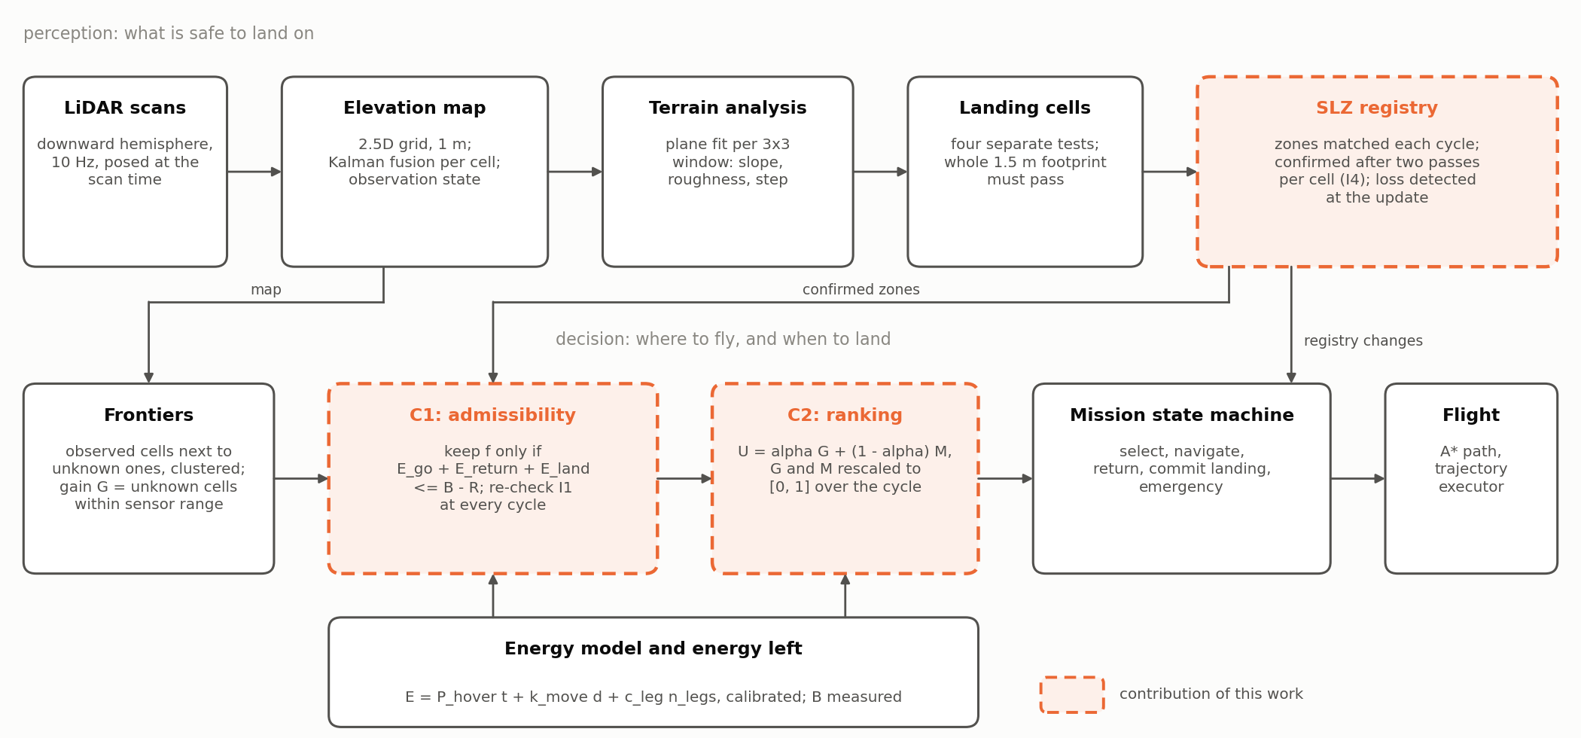
Figure 1. Method overview: the perception chain (top) and the decision chain (bottom). Dashed boxes are the contributions of this work, solid boxes reused techniques.
Almost every technical choice of the proposal was changed during the project, each time because a measurement showed that the proposed choice would not support the guarantee. Table 3 lists the changes and the evidence for each. The research question, the two contributions and the evaluation logic are unchanged.

Table 3. Design changes from the research proposal and the measurement that motivated each.
Component | Proposal | Final design | Reason
Energy model | $E = k d$, calibrated on PX4 battery telemetry | $E = P_{hover} t + k_{move} d + c_{leg} n_{legs}$, calibrated on rotor shaft power | SITL telemetry depends only on armed time; k d predicts 77 J for a 60 s hover costing over 17 kJ (Section 4.5)
Terrain scoring | weighted composite score; slope 10°, roughness 0.3 m, step 0.5 m; 0.5 m grid | four separate tests; slope 6°, roughness 0.05 m, step 0.24 m; 1 m grid | thresholds set by the measured map noise; a weighted sum lets one good descriptor mask a failing one (Section 4.3)
Exploration map | ray-cast occupancy grid | frontiers on the observation state of the elevation map | one map for exploring and for judging terrain, so both agree on what is known
Return cost | bounded Dijkstra on a roadmap | A* on the inflated obstacle grid; one return field per cycle | the same planner serves flight and C1
Launch point | never assumed safe | provisional zone in the registry | gives I1 a meaning from t = 0 (Section 3.4)
Zone confirmation | safe cluster larger than the footprint | whole footprint seen on two passes per cell (I4) | single oblique views confirmed zones that later vanished (Section 4.4)
Configurations | (a) no filter, (b) C1 only, (c) C1 + C2 with α by 0.2 | B0, B1 (30 % threshold), B3 with α ∈ {0, 0.25, 0.5, 0.75, 1} | B1 is the practice to beat; (b) equals B3 at α = 1 by construction
Statistics | means with 95 % confidence intervals | medians, interquartile ranges, Mann-Whitney U, Spearman | bounded distributions with many zeros; runs not seed-repeatable

4.2 Elevation Mapping and Observation State
Each LiDAR return is transformed into the world frame (Section 5.2) and fused into the cell it falls in by a scalar Kalman filter, $k = \frac{p}{(p + r)}$, with the measurement variance growing with range as $σ = 0.02 + 0.009 d$ metres. The cell variance is floored at (0.02 m)²: without the floor it decays as 1/n, and after a few hundred observations a cell is frozen and cannot be corrected even by a much better observation from close range.
Every cell is assigned an observation state: UNKNOWN when it has no return, OBSERVED when it has at least 10 returns and a variance below 2 × 10⁻³ m² (the median fused variance at that count), and SPARSE otherwise. Frontiers and coverage are defined on this state, and the terrain analysis refuses any window that contains an unknown cell (invariant I2: nothing is declared safe that has not been seen).

4.3 Terrain Analysis and Landing Cells
For each cell a plane is fitted by least squares to the 3 × 3 window around it. Slope is the inclination of that plane, roughness the standard deviation of the residuals to it, and step the largest height difference between the cell and its neighbours. With 5 cm of noise between neighbours a finite difference produces about 6° of spurious slope, which the fit reduces roughly threefold. Because the plane is removed first, roughness is independent of slope by construction: a smooth ramp reads as slope, a rubble field as roughness (verified in Section 6.2).
A cell passes when its slope is at most 6°, its roughness at most 0.05 m and its step at most 0.24 m, and its window is fully observed. The four tests are applied separately rather than combined into a weighted score as in the proposal, because a weighted sum lets a flat but stepped cell compensate its step with its flatness. The slope threshold sits between the slope read on flat ground and on the 10° ramp of the reference map (Section 6.2).
A cell is landable only if every cell covered by a landing footprint of 1.5 m centred on it passes. The footprint element is an over-approximation of the disc: every cell the disc touches, even partially, must pass, which at 1 m resolution is the 3 × 3 square. An earlier element kept only the cells contained in the disc, a single cell for a 1.5 m footprint, and therefore accepted cells it had never tested; correcting it reduced the dangerous false accepts on the reference map from 25 to 0. The landing precision alone (Section 6.3) would allow 1.13 m, but a 1.2 m footprint, whose element loses the diagonal cells, reintroduced 2 dangerous false accepts: the diagonal cells are a margin that the map error requires, and 1.5 m was kept. With an analysis radius $r_{a}$ and a footprint radius $r_{f}$ in cells, an isolated zone must be at least $2(r_{a} + r_{f}) + 1$ cells wide to be detected, 5 m here.

4.4 Dynamic Landing Zone Registry
Landable cells are grouped into zones by 8-connected flood fill at every map cycle. Because zones are re-detected from a map that changes, each new zone is matched to the zones of the previous cycle by cell overlap, so that a zone keeps its identity and its history. A zone enters as CANDIDATE and is not usable by C1. It becomes CONFIRMED when a whole footprint of its landable cells has been observed on at least two distinct passes, cell by cell (invariant I4). A pass of a cell begins when the vehicle comes within $r_{in}= 14.4 m$ of it and ends when it moves beyond $r_{out}= 18 m$, the radius of the sensor footprint at cruise altitude; the hysteresis prevents a vehicle hovering near the boundary from counting many passes. The rule replaced one that counted passes over the zone's centroid, which offline confirmed zones of which only 538 m² out of 2465 m² had been seen twice. A zone is also confirmed only if it holds a whole footprint of landable cells (Section 6.2), and it is demoted or retired when an update refuses enough of its cells that no whole footprint remains.
The registry is what makes the safe set dynamic, and its shrinking is the case no prior work on energy-constrained exploration treats. When an update removes a confirmed zone, the system (1) detects it at the registry update; (2) re-evaluates I1 at once; (3) continues if I1 holds through another zone; (4) otherwise interrupts the navigation and returns to the nearest reachable zone; and (5) if no zone is reachable within the guarantee, logs a violation and still flies to the nearest one, the reserve covering the shortfall. Section 6.6 provokes this sequence.

4.5 Energy Model
The proposal planned a model $E = k d$, calibrated from the battery telemetry of the PX4 simulator. Both parts were refuted. The simulated battery reports a remaining fraction that decreases linearly with the time the vehicle has been armed, whatever it does. The signal used instead is the mechanical shaft power of the four rotors, computed from the motor speed commands that PX4 sends to the simulator, and validated in hover within 0.2 % of the analytic prediction from weight and thrust coefficients. Fitted to a survey flight, the distance model predicts 77 J for a 60 s hover that costs over 17 kJ: flight time explains 87 % of the survey energy.
The adopted model charges time, distance and each straight leg of a path:
$E = P_{hover} t + k_{move} d + c_{leg} n_{legs}, t_{leg} = L/v + v/a + 0.06 s$, (4)
where every leg of length L is flown on a trapezoidal profile from rest to rest at v = 5 m/s and a = 3 m/s², and 0.06 s of settling is measured at each arrival. The time of a path is thus known exactly from the plan, which is what allows C1 to predict an energy before flying. The model was calibrated on 12 flights on fresh simulator instances, squares of 10 to 60 m with hovers of varied length to decorrelate time from distance, and checked on four validation flights never used in the fit, including an eight-leg zigzag (Table 4). Without the leg term the error is structured and optimistic, up to 4.2 % on 10 m legs, because every leg pays the same two accelerations; with it the transit errors fall within ±0.16 %. $E_{land}$ is calibrated separately from twelve descents from 8 m (3199 J); the planner uses 3387 J, the 95th percentile of the landings commanded in missions, which include their pauses.
Table 4. Energy model parameters, least-squares fit on 36 segments of 12 calibration flights, with 95 % confidence intervals.
Parameter | Value | Interpretation
$P_{hover}$ | 285.64 ± 0.12 W | power to stay airborne; 285.9 W in a pure hover
$k_{move}$ | −0.400 ± 0.042 J/m | cruise at 5 m/s costs about 2 W less than hover
$c_{leg}$ | 65.2 ± 1.3 J | the two accelerations of each leg
$E_{land}$ (calibrated) | 3199 J, s.d. 15 J | descent from 8 m and touchdown, 12 descents
$E_{land}$ (planning) | 3387 J | 95th percentile of the landings commanded in missions

Three caveats bound the claims. The intervals measure the model's lack of fit rather than noise, since the simulation repeats to 0.02 %. The negative $k_{move}$, cruise slightly cheaper than hover, is measured but its origin in the rotor model was not established. And the model is valid only for the calibrated profile, which the trajectory executor therefore flies by construction: stop at every vertex, constant speed and acceleration, constant altitude.

4.6 C1: Energy-Feasibility Filter and Monitor
C1 evaluates (3) for every frontier at every selection, and the margin (1) at every map cycle, about once per second. Figure 2 shows one real decision. The terms are computed as follows. E_{go} is the energy of the planned path from the vehicle to the frontier viewpoint by (4), plus a hover of duration τ for what the plan does not contain: the computation before the path starts and the wait at the frontier before the next command. E_{ret} is the energy of the path from the viewpoint to the nearest landable cell of any confirmed zone, the take-off point included, plus another τ. A single return field, a distance transform seeded on every landable cell of every confirmed zone, gives the return cost from all frontiers in one pass.
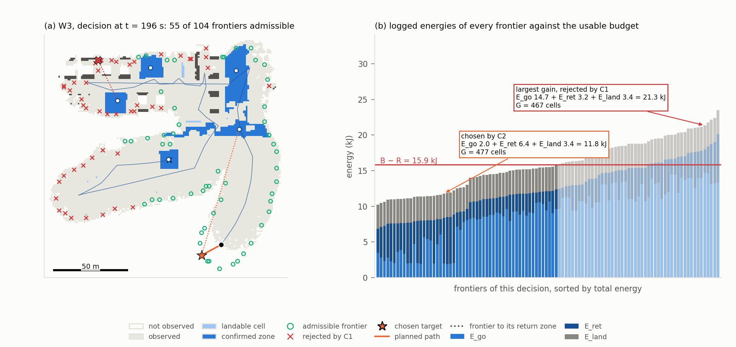
Figure 2. C1 on one real decision, 196 s into the W3 mission of Figure 17. (a) 55 admissible frontiers (circles), 49 rejected (crosses), the target chosen by C2 (star) and its path. (b) $E_{go} + E_{ret} + E_{land}$ of every frontier, sorted, against B − R = 15.9 kJ: a frontier of 467 unknown cells needing 21.3 kJ is rejected before any ranking.
The latency τ was first a constant of 2 s. On a 190 m area the decision time grew with the map up to 21.5 s, 301 s of hover went uncounted, and I1 was violated seven times with C1 active. τ is now measured at every decision and C1 charges the maximum of the last five latencies plus the largest recent increase; with 5 s of latency injected on purpose, the violations fell from 2, 2 and 1 per mission to 0, 0 and 0. A guarantee is no stronger than the worst term it omits.
Two approximations remain. The return from f is planned on the current map, whereas the map at f is unknowable; this is optimistic, and the reserve R covers it. And the registry and the energy may change during the transit, which the monitor addresses: while the vehicle flies to its target, (3) is re-evaluated for that target from the current position at every cycle, and if it fails the target is abandoned and the vehicle returns. It does not select another frontier, a conservative choice discussed in Section 7. Algorithm 1 shows how the filter, the monitor and the shrink handling of Section 4.4 fit into one decision cycle. When no frontier is admissible, exploration is over for energy reasons, which is a legitimate end of mission rather than an error.
Algorithm 1. One decision cycle of the exploration manager, run on every new map (about 1 Hz).
Input: map H, registry Z, energy left B, position p, reserve R, weight α, mission state, current target f*
Notation: $E_{tot}\left(f\right)= E_{go}(p, f) + D(f) + E_{land}$, the energy to reach f, return from it and land
1: (L, F, O) ← Analyse(H) landable cells, frontiers, obstacles
2: (Z, lost) ← UpdateRegistry(Z, L) match, confirm (I4), demote
3: D ← ReturnField(O, Z) energy to the nearest confirmed zone
4: m ← B − R − E_{land} − D(p) margin (1), logged
5: if lost ≠ ∅ and m < 0 then the registry shrank under I1
6: log a violation; FlyBack(p, Z)
7: if state = NAVIGATING and $E_{tot}(f*) > B - R$ then C1 monitor
8: abandon f*; FlyBack(p, Z)
9: if state = SELECTING then
10: A ← {$f ∈ F : E_{tot}(f) ≤ B - R$} C1 filter (3)
11: if A = ∅ then FlyBack(p, Z) no affordable frontier left
12: else
13: rescale G and M to [0, 1] over A as in (6)
14: f* ← argmax_{f∈A} α G̃(f) + (1 − α) M̃(f) C2
15: Navigate(f*)
16: if state = RETURNING then Section 4.8
17: if a zone z′ is cheaper to reach by more than 541 J
18: and I1 would hold without z′ then switch the return to z′ at most 3 times
19: if arrived at the end of the return path then CommitLanding irreversible
FlyBack(p, Z): stop exploring and fly to the nearest confirmed zone, argmin_{z∈Z} E_{ret}(p, z) (state RETURNING).

4.7 C2: Energy-Margin Utility
C1 is a filter and treats all admissible frontiers as equal. C2 ranks them by trading information against margin. For each admissible frontier the share of the usable budget it would leave is
share(f) = clip((B − R − E_{tot}(f)) / (B − R), 0, 1), E_{tot} = E_{go} + E_{ret} + E_{land}, (5)
and the utility is
U(f) = α G̃(f) + (1 − α) M̃(f), x̃ = (x − min_{A} x) / (max_{A} x − min_{A} x), (6)
where G is the number of unknown cells within the sensor radius of the viewpoint, M is the share, and both are rescaled to [0, 1] over the admissible set A of the current cycle. The rescaling of both terms is essential and was established by measurement. In the first version G was divided by its maximum and M was the share itself. Over 2225 decisions of 60 missions, G spread by 0.88 between candidates and M by only 0.12 (medians), so G dominated from α = 0.10 and 92 % of the decisions at α = 0.5 were already the pure-gain choice: α acted only on [0, 0.2]. With both terms rescaled per cycle, the choice leaves the pure-margin one at α = 0.35 and joins the pure-gain one at α = 0.55 (medians), and 52 % of the decisions at α = 0.5 differ from pure gain. The cost is that nearly equal margins are magnified, but only among frontiers C1 has already judged safe. At α = 1 the ranking is pure gain among admissible frontiers, configuration (b) of the proposal.

4.8 Mission State Machine and Returns
The exploration manager is a state machine: INIT, TAKEOFF, SELECTING (frontiers, C1, C2), NAVIGATING (following the path while the margin is monitored), RETURNING (transit to the chosen zone), COMMIT_LANDING (descent engaged), LANDED and EMERGENCY. A mission ends on complete coverage, on no admissible frontier, on a target abandoned by the monitor, or on an external stop, and in all four the vehicle lands on a registry zone. Once the descent is engaged the decision is irreversible: oscillating between zones at the end of a mission is the worst behaviour energetically.
Three refinements were found necessary in flight. During a return the target may be switched to a confirmed zone that has become cheaper to reach by more than the cost of one stop and restart$, c_{leg} + P_{hover} v/a = 541 J$, at most three times per return, and only if I1 would still hold should the new zone be lost on arrival: the first version switched to zones that vanished one or two seconds after their confirmation, and one mission ended in its reserve. A frontier whose target cell turns out to be unreachable on approach (a roof measured higher up close) is blacklisted for 30 s, and for 300 s after three failures. And when the inflated obstacles enclose the vehicle, as over the rooftop units of W3, the return may use an escape map with a 1 m vertical margin instead of 2 m, never used to explore.

5 Implementation

5.1 Software Architecture
The system runs on ROS 2 Jazzy with PX4 SITL (v1.17.0-alpha1) and Gazebo Harmonic (8.11.0) under Ubuntu 24.04 on WSL2 (Macenski et al., 2022; Meier et al., 2015; Koenig & Howard, 2004). Figure 3 shows what runs and the topics between the components. The code separates pure Python modules, which contain every algorithm of Section 4 and import no ROS, from four thin ROS nodes that only move messages: cloud_world (scan to map), energy_monitor (rotor power to energy), exploration_manager (the state machine and the only decision authority) and trajectory_executor (path to PX4 setpoints). The separation makes the decision logic testable without a simulator: 120 unit tests, run on every build, cover every module of Section 4 from the footprint element to the state machine, including the rules that enforce I3, I4 and I5, and every rule added after a flight came with its test. The map fusion and the terrain descriptors are validated against ground truth instead (Section 6.2), and the ROS nodes and the PX4 interface by the flights.
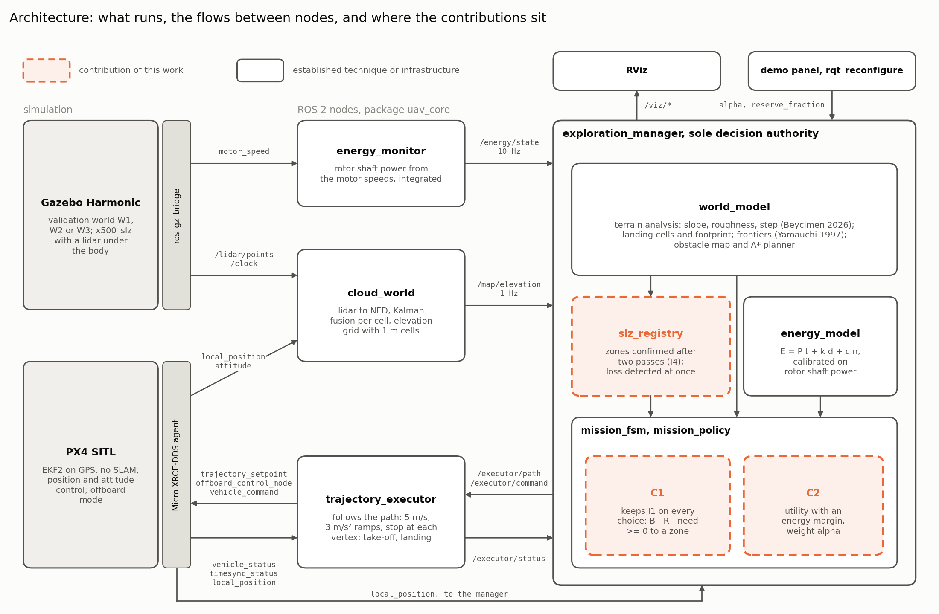
Figure 3. Software architecture as it runs: simulation and bridges (left), the four ROS 2 nodes (middle), the exploration manager and the pure modules it calls (right). Arrows carry the real topic names, PX4 ones without their /fmu prefixes and version suffixes; the RViz point cloud and the external stop topic are omitted. Appendix C explains the ROS 2 vocabulary and compares the figure with the graph ROS reports in flight.

5.2 Frames and Timing
Four frames are involved (Figure 4). LiDAR points arrive in the sensor frame (forward, left, up), are converted to the body frame (forward, right, down) with the 0.15 m sensor offset, rotated into the local north-east-down frame by the attitude quaternion and translated by the vehicle position; without the rotation a point 15 m ahead is misplaced in height as soon as the vehicle tilts. The simulator world, in which the ground truth is drawn, is east-north-up.
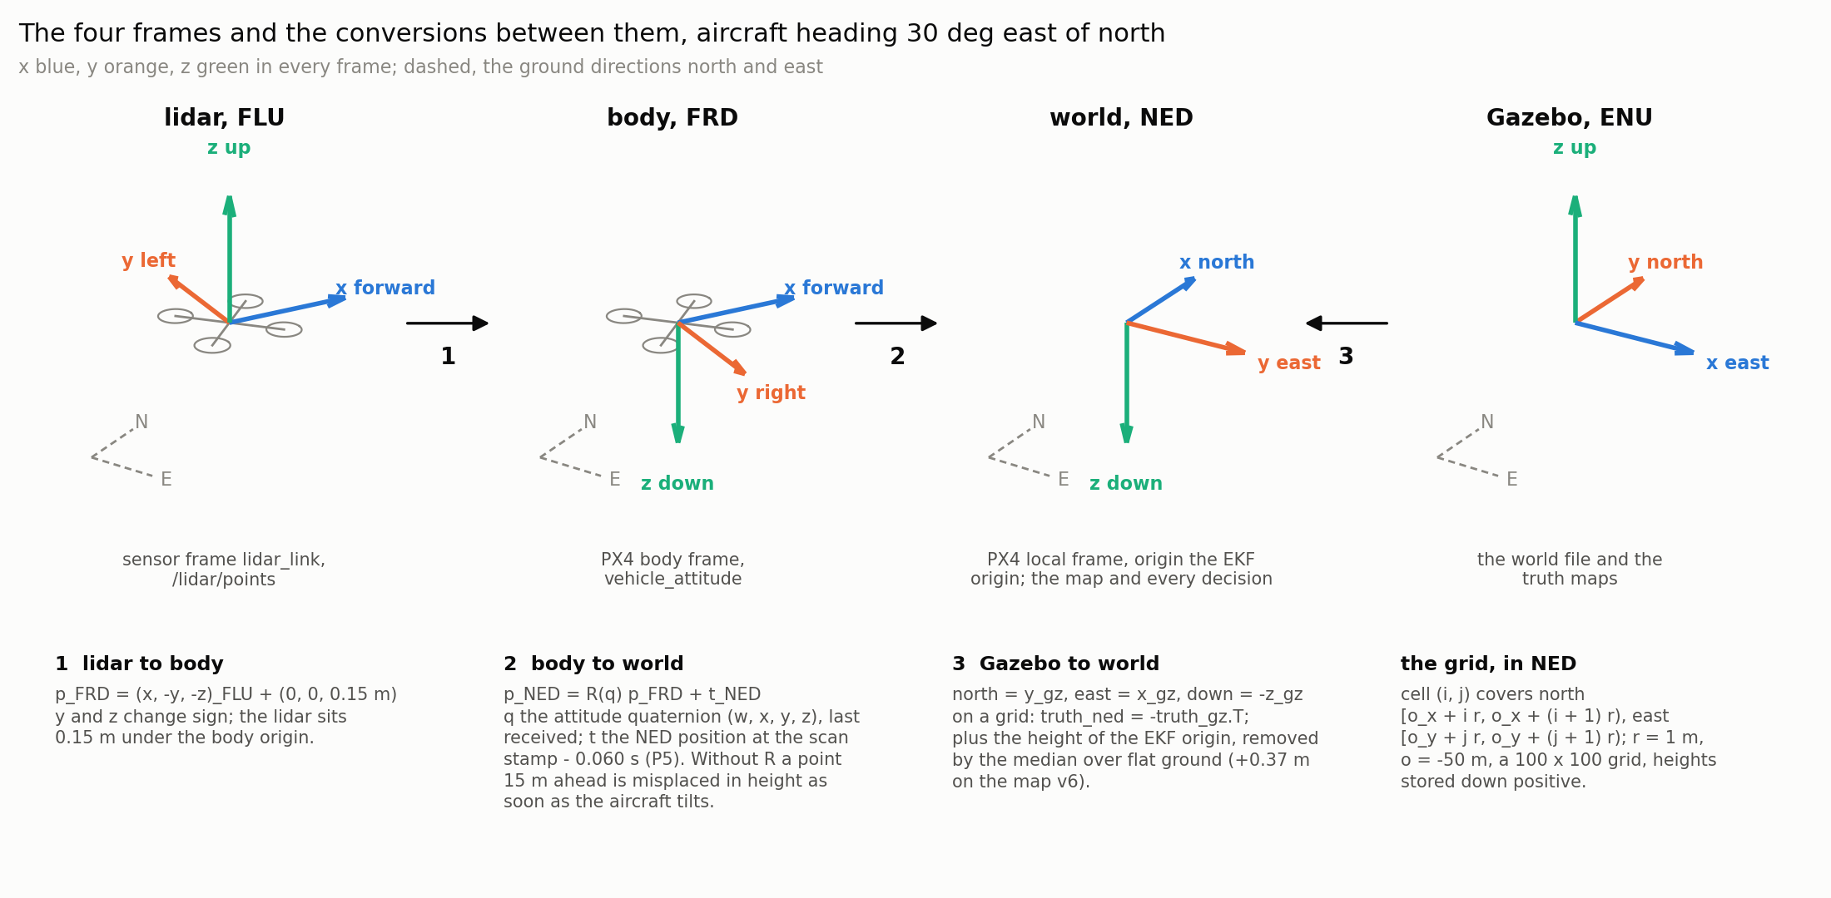
Figure 4. The four frames and the conversions applied by the code, for a heading of 30°: (1) LiDAR to body; (2) body to world, at the scan time; (3) simulator to world, for the ground truth.
Timing mattered as much as geometry. On the ramps of W1 the map was offset by one cell along the direction of flight, because the pose used to place a scan was 0.11 to 0.12 s ahead of the scene the LiDAR had seen. The fix takes the position at the scan timestamp minus a calibrated 0.060 s and the attitude last received; on six fresh surveys the offset vanished, the ramp error fell from 0.34 to 0.16 m RMS and the dangerous false accepts from 3 or 4 to 0, with the recall kept. Offboard setpoints must likewise be stamped in microseconds since the autopilot booted: copying the 1 Hz synchronisation stamp caused 177 failsafes in one test series.

5.3 Vehicle, Sensor and Flight
The vehicle is the PX4 x500 quadrotor with a LiDAR mounted 0.15 m below the body, so that the sensor does not see the arms; Table 5 lists the parameters. The trajectory executor follows straight legs on the calibrated profile. Paths are planned by A* (Hart et al., 1968) on an obstacle grid in which a cell is blocked when its height exceeds the cruise altitude minus a 2 m vertical margin, inflated by 1.25 m (half the span plus the measured tracking error).
Table 5. Parameters of the implementation used in every experiment.
Group | Parameter | Value
LiDAR | beams; rate; range; noise | 360 × 32, downward hemisphere; 10 Hz; 0.3 to 25 m (20 m used); σ = 0.02 m
Flight | altitude; speed; acceleration | 8 m; 5 m/s; 3 m/s², stop at every vertex
Map | cell; fusion; variance floor | 1 m; scalar Kalman, σ = 0.02 + 0.009 d; (0.02 m)²
Observation | OBSERVED | ≥ 10 returns and variance ≤ 2 × 10⁻³ m²
Terrain | slope; roughness; step; window | 6°; 0.05 m; 0.24 m; 3 × 3 plane fit
Landing | footprint; confirmation | 1.5 m (3 × 3 cells); two passes per cell (r_{in} 14.4 m, r_{out} 18 m)
Planning | inflation; vertical margin; escape | 1.25 m; 2 m; 1 m (returns only)
Energy | reserve; E_{land}; latency τ | 10 % of the budget; 3387 J; measured, max of last five plus largest rise
Frontiers | minimum cluster; viewpoint radius; blacklist | 3 cells; 5 m; 30 s, then 300 s after three failures
Returns | switch threshold; switches | 541 J; at most 3 per return

5.4 Energy Measurement, Logging and Reproducibility
The energy_monitor node integrates the rotor shaft power at 10 Hz against the logical budget of the mission. Every mission writes its configuration and git commit, the trajectory, the registry history, map snapshots every 10 s, every event, and, at every cycle, the margin and all candidates with G, M, E_{go}, E_{ret}, U and their admissibility, not only the winner. Campaigns are run headless: because the energy is integrated on the system clock, a simulation slowed by rendering would be charged more energy for the same flight, which is conservative but would bias the comparisons.
Reproducibility. The code, the worlds, the mission logs of every campaign reported here (about 2 GB, map snapshots included) and the scripts that draw every figure and compute every number of Sections 4 to 6 are in the project repository [REPOSITORY LINK], at the tag thesis-2026-10-27 for the flight code and the experiment directories named in each script header for the analyses. No figure needs a simulation to be redrawn.
Demonstration videos. Video 1 presents nine filmed missions on the three worlds in RViz, each beside its energy chart; Video 2 follows one W1 mission in Gazebo itself, the camera tracking the vehicle. Appendix B lists their chapters and the section each illustrates. Rendering slows the simulation, so filmed missions illustrate the behaviour and are never used as measurements.

6 Experiments and Results

6.1 Experimental Setup
Worlds. Three worlds were built, each with a ground truth rasterised from the same geometry as the simulated world, so that map and truth cannot diverge (Figure 5, Table 6). W1 holds flat ground and four test zones, each designed to pass or fail one test. W2 is a field sloped at 20° with three flat pads of 16 m, two of them 62.5 m from the central one, so that safe zones are far apart. W3 mixes a road, a town with flat and gabled roofs, cars, a forest, scrub, rocks and hills, so that landable ground lies between obstacles. Each budget binds: about half of what complete coverage requires (97 kJ on W2), since a budget that fits a full exploration lets no configuration fail; on W1, 16 kJ is the budget at which a sweep showed α to act.
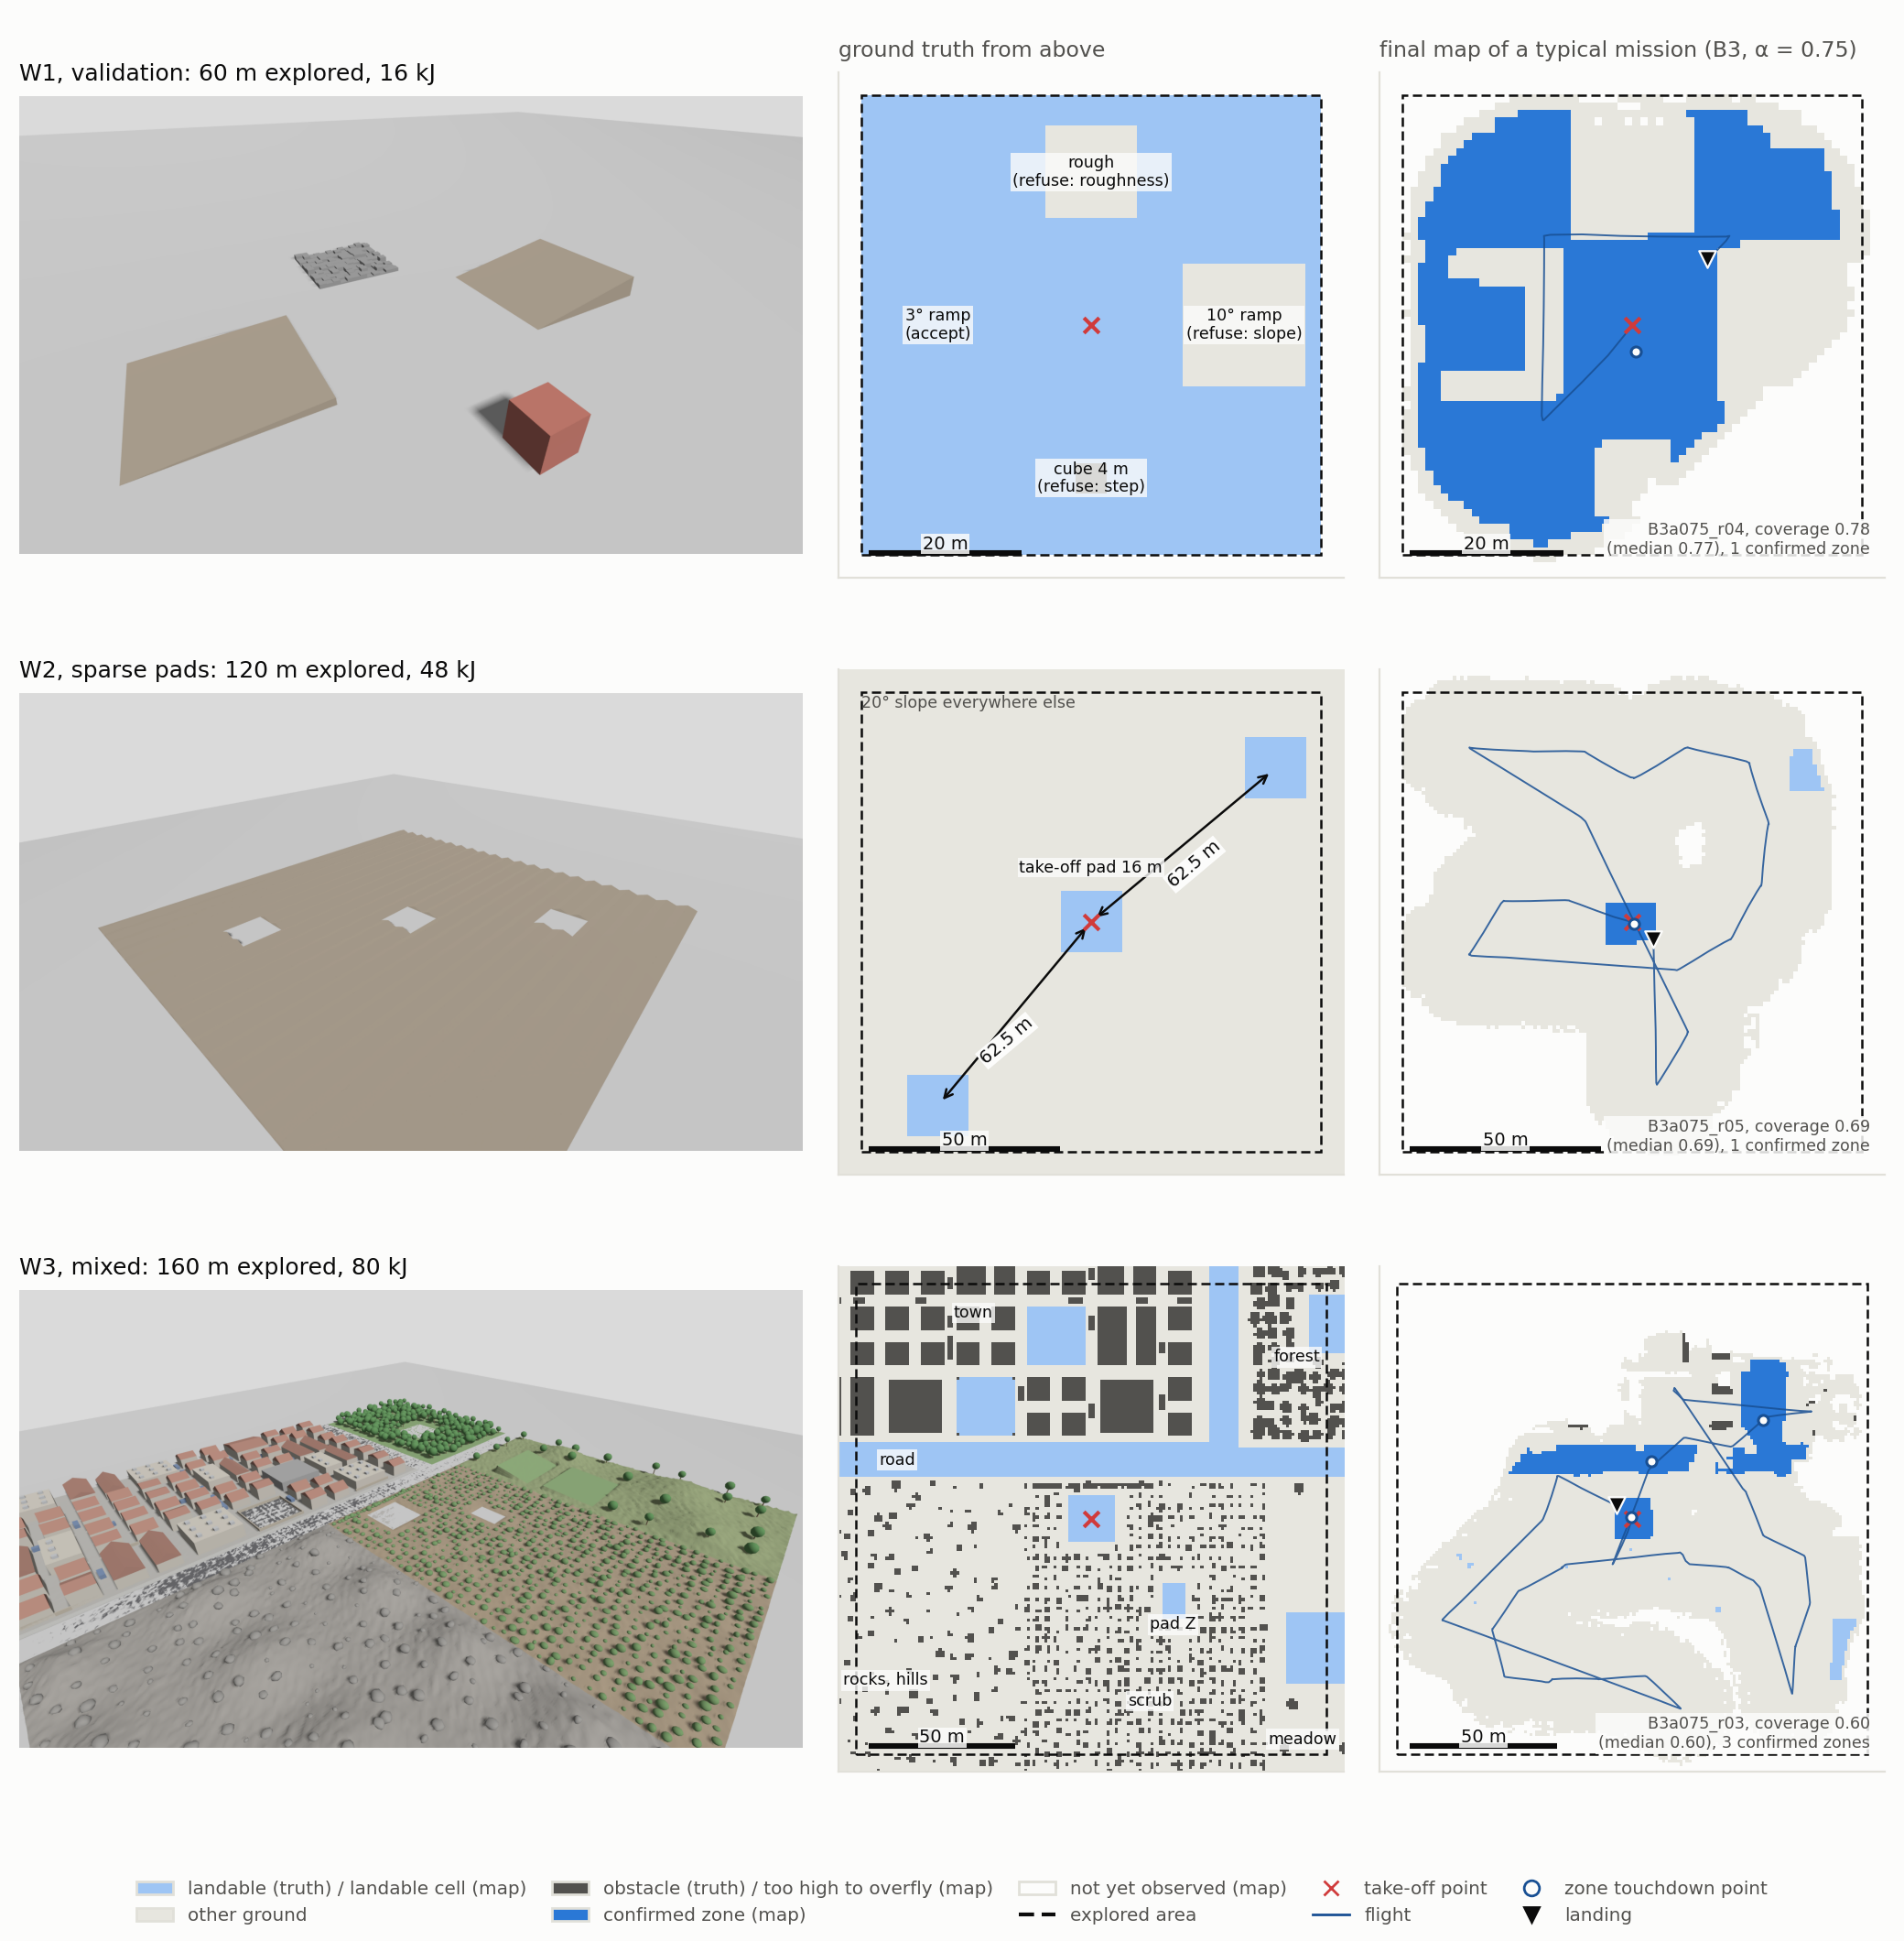
Figure 5. The three test worlds. Left: Gazebo render. Middle: ground truth, with the ground landable by design, the explored area (dashed) and the take-off point. Right: final map of a typical mission (B3, α = 0.75, coverage closest to its median), replayed through the flight perception code. Middle and right share one scale; north is up. Video 2 shows W1 in flight.
Table 6. Test worlds and budgets.
World | Map / explored area | Budget | Reserve | Character and purpose
W1, validation | 100 m / 60 m | 16 kJ | 1.6 kJ | known test zones; perception against exact truth; budget where α acts
W2, sparse pads | 200 m / 120 m | 48 kJ | 4.8 kJ | three flat pads in a 20° field; puts C1 under tension
W3, mixed | 240 m / 160 m | 80 kJ | 8.0 kJ | town, forest, hills; zones between obstacles; registry dynamics

Configurations. B0 explores the nearest frontier with no energy reasoning until its budget is exhausted. B1 explores the frontier of largest information gain and returns to the nearest zone when its energy falls below 30 % of the budget, the classical practice. B3 applies C1 and C2 with α ∈ {0, 0.25, 0.5, 0.75, 1}; the proposal's C1-only configuration is B3 at α = 1 by construction. Seven configurations, ten missions each per world, give 210 missions.
Protocol. Every mission starts on a fresh simulator instance, configurations are interleaved, and the host clock is watched during every mission, after a clock fault of the WSL2 virtual machine was found to corrupt earlier flights. All 210 missions completed at the first attempt, with no technical failure, no autopilot failsafe and no clock step. The acceptance criteria and the statistical comparisons were written down before each campaign.
Metrics and statistics. Safety is measured by the number of cycles violating I1 and the minimum margin of each mission, by the use of the reserve, and by where the vehicle landed relative to the truth. Exploration is measured by coverage, the fraction of the explored area whose cells reached the OBSERVED state, and by cells observed per kilojoule. Because the purpose of the mission is to find landing zones, it is also measured by the confirmed landing area the mission leaves behind and by the energy spent until the first discovered zone is confirmed. Perception is measured by the elevation error per zone, the recall of landable cells, and the number of dangerous false accepts, cells declared landable whose true slope or step exceeds twice its limit. Results are medians with interquartile ranges. Because a simulated mission is not repeatable to the seed, configurations are compared with the unpaired Mann-Whitney U test (Mann & Whitney, 1947) with the rank-biserial correlation r as effect size, and trends in α with Spearman's rank correlation; comparisons beyond those fixed before the campaigns are Holm-corrected within each world (Holm, 1979).

6.2 Perception Against Ground Truth
The perception results are measured on the reference map of W1, a survey map that every figure of this section uses and that was never regenerated (W1 is the top row of Figure 5). Figure 6 compares the map with the truth. On flat ground the elevation error is 0.240 m RMS with a bias of 0.014 m after removal of the constant offset of the estimator origin; the 3° ramp is mapped to 0.128 m RMS and the 10° ramp to 0.466 m, its error concentrated on its raised edges. The cube is mapped 1.67 m too low on average: a single Gaussian per cell cannot represent both the top of a structure and the ground beside it, so the map shrinks raised structures at their edges. This limitation of the representation is not corrected here; for flight it is bounded by the obstacle inflation, for landing it is not, as shown below.
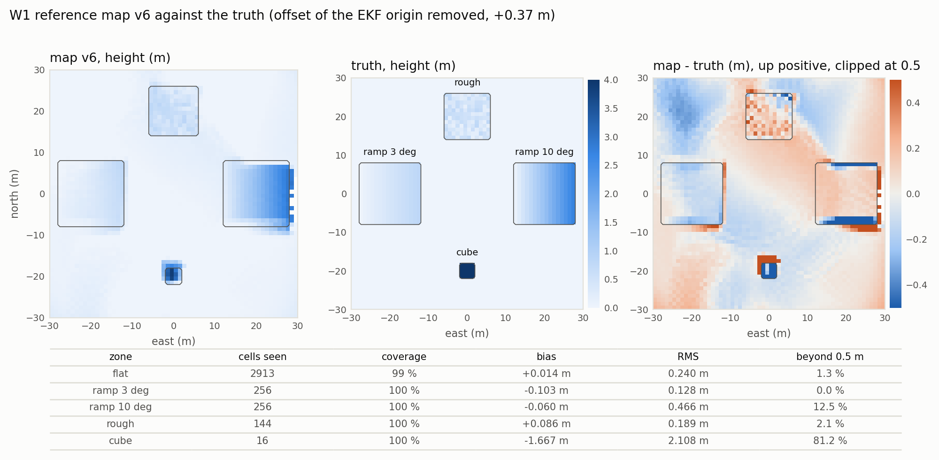
Figure 6. Reference map of W1 against the truth: map height, true height and their difference (clipped at ±0.5 m), with the error per zone.
Figure 7 justifies the slope threshold. On flat ground the slope read on the map has a 95th percentile of 4.34°, on the 10° ramp a 1st percentile of 8.25°, so 6° separates the two for 95 % and 99 % of their cells; only 1 % of the 3° ramp reads above 6°. The tail of the flat distribution (99th percentile 21.66°) is not noise: 81 of the 88 flat cells that read above 6° lie within 3 m of a real step of another zone, which the representation smears beyond the one-cell margin of the analysis window. Figure 8 verifies the separation of descriptors: the zone medians fall where they should, slope without roughness on the ramps (2.9° and 10.4° with roughness 0.013 and 0.014 m) and roughness without excessive slope on the rough patch (0.085 m against 0.150 m in the truth, 4.4°).
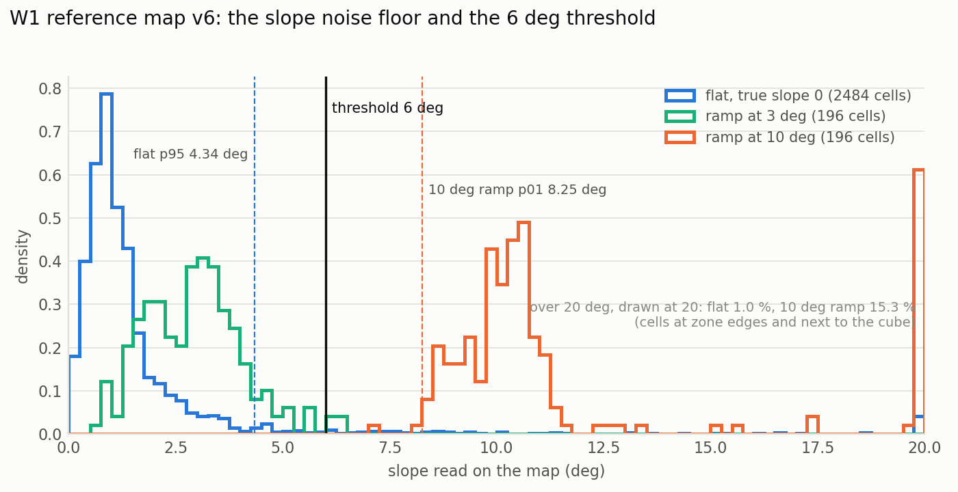
Figure 7. Slope read on the map per zone of W1, with the 6° threshold.
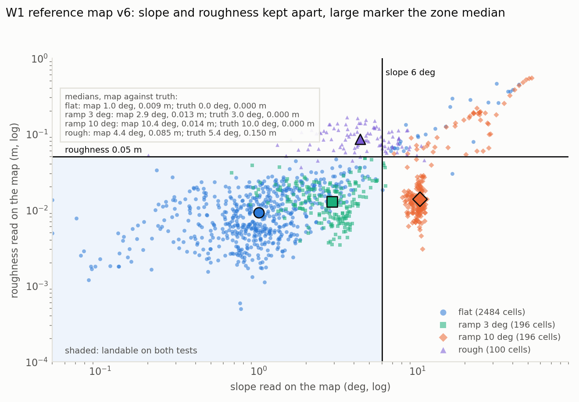
Figure 8. Slope against roughness, one point per cell (log scales), with the thresholds and the zone medians (large markers): ramps read as slope, the rough patch as roughness.
Figure 9 brings the chain together. With the 1.5 m footprint the detector recovers 94.2 % of the truly landable cells. It produces 46 false accepts, all benign (cells slightly beyond a limit, such as a gentle slope just over 6°), and no dangerous one. But one map is an observation, not a result, so the detector was replayed on the last map of every mission of three W1 campaigns (Table 7). On the first, 14 of 80 maps carried a dangerous landable cell, all in small islands of the rough patch, where the map reads a 0.12 to 0.19 m step for a true 0.52 m. The confirmation guard of Section 4.4 was chosen on that campaign and held on a second, independent one, with the recall unchanged. On the final campaign, flown after the timing fix of Section 5.2, it no longer suffices: 10 of 70 maps carry a dangerous landable cell, always one or both of two cells at the raised north corner of the 3° ramp, where a true 0.66 to 0.71 m step is read as 0.04 to 0.14 m. These cells belong to the large flat zone, and 10 of the 12 lay in a confirmed zone at the end of their mission, so they were possible landing targets. No mission landed there: of the 150 C1 landings, 149 were on ground landable by design and one on forest floor, none on a dangerous cell. The absence of dangerous false accepts is therefore a property of the reference map, not of the chain: a raised edge smoothed by the single-height map remains a residual hazard on mission maps.
Table 7. Dangerous landable cells on the last map of every mission of three W1 campaigns, footprint 1.5 m, before and after the confirmation guard (a zone must hold a whole footprint of landable cells).
Campaign | Maps | Without guard: maps (cells) | With guard: maps (cells) | Where
19 Oct (guard chosen) | 80 | 14 (14) | 0 (0) | islands in the rough patch
20 Oct (guard checked) | 80 | 17 (22) | 0 (0) | islands of fewer than 9 cells
23 Oct, final | 70 | 11 (13) | 10 (12) | north corner of the 3° ramp

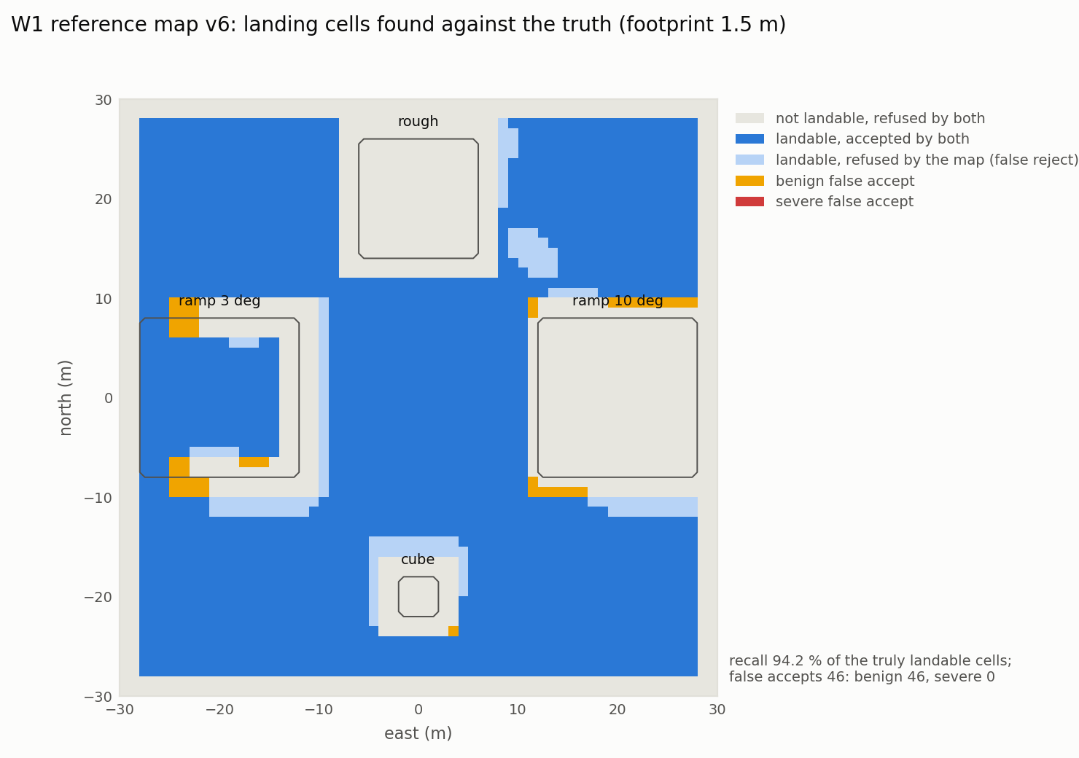
Figure 9. Landing cells detected on the reference map against the truth (footprint 1.5 m): recall 94.2 %, 46 benign false accepts, no dangerous one.

6.3 Energy Prediction and Landing Precision
Figure 10 shows the calibration of Section 4.5: predicted and measured energies lie on the identity line for hover segments, transits and the four validation flights, and the leg term removes the structure of the transit error by leg length. Predicted from the plan alone, the validation flights fall within 0.13 to 0.26 % of the measurement, slightly below it.
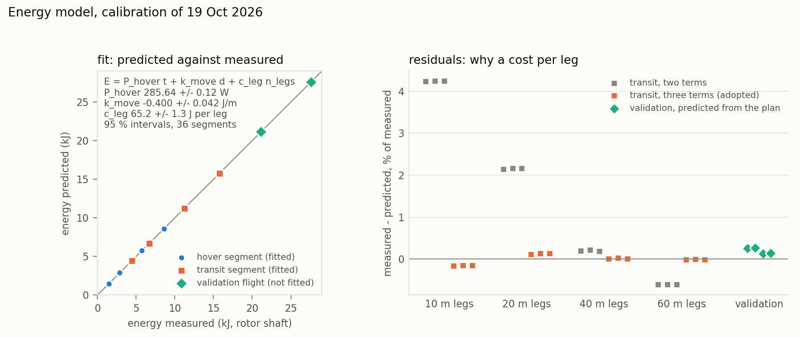
Figure 10. Energy model calibration. Left: predicted against measured energy per segment and for the four validation flights. Right: transit error by leg length without and with the leg term.
The guarantee rests on the energies C1 actually charged in missions. Figure 11a compares them with the energy measured over the same interval, for every transit to a chosen frontier (2535) and every final return leg (180) of the B1 and B3 missions. Charged as C1 charges it, path plus the measured latency τ, $E_{go}$ was above the measurement in 2530 transits, by 309 J at the median (14 %), and below it in 5, by 9 to 137 J; the path alone would have been short by about one second of hover, the time τ is there to cover. $E_{ret}$ plus τ was above the measured return in 174 of 180 legs; five of the six exceptions are legs of 4 m or less, where stopping and detecting the arrival costs more than τ, by at most 661 J. The planning $E_{land}$ exceeded the measured landing in 176 of 180 cases, by at most 10 J the other way. Return and landing together were under-charged in 5 of 180 cases, by at most 488 J against a reserve of at least 1.6 kJ.
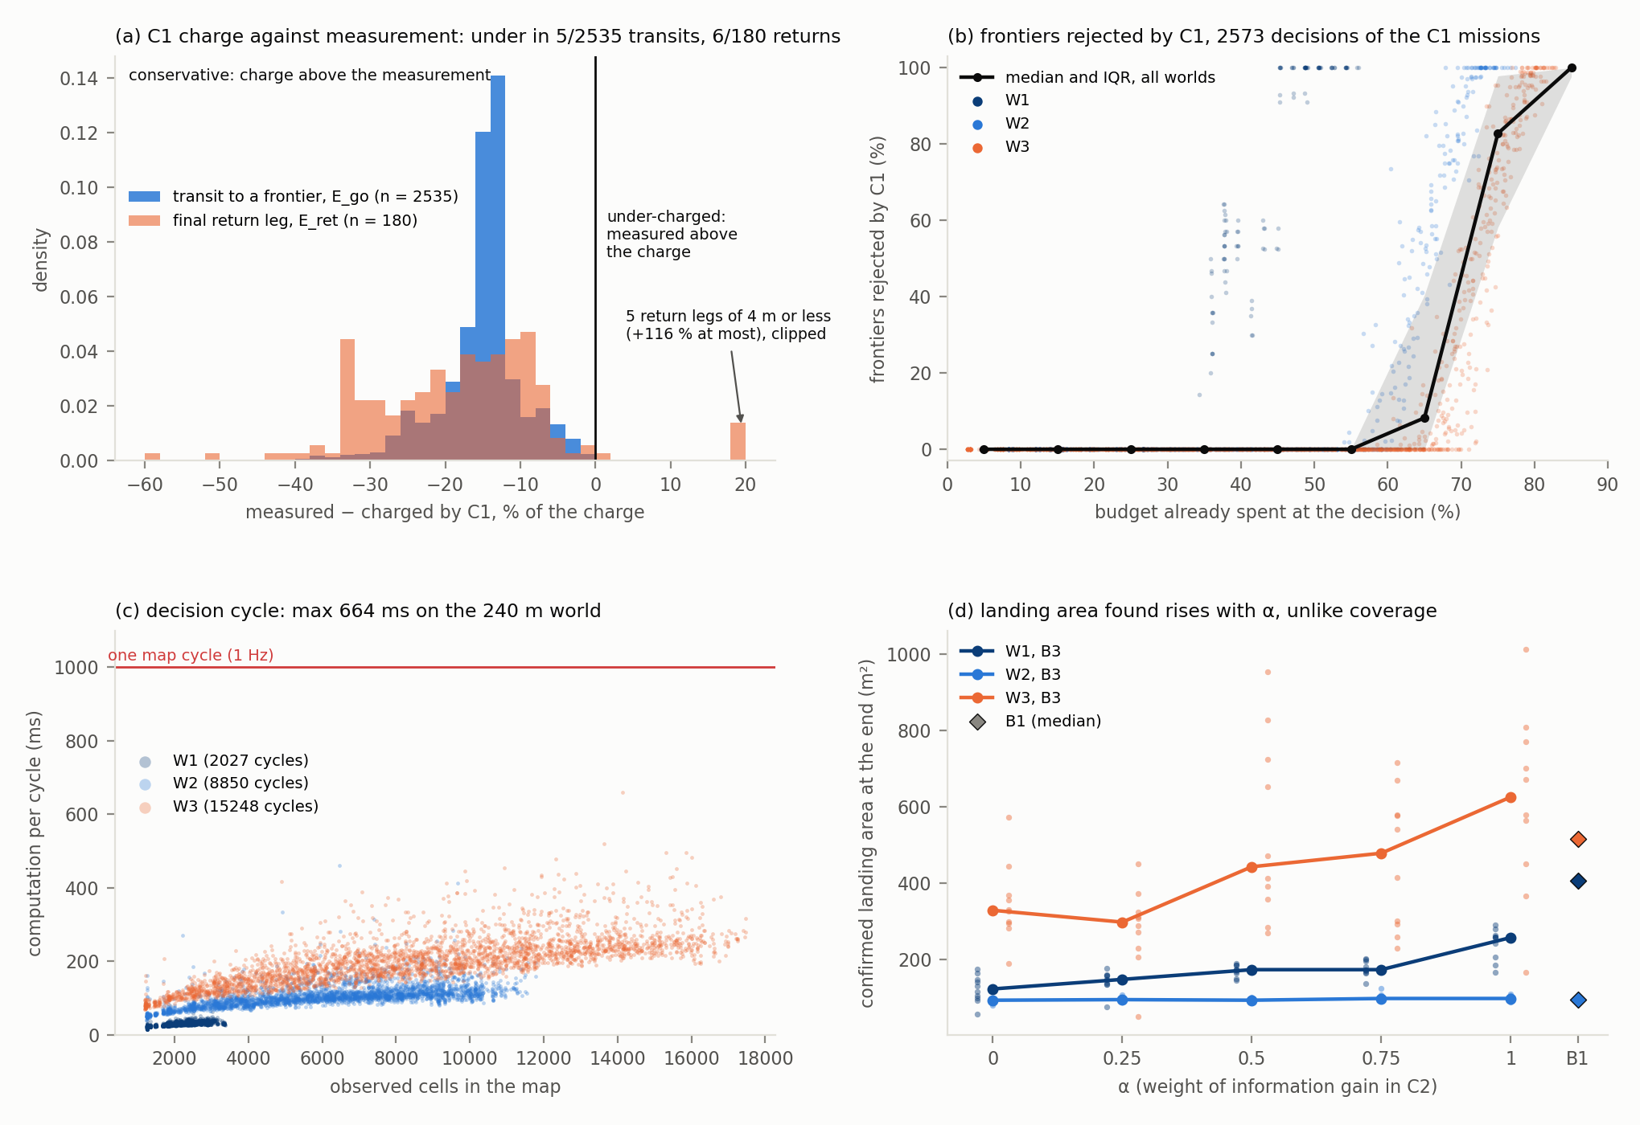
Figure 11. Four analyses of the 210 campaign missions. (a) Energy measured minus energy charged by C1, per transit ($E_{go}$) and per final return ($E_{ret}$), latency included; negative is conservative. (b) Share of frontiers rejected by C1 against the share of the budget spent. (c) Decision cycle time against observed cells. (d) Confirmed landing area at the end of the mission against α.
The footprint depends on how precisely the vehicle lands. Over 15 landings commanded on the same setpoint, the radial error of the touchdown was 0.124 m on average and 0.195 m at most (Figure 12). With the blade tips 0.386 m from the centre, the 1.5 m footprint leaves room for an error of 0.364 m, twice the measured 95th percentile.
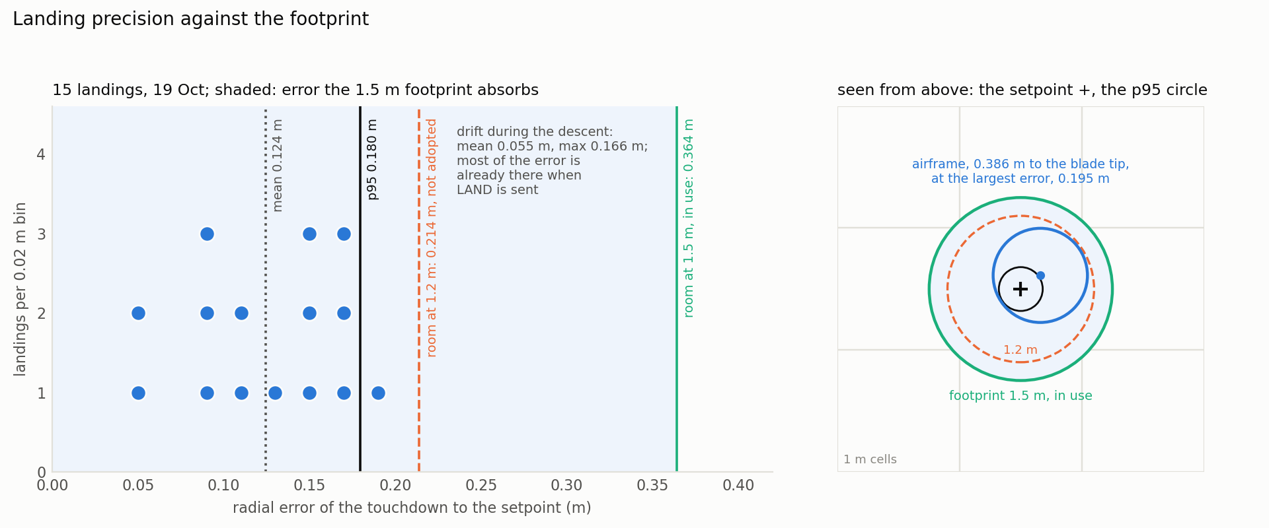
Figure 12. Landing precision. Left: radial error of 15 landings against the error each footprint can absorb. Right: the same from above, the airframe drawn at the largest error.

6.4 Safety: the Invariant Against the Baselines
Table 8 gives the central result. No mission with C1 violated the invariant on any world, 0 of 150, and none used its reserve. B0, which ignores energy, violated it in every mission and ran out of energy in flight in all 30: on a real battery each would have ended in a crash (Video 1, 1:41). The simulator landed them 12 to 18 s later, three times on a cell dangerous in the truth, only because the budget is a counter in the manager and not the simulated battery. Against B0 the difference in violations is significant on every world (p ≤ 0.0001, r = −1.00).
Table 8. Invariant I1 per world and configuration, ten missions per cell (B3 pools its five values of α, 50 missions).
World | Configuration | Missions violating I1 | Out of energy in flight | Energy left at landing (median)
W1, 16 kJ | B0 | 10/10 (median 24 cycles) | 10 | −4.17 kJ (budget overdrawn)
 | B1 | 10/10 (median 6 cycles) | 0 | 0.52 kJ (1.08 kJ into the 1.6 kJ reserve)
 | B3, all α | 0/50 | 0 | 3.1 to 3.9 kJ
W2, 48 kJ | B0 | 10/10 (median 44.5 cycles) | 10 | −4.05 kJ (budget overdrawn)
 | B1 | 0/10 | 0 | 8.7 kJ
 | B3, all α | 0/50 | 0 | 6.4 to 7.0 kJ
W3, 80 kJ | B0 | 10/10 (median 52.5 cycles) | 10 | −4.20 kJ (budget overdrawn)
 | B1 | 1/10 (9 cycles) | 0 | 17.6 kJ
 | B3, all α | 0/50 | 0 | 9.6 to 11.0 kJ

B1 is the more instructive comparison. Its outcome depends on the pairing of its threshold with the world and the budget. On W1 at 16 kJ, 30 % of the budget is less than the return, the landing and the reserve together, and B1 violated I1 in every mission, landing 1.08 kJ into its reserve each time (Figure 13; Video 1, 2:55). On W2 the same threshold covers the return from anywhere in the area, and B1 held I1 in all ten missions; on W3 it failed once. A threshold can be tuned to one world; a guarantee computed from the actual registry and position needs no tuning.
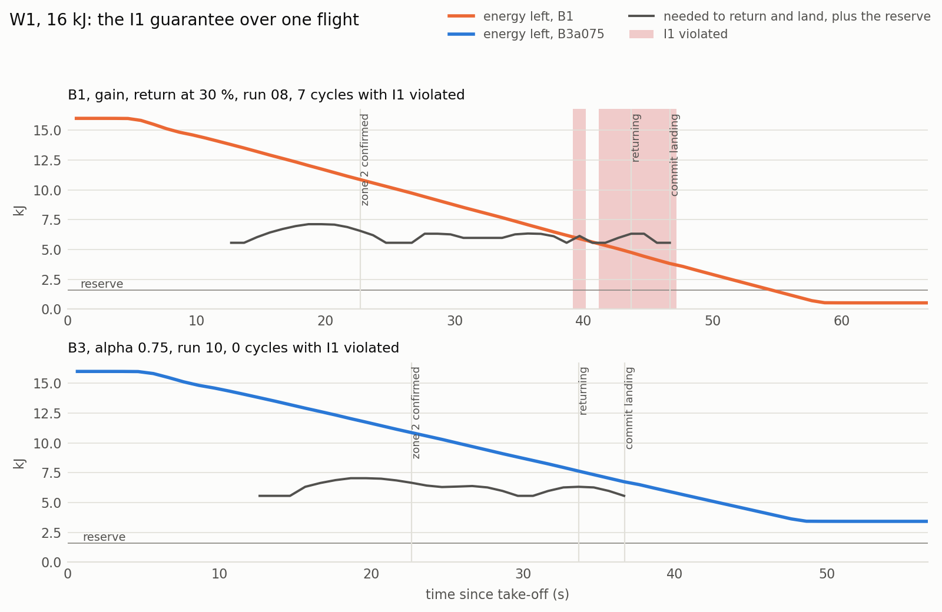
Figure 13. One flight on W1 at 16 kJ: energy left against what the return, the landing and the reserve need. Top: B1 violates I1 (shaded) before its 30 % return. Bottom: B3 at α = 0.75 returns when C1 admits no frontier; the margin stays positive.
Figure 11b shows when the filter acts. Over the 2573 decisions of the C1 missions, C1 rejected no frontier while less than 30 % of the budget was spent; between 30 and 60 % it rejected some at 11 to 13 % of the decisions, between 60 and 70 % at 63 %, and beyond 70 % at every decision, a median of 83 % and then 100 % of the frontiers. The filter is idle for most of a mission and decisive in its last third, where the baselines fail. The admissibility of every candidate is also computed, unused, in the baseline missions: C1 would have refused 10 of the 40 frontier choices of B1 on W1, 6 of 105 on W2 and 2 of 178 on W3, a rate that follows the failures of B1 in Table 8, and 66 %, 34 % and 22 % of the choices of B0.
The guarantee costs coverage only relative to policies that break it. On W1, B1 covered 0.89 of the area against 0.69 for B3 at α = 0.5, by taking energy from its reserve. On W2 and W3, where B1 does not overspend, C1 with C2 covered more than B1 (0.70 against 0.54 on W2, 0.63 against 0.50 coverage seen on W3 at α = 0.5; p = 0.0002, r = +1.00 on both) and landed with less energy left: the margin that B1 wastes on a conservative threshold, C1 spends on exploration. B0 covers the most, by flying until its budget is exhausted.

6.5 The Coverage and Margin Trade-off
Table 9 and Figure 15 report the effect of α on coverage. The comparison fixed in advance, α = 0.75 against each end of the range, holds on all three worlds: 0.77 against 0.65 (α = 0) and 0.76 (α = 1) on W1, 0.69 against 0.61 and 0.59 on W2, 0.60 against 0.48 and 0.52 on W3 (Holm-corrected p ≤ 0.0091 in all six cases). The location of the optimum is less sharp than that. On W1, α = 0.75 covers more than every other value, significantly so against 0, 0.25 and 0.5 (Holm-corrected p = 0.0018), not against α = 1 (p = 0.055). On W2 and W3 the highest median is at α = 0.5 (0.70 and 0.60), and the three interior values are not distinguishable from one another after correction (α = 0.5 against 0.75: uncorrected p = 0.47 and 0.21); α = 0.5 and 0.75 cover significantly more than either end on both worlds. The supported statement is an interior optimum between α = 0.5 and 0.75, a plateau on the two larger worlds rather than a single best value.
Table 9. Coverage (fraction of the explored area OBSERVED), median with interquartile range, ten missions each. Bold: the highest median of each world and the values not distinguishable from it among the B3 configurations (Mann-Whitney, Holm-corrected p > 0.05).
Configuration | W1, 16 kJ | W2, 48 kJ | W3, 80 kJ
B0, nearest frontier | 0.87 [0.86, 0.88] | 0.78 [0.73, 0.80] | 0.60 [0.56, 0.62]
B1, gain, 30 % return | 0.89 [0.89, 0.90] | 0.54 [0.48, 0.56] | 0.47 [0.43, 0.49]
B3, α = 0 | 0.65 [0.64, 0.66] | 0.61 [0.61, 0.62] | 0.48 [0.44, 0.49]
B3, α = 0.25 | 0.67 [0.66, 0.67] | 0.68 [0.67, 0.69] | 0.56 [0.53, 0.62]
B3, α = 0.5 | 0.69 [0.67, 0.71] | 0.70 [0.67, 0.72] | 0.60 [0.60, 0.63]
B3, α = 0.75 | 0.77 [0.77, 0.78] | 0.69 [0.67, 0.70] | 0.60 [0.58, 0.60]
B3, α = 1 | 0.76 [0.67, 0.77] | 0.59 [0.57, 0.61] | 0.52 [0.47, 0.56]

The mechanism is visible in the decisions. The number of frontiers chosen per mission falls with α (on W3 from 40 to 21; ρ = −0.96). Figure 14 shows it on two W2 flights filmed for Video 1 (6:52). At α = 0.1 the vehicle circles its take-off pad in widening loops, 19 short trips around its only confirmed zone; at α = 0.9 it strikes out on long legs to the far side, 13 trips. Both cover about the same area (0.61 and 0.63); what differs is the order. At α = 1 the vehicle goes for the largest gain first, often far away, and C1 then finds no second admissible round trip: the monitor abandoned the target and ended 15 of the 30 missions at α = 1, against 3 to 7 at the other values. The intermediate weights see new ground while keeping the next trips admissible. On W1 the minimum margin also decreases with α (ρ = −0.36, p = 0.01): information is bought with margin. Figure 16 shows the same pattern over all the W2 campaign flights.
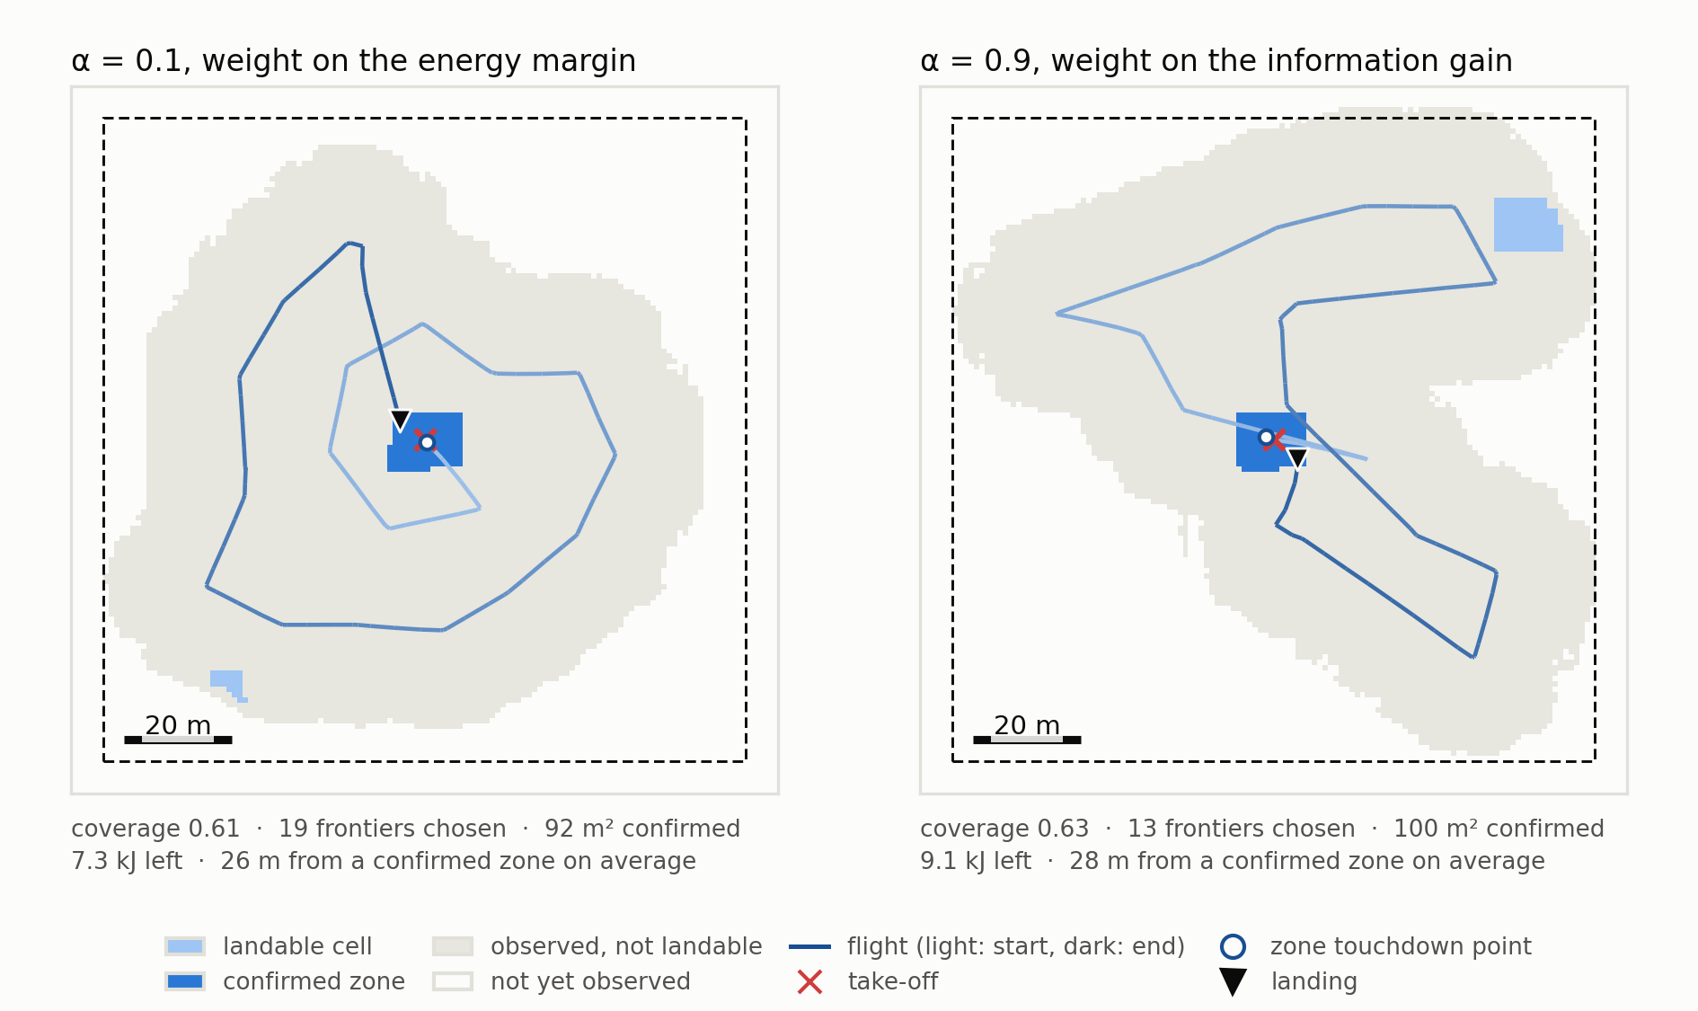
Figure 14. Final maps of two W2 missions at α = 0.1 and α = 0.9, filmed for Video 1; the track goes from light (start) to dark (end). Illustrations only: no campaign flew these two values.
C2 does not degenerate into a switch. With two admissible frontiers the per-decision rescaling maps G and M to {0, 1} and U can only be α or 1 − α; this happened in at most 1 % of the decisions, and 71 to 99 % had three or more admissible frontiers. Recomputed from the logged G̃ and M̃, the choice at α = 0.5 differs from both the pure-gain and the pure-margin choice in 37 %, 68 % and 71 % of the decisions on W1, W2 and W3. But the coverage optimum does not carry over to the quantity the mission is for. The confirmed landing area left at the end of the mission rises with α (Figure 11d): on W3 from 328 m² at α = 0 to 625 m² at α = 1 (median; Spearman ρ = +0.44, p = 0.0014), on W1 from 122 to 257 m² (ρ = +0.79), and it is nearly flat on W2 (93 to 98 m²), where 48 of the 50 C1 missions confirmed only the central pad. The energy spent until the first discovered zone is confirmed shows no trend with α on W1 or W3 (p = 0.10 and 0.26), and on W2 it is lowest at α = 0. C2 therefore does not find zones faster; more weight on information finds more of them.
The mechanism is the second pass that confirmation requires. Attributing every increase of the confirmed area to the state of the vehicle, the share gained while flying to frontiers rises from α = 0 to α = 1, from 31 % to 91 % on W1, 26 % to 87 % on W2 and 81 % to 93 % on W3: long excursions re-cross ground seen on the way out, whereas at low α much of the area (up to 64 % on W1 and 77 % on W2) is only confirmed during the final return. The choice of α is thus a choice of objective, 0.5 to 0.75 for coverage and higher for landing area, both inside the guarantee. B1 left a comparable area on W3 (515 m²) and more on W1 (406 m²), there by spending its reserve.
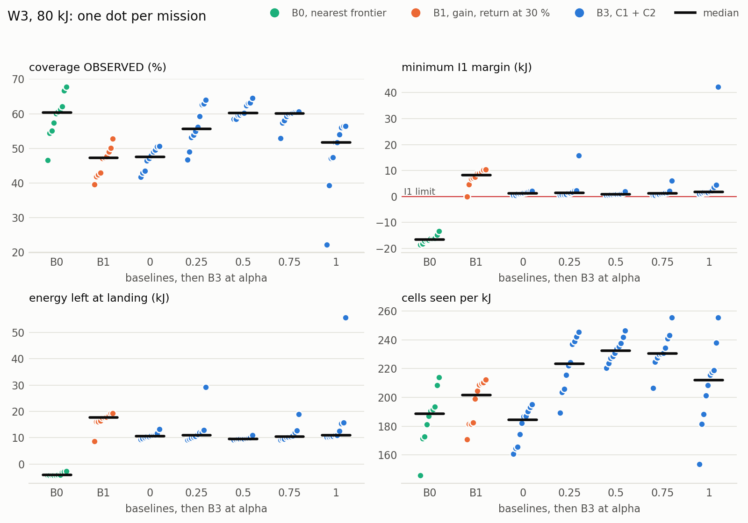
Figure 15. Mission metrics on W3, one dot per mission, medians as bars. The α = 1 mission at 22 % coverage was ended early by an escape (Section 7).
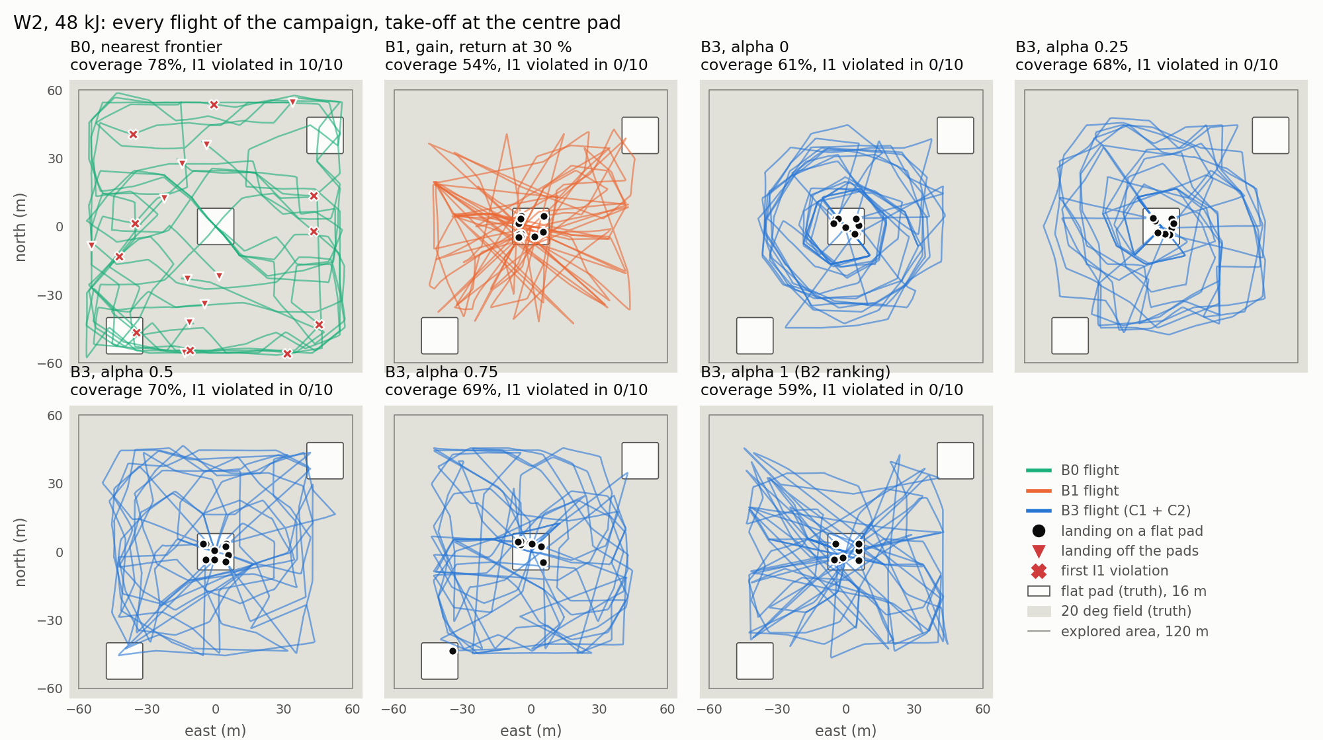
Figure 16. Every flight of the W2 campaign over the truth (flat pads in white), with the landings and the first violation of I1. Only B0 violates I1 and lands off the pads.

6.6 Registry Dynamics and the Loss of a Zone in Use
The registry is not static in practice. Figure 17 follows one W3 mission from take-off to landing: the registry grows to five zones and 579 m² of confirmed landing area, loses zones four times, and the energy margin narrows until C1 abandons the last target. Over the 50 C1 missions of W3 the registry shrank 90 times without any intervention; 35 of these removed the zone the vehicle was relying on and 8 the target of a return. Each was answered at the same cycle and none was followed by a violation. On W2 the registry shrank twice, and on W1 never. Replaying the perception code on the map snapshots around each W3 event, 609 of the 637 cells newly refused failed the roughness test while their variance did not change; the truth under them is flat, and they lie a median 3 m from a building, tree, car or rock. The most probable mechanism, inferred since point clouds are not logged, is the single-height map seen obliquely: returns from the side of an obstacle raise the roughness of the cells at its foot. The refusals are false but conservative; in the W3 mission of Video 1 (0:24) they appear as landable cells turning red at the foot of buildings and trees.
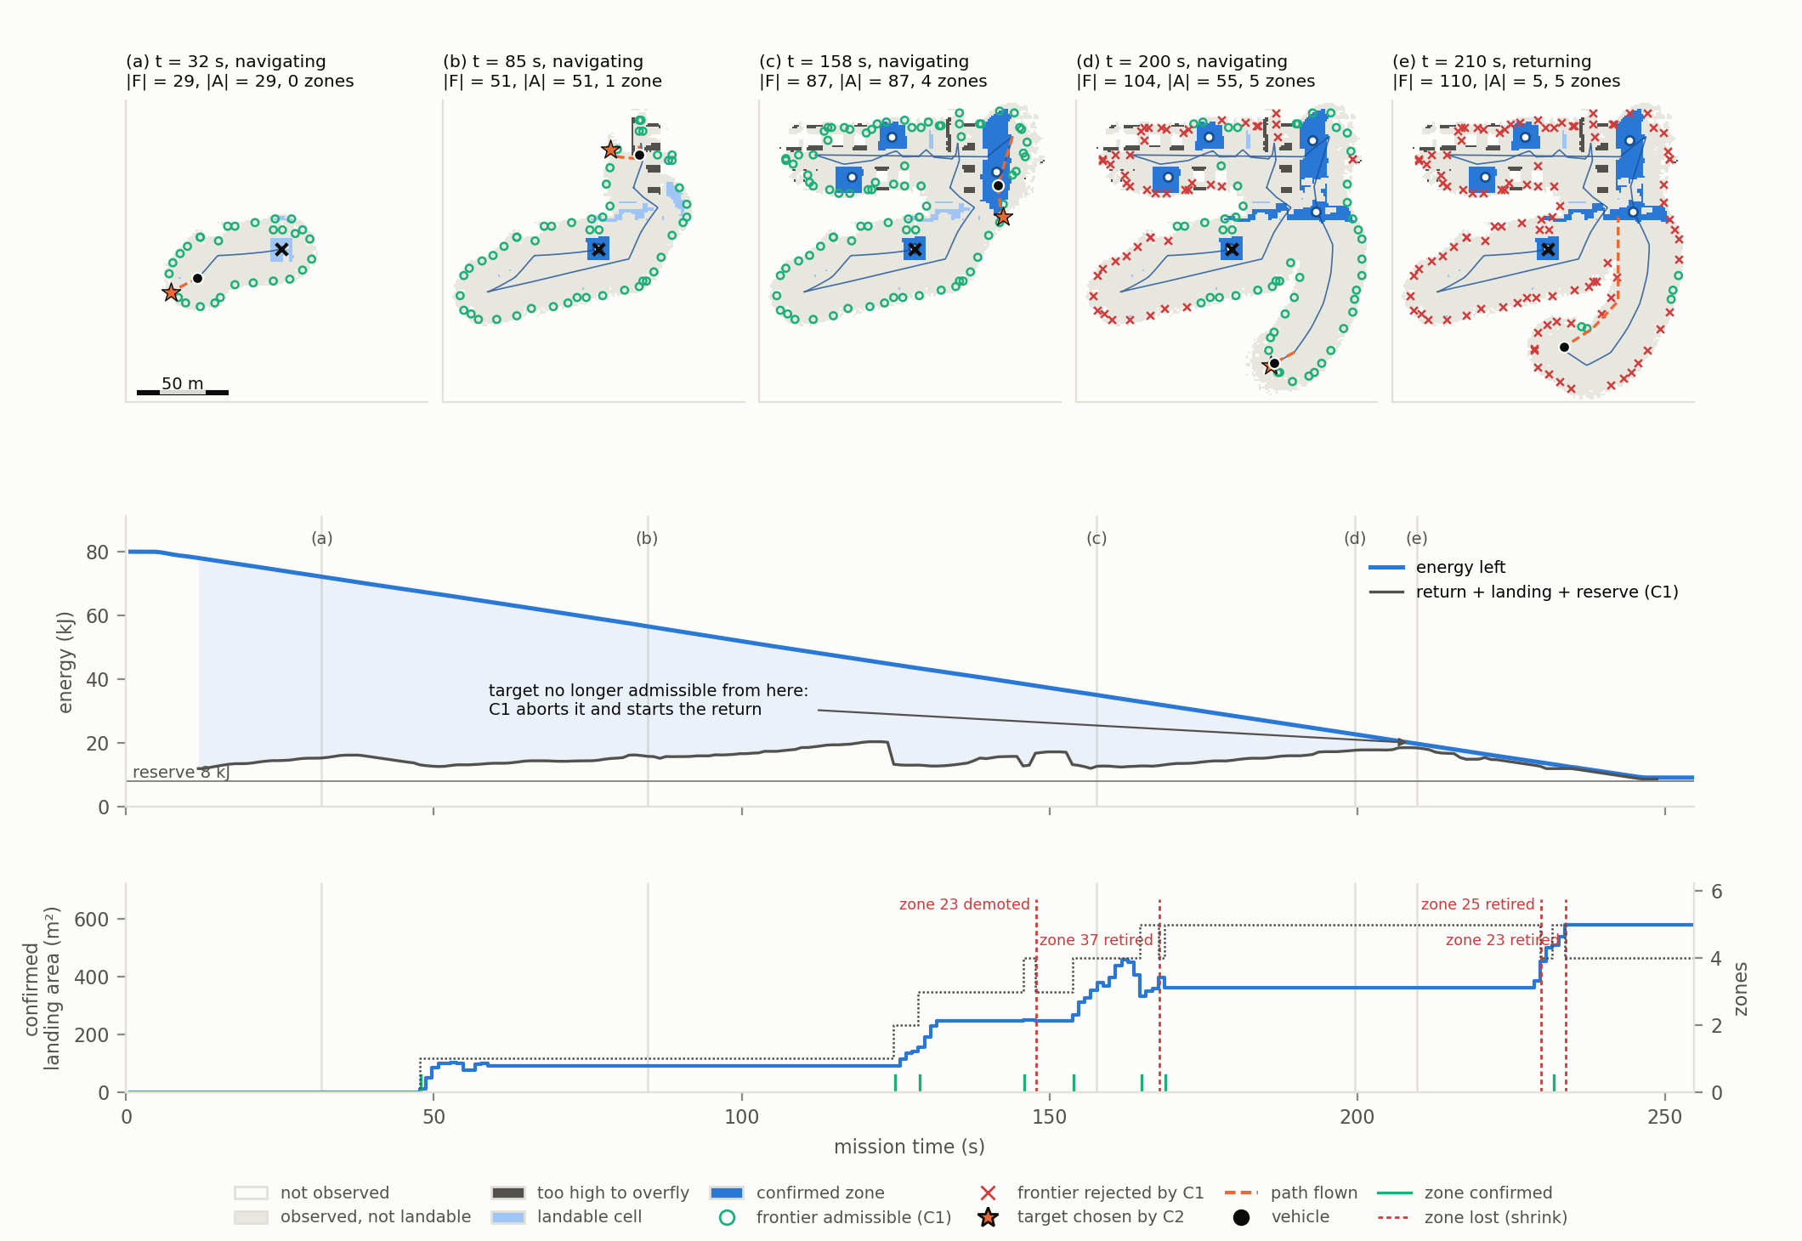
Figure 17. One W3 mission (B3, α = 0.75, median coverage). Top: five map snapshots with the frontiers admitted or rejected by C1, the target chosen by C2 and the confirmed zones; in (e) C1 has abandoned the target. Middle: energy left against what the return, the landing and the reserve need. Bottom: confirmed landing area, with every confirmation (green) and loss of a zone (red).
How often did a decision depend on a single zone? The manager also logged whether each target would have stayed admissible through the next-best confirmed zone. Of the 2423 decisions of the C1 missions, 713 (29 %) relied on the provisional take-off zone, for which this was not computed; of the other 1710, 1640 (96 %) would have stayed admissible without their zone and 70 (4 %) depended on it alone. A guarantee independent of the zone in use would thus have constrained few frontier decisions; it is the return that is left without a second zone, as the provoked experiment shows.
To test the reaction of Section 4.4 deliberately, a field of 36 crates (2 m cubes on a 3.5 m pitch over a 20 m square, with gaps too narrow for a footprint) was placed by script over the target of a return while the vehicle was 35 to 20 m from it, before the commitment to land, on W3 at α = 1, the configuration that returns to small and distant zones most often. An earlier scenario that placed the obstacle during a frontier transit never fired in 26 missions, consistent with the 4 % above: a transit rarely relies on a single zone, whereas a return always flies towards the zone it relies on, with the least energy left.

Table 10. Registry shrink provoked during a return on W3: four missions in which the crate field was placed (13 flown).
Mission | Zone lost (area) | Lost after placement | Margin at re-evaluation | Branch | Landing | Above reserve
r05 | 16 (190 m²) | 3.1 s | −278 J | no zone within guarantee | zone 4 | +0.11 kJ
r08 | 26 (174 m²) | 3.1 s | +11 837 J | I1 holds via zone 25 | zone 4 | +12.21 kJ
r10 | 21 (209 m²) | 4.1 s | −461 J | no zone within guarantee | zone 9 | 0.00 kJ
r13 | 20 (49 m²) | 3.2 s | −914 J | no zone within guarantee | zone 3 | −0.30 kJ

Table 10 and Figure 18 give the outcome. In all four missions the zone left the CONFIRMED state 3.1 to 4.1 s after placement, the assumed 2.5 s of detection plus at most one map cycle; I1 was re-evaluated at that very cycle; the return turned to the nearest reachable zone within 0.5 s; and every landing was a committed landing on another registry zone, on ground safe in the truth. The sequence of Section 4.4 is executed as designed. The result also delimits the guarantee. In three of the four missions no zone remained within it after the loss: C1 returns when no frontier is admissible any longer, so the margin it keeps is then smaller than the detour to the next zone. The violation was logged, and the vehicle landed on the nearest zone using at most 0.30 kJ of its 8 kJ reserve. I1 holds as long as the registry does not shrink under the zone it relies on; when it does, the reserve absorbs the shortfall. Over all 188 C1 missions flown since the invariant was introduced, the reserve was touched twice (1.63 kJ before the final corrections, 0.30 kJ here).
A fifth provoked case, flown while filming Video 1 (9:12), exposed a gap. The crate field covered only part of the target zone, which stayed CONFIRMED through its other cells, so no loss was detected; the return flew on to its original end, inside the field, and the arrival committed the landing there: the commit checks that the vehicle has arrived, not that the cell is still landable. In the final campaigns, 149 of 150 commits were over a cell the map still held landable, the other over a refused road cell, safe in the truth. A first correction, replanning such a return, kept a filmed vehicle out of the crates but delayed landings over flickering cells and broke I1 in 2 of 5 filmed flights; it is not part of the evaluated system.
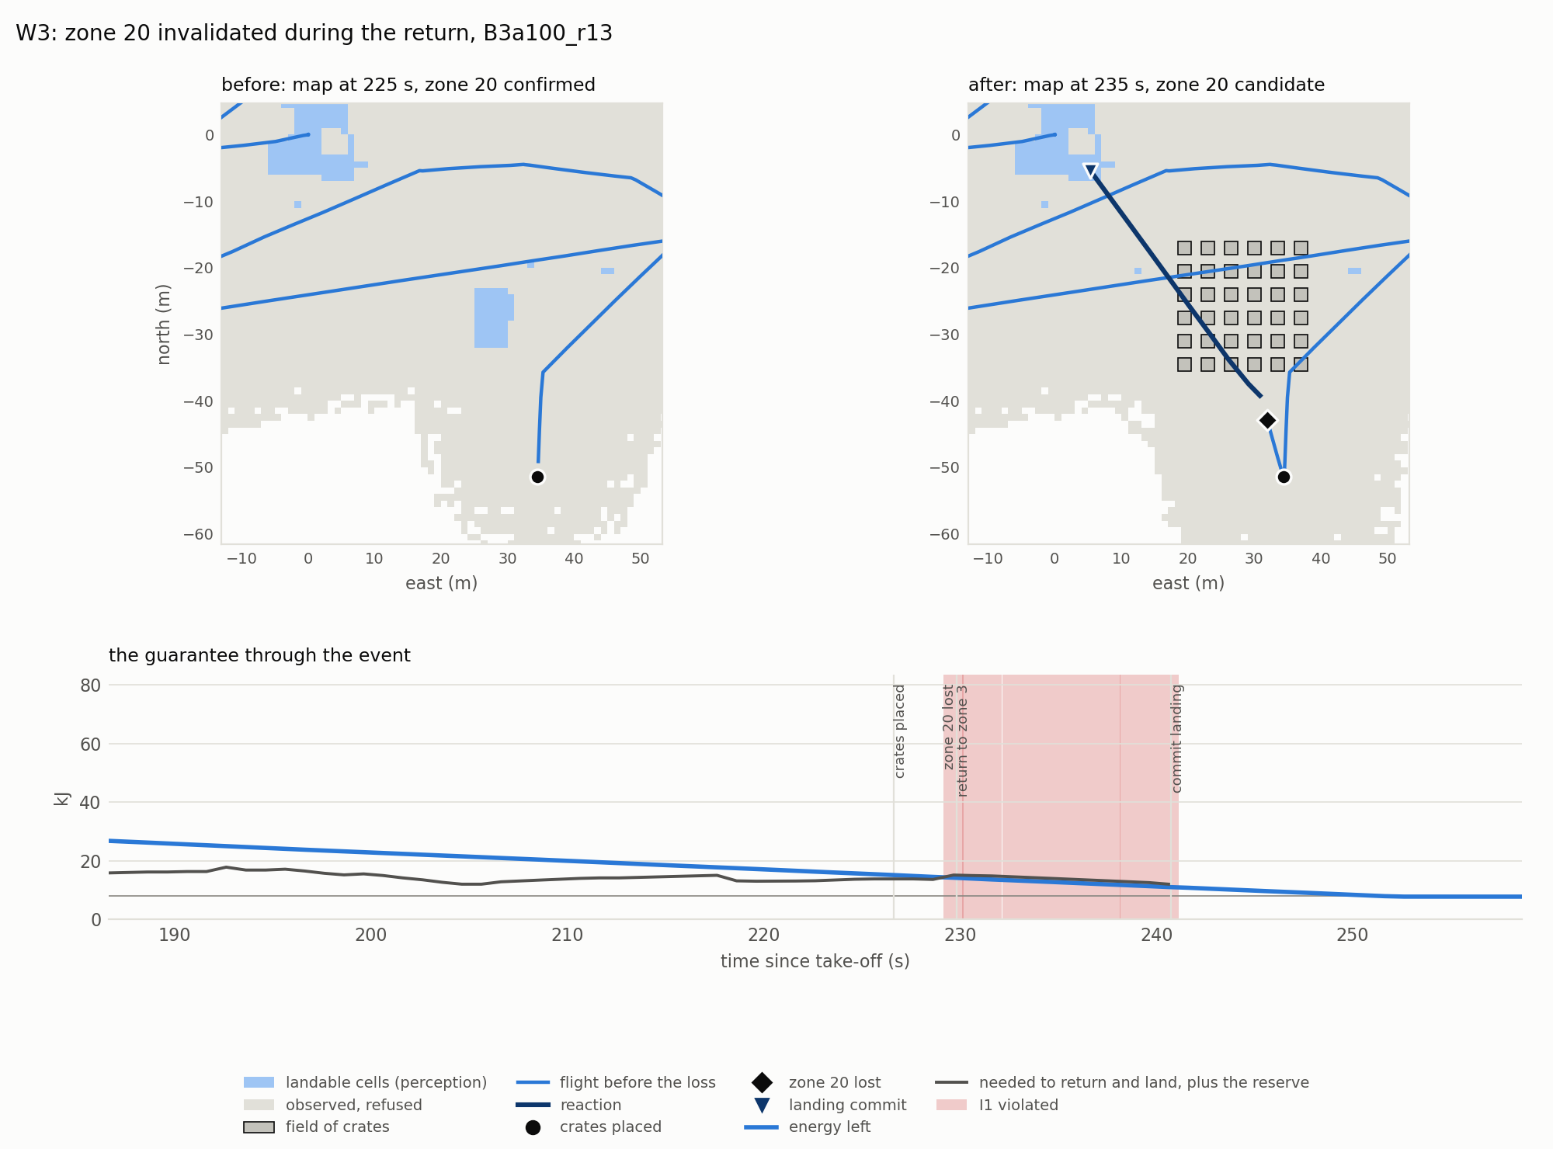
Figure 18. Provoked loss of the zone in use during a return (W3, mission r13). Top: the map before and after the crates are seen, with the reaction and the landing on zone 3. Bottom: I1 is violated from the loss to the landing commit (shaded); the reserve covers 0.30 kJ.

6.7 Computational Cost
The method runs online, one decision cycle per map at about 1 Hz. Figure 11c gives the computation time of every cycle of the final campaigns: a median of 29 ms on W1, 103 ms on W2 and 198 ms on W3, with a maximum of 664 ms on W3, within the one-second cycle on the development laptop. Time grows with the observed part of the map (ρ = +0.78) and with the number of candidates (ρ = +0.84, about 2.5 ms per candidate on W3). The dominant terms are the distance field from the vehicle (68 ms median on W3) and the decision step (54 ms), which updates the registry, computes the return field from the confirmed zones and evaluates every candidate; both fields are recomputed at every cycle. Each field is computed by vectorised relaxation sweeps until convergence, so its cost grows with the number of cells N times the longest path in cells L. This sets the scaling limit: a 1 km² area at the same resolution has 17 times the cells of W3 and paths about four times longer, so by extrapolation a field would take several seconds. The guarantee would not break, since τ charges the decision time as hover, but latency would consume budget; heap-based or incremental shortest paths would restore the margin. The 21.5 s decisions of Section 4.6 predate the rewriting of two other steps of the cycle.

6.8 Negative Results and Discussion
Several results were negative, and each changed the design or its claims. The energy model and the telemetry of the proposal were refuted (Section 4.5), and a constant decision latency broke I1 (Section 4.6). A Mahalanobis gate meant to handle discontinuities raised the dangerous false accepts from 26 to 138, because it locked each cell to the first surface seen: any fix to the single-height limit must keep two surface hypotheses per cell. The invariant itself first failed on W3 (2 of 25 C1 missions, after the loss of their return target) until three corrections, each measured on its own, brought the count to 0 of 150. The confirmation guard that removed every dangerous false accept on two campaigns did not on the third (Section 6.2), and the coverage optimum of C2 is not an optimum for the landing area found (Section 6.5). And a well-tuned fixed threshold holds I1 (B1 on W2): the advantage of C1 is not to beat every threshold but to hold without tuning.
Taken together, the results answer the sub-questions behind the research question. The map supports a classification with a recall near 94 % and no dangerous false accept on the reference map, but not on every mission map, where one smoothed raised edge recurs. The calibrated model predicts energy within 0.3 % on unseen trajectories, and the energies C1 charged in flight were conservative in all but a handful of short, explained cases. C1 prevents the vehicle from entering a state in which no confirmed zone is reachable, as long as the registry does not shrink under the zone in use, at no coverage cost relative to a baseline that respects the same reserve; it acts in the last third of a mission. And C2 exposes a real trade-off: an interior optimum for coverage between α = 0.5 and 0.75 on all three worlds, and more landing area with more weight on information.

7 Conclusion and Future Work

7.1 Conclusion
This report addressed how a UAV can explore unknown terrain for safe landing zones while keeping a confirmed zone continuously reachable. The answer proposed is an energy-feasibility invariant over a registry of zones discovered online, enforced as a filter on every exploration decision and monitored at every map update, together with a utility that trades information against energy margin. The system kept the invariant in all 150 missions in which it was active, across three worlds, where a coverage-only explorer broke it every time and a fixed-threshold return broke it whenever its threshold did not suit the world; the energies it charged were checked against every leg flown. The trade-off parameter has an interior optimum for coverage, between 0.5 and 0.75, while the landing area found grows with it. The deliberate removal of a zone in use showed the reaction working as designed and the scope of the guarantee: it rests on the zone the vehicle relies on, and the reserve covers the case where that zone disappears late.
The limitations must be stated with the same precision. All results are in simulation, with a static environment, a single sensor and the mechanical rotor energy of the simulator, which excludes motor and battery losses. The take-off point is assumed free for the whole mission, the landing is committed without checking that the end cell of the return is still landable (Section 6.6), and nothing is re-evaluated after the commit. The single-height map shrinks raised structures, causes false refusals near obstacles and, on mission maps, can accept a cell at the foot of a smoothed raised edge. After C1 abandons a target, or after an escape, the vehicle returns instead of selecting again, which leaves some missions with admissible frontiers unused. And five experiments that would test these conclusions further were not run: an ablation keeping the registry and the monitor but no filter on the selection, which alone would isolate the filter of C1; randomised take-off points, which would make the ten missions per configuration a sample of the world rather than of the simulator; a sweep of the reserve R; injected localisation noise; and wind. Every result holds only for a clean GPS pose, still air, one take-off point per world and R = 10 %.

7.2 Short-Term Future Work
With three more months, the first improvements would address these limits directly. (i) Run the five experiments listed above, the monitor-only ablation and the randomised take-off points first. (ii) Select again after an abort or an escape instead of returning, which would recover the coverage those missions leave. (iii) Make the end-cell check of Section 6.6 robust to flickering cells, repeat the provoked experiment, implement the landing abort when an obstacle appears on the committed site, and let observations retire the take-off point like any other zone. (iv) Replace the single Gaussian per cell by two surface hypotheses, which addresses both the oblique false refusals that drive the demotions on W3 and the smoothed edge that defeats the confirmation guard. (v) Integrate the energy on simulation time rather than system time. (vi) Offer, as an option, a stricter guarantee that holds without the zone in use and measure its coverage cost; Section 6.6 suggests it would bind mostly on the return. (vii) Replace the relaxation sweeps by a heap-based or incremental shortest-path field before scaling the area up (Section 6.7).

7.3 Long-Term Research Directions
At the scale of a PhD, three directions stand out. The first is to make the guarantee robust to uncertainty: replace the deterministic energy prediction by a conservative bound, as the proposal anticipated, and state the invariant as a chance constraint over battery state, wind and map error, validated on real flights with an electrical energy model. The second is to treat landing safety as an object of active perception: confirming a zone requires a second view, so the planner could choose where to look not only for coverage but to confirm or reject candidate zones, with the value of a confirmation measured by the energy margin it unlocks. The third is to share and maintain the registry over time and across vehicles, which raises the question of how a guarantee should account for zones that other agents observed, and for a terrain that changes.

Declaration of Generative AI Usage
This work used Claude Code (Anthropic, 2026a), Anthropic's coding assistant, running the large language model Claude Opus 5.5 (Anthropic, 2026b) in the author's development environment (Visual Studio Code with Ubuntu under WSL2), where it could read and edit the project files and run commands. This use is within the purposes permitted for the assessment. The complete chat transcripts are submitted with this report, each declared at its top as a true transcript.
Claude was used for four tasks, on the author's instructions:
- Code: It helped test, organise and partially write the code: the ROS 2 package, the experiment and campaign scripts, and the analysis scripts.

- Experiments: It ran the simulation campaigns on my own computer. Instead of my launching several hundred PX4 SITL missions by hand, Claude ran them as background jobs, monitored them and reported the results while I worked on other tasks. It then ran the analyses and drew the figures from the mission logs.

- Writing: It drafted the structure of the report based on my suggestions and some figures using the results of the campaigns (hundreds of simulations), my outline and instructions, and revised them after each of my reviews.

- Video: It edited the two demonstration videos (cuts, title cards, energy charts and assembly) from screen recordings of simulated missions made beforehand.

Claude proposed many technical choices, each documented with its reason in the code and the experiment notes; I reviewed them carefully, accepted, changed or rejected them, and can explain and defend every part of the work.

References
Abeywickrama, H. V., Jayawickrama, B. A., He, Y., & Dutkiewicz, E. (2018). Comprehensive energy consumption model for unmanned aerial vehicles, based on empirical studies of battery performance. IEEE Access, 6, 58383–58394. https://doi.org/10.1109/ACCESS.2018.2875040
Ames, A. D., Coogan, S., Egerstedt, M., Notomista, G., Sreenath, K., & Tabuada, P. (2019). Control barrier functions: Theory and applications. In 2019 18th European Control Conference (ECC) (pp. 3420–3431). IEEE. https://doi.org/10.23919/ECC.2019.8796030
Anthropic. (2026a). Claude Code (Versions 2.1.301–2.1.314) [Computer software]. https://claude.com/claude-code
Anthropic. (2026b). Claude Opus 5.5 (claude-opus-5-5) [Large language model]. https://www.anthropic.com/claude
Beycimen, S., Ignatyev, D., & Zolotas, A. (2026). Real-time terrain traversability analysis and mapping for autonomous robotics in dynamic environments: Fusing appearance- and geometry-based approaches. Journal of Field Robotics, 43(3), 1719–1738. https://doi.org/10.1002/rob.70097
Bircher, A., Kamel, M., Alexis, K., Oleynikova, H., & Siegwart, R. (2016). Receding horizon "next-best-view" planner for 3D exploration. In 2016 IEEE International Conference on Robotics and Automation (ICRA) (pp. 1462–1468). IEEE. https://doi.org/10.1109/ICRA.2016.7487281
Brubaker, K. M., Myers, W. L., Drohan, P. J., Miller, D. A., & Boyer, E. W. (2013). The use of LiDAR terrain data in characterizing surface roughness and microtopography. Applied and Environmental Soil Science, 2013, 1–13. https://doi.org/10.1155/2013/891534
Cadena, C., Carlone, L., Carrillo, H., Latif, Y., Scaramuzza, D., Neira, J., Reid, I., & Leonard, J. J. (2016). Past, present, and future of simultaneous localization and mapping: Toward the robust-perception age. IEEE Transactions on Robotics, 32(6), 1309–1332. https://doi.org/10.1109/TRO.2016.2624754
Campos, C., Elvira, R., Rodríguez, J. J. G., Montiel, J. M. M., & Tardós, J. D. (2021). ORB-SLAM3: An accurate open-source library for visual, visual-inertial, and multimap SLAM. IEEE Transactions on Robotics, 37(6), 1874–1890. https://doi.org/10.1109/TRO.2021.3075644
Cesare, K., Skeele, R., Yoo, S.-H., Zhang, Y., & Hollinger, G. (2015). Multi-UAV exploration with limited communication and battery. In 2015 IEEE International Conference on Robotics and Automation (ICRA) (pp. 2230–2235). IEEE. https://doi.org/10.1109/ICRA.2015.7139494
Cherenson, D. M., Agrawal, D. R., & Panagou, D. (2025). Autonomy architectures for safe planning in unknown environments under budget constraints (arXiv:2504.03001). arXiv. https://doi.org/10.48550/arXiv.2504.03001
Elskamp, J., Shi, M., Bauersfeld, L., Scaramuzza, D., & Popović, M. (2026). EAAE: Energy-aware autonomous exploration for UAVs in unknown 3D environments (arXiv:2603.15604). arXiv. https://doi.org/10.48550/arXiv.2603.15604
Fankhauser, P., Bloesch, M., Gehring, C., Hutter, M., & Siegwart, R. (2014). Robot-centric elevation mapping with uncertainty estimates. In Mobile Service Robotics: Proceedings of the 17th International Conference on Climbing and Walking Robots (CLAWAR 2014) (pp. 433–440). World Scientific. https://doi.org/10.3929/ethz-a-010173654
Fankhauser, P., Bloesch, M., & Hutter, M. (2018). Probabilistic terrain mapping for mobile robots with uncertain localization. IEEE Robotics and Automation Letters, 3(4), 3019–3026. https://doi.org/10.1109/LRA.2018.2849506
Gasche, S., Kallies, C., Himmel, A., & Findeisen, R. (2025). Energy aware and safe path planning for unmanned aircraft systems (arXiv:2504.03271). arXiv. https://doi.org/10.48550/arXiv.2504.03271
Gramajo, G., & Shankar, P. (2017). An efficient energy constraint based UAV path planning for search and coverage. International Journal of Aerospace Engineering, 2017, 1–13. https://doi.org/10.1155/2017/8085623
Han, W. (2023). Risk aware planning and probabilistic prediction for autonomous systems under uncertain environments [Doctoral dissertation, Massachusetts Institute of Technology]. https://hdl.handle.net/1721.1/150099
Hart, P. E., Nilsson, N. J., & Raphael, B. (1968). A formal basis for the heuristic determination of minimum cost paths. IEEE Transactions on Systems Science and Cybernetics, 4(2), 100–107. https://doi.org/10.1109/TSSC.1968.300136
Holm, S. (1979). A simple sequentially rejective multiple test procedure. Scandinavian Journal of Statistics, 6(2), 65–70.
Hornung, A., Wurm, K. M., Bennewitz, M., Stachniss, C., & Burgard, W. (2013). OctoMap: An efficient probabilistic 3D mapping framework based on octrees. Autonomous Robots, 34(3), 189–206. https://doi.org/10.1007/s10514-012-9321-0
Johnson, A. E., Klumpp, A. R., Collier, J. B., & Wolf, A. A. (2002). Lidar-based hazard avoidance for safe landing on Mars. Journal of Guidance, Control, and Dynamics, 25(6), 1091–1099. https://doi.org/10.2514/2.4988
Kalman, R. E. (1960). A new approach to linear filtering and prediction problems. Journal of Basic Engineering, 82(1), 35–45. https://doi.org/10.1115/1.3662552
Koenig, N., & Howard, A. (2004). Design and use paradigms for Gazebo, an open-source multi-robot simulator. In 2004 IEEE/RSJ International Conference on Intelligent Robots and Systems (IROS) (pp. 2149–2154). IEEE. https://doi.org/10.1109/IROS.2004.1389727
Liu, Z., Sengupta, R., & Kurzhanskiy, A. (2017). A power consumption model for multi-rotor small unmanned aircraft systems. In 2017 International Conference on Unmanned Aircraft Systems (ICUAS) (pp. 310–315). IEEE. https://doi.org/10.1109/ICUAS.2017.7991310
Macenski, S., Foote, T., Gerkey, B., Lalancette, C., & Woodall, W. (2022). Robot Operating System 2: Design, architecture, and uses in the wild. Science Robotics, 7(66), eabm6074. https://doi.org/10.1126/scirobotics.abm6074
Mann, H. B., & Whitney, D. R. (1947). On a test of whether one of two random variables is stochastically larger than the other. The Annals of Mathematical Statistics, 18(1), 50–60. https://doi.org/10.1214/aoms/1177730491
Meier, L., Honegger, D., & Pollefeys, M. (2015). PX4: A node-based multithreaded open source robotics framework for deeply embedded platforms. In 2015 IEEE International Conference on Robotics and Automation (ICRA) (pp. 6235–6240). IEEE. https://doi.org/10.1109/ICRA.2015.7140074
Papachristos, C., Khattak, S., & Alexis, K. (2017). Uncertainty-aware receding horizon exploration and mapping using aerial robots. In 2017 IEEE International Conference on Robotics and Automation (ICRA) (pp. 4568–4575). IEEE. https://doi.org/10.1109/ICRA.2017.7989531
Scherer, S., Chamberlain, L., & Singh, S. (2012). Autonomous landing at unprepared sites by a full-scale helicopter. Robotics and Autonomous Systems, 60(12), 1545–1562. https://doi.org/10.1016/j.robot.2012.09.004
Shah Alam, M., & Oluoch, J. (2021). A survey of safe landing zone detection techniques for autonomous unmanned aerial vehicles (UAVs). Expert Systems with Applications, 179, 115091. https://doi.org/10.1016/j.eswa.2021.115091
Takahashi, M. D., Abershitz, A., Rubinets, R., & Whalley, M. S. (2013). Evaluation of safe landing area determination algorithms for autonomous rotorcraft using site benchmarking. Journal of the American Helicopter Society, 58(3), 1–13. https://doi.org/10.4050/JAHS.58.032007
Yamauchi, B. (1997). A frontier-based approach for autonomous exploration. In Proceedings of the 1997 IEEE International Symposium on Computational Intelligence in Robotics and Automation (CIRA'97) (pp. 146–151). IEEE. https://doi.org/10.1109/CIRA.1997.613851

Appendix A: Communication Log with Supervisor

Project Title: | Robotic Geometry-Aware Exploration for Safe Landing and Shore Access
Student Name: | Dorian Veloso |  | Supervisor Name: | Dr Graeme Best
Date | Event | Topic of Communication |  | Outcome
Week 4 - Monday | In person meeting | Introduction meeting |  | Semester introduction and discovering project of new students
Week 5 - Monday | In person meeting | Weekly meeting |  | Presenting what was done during holidays
Week 6 - Monday | Teams discussion | Weekly report |  | Linux issue for smooth simulation discussion
Week 7 - Monday | In person meeting | Weekly meeting |  | Issue regarding the tilt of the drone impacting the terrain scoring to be solved
Week 8 - Monday | In person meeting | Weekly meeting |  | Focus on doing mapping
Week 9 - Monday | In person meeting | Weekly meeting |  | Strong review overall  Advices for next deliverables
Week 11 - Monday | In person meeting | Weekly meeting |  | Project advancement presentation (issue as my computer a fan out of service, making the laptop went into several overheating shutdowns)
Week 12 - Monday | In person meeting | Weekly meeting |  | Advices for writing report (format, link etc)

Appendix B: Demonstration Videos
Both videos were recorded from simulated missions flown with the flight code of the campaigns. Rendering slows the simulation, and the energy is integrated on the system clock, so a filmed mission is charged more energy than a measured one: the videos illustrate the behaviour reported in Sections 6.4 to 6.6, and no number of the report comes from them.
Video 1, https://youtu.be/ekzL6OfNzm8 (10 min 40 s). Nine missions on the three worlds, each shown in RViz, the vehicle's own map, beside its energy chart drawn from the mission log: energy left against what the return, the landing and the reserve need. A card introduces each mission, with an orbit view of the world when it first appears. Table 11 gives the chapters; each time is a link to that moment.
Table 11. Chapters of Video 1 and the results they illustrate.
Time | Mission | What it shows | Section
0:00 | none | title and legend: map colours, zone states, energy chart
0:24 | W3, B3, α = 0.75 | a full mission: zones confirmed and lost, frontiers rejected by C1 late in the flight, return and landing on a confirmed zone | 6.4, 6.6
1:41 | W3, B0 | no energy reasoning: I1 violated, energy exhausted in flight | 6.4
2:55 | W1, B1 | the 30 % return comes too late on 16 kJ: landing in the reserve | 6.4
3:57 | W1, B3, α = 0.75 | same world and budget: C1 ends the exploration, the margin stays positive | 6.4
4:41 | W2, B0 | far from every pad when the energy runs out | 6.4
5:52 | W2, B3, α = 0.75 | exploration around the reachable pad, landing on it | 6.5
6:52 | W2, α = 0.1 and 0.9 | the two flights of Figure 14, then their final maps side by side (8:56) | 6.5
9:12 | W3, crates on the return target | the zone survives in part; the landing is committed among the crates | 6.6
10:26 | none | summary of the measured results

Video 2, https://youtu.be/npNtkhwtkUM (1 min 10 s). One W1 mission (B3, α = 0.75, 16 kJ) seen in Gazebo itself, in real time, the camera following the vehicle from take-off over the ramps and the rough patch to its landing on a confirmed zone; a panel drawn from the mission log gives the mission time, the state and the energy left against what I1 needs.

Appendix C: The ROS 2 Graph at Run Time
Figure 3 is drawn from the code, not captured from the running system. This appendix explains the ROS 2 vocabulary for readers who do not use it, then compares the figure with the graph that ROS itself reports during a mission.
ROS 2 in brief. ROS 2 (Macenski et al., 2022) is not an operating system but a communication framework: it lets separate programs, each with one job, exchange data, here on one computer. Five notions are enough to read Figure 3 and Figure 19:
- Node: one running program with one role, drawn as an ellipse by rqt_graph. cloud_world, for example, turns LiDAR scans into the elevation map. A node can be started, stopped, replaced or tested on its own.
- Topic: a named, typed stream of messages, drawn as a rectangle, such as /map/elevation. A node publishes on it without knowing who listens, and any number of nodes subscribe to it. It suits data produced continuously: scans, poses, energy, maps.
- Service: a request followed by one reply, like a function call to another node, for a short query.
- Action: a long task with a goal, progress reports and the possibility to cancel it, such as "fly to this point".
- Parameter: a named setting of a node, read at start-up and, if the node allows it, changeable while it runs.
The system uses topics and parameters only: its four nodes offer no service or action of their own. Every exchange is a stream that one node produces and others read at their own pace, which is what topics are for. Of the parameters, only α and the reserve can be changed in flight, through the parameter interface every node has (the rqt_reconfigure tool of Figure 3); the others are read at start-up. Two bridges connect programs that are not ROS nodes: ros_gz_bridge republishes the LiDAR points, motor speeds and clock of the Gazebo simulator, and the Micro XRCE-DDS agent carries the internal messages of the PX4 autopilot as /fmu/... topics.
The graph reported by ROS. rqt_graph is the standard ROS tool that draws the nodes and topics it discovers. Figure 19 was generated with its own code and the default filters of its window, 5 s after the vehicle began its first frontier transit in a W1 mission (B3, α = 0.75, 16 kJ, without display), and laid out top to bottom to fit the page; the scripts and the full lists of publishers and subscriptions of every node are in experiments/2026-11-01_rqt_graph. It differs from Figure 3 in three ways, all due to what rqt_graph can see:
- PX4 does not appear. Its messages enter ROS through the bridge agent, not through a ROS node, so rqt_graph draws no PX4 box. Of its topics only the vehicle position is kept, because three nodes read it; the others have a single ROS endpoint and are hidden by the default filter.
- Some topics are filtered out: the RViz display topics (/viz/...), which nobody reads when no display runs, and the simulation clock, hidden as infrastructure.
- The inside of the exploration manager is invisible: the registry, the energy model, C1 and C2 are Python modules called by one node, not nodes. Figure 3 draws them because they hold the contributions.
Every topic drawn in Figure 3 was found on the node it is drawn on. The comparison led to one correction of the figure, which now shows that the trajectory executor also reads the vehicle position, to detect its arrival. The figure still omits two topics that play no part in the method: the point cloud published for RViz and the external stop used by the campaign scripts.
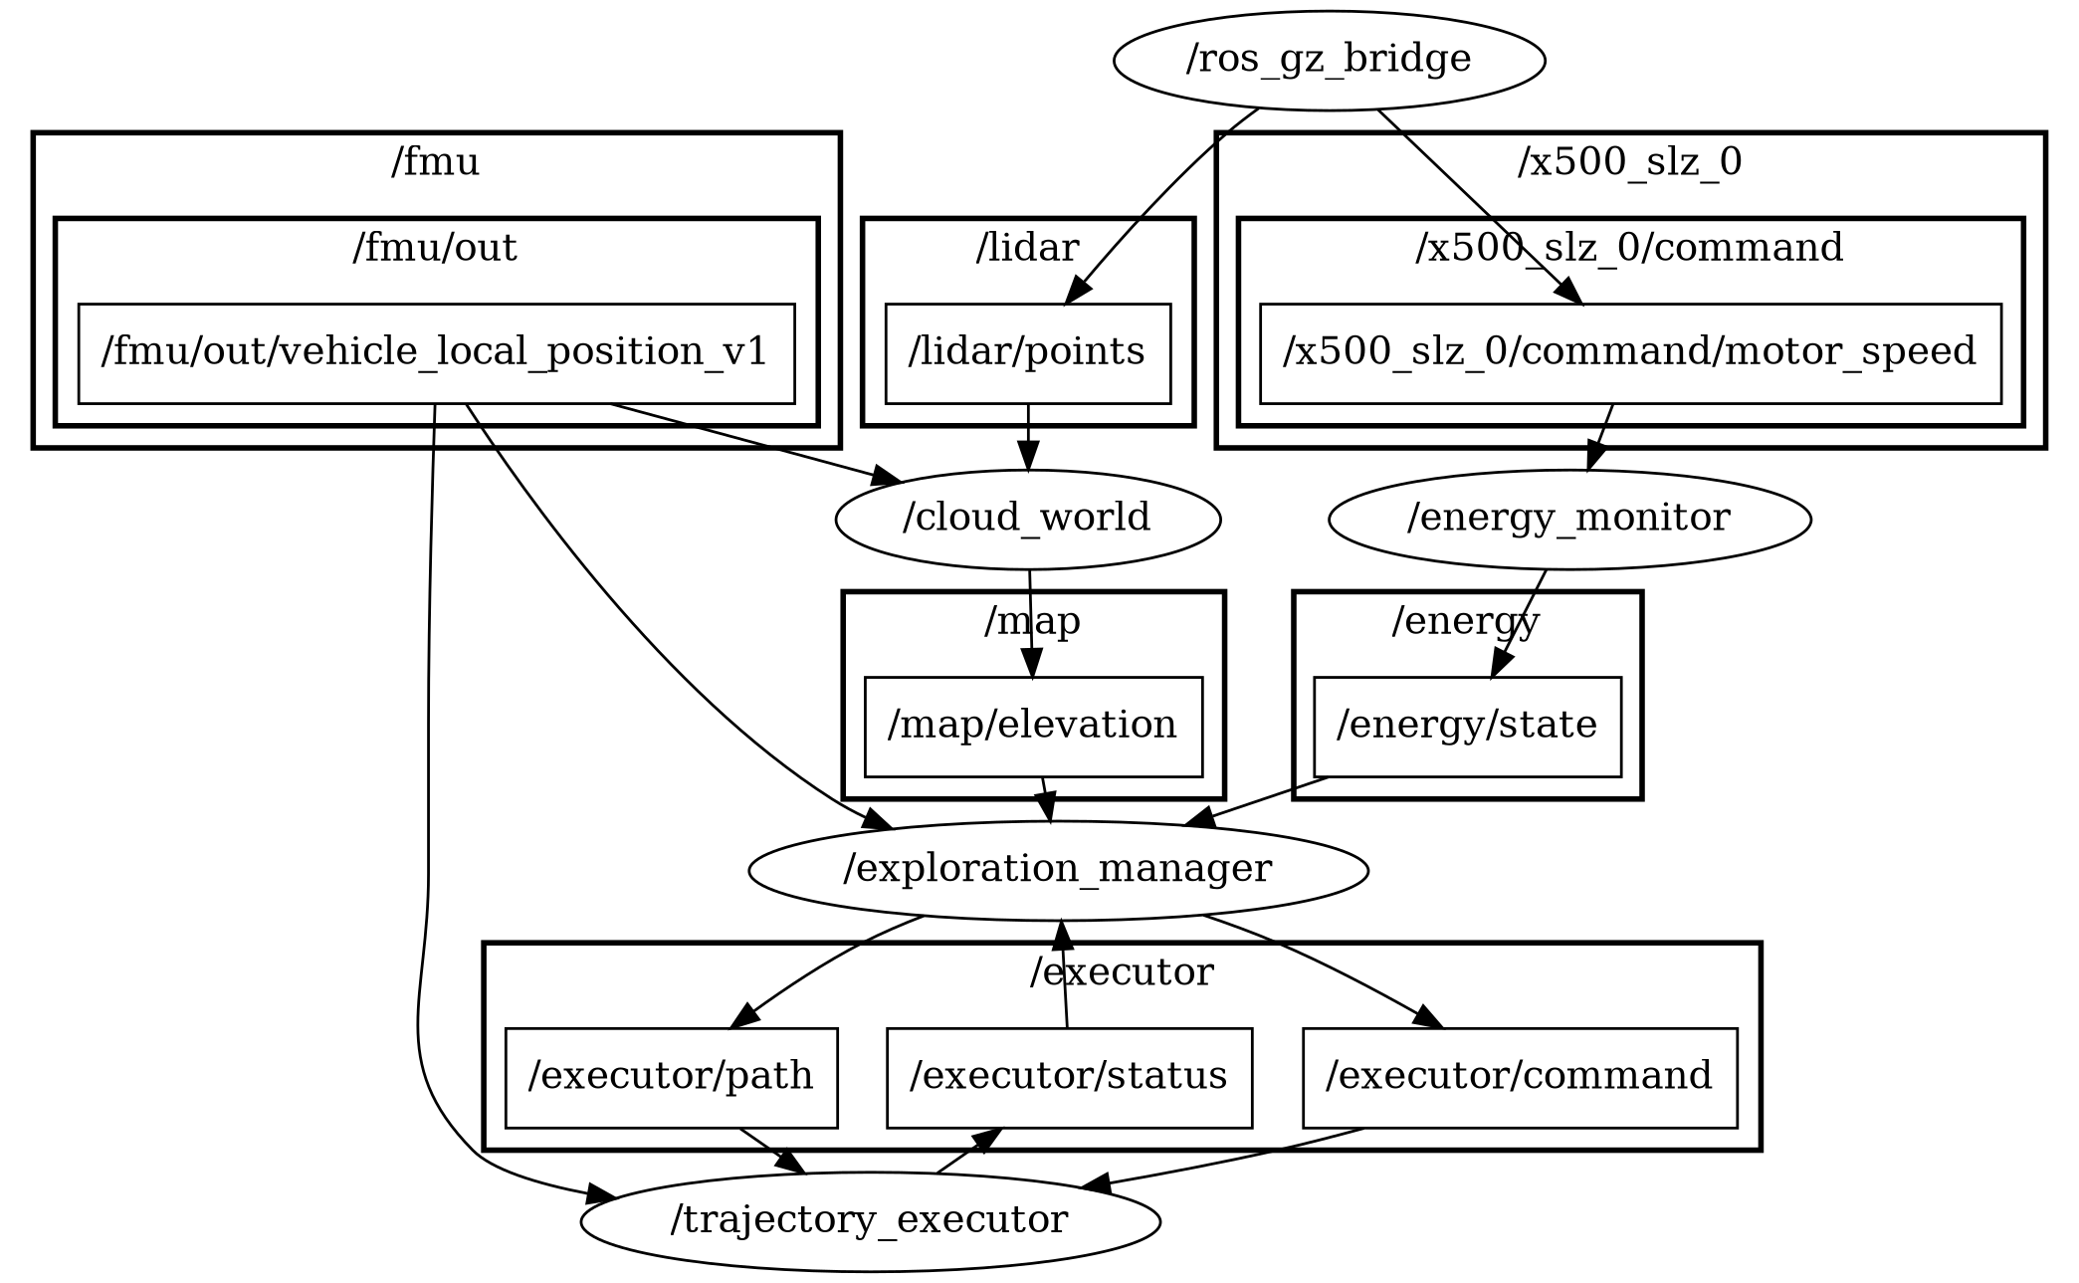
Figure 19. The ROS graph during a W1 mission, as rqt_graph draws it in its "Nodes/Topics (active)" view with default filters: nodes as ellipses, topics as rectangles grouped by namespace, arrows from publisher to subscriber.

