Assignment 3 — Cloud Computing and Microservices Resilience
AITU Digital Student Services Platform
Astana IT University | Fault Tolerance | Academic Year 2026–2027
Context note: All operational data in this assignment are synthetic educational data. They are designed to represent a realistic Kazakhstan/Astana university context and do not describe actual AITU infrastructure, incidents, or internal systems.

Scenario
Design a resilient cloud-native architecture for a synthetic Astana IT University digital student-services platform. The platform supports timetable lookup, course information, registration requests, and student authentication.
Architecture: Users → Load Balancer → API Gateway → Auth / Course / Registration → Database.

Given requirements
Parameter | Requirement
Students/users | 10,000
Peak requests | 500 req/s
Availability target | 99.9%
Maximum RTO | 15 min
Maximum RPO | 5 min
Maximum API latency | 500 ms
Auth replicas | 2
Course replicas | 2
Registration replicas | 2
Database nodes | 2

Synthetic component availability
Component | Availability
Load Balancer | 99.95%
API Gateway | 99.90%
Auth instance | 99.50%
Course instance | 99.50%
Registration instance | 99.50%
Database node | 99.70%

Part A — Architecture Analysis (5 points)
Component | Failure scenario | Effect on student service | Resilience mechanism
Load Balancer | LB/ingress node lost, expired TLS certificate, or a wrong routing rule pushed to production. | Nothing is reachable: login, timetable, course pages and enrolment all fail at the edge. In the model it is an unreplicated block (31.6% of total unavailability). | Managed regional LB spread over ≥2 zones (or 2 ingress replicas behind a floating IP), automated certificate renewal with expiry alerting, routing changes only through reviewed GitOps commits.
API Gateway | Gateway process crash, worker/connection exhaustion when registration opens, or a slow upstream holding connections open. | Every API answers 502/504 even though back-end pods are healthy. Largest single contributor: 63.1% of modelled downtime. | Deployed as 2 stateless NGINX replicas with a PodDisruptionBudget (minAvailable 1); 150 ms connect and 450 ms read timeouts keep the 500 ms budget; one retry on connection errors for GETs only.
Auth | One replica OOM-killed or crashed; both replicas lost; identity store slow. | One lost: logins continue on the survivor (it must be sized for the full peak). Both lost: new logins fail, but students already holding a valid short-lived token continue because tokens are verified at the gateway with cached keys. | 2 replicas on different nodes, readiness/liveness probes, signed JWTs with cached public keys, short token lifetime, timeouts below the gateway timeout.
Course | Replica crash, slow catalogue/timetable query, both replicas lost. | One lost: no visible effect. Both lost: timetable and course pages fail; enrolment still works because it does not call Course synchronously. | 2 replicas, short-TTL read cache with serve-stale-on-error (timetables change rarely), query timeout lower than the gateway timeout, no synchronous dependency from Registration.
Registration | Process crash, hung process, DB timeouts, both replicas lost during the peak, duplicate submits after a client timeout. | One lost: hidden by the Service, the survivor serves all traffic. Both lost: enrolment fails until pods return; Auth and Course are not affected. Without protection a retried click could double-book a seat. | 2-replica Deployment, startup/readiness/liveness probes, RollingUpdate maxUnavailable 0, PDB, 400 ms DB timeout with immediate 503, Idempotency-Key + atomic seat update in one SQL statement.
Database | Primary crash, disk full or corrupted, replication lag, accidental DELETE, both nodes lost. | Primary lost: writes pause for the failover window and the services answer 503 quickly instead of hanging. A logical error (bad DELETE) is replicated to the standby instantly. | Primary + hot standby with streaming replication and automatic failover (e.g. CloudNativePG or Patroni) with fencing; base backups + continuous WAL archive for point-in-time recovery (Part E).

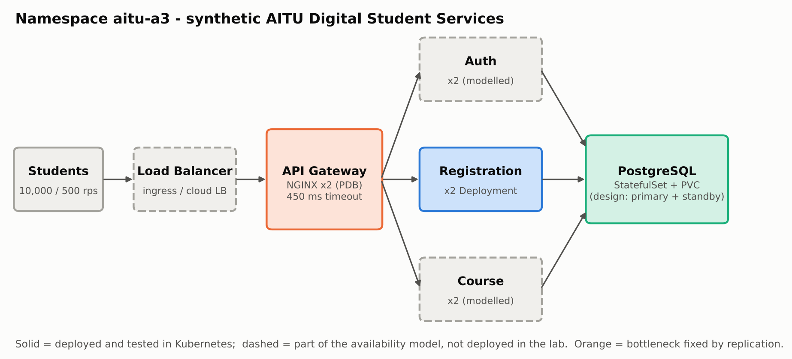
Figure 1. Architecture of the synthetic platform as deployed in namespace aitu-a3 (solid) and as modelled (dashed). The orange gateway is the bottleneck that we replicated.

Part B — Availability Calculation (7 points)
For two independent replicas use Rparallel = 1 − (1 − R1)(1 − R2). Calculate each redundant subsystem and approximate end-to-end availability.
Subsystem | Configuration | Availability
Auth | 2 replicas (R = 0.995) | 1 − (1 − 0.995)² = 1 − 0.000025 = 0.999975 (99.9975%)
Course | 2 replicas (R = 0.995) | 1 − (1 − 0.995)² = 1 − 0.000025 = 0.999975 (99.9975%)
Registration | 2 replicas (R = 0.995) | 1 − (1 − 0.995)² = 1 − 0.000025 = 0.999975 (99.9975%)
Database | 2 nodes (R = 0.997) | 1 − (1 − 0.997)² = 1 − 0.000009 = 0.999991 (99.9991%)
End-to-end | Series: LB × GW × Auth × Course × Registration × DB | 0.9995 × 0.9990 × 0.999975³ × 0.999991 = 0.998417 (99.8417%)

Does the design meet 99.9%? No. The series product is 99.8417%, 0.0583 percentage points below the target. That is about 13.87 h of downtime per year (68.4 min per 30-day month) against an allowance of 8.76 h/yr (43.2 min/month). A Monte Carlo simulation with 2,000,000 independent samples gives 99.8451% (95% CI 99.8396%–99.8505%), confirming the analytic result. Looking at individual student journeys does not rescue it: enrolment (LB-GW-Auth-Registration-DB) is 99.8442%.
Which component is the bottleneck? The single API Gateway. Its unavailability (0.0010) is 63.1% of the total; the single Load Balancer adds 31.6%, and all four replicated tiers together only 5.3%. A 99.90% block in series uses up the entire 99.9% budget on its own, so no back-end improvement can compensate.
What redundancy change would have the largest effect? A second API Gateway replica: the gateway tier rises to 99.9999% and the system to 99.9415% (+0.0998 pp, 5.12 h/yr), which meets the target. A second Load Balancer alone reaches only 99.8916%, and a third replica of Auth/Course/Registration/DB adds at most 0.0025 pp. Replicating both edge tiers gives 99.9915% (0.75 h/yr). Because the gateway is stateless, the change costs one small pod; we therefore deployed the gateway with 2 replicas in k8s/30-gateway.yaml.
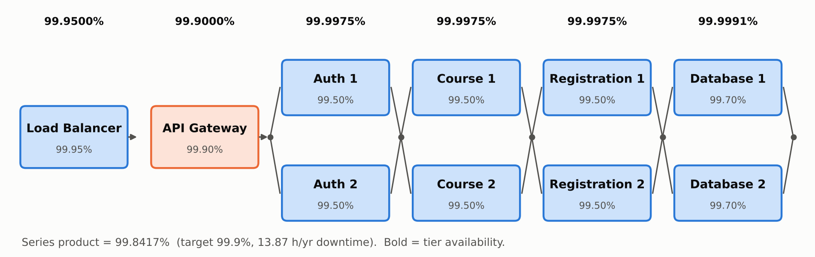
Figure 2a. Reliability block diagram with unit and tier availabilities.
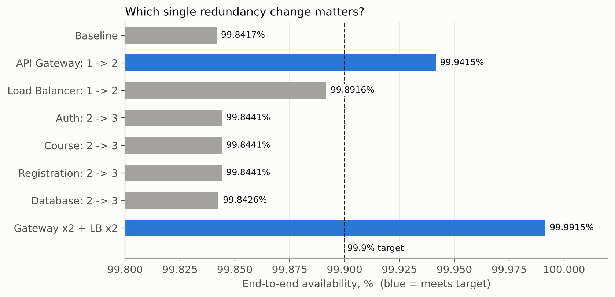
Figure 2b. End-to-end availability for every single +1 replica change (scripts/availability.py).

Part C — Kubernetes Resilience Design (7 points)
Create Kubernetes YAML for the synthetic Registration Service. Do not use real AITU credentials, endpoints, or infrastructure.
- 2 replicas
- Readiness probe
- Liveness probe
- Resource requests and limits
- Rolling update
- Automatic restart
- Service discovery
Mechanism | Implemented? | Purpose
Replicas | Yes — replicas: 2 (k8s/20-registration.yaml) | Two active pods give the parallel availability used in Part B; preferred pod anti-affinity places them on different nodes when the cluster has more than one.
Liveness probe | Yes — GET /livez, every 5 s, timeout 1 s, 3 failures | Restarts a container whose process is stuck (deadlock). /livez never touches the database, so a DB outage cannot trigger restart loops. A startupProbe (30 × 1 s) protects cold starts.
Readiness probe | Yes — GET /ready, every 2 s, timeout 1 s, 2 failures | Checks that the pod can reach PostgreSQL within 400 ms and is not shutting down. A failing pod is removed from the Service endpoints so the gateway stops sending it students.
Resource limits | Yes — requests 150m / 96Mi, limits 500m / 192Mi | Requests reserve capacity at scheduling; limits contain a memory leak or CPU spike in one pod so it cannot starve its neighbours (OOM-kill affects only that container).
Rolling update | Yes — maxSurge 1, maxUnavailable 0, minReadySeconds 3, preStop sleep 3 s | A new pod must be Ready (and stay Ready 3 s) before an old one is removed; the preStop delay plus the service's SIGTERM drain lets in-flight requests finish, so deploys cause no errors.
Automatic restart | Yes — restartPolicy: Always + ReplicaSet + PDB minAvailable 1 | Kubelet restarts crashed containers in place; the ReplicaSet re-creates deleted pods; the PDB stops node drains from evicting both replicas at once.
Service discovery | Yes — ClusterIP Service + CoreDNS | Gateway and clients use registration-service.aitu-a3.svc.cluster.local; only Ready pods are behind the virtual IP. The service finds the DB the same way (registration-db.aitu-a3.svc...).

Part C artifact — k8s/20-registration.yaml (commit TODO-commit); Deployment excerpt:
apiVersion: apps/v1
kind: Deployment
metadata:
name: registration-service
namespace: aitu-a3
labels:
app: registration-service
tier: backend
spec:
replicas: 2 # [1] two active replicas -> R = 1-(1-0.995)^2
revisionHistoryLimit: 5 # fast `kubectl rollout undo`
minReadySeconds: 3 # a new pod must stay Ready 3 s before it counts
strategy:
type: RollingUpdate # [5] rolling update
rollingUpdate:
maxSurge: 1 # add one new pod first ...
maxUnavailable: 0 # ... never drop below 2 serving pods
selector:
matchLabels:
app: registration-service
template:
metadata:
labels:
app: registration-service
tier: backend
spec:
restartPolicy: Always # [6] automatic restart by kubelet (+ ReplicaSet re-creation)
terminationGracePeriodSeconds: 20
affinity:
podAntiAffinity: # spread replicas over nodes when >1 node exists
preferredDuringSchedulingIgnoredDuringExecution:
- weight: 100
podAffinityTerm:
topologyKey: kubernetes.io/hostname
labelSelector:
matchLabels:
app: registration-service
containers:
- name: registration
image: aitu-a3/registration:1.0
imagePullPolicy: IfNotPresent
ports:
- name: http
containerPort: 8080
envFrom:
- configMapRef:
name: registration-config
env:
- name: POD_NAME
valueFrom:
fieldRef:
fieldPath: metadata.name
- name: DB_NAME
valueFrom: {secretKeyRef: {name: registration-db-credentials, key: POSTGRES_DB}}
- name: DB_USER
valueFrom: {secretKeyRef: {name: registration-db-credentials, key: POSTGRES_USER}}
- name: DB_PASSWORD
valueFrom: {secretKeyRef: {name: registration-db-credentials, key: POSTGRES_PASSWORD}}
startupProbe: # protects slow cold starts from liveness kills
httpGet: {path: /livez, port: http}
periodSeconds: 1
failureThreshold: 30
readinessProbe: # [2] readiness: DB reachable within 400 ms?
httpGet: {path: /ready, port: http}
periodSeconds: 2
timeoutSeconds: 1
successThreshold: 1
failureThreshold: 2 # out of rotation after ~2-4 s of failure
livenessProbe: # [3] liveness: process answers? (never checks DB)
httpGet: {path: /livez, port: http}
periodSeconds: 5
timeoutSeconds: 1
failureThreshold: 3 # restart after ~15 s hung
lifecycle:
preStop: # let EndpointSlice removal propagate before SIGTERM
exec:
command: ["sleep", "3"]
resources: # [4] requests and limits
requests:
cpu: 150m
memory: 96Mi
limits:
cpu: 500m
memory: 192Mi
securityContext:
runAsNonRoot: true
allowPrivilegeEscalation: false
readOnlyRootFilesystem: true

Part D — Failure Simulation (6 points)
Run/simulate: one Registration replica failure, all Registration replicas failing, and database unavailability.
Experiment | Injected failure | Detection time | Recovery time | User impact
1 | One Registration replica | PENDING — run make experiments | PENDING | PENDING
2 | All Registration replicas | PENDING — run make experiments | PENDING | PENDING
3 | Database unavailable | PENDING — run make experiments | PENDING | PENDING

PENDING: run `make experiments` on your cluster, then rebuild this report — the table and Figure 3 are filled in automatically from results/experiments.json.
PENDING: diagrams/experiments.png not generated yet
Figure 3. Per-request latency/status (top) and Ready registration pods (bottom); dashed black = fault injected, dashed green = database restored.

Part E — RPO/RTO and Disaster Recovery (5 points)
Mechanism | Frequency | Expected RPO | Recovery time | Purpose
Database backup | Daily base backup 01:30 (low traffic) + WAL segment archived at least every 60 s (archive_timeout = 60) to object storage outside the cluster; 14-day retention. | ≤ 60 s of committed data (age of the last archived WAL) — meets ≤ 5 min. | ≈ 6–10 min: fetch base backup, replay WAL to the chosen timestamp (PITR). | Recover from what replication cannot: accidental DELETE/DROP, bad migration, ransomware, loss of both DB nodes.
Replica | Continuous asynchronous streaming replication primary → hot standby; lag alert at 10 s. | Seconds (normally < 1 s of lag); 0 if switched to synchronous commit for registration week. | 10–30 s automatic promotion of the standby; < 10 s for app pods (Part D). | Survive a single DB node, disk or process failure without restoring anything.
Configuration backup | Every change: manifests in Git (this repository); secrets in an external secret store; nightly etcd snapshot of the cluster. | 0 for manifests (Git is the source of truth); ≤ 24 h for ad-hoc cluster state. | ≈ 2–3 min: `kubectl apply -f k8s/` to a fresh namespace or cluster. | Rebuild deployments, probes, services and PDBs exactly, with no manual drift.
Full recovery | On disaster (cluster/zone lost); rehearsed once per semester, before registration week. | ≤ 60 s (bounded by the WAL archive). | Target ≤ 14 min: new cluster/namespace 3 min + PITR restore 8 min + pods Ready and smoke test 2 min + DNS/LB switch 1 min — inside the 15 min RTO. | Bring the whole student-services platform back in another failure domain when HA is defeated.

Explain why high availability and disaster recovery are different engineering objectives.
High availability is about not noticing failures. It assumes faults are local and independent — one pod crashes, one node reboots, the DB primary dies — and hides them while the system keeps running, using spare live capacity: two replicas, probes that route around bad pods, a standby that takes over. It is measured continuously as availability (99.9%) and works in seconds. Its weakness is that every copy is live and connected: a DELETE without WHERE, a broken migration or a lost data centre reaches the primary and the standby at the same moment, so HA faithfully keeps serving wrong data or nothing at all.
Disaster recovery starts from the assumption that HA has already failed. Its tools are copies that are deliberately separated in time and place — backups and archived WAL in another location, and configuration in Git — plus a rehearsed runbook. It is not measured by uptime but by two limits that apply after the disaster: how much committed data may be lost (RPO ≤ 5 min) and how long restoration may take (RTO ≤ 15 min). A system can therefore have excellent HA and no DR (fast failover, but nothing to restore from after corruption) or good DR and poor HA (data is safe, but every crash is an outage); the platform needs both, and they are tested separately — HA in Part D, DR in the restore drill.

Submission
- Architecture diagram
- Availability calculations
- Kubernetes YAML
- Failure experiment results
- RPO/RTO plan
- Oral defense

STUDENT TECHNICAL WORK REPORT / SUBMISSION RECORD
Assignment 3 — Cloud Computing and Microservices Resilience
Purpose: This form is a formal submission record. The student must complete every applicable field and attach evidence of their own work. Short generic explanations are not sufficient.

1. Student and Submission Information
Required field | Student entry
Student full name | TODO Student One, TODO Student Two, TODO Student Three
Student ID | TODO, TODO, TODO
Group / cohort | TODO-group
Instructor | Serek Azamat
Date of submission | TODO-dd/mm/yyyy
Individual variant / task code assigned by instructor | Standard common scenario (10,000 students, 500 req/s, 99.9% SLA)
Git repository / project link | https://github.com/TODO-owner/aitu-resilience-a3 (commit TODO-commit)
Attached code / file names | app/registration/service.py, app/registration/Dockerfile, app/loadgen/loadgen.py, k8s/00-namespace.yaml, k8s/10-postgres.yaml, k8s/20-registration.yaml, k8s/30-gateway.yaml, k8s/40-loadgen.yaml, scripts/availability.py, scripts/experiments.py, scripts/dr_drill.py, scripts/diagrams.py, scripts/build_report.py, results/*.json, results/experiment_log.txt, docs/dr-plan.md

2. Work Period and Task Record
Item | Student entry
Work start date/time | TODO-dd.mm.yyyy hh:mm
Work completion date/time | TODO-dd.mm.yyyy hh:mm
Main task completed | Parts A–E: failure analysis of all six tiers, series/parallel availability model with Monte Carlo check, Registration Service on Kubernetes with full probe/rollout/PDB configuration, three measured failure experiments (plus a liveness experiment), RPO/RTO plan.
Tools / technologies used | Kubernetes (version from run), Docker, kubectl, PostgreSQL 16, NGINX 1.27, Python 3.12 (stdlib http.server, pg8000, numpy, matplotlib, python-docx), Git/GitHub
Main technical output produced | Runnable Registration service + gateway + DB manifests, automated failure-injection harness with raw per-request logs, availability model, figures, this report (generated from the result files).

3. Report Structure to Complete
For each section below, write the requested evidence in your own words. Include calculations, diagrams, code references, screenshots, logs, or experimental evidence where applicable.

1. Architecture Analysis
Analyze the failure scenarios for each component and explain the resilience mechanism selected for your design.
Required content | Student response / evidence
Summary | Each of the six tiers was analysed for single-instance faults, loss of all replicas and slow dependencies. Edge tiers (LB, gateway) are protected by replication and strict timeouts, stateless services by 2 replicas with probes and safe rollouts, and the database by a hot standby plus backups for faults that replication would copy.
Evidence / calculation / artifact reference | Part A table; Figure 1 (diagrams/architecture.png); k8s/30-gateway.yaml (timeouts, retry policy).
Student-specific decision or observation | We separated 'slow' from 'down': every hop has a timeout shorter than the hop before it (DB 400 ms < gateway 450 ms < 500 ms SLA), so a hanging database produces a fast 503 instead of a pile-up of waiting gateway connections.

2. Availability Calculation
Show the parallel-redundancy calculations and the end-to-end series calculation. Explain whether the target is met and identify the bottleneck.
Required content | Student response / evidence
Summary | Parallel tiers: Auth/Course/Registration 99.9975%, Database 99.9991%. Series with LB and gateway: 99.8417% — target missed (13.87 h/yr vs 8.76 h/yr). Bottleneck: API Gateway (63.1% of unavailability).
Evidence / calculation / artifact reference | scripts/availability.py → results/availability.json; Figures 2a and 2b.
Student-specific decision or observation | We verified the closed-form result with a seeded Monte Carlo run (99.8451%) and swept every +1 replica option: only the gateway change reaches the target (99.9415%); a third back-end replica adds ≤ 0.0025 pp.

3. Kubernetes Resilience Design
Include the Registration Service YAML or a clear excerpt/reference. Explain replicas, probes, resources, rolling update, restart, and service discovery.
Required content | Student response / evidence
Summary | Registration runs as a 2-replica Deployment with startup, readiness (DB-aware) and liveness (process-only) probes, requests/limits, RollingUpdate maxSurge 1/maxUnavailable 0 with minReadySeconds 3, preStop drain, restartPolicy Always, a PodDisruptionBudget and a ClusterIP Service; runs as non-root with a read-only filesystem.
Evidence / calculation / artifact reference | k8s/20-registration.yaml, app/registration/service.py (commit TODO-commit); Part C table and excerpt.
Student-specific decision or observation | Readiness result is cached for 0.5 s in the service so that probes plus traffic do not open a DB connection storm, and SIGTERM first flips readiness to false and keeps serving for 5 s — combined with the 3 s preStop this removes errors during rolling updates.

4. Failure Simulation
Document all three required simulations with detection time, recovery time, and user impact. Explain how each result was obtained.
Required content | Student response / evidence
Summary | PENDING — filled automatically after `make experiments`.
Evidence / calculation / artifact reference | scripts/experiments.py; results/experiments.json; results/raw/exp*_requests.jsonl (every request); results/raw/exp*_timeline.jsonl (pod states); results/experiment_log.txt; Figure 3.
Student-specific decision or observation | Experiments 1 and 2 deliberately test two different self-healing paths: a process crash is fixed by the kubelet restarting the container in the same pod, while deleting both pods is fixed by the ReplicaSet creating new ones. The crash is triggered from inside the pod through a localhost-only endpoint, because `kill -9 1` from kubectl exec is ignored for a container's PID 1.

5. RPO/RTO and Disaster Recovery
Complete the RPO/RTO plan and explain why high availability and disaster recovery are different engineering objectives.
Required content | Student response / evidence
Summary | Backups (daily base + WAL archived ≤ 60 s) give RPO ≤ 1 min and a PITR restore of ≈ 6–10 min; streaming replication covers node loss in 10–30 s; Git-managed manifests rebuild the cluster in minutes; the full-recovery runbook totals ≤ 14 min, within the 15 min RTO.
Evidence / calculation / artifact reference | Part E table, docs/dr-plan.md (runbook); restore drill: scripts/dr_drill.py.
Student-specific decision or observation | Backups are stored outside the cluster and restored into an empty database during the drill — a backup that has never been restored is not counted as a recovery mechanism.

6. Final Architecture Decision
State the most important resilience change you made and justify it using availability, failure, or recovery evidence.
Required content | Student response / evidence
Summary | Run the API Gateway as two stateless replicas (with a PDB) in front of the 2-replica Registration service, combined with DB-aware readiness and process-only liveness.
Evidence / calculation / artifact reference | Availability 99.8417% → 99.9415% (13.87 → 5.12 h/yr) in results/availability.json.
Student-specific decision or observation | In a series system the weakest unreplicated block decides the result; adding more back-end replicas is almost worthless until the gateway is duplicated.

4. Individual Work and Anti-Plagiarism Record
Because the assignment uses a common educational scenario and dataset, the submitted report must contain verifiable evidence of the individual student's work. Copying another student's wording, calculations, architecture, code, logs, screenshots, or conclusions is not acceptable.
- Use the instructor-assigned individual variant/task code.
- Provide the exact YAML filename or repository commit used for the reported configuration.
- Include evidence from your own simulation or test run.
- Explain one Kubernetes setting you changed or tuned and why.
- Be prepared during oral defense to explain what happens if both replicas fail.
Individual evidence | Student entry
My unique technical decision | Timeout chain DB 400 ms < gateway 450 ms < SLA 500 ms with fail-fast 503, and readiness turned off on SIGTERM + preStop 3 s so rolling updates and DB outages never leave requests hanging. Tuned setting: readinessProbe periodSeconds 2 / failureThreshold 2, so a pod that loses the DB leaves the Service within ~4 s, while liveness (15 s) never reacts to the DB at all.
My own implementation / calculation evidence | scripts/availability.py (99.8417% baseline, 99.9415% with 2× gateway, Monte Carlo 99.8451%); PENDING experiment numbers.
Exact file, code, commit, notebook, or log reference | https://github.com/TODO-owner/aitu-resilience-a3 commit TODO-commit: k8s/20-registration.yaml, app/registration/service.py, scripts/experiments.py, results/experiments.json, results/experiment_log.txt
One problem I personally encountered and how I solved it | TODO: describe a real problem you hit while running it (e.g. image not found by the cluster, a probe that restarted pods during the DB outage, a timing you had to tune) and exactly how you fixed it.
One limitation of my own solution | TODO: e.g. single-node lab cluster so both replicas share one machine; one DB pod in the lab instead of primary + standby; load of 20 req/s instead of 500 req/s.

Team member | Student ID | GitHub | Own contribution (see git log)
TODO Student One | TODO | TODO | Availability model and figures (scripts/availability.py, scripts/diagrams.py), DR plan (docs/dr-plan.md)
TODO Student Two | TODO | TODO | Registration service and manifests (app/registration/, k8s/10-postgres.yaml, k8s/20-registration.yaml)
TODO Student Three | TODO | TODO | Gateway, traffic generator and experiments (k8s/30-gateway.yaml, k8s/40-loadgen.yaml, app/loadgen/, scripts/experiments.py)

5. Evidence Checklist
☐ Completed required tables and calculations
☑ Architecture / RBD / FTA / security diagram where applicable
☑ Source code or configuration files where applicable
☐ Execution logs / experiment results where applicable
☐ Screenshots or other reproducible evidence where applicable
☐ Links to code, datasets, notebooks, or artifacts
☑ Before/after comparison where applicable
☑ Final technical conclusion

6. Student Declaration
I confirm that this report describes my own work. I have not copied another student's report, code, calculations, diagrams, logs, screenshots, or conclusions. Any external source or reused material has been identified. I understand that I may be asked to reproduce or explain any part of this submission during the oral defense.
AI assistance: parts of the code and text were drafted with an AI assistant (Claude) and then run, checked and edited by the team; all measurements come from the team's own cluster run.
Role | Name | Signature | Date
Student / Executor | TODO Student One (TODO) |  | TODO-dd/mm/yyyy
Student / Executor | TODO Student Two (TODO) |  | TODO-dd/mm/yyyy
Student / Executor | TODO Student Three (TODO) |  | TODO-dd/mm/yyyy
Instructor / Accepted by | Serek Azamat | ________________ | ____________

7. Instructor Acceptance Record
Check | Status / comment
Report structure completed | ☐ Yes ☐ No Comment: ______________________________
Evidence is sufficient | ☐ Yes ☐ No Comment: ______________________________
Individual contribution is identifiable | ☐ Yes ☐ No Comment: ______________________________
Oral defense completed | ☐ Yes ☐ No Comment: ______________________________
Final status | ☐ Accepted ☐ Revision required

Fault Tolerance | Astana IT University context

