**Class Assignment 6**

**Results Document**

**Connor Welch**

1. **Setting the path for Python:**

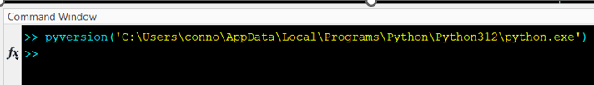

1. **Calling Python Functions from MATLAB:**

**Results:**

1. **Using Python Libraries in MATLAB:**

**Results:**

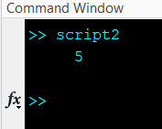 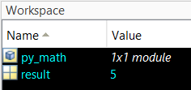

1. **Running Custom Python Scripts:**

**Results:**

