**Technology in Automobiles: Evolution and Development**

**Odera Agba**

**11/1/24**

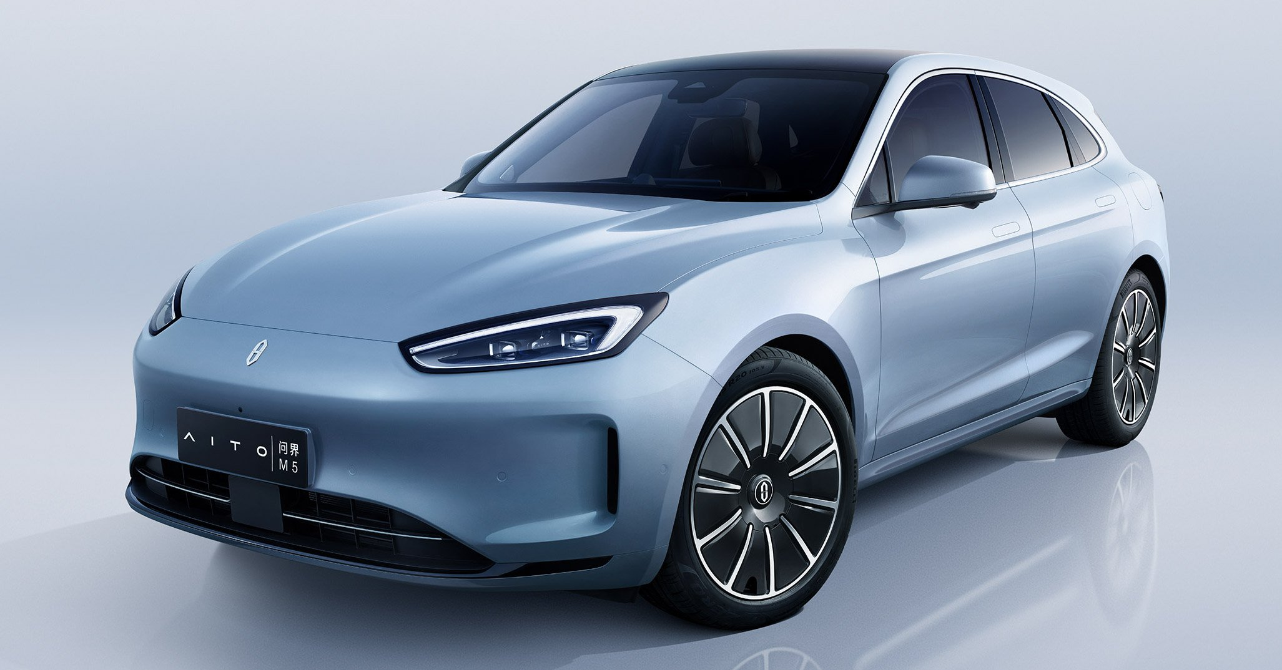**CSIT 100**

The automobile is one of the most innovative inventions in modern history, shaping how we live, work, and move through the world. Since Karl Benz's creation of the first practical automobile in 1885, the car has evolved from a basic transportation machine to a highly complex, technologically advanced machine that uses advanced electronics, alternative energy systems, and even artificial intelligence. The automotive industry is constantly developing and is driven by the pursuit of greater performance, fuel efficiency, safety, and environmental sustainability.

This paper examines the evolution of automobile technology, from its mechanical origins to today’s state of the art electric and autonomous vehicles. It explores key technological advancements, such as the development of the internal combustion engine, the integration of safety features, the rise of electric and hybrid vehicles, and the rising use of autonomous driving. By looking at the historical milestones, developments, and current trends, this paper serves to provide a better understanding of how car technology has evolved and what future innovations may look like.

The automobile's history begins in the late 19th century, when a number of inventors experimented with powered vehicles. Among them, Karl Benz is often credited with creating the first practical automobile. In 1885, Benz built the Benz Patent-Motorwagen, a three-wheeled vehicle powered by an internal combustion engine. This vehicle is recognized as the first of its kind, capable of providing personal transport to individuals. However, it was not until Henry Ford’s assembly line revolution in the early 20th century that cars became accessible to the mass market. The introduction of Ford’s Model T in 1908 made it far more accessible and affordable for the average person, which paved the foundation for the automobile as a critical component of modern society. “Mass production significantly cut down on the time required to produce an automobile, which allowed costs to stay low.” (history.com).

As automotive production began to increase, so did the technological and engineering challenges. The internal combustion engine that powered the Model T and many early cars was not without its flaws, chief among them, inefficient fuel consumption, limited power, and the emissions it produced. However, this engine remained the dominant technology for the next several decades, constantly evolving through improvements in materials, design, and performance.

The internal combustion engine is the core of original gasoline and diesel-powered vehicles. It works by igniting a mixture of fuel and air inside a cylinder, creating an explosion that drives a piston. This mechanical energy is then transmitted to the wheels, propelling the car forward. Despite the inefficiency and environmental concerns associated with internal combustion engines, these engines have dominated the automotive market for over a century. (Britannica).

As the demand for automobiles grew, so did the need for improved fuel efficiency and better overall performance. In the early 20th century, engineers focused on refining engine designs, reducing friction, and improving fuel delivery systems. In the 1960s and 1970s, technologies like fuel injection and turbocharging were introduced, improving engine performance and efficiency. "This [turbo chargers] enables engines to extract more energy from each fuel molecule which, in turn, translates to higher power output. And because turbocharged engines can operate with leaner fuel-air mixtures, fuel efficiency is also improved, and corresponding greenhouse gas emissions reduced." (garretmotion.com). This improvement contributed to the growing global use of automobiles, even as environmental concerns about exhaust emissions began to emerge.

By the mid-20th century, performance became a major focal point in car design. American muscle cars, such as the Ford Mustang and Chevrolet Camaro, became cultural icons, providing high horsepower engines that appealed to consumers. These vehicles were designed not only for speed but also to showcase innovation in terms of engine technology and design. The competition between automakers during this period led to some of the most powerful engines ever put into production cars.

At the same time, safety began to emerge as a significant area of focus. In the early days of motoring, vehicles had few safety features, and accidents were frequent. As the number of cars on the road grew, so did the awareness of the need for car safety systems. Volvo, a Swedish automaker, became a leader in automotive safety innovation. In 1959, Volvo engineer Nils Bohlin invented the three-point seatbelt, which revolutionized vehicle safety by offering greater protection in the event of a crash. The three-point seatbelt became a standard feature in vehicles worldwide, saving countless lives in the decades that followed. “The modern three-point safety belt was perfected by Volvo engineer Nils Bohlin in 1959 – and its patent given for free to the world. The invention has been credited with saving at least a million lives worldwide.” (volvogroup.com).

The 1970s and 1980s brought even more technological advancements aimed at improving vehicle safety. The implementation of airbags in the 1970s and 1980s represented a significant leap forward in driver and passenger protection. As regulatory bodies such as the U.S. National Highway Traffic Safety Administration (NHTSA) enforced new safety standards; features like electronic stability control and antilock braking systems began to appear in vehicles. These systems helped prevent skidding and loss of control, making driving safer in adverse conditions. “The United States Intermodal Surface Transportation Efficiency Act of 1991 required passenger cars and light trucks built after 1 September 1998 to have airbags for the driver and the front passenger.” (wikepedia.org).

In the late 20th and early 21st centuries digital technologies were rapidly integrated into automobiles. One of the most notable advancements was the introduction of advanced infotainment systems, which allow drivers to interact with entertainment, navigation, and communication systems via touchscreens and voice commands. In the 2000s, companies like Apple and Google revolutionized the in-car experience by creating smartphone integration systems like Apple CarPlay and Android Auto that allowed users to seamlessly connect their mobile devices with their car’s infotainment system. As cars became more connected, the opportunity arose to enhance the driver experience with features like real-time traffic updates, music streaming, and even integration with home automation systems. These innovations marked the beginning of a new era in which vehicles were no longer isolated machines solely for getting from point A to point B, but integrated digital hubs. "CarPlay is a smarter, safer way to use your iPhone while you drive. You can get directions, make calls, send and receive messages, and enjoy your favorite music. All on your car’s built-in display." (apple.com).

As global awareness of climate change grew, automakers began to turn their attention to greener, more sustainable alternatives to the internal combustion engine. Hybrid vehicles, which combine an internal combustion engine with an electric motor, emerged as an interim solution. The Toyota Prius, introduced in 1997, was one of the first mass-market hybrids, and it helped to pave the way for other hybrid models from brands like Honda, Ford, and General Motors.

In recent years, however, the electric vehicle has gained the most attention. Tesla, founded in 2003, has been the face of the electric vehicle production, demonstrating that electric vehicles can offer both performance and sustainability. For example, The Tesla Model S, introduced in 2012, is a high-performance electric car with an impressive range. According to Tesla, " Model S is built for speed and range, with beyond ludicrous acceleration, unparalleled performance and a refined design. " (Tesla.com).

Electric vehicles are powered by large battery packs, typically using lithium-ion technology, and offer significant benefits over traditional vehicles. One of these benefits is the environmental friendliness as they produce zero tailpipe emissions, making them a critical part of the fight against climate change. “Electric vehicles typically have a smaller carbon footprint than gasoline cars, even when accounting for the electricity used for charging. Electric vehicles (EVs) have no tailpipe emissions” ([www.epa.gov](https://www.epa.gov)). The use of self-driving, autonomous, electric vehicles has also been on the rise with things like Tesla’s autopilot mode.

One of the most innovative achievements in modern automotive technology is the development of autonomous, or self-driving, vehicles. These vehicles use a combination of sensors, cameras, radar, and artificial intelligence to navigate roads without the need for human drivers. The technology behind self-driving cars has advanced significantly over the past decade, with companies like Waymo, Tesla, and traditional automakers investing heavily in research and development.

While fully autonomous vehicles are relatively new and testing, the potential benefits are enormous. Autonomous vehicles could reduce accidents caused by human error, decrease traffic congestion, and make transportation more accessible to those unable to drive. According to the NHTSA, “Vehicle safety promises to be one of automation's biggest benefits. Higher levels of automation, referred to as automated driving systems, remove the human driver from the chain of events that can lead to a crash. " (nhtsa.gov). Though autonomous vehicles can still have some errors, it is still being thoroughly tested and improved in order to be integrated into more vehicles around the world. Artificial intelligence is not just a key component of autonomous driving systems, but it is also increasingly used to improve other aspects of automotive technology. AI algorithms enable cars to learn from their environment, making decisions based on real-time data from sensors and cameras. This learning capability improves the vehicle’s ability to navigate complex road conditions and make safer decisions. "The integration of AI algorithms enables autonomous vehicles to navigate, perceive, and adapt to dynamic environments, making them safer and more efficient. " (mdpi.com). Beyond autonomous driving, AI is being used in predictive maintenance systems, helping vehicles predict potential mechanical failures before they occur. For instance, AI can monitor engine health, battery life, and other components, providing drivers with alerts. (medium.com)

**Sources**

<https://www.history.com/topics/inventions/henry-ford>

<https://www.britannica.com/biography/Karl-Benz>

<https://www.britannica.com/technology/internal-combustion-engine>

https://www,garrettmotion.com

<https://www.history.com/topics/inventions/automobiles>

<https://en.wikipedia.org/wiki/History_of_the_automobile>

<https://www.volvobuses.com/en/news-stories/stories/2019/jul/the-three-point-seat-belt-an-innovation-that-saved-over-1-million-lives.html>

<https://www.autotrainingcentre.com/blog/evolution-airbag/>

<https://en.wikipedia.org/wiki/Airbag#:~:text=Regulatory%20specifications-,United%20States,in%20SAE%20USCAR%2024%E2%80%932>.

Wikipedia.org

<https://www.epa.gov/greenvehicles/electric-vehicle-myths>

<https://www.nhtsa.gov/vehicle-safety/automated-vehicles-safety>

<https://www.mdpi.com/2504-2289/8/4/42#:~:text=Artificial%20intelligence%20(AI)%20currently%20plays,them%20safer%20and%20more%20efficient>.

https://medium.com/@kristi.ray2608/ai-in-the-automotive-industry-driving-innovation-and-transformation-40f11b56c030