Forecasting Cristiano Ronaldo Road to 1,000 Goals
Machine learning project report | Forecast cutoff: 28 August 2026
Prepared by: Ojo Jonathan Felix

Contents
1. Executive summary 2
2. Objective and scope 2
3. Data and forecasting design 2
4. Goal-prediction model 2
5. Appearance-probability model 3
6. Monte Carlo methodology 3
7. Forecast results 3
Monthly cumulative completion probability 3
Paths unfinished at the calendar cutoff 4
8. Visual results 4
9. Limitations and interpretation 5
10. Conclusion 5
11. Project evidence and reproducibility 6

1. Executive summary
Developed a fixture-level forecasting system to estimate Cristiano Ronaldo’s goals in upcoming matches and the timing of his 1,000th career goal. The system combines a goal-count ensemble, a separate appearance-probability model, and recursive Monte Carlo simulation. Historical inputs contain 1,333 appearances and 978 goals through 28 August 2026; the milestone therefore requires 22 additional goals.
Across 1,000 baseline simulations over 45 scheduled fixtures ending 28 May 2027, 94.2% reached the milestone. The median milestone date among successful baseline simulations was 25 February 2027. A separate 1,000-path baseline run returned 94.9% and a conditional median of 11 March 2027, demonstrating simulation variability. These are conditional, model-based estimates—not a guaranteed date or an assessment of matches after the forecast cutoff.

2. Objective and scope
Estimate goals per appearance, estimate whether Ronaldo appears in each eligible fixture, and simulate cumulative goals until the 1,000-goal threshold is reached or the available fixture calendar ends. The forecast includes club and Portugal fixtures in the modeled schedule. It does not extend beyond 28 May 2027 or incorporate actual results occurring after 28 August 2026.

3. Data and forecasting design
The goal-model dataset contains 1,333 historical appearances from 14 August 2002 to 28 August 2026 and 978 recorded goals. The appearance dataset contains 1,584 eligible opportunities: 1,485 development opportunities and 99 final-test opportunities. Features are constructed from information available before each fixture. During simulation, appearance state is updated after every eligible fixture, while goal-scoring state is updated after appearances; the forecast stops at the milestone.
The forward simulation covers 45 fixtures (39 Al-Nassr and six Portugal). The calendar is a finite modeling input, not a promise that all fixtures will take place as listed. Model selection and evaluation use chronological splits rather than random train/test mixing.

4. Goal-prediction model
Selected a fixed ensemble of 60% XGBoost and 40% CatBoost to predict expected goals per appearance. Poisson draws convert each expected-goal estimate into a simulated integer goal count. The final held-out goal-model test comprises 78 appearances between 9 January 2025 and 28 August 2026, with 62 observed goals.
Model | Poisson deviance ↓ | MAE ↓ | RMSE ↓
XGBoost | 0.8177 | 0.5946 | 0.6995
CatBoost | 0.7949 | 0.5461 | 0.6856
Selected ensemble | 0.8032 | 0.5752 | 0.6910

CatBoost had the lowest test errors among these three candidates. The preselected ensemble predicted 0.8061 goals per appearance on average against 0.7949 observed, a mean difference of +0.0112. It predicted a 55.3% probability of scoring at least once versus a 62.8% observed rate, and a 19.4% probability of scoring twice or more versus 16.7% observed. These gaps limit the precision of downstream milestone probabilities. Out-of-fold Pearson dispersion was approximately 0.979; the locked simulation used Poisson goal counts.

5. Appearance-probability model
Combined 50% CatBoost probability with 50% historical appearance rate. Development evaluation used expanding chronological folds; the final test covered 99 eligible opportunities from 9 January 2025 through 28 August 2026, including 78 appearances and 21 nonappearances.
Measure | Selected 50/50 model
Development out-of-fold Brier score | 0.134174
Final-test Brier score | 0.161531
Final-test log loss | 0.498748
Final-test ROC AUC | 0.6941
Final-test predicted appearance rate | 84.68%
Final-test observed appearance rate | 78.79%

The appearance model overpredicted the test-period appearance rate by 5.89 percentage points. The scenario analysis therefore adjusts the simulated appearance probability by −5 percentage points, zero, and +5 percentage points. These are sensitivity assumptions, not statistically calibrated confidence limits.

6. Monte Carlo methodology
For each fixture, sample appearance using the predicted participation probability. If Ronaldo appears, predict expected goals from the current pre-match state and draw a Poisson goal count. Update the recursive states and accumulate goals. Record the milestone date when cumulative goals first reach 1,000; otherwise record the goals remaining at the calendar cutoff. The sensitivity experiment uses 1,000 simulated paths per scenario, totaling 3,000 paths.

7. Forecast results
Appearance scenario | Reached by 28 May 2027 | Conditional median date | 10th–90th percentile dates
Conservative (−5 pp) | 87.8% (878/1,000) | 2 Apr 2027 | 10 Dec 2026 – 12 May 2027
Baseline | 94.2% (942/1,000) | 25 Feb 2027 | 3 Dec 2026 – 6 May 2027
Optimistic (+5 pp) | 96.4% (964/1,000) | 18 Feb 2027 | 1 Dec 2026 – 22 Apr 2027

Milestone-date medians and percentile ranges are calculated only among paths reaching 1,000 within the calendar. Completion percentages include all 1,000 paths per scenario in their denominators. A separate baseline simulation of 1,000 paths reached the milestone in 94.9% of cases, with a conditional median of 11 March 2027; the report retains both results rather than presenting one date as exact.

Monthly cumulative completion probability
End of month | Conservative | Baseline | Optimistic
Sep 2026 | 0.0% | 0.0% | 0.0%
Oct 2026 | 0.0% | 0.0% | 0.1%
Nov 2026 | 2.8% | 6.0% | 9.2%
Dec 2026 | 12.1% | 18.9% | 30.3%
Jan 2027 | 12.1% | 18.9% | 30.3%
Feb 2027 | 32.1% | 47.2% | 58.6%
Mar 2027 | 42.7% | 56.6% | 69.0%
Apr 2027 | 74.6% | 83.7% | 90.6%
28 May 2027 | 87.8% | 94.2% | 96.4%

The unchanged December-to-January values mean that none of these simulated paths reached the threshold during January; the monthly series is derived from milestone dates, not a continuously updated probability model.

Paths unfinished at the calendar cutoff
Scenario | Unfinished paths | Mean goals still needed | Median goals still needed
Conservative | 122 | 3.14 | 2
Baseline | 58 | 2.86 | 2.5
Optimistic | 36 | 2.25 | 2

Of the 58 unfinished baseline paths, 29 ended one or two goals short. A path unfinished on 28 May 2027 is a horizon-limited result, not evidence that Ronaldo would never reach 1,000.

8. Visual results
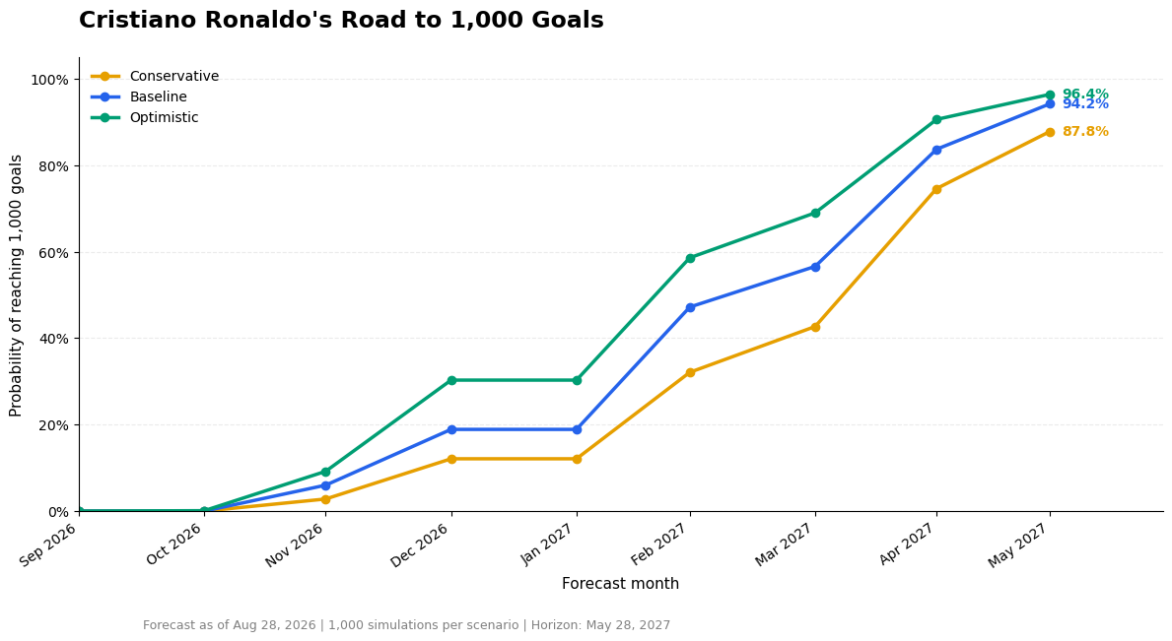
Figure 1. Cumulative probability of reaching 1,000 goals by month across appearance scenarios.
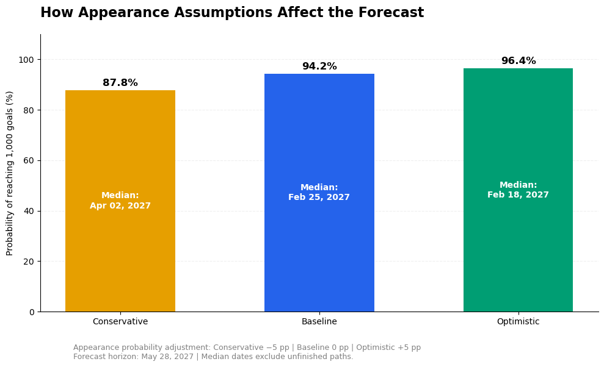
Figure 2. Completion probability and conditional median milestone date under each appearance assumption.
A separate milestone-month distribution chart was also generated in the visualization notebook. Its final monthly interval should retain 1 June 2027 as an exclusive counting boundary so that milestones on 28 May are not inadvertently omitted; this boundary does not extend the forecast horizon.

9. Limitations and interpretation
- The forecast is conditional on a 45-fixture calendar and cannot identify a milestone date beyond 28 May 2027 without additional fixtures.
- Goal-model test probabilities show differences from observed scoring and multi-goal frequencies; good average-goal agreement does not guarantee perfect count calibration.
- Appearance probabilities overpredicted the final-test rate by 5.89 percentage points. The ±5-point scenarios explore sensitivity but do not cover every source of uncertainty.
- The 78-appearance goal test and 99-opportunity appearance test are relatively small; Monte Carlo sampling variability and model misspecification both affect reported dates and probabilities.
- The report preserves the historical cutoff. Matches played after 28 August 2026 require a separate updated forecast, not retroactive insertion into this evaluation.
- Monte Carlo simulation was limited to 1,000 runs per scenario due to available computational resources. All simulations were executed on a CPU, resulting in longer processing times and limiting the number of runs used to estimate milestone probabilities and dates. Consequently, the reported results remain subject to Monte Carlo sampling variability.

10. Conclusion
Built and evaluated a two-stage machine learning system that links expected goals, match participation, and recursive simulation to a defined career-goal milestone. The baseline simulation estimates a 94.2% probability of reaching 1,000 goals within the modeled calendar, with a conditional median of 25 February 2027; an independent baseline run produced 94.9% and 11 March 2027. Appearance assumptions materially affect the forecast: the completion estimate ranges from 87.8% to 96.4% across the specified scenarios. The appropriate output is therefore a dated, conditional probability forecast with documented assumptions, rather than a single definitive milestone date.

