Banking System 测试文档

## System Architecture

The system architecture is shown below:

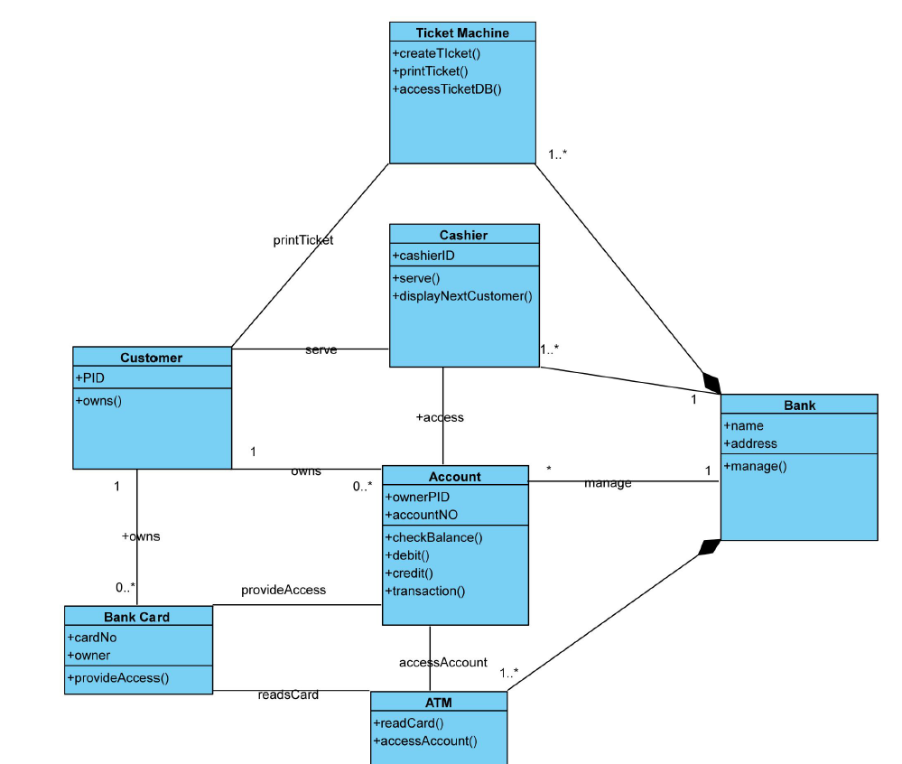

1. Open Account 测试

正常需求测试：

|  |  |  |  |
| --- | --- | --- | --- |
| id | password | Valid output | Real output |
| 123 | 123 | success | success |

重复性测试：

|  |  |  |  |
| --- | --- | --- | --- |
| id | password | Valid output | Real output |
| 123  123 | 123  123 | Success (lead to duplicate card id) | Success |

边界测试：

|  |  |  |  |
| --- | --- | --- | --- |
| id | password | Valid output | Real output |
| 1234 |  | Fail | Fail |
|  | 1234 | Fail | Fail |
| -123 | 123 | Fail | Fail |
| 12345 | -123 | Fail | Fail |

1. Close Account 测试

正常需求测试：

open account:

|  |  |  |  |
| --- | --- | --- | --- |
| id | password | Valid output | Real output |
| 123 | 123 | success | success |

close account:

|  |  |  |  |  |
| --- | --- | --- | --- | --- |
| id | password | Account No | Valid output | Real output |
| 123 | 123 | 1 | Success | Success |

open account:

|  |  |  |  |
| --- | --- | --- | --- |
| id | password | Valid output | Real output |
| 123 | 123 | success | success |

close account:

|  |  |  |  |  |
| --- | --- | --- | --- | --- |
| id | password | Account No | Valid output | Real output |
| 123 | 123 | 2 | Fail | Fail |

open account:

|  |  |  |  |
| --- | --- | --- | --- |
| id | password | Valid output | Real output |
| 123 | 123 | success |  |

close account:

|  |  |  |  |  |
| --- | --- | --- | --- | --- |
| id | password | Account No | Valid output | Real output |
| 123456 | 123 | 1 | Fail | Fail |

open account:

|  |  |  |  |
| --- | --- | --- | --- |
| id | password | Valid output | Real output |
| 123 | 123 | success | success |

close account:

|  |  |  |  |  |
| --- | --- | --- | --- | --- |
| id | password | Account No | Valid output | Real output |
| 123 | 123456 | 1 | Fail | Fail |

边界测试：

miss account：

close account:

|  |  |  |  |  |
| --- | --- | --- | --- | --- |
| id | password | Account No | Valid output | Real output |
|  | 123456 | 1 | Fail | Fail |

miss password：

close account:

|  |  |  |  |  |
| --- | --- | --- | --- | --- |
| id | password | Account No | Valid output | Real output |
| 123 |  | 1 | Fail | Fail |

1. Deposit 测试：

open account:

|  |  |  |  |
| --- | --- | --- | --- |
| Id | password | Valid output | Real output |
|  |  |  |  |
| 123 | 123 | Success & Account id | Success |

deposit:

|  |  |  |  |
| --- | --- | --- | --- |
| Account No. | Amount | Valid output | Real output |
| Account id | 100 | Success | Success |

边界测试：

deposit:

|  |  |  |  |
| --- | --- | --- | --- |
| Account No. | Amount | Valid output | Real output |
| Id that no created: eg. 10000 | 100 | Fail | Fail |
| Account id | -1 | Fail | Fail |
|  | 1 | Fail | Fail |

1. Withdraw 测试：

open account:

|  |  |  |  |
| --- | --- | --- | --- |
| Id | password | Valid output | Real output |
|  |  |  |  |
| 123 | 123 | Success & Account id |  |

deposit:

|  |  |  |  |
| --- | --- | --- | --- |
| Account No. | Amount | Valid output | Real output |
| Account id | 100 | Success | Success |

withdraw:

|  |  |  |  |  |
| --- | --- | --- | --- | --- |
| Account No. | Password | Amount | Valid output | Real output |
| Account id | 123 | 100 | Success | Success |

边界测试：

withdraw:

|  |  |  |  |  |
| --- | --- | --- | --- | --- |
| Account No. | Password | Amount | Valid output | Real output |
| Account id | 123 | 1000 | Fail | Fail |
| Account id | 123 | -1 | Fail | Fail |

2. Test_UI:

test_main.m: