KAZAKH-BRITISH TECHNICAL UNIVERSITY

Course: Data Collection and Preparation
Student Independent Work (SIS) №1
Population and Country Area Analysis
World Bank API and Wikipedia Web Scraping
Student: Nussipakhyn Ablaikhan
Student ID: 23B031388
Group: Thursday4PM
Almaty, 2026

1. Introduction
This project looks at how the population of a country is connected with its area. I took population data from the World Bank API and area data from a static Wikipedia page. Then I cleaned both datasets, merged them by country name, and calculated population per square kilometre. After that I did descriptive statistics, correlation analysis and visualizations. The final dataset has 200 countries and territories.

2. Data Sources
World Bank API. The first source was the World Bank REST API. I used the indicator SP.POP.TOTL (total population) for the year 2024. The API returns JSON, and I changed the records into a Pandas DataFrame with the columns Country, Country_Code, Population and Year.
Wikipedia. The second source was the static Wikipedia page “List of countries and dependencies by area”. I downloaded the HTML with requests and used BeautifulSoup to take the country name and the total area from the table rows.

3. API Data Collection and Cleaning
I sent a GET request to the World Bank API and the status code was 200. The response is a list with two elements. The first one is metadata (it shows 1 page and 266 records in total), and the second one is the list of records. I converted the 266 records into api_df.
I checked the data: the DataFrame had 266 rows and 4 columns, 1 missing Population value and 0 duplicates. Population was changed to a numeric type and Year was changed to an integer.
The main problem was that the World Bank response does not contain only countries. It also has regions and income groups such as Arab World, Euro area and European Union. To solve this I requested the country list from another World Bank endpoint, merged it with api_df by Country_Code, and used the Region column to find rows where the region is “Aggregates”. 44 aggregate rows were removed, so 222 rows were left.
Four income-group rows (High income, Low income, Lower middle income, Upper middle income) have an empty country code, so the region merge did not mark them. They stayed in the data until the final merge, where they had no match in the Wikipedia table and were dropped. One more row, “Not classified”, had no population value, so I removed it because population is needed for the density calculation. After cleaning, api_df had 221 rows.

4. Web Scraping and Cleaning
I downloaded the Wikipedia page (status code 200) and parsed it with BeautifulSoup. The page has one table with class wikitable, with the columns country/dependency, total area, land area, inland water and % water. The table has 278 rows including the header, and I extracted 276 records with the country text and the area text.
The cleaning steps were:
- removed footnote numbers from the table;
- cleaned the country names, for example “Australian Antarctic Territory(Australia)” became “Australian Antarctic Territory”;
- took the first number from the area text, for example “17,098,246 (6,601,667)” became “17098246”, removed the commas and converted it to a numeric type;
- checked missing values (0) and areas less than or equal to zero (0).
Two country names appeared twice, France and Norway, because the table has two rows for each of them with different areas. I kept the first row, which has the larger area, and the DataFrame went from 276 to 274 rows.
The table also contains entries that are not countries, such as Earth, Antarctica and the Antarctic territorial claims. They have no match in the World Bank data, so they are removed by the inner merge. The scraped area is the total area (land and water), so my calculated measure is population per square kilometre of total area.

5. Data Merging
The country names are not the same in both sources, so the first merge had many unmatched records. First I used an outer merge with indicator=True only to find the problems. The result was 180 matched rows, 41 rows only in the World Bank data and 94 rows only in Wikipedia.
The unmatched World Bank names showed real naming differences, for example Russian Federation / Russia, Egypt, Arab Rep. / Egypt, Korea, Rep. / South Korea, Turkiye / Turkey and Viet Nam / Vietnam. I made a dictionary with these name fixes and merged again. After that there were 200 matched rows, 21 rows only in the World Bank data and 74 only in Wikipedia.
For the final dataset I used an inner merge, because population density needs both population and area. Rows before and after the merge:
- World Bank data: 221 rows
- Wikipedia data: 274 rows
- Final merged dataset: 200 rows, with 0 missing values and 0 duplicates
The 74 Wikipedia-only rows are mostly dependencies, Antarctic claims and other territories without a World Bank record, for example Anguilla, Åland, Western Sahara and Vatican City. Of the 21 World Bank-only rows, 4 are the income groups described above and 17 are real countries or territories that were not matched because their names are written differently in the two sources (for example Czechia, Gambia, Somalia, Puerto Rico and West Bank and Gaza). These 17 are missing from the final dataset, which is a limitation of my name standardization.

6. Calculated Variable
The new column is:
Population_Density = Population / Area_km2
In this project it is the number of people per square kilometre of total country area (land and water together), not land-only density.

7. Exploratory Data Analysis
I used describe(), sorting and correlation for three numerical variables: Population, Area_km2 and Population_Density.
Descriptive statistics (200 countries and territories).
- Population: mean about 39.8 million, median about 7.5 million, maximum about 1.45 billion.
- Area: mean about 663,514 km², median about 111,931 km², maximum 17,098,246 km², minimum 2 km².
- Population density: mean about 469 people/km², median about 87 people/km², maximum about 20,818 people/km².
The mean is much higher than the median for all three variables, so the distributions are strongly skewed to the right: a few very large or very dense places pull the average up.
Rankings.
- Largest populations: India (about 1.451 billion), China (1.409 billion), United States (340.0 million), Indonesia (283.5 million), Pakistan (251.3 million), Nigeria (232.7 million), Brazil (212.0 million), Bangladesh (173.6 million), Russia (143.7 million), Ethiopia (132.1 million).
- Largest areas: Russia (17,098,246 km²), Canada (9,984,670), China (9,596,960), United States (9,525,067), Brazil (8,510,346), Australia (7,741,220), India (3,287,263), Argentina (2,780,400), Kazakhstan (2,724,910), Algeria (2,381,741).
- Highest density: Macau (20,818 people/km²), Monaco (19,316), Singapore (8,103), Hong Kong (6,754), Gibraltar (5,784), Bahrain (2,042), Malta (1,806), Maldives (1,759), Bermuda (1,197), Bangladesh (1,169).
Correlation. Pearson correlation measures a linear relationship. Spearman correlation compares the ranks of the values, and it is useful here because country area and population are very skewed.
- Area and Population: Pearson = 0.44, Spearman = 0.81
- Area and Population_Density: Pearson = -0.07, Spearman = -0.56
- Population and Population_Density: Pearson = -0.03, Spearman = -0.06

8. Visualizations
The notebook has four plots, and the assignment requires at least three.
Plot 1: Top 10 countries by population. Purpose: to compare the countries with the largest populations.
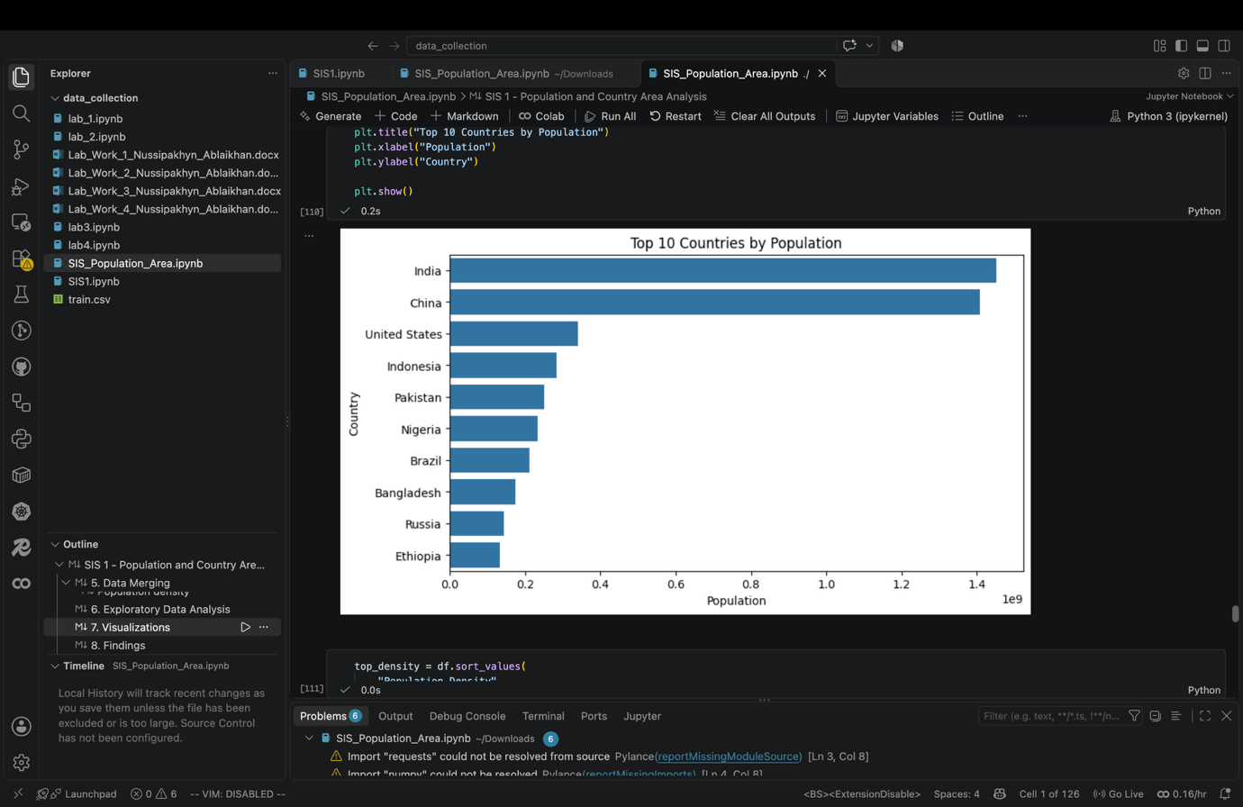
Plot 2: Top 10 countries by population density. Purpose: to compare how densely populated countries are relative to their total area.
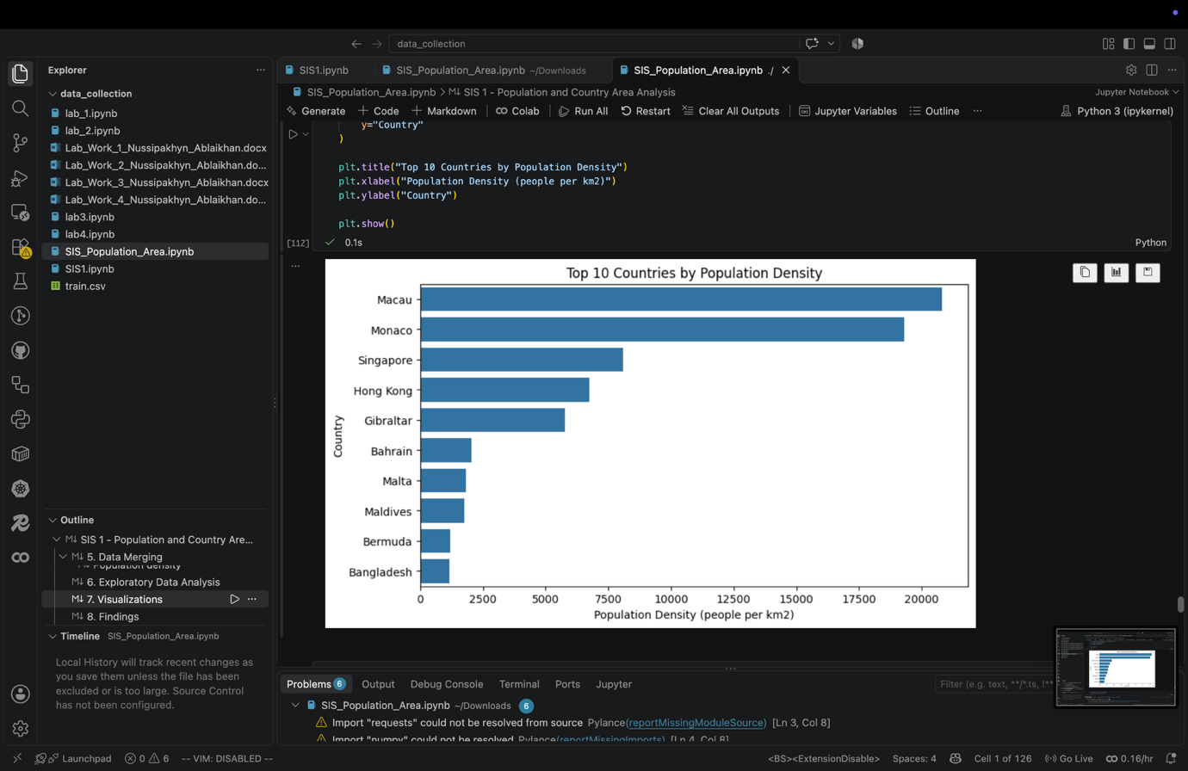
Plot 3: Area vs Population. Purpose: to check whether larger countries generally have larger populations.
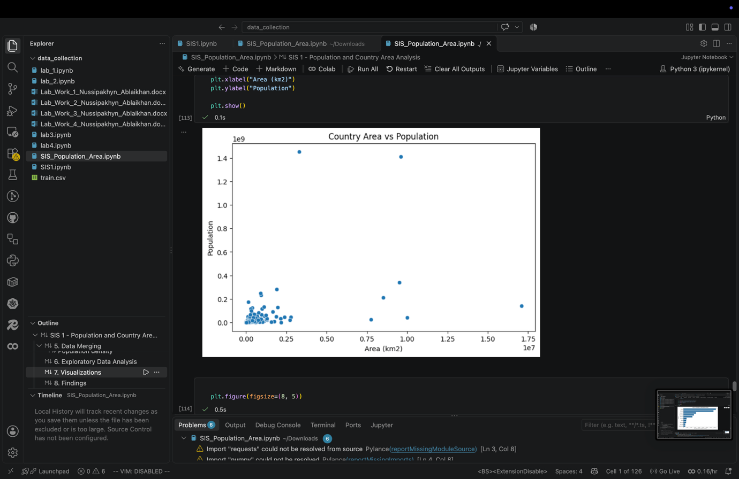
Plot 4: Area vs Population on a log scale. Purpose: to make the pattern easier to see. On the normal scale a few very large countries dominate the graph and most countries are close together. A logarithmic scale compresses the big values and makes smaller countries easier to compare.
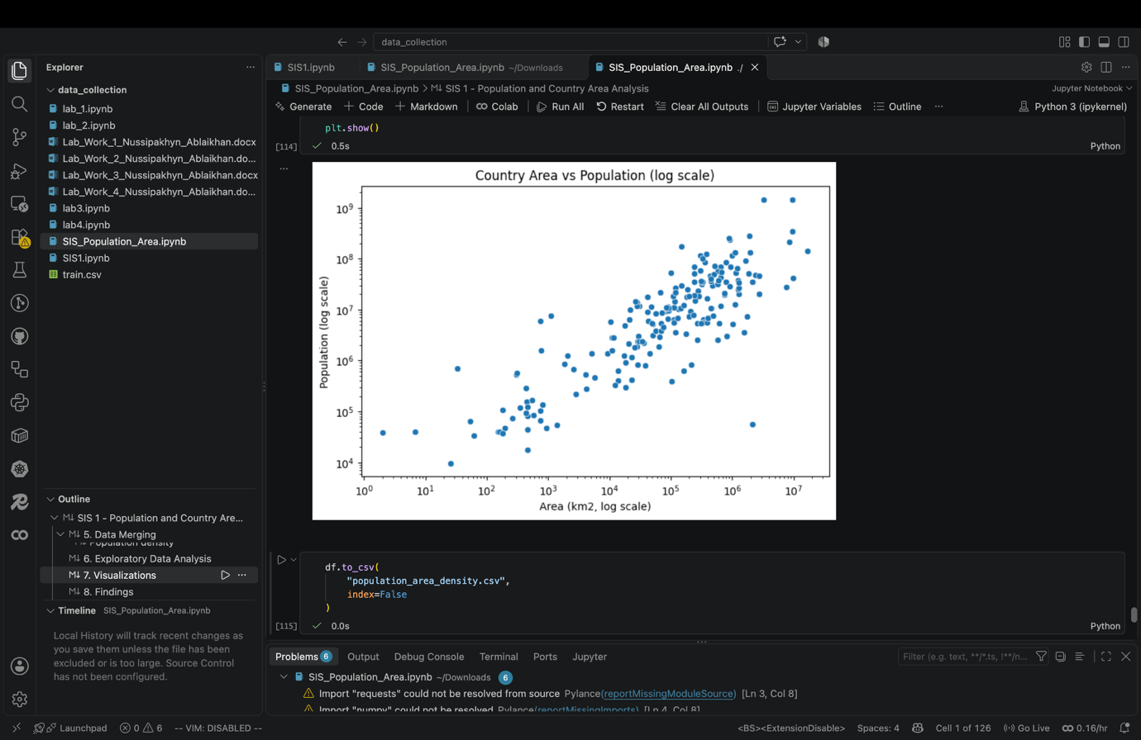

9. Main Findings
Finding 1. The final merged dataset contains 200 countries and territories.
Finding 2. The country with the largest population is India, with about 1.451 billion people. China is second with about 1.409 billion.
Finding 3. The country with the largest area is Russia, with 17,098,246 km². Its population is about 143.7 million, so it is only ninth by population.
Finding 4. The highest population per area belongs to Macau, with about 20,818 people/km² (687,000 people on 33 km²). Monaco is second with about 19,316 people/km² on about 2 km². Nine of the top 10 are small states or territories, so their small area has a strong effect on the value. The only large country in the top 10 is Bangladesh, with about 1,169 people/km².
Finding 5. The Pearson correlation between area and population is 0.44 and the Spearman correlation is 0.81. Both are positive, so larger countries tend to have larger populations. The Spearman value is much higher than the Pearson value, which means the relationship is clearer in the ranking than in the raw numbers: a few countries do not follow the pattern. Russia, Canada and Australia have very large areas but relatively small populations, while Bangladesh has a large population on a small area. This is only an association, it does not mean that area causes population.
Lost records. 21 World Bank rows were lost in the inner merge. Four are income groups, and 17 are countries or territories whose names did not match Wikipedia. Because of this, the final dataset does not cover every country, and the correlation values could change a little if these names were also fixed.

10. Conclusion
In this project I used two different ways of collecting online data. The World Bank API gave structured JSON data that was easy to process, but it also included regions and income groups that had to be removed. The Wikipedia page needed HTML scraping and more manual cleaning: footnotes, brackets, commas and duplicate rows. The country names were different in the two sources, so I had to standardize some of them before the final merge. After merging, I calculated population per square kilometre of total area, and the analysis showed big differences between countries. The most populated countries are not the biggest by area, and the highest density values belong to very small territories. Area and population are positively related, especially when we compare ranks (Spearman 0.81). The project showed the full pipeline of data collection, cleaning, merging, analysis and visualization.

