**Similar programs**

Simple Dice Roller: <https://codepen.io/Pyremell/pen/eZGGXX/>

Throw a Die: <http://jsfiddle.net/gaby/zZUgF/262/>

Animation with setTimeout: <http://jsfiddle.net/twTab/>

**Useful links**

**Different git commands**

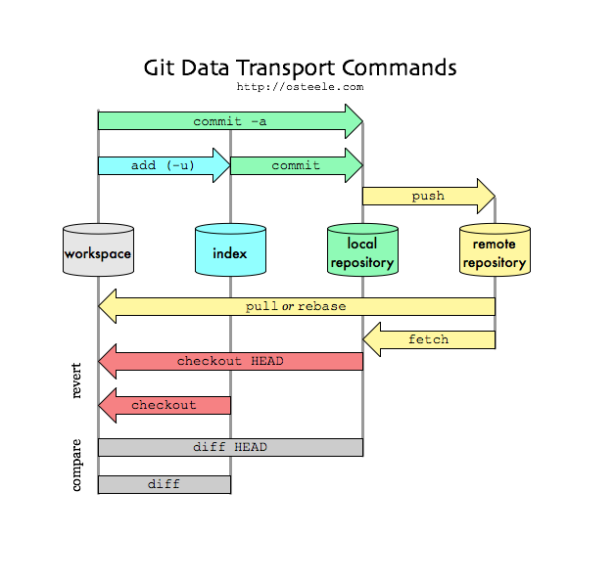

<https://stackoverflow.com/questions/2745076/what-are-the-differences-between-git-commit-and-git-push>

**Timing events in javascript**

<https://www.w3schools.com/js/js_timing.asp>

**How to modify Attributes, Classes, and Styles in DOM**

<https://www.digitalocean.com/community/tutorials/how-to-modify-attributes-classes-and-styles-in-the-dom>

**Adding and removing Classes**

<https://clubmate.fi/javascript-adding-and-removing-class-names-from-elements/>

**Rounding corners with CSS**

<https://www.w3schools.com/css/css3_borders.asp>

**Margins, padding, and borders in CSS**

<https://www.w3schools.com/cssref/pr_margin.asp>

**Change the src attribute of an image with DOM**

<https://www.w3schools.com/jsref/prop_img_src.asp>

**Resources**

Javascript animation libraries: <https://blog.bitsrc.io/11-javascript-animation-libraries-for-2018-9d7ac93a2c59>

Get free images at: <https://pixabay.com/>

Cannot read property 'style' of null

at script.js:33