Ever wonder what audio looks like? This is a simple H-sync, V-sync, and blank gating of the RGB signal to allow ramming just about anything down the RGB lines of your standard VGA cable to make interesting patterns. This module's core is a simple Arduino script that runs on an attiny 85. it can accept dc to about 3mhz or up to the pixel clock. Base code was adapted from Kevin (last name unknown) to produce a higher resolution, and add 3 outputs to gate incoming signals for proper signal drop out during the v-sync and h-sync porches. If you’re interested in how this code works the original code can be seen here: https://emalliab.wordpress.com/2020/05/03/attiny85-vga-sync/

Words of caution on R1 boards!!!! There are some critical errors in pcb design mainly around my transition from tht to smd. All of the 3904 footprints are wrong as well as the LD1117S50TR +5V regulators. Don’t fret my dearies, we have a fix for that! I’ve included the workaround for that below.

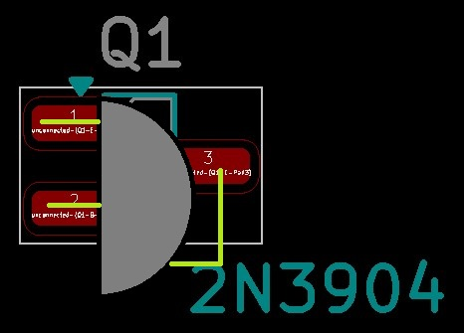

Any 2n3904s will have this issue, and should be fixed with a to “regular” TO-92 package with the pins bent as shown. The same with the LD1117S50TR seen below.

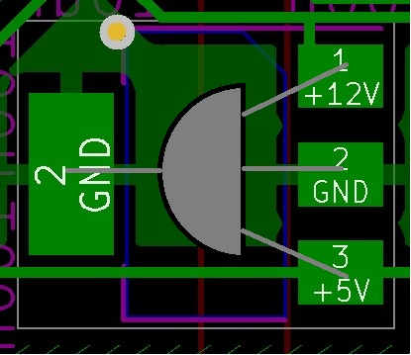
That footprint should be fixed with a 78L05 TO-92 package note that the ground pin can be either or pad it does not need to be both.

Also the diode footprints are a little small (if equipped), they do solder but just be careful as to not create a solder bridge.

