**Nucleotide Pairing**:

Purine Adenine (A) always pairs with Pyrimidine Thymine (T)

Pyrimidine Cytosine (C) always pairs with Purine Guanine (G)

Why only the 2 combinations?

Only with A + T can hydrogen bonds form. Same applies for C + G. Also the same letter can pair with itself.

DNA Proportions of bases in humans:

1. 30.9% (T) 29.4 (C) 19.8 (G) 19.9

**James Watson and Franklin Crick discovered the double helix structure.** (below)

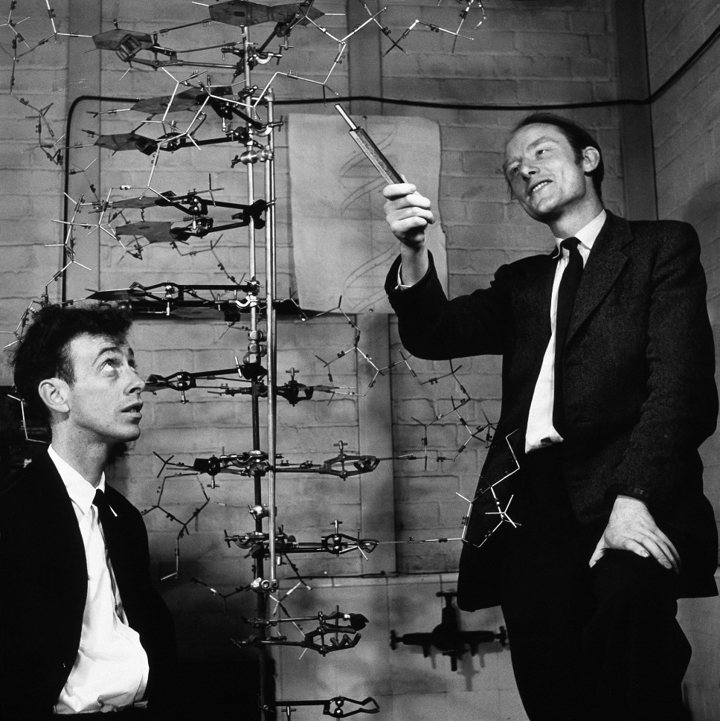

Normal Structure:

A G

| |

T C

And repeating…

DNA Replication:

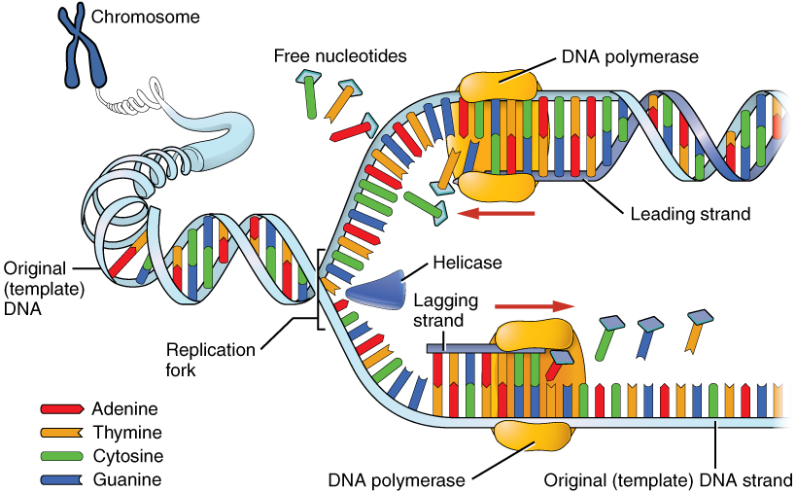

**Explanation:**

The original DNA template splits into 2 different parts and a DNA Polymerase pairs the strand when it is split into it’s original un-split form. Then the leading strand is repaired in the same way…

The Helicase seperates the singular strand into 2 strands to then be replicated.

The Polymerase adds the corresponding protein back into the strand it is on.

The Leading Strand is the original strand that will be repaired after separation and the Lagging Strand is the strand that will be replicating the other half of the original strand.