Nanobot Wars

**Edoardo Carrer**

Game Programmer / Game Designer

**David Leonardo Gomez**

Game programmer / Game Designer

0.0 DESIGN PLAN

[Link to calendar](https://docs.google.com/spreadsheets/u/0/d/19bpPmgDnUGR-kMIcATinlsuGKC5ivXK8ySQv4y-PEzU/edit)

1.0 VISION STATEMENT

“Nanobot Wars” is a strategy game where you simulate battles between two enemy swarms of nanobots. You choose the characteristics of your creation and then you let them fight in an arena to see which is the deadliest bot.

You can set up your part of the battlefield before the round starts, adding walls, energy or danger-zones for the robots. But be careful! You will affect both your and your enemy robots! So use these tools carefully!

Battle against the premade scientists that you will find in the **Single Player Mode**, unlock **upgrades** and items for your personal robots and then **challenge your friends** online to see who is the best nanobot engineer!

## 1.1 Game Logline

*Destroy your enemy in epic nanobot wars!*

## 1.2 Gameplay Synopsis

When you first start the game you receive your first nanobot, you can choose between some options made for you and you start with an introduction fight.

### Pre-Battle

Before the fight begins you see only half of the field, have the option to modify the deployment of your nanobot swarm (you can choose how to place them), you can also choose to place some energy, traps or power ups on the field. Once you are ready the battle starts, and you can see how the enemy placed the elements on it’s side of the arena.

### Battle

While the battle is taking place your bots will do what they are programmed to do, roam around, find energy sources, multiply, avoid obstacles and finally attack the enemy swarm. The battle lasts around 45 seconds, around the 30 seconds mark the remaining creatures are pushed to the center of the arena and finish the fight.

### Upgrade

After each battle you receive points which you can use to modify your nanobots and upgrade them. You can modify your creature in **the LAB**, when in edit mode you will see one of the creatures zoomed in, with it’s stats and characteristics next to it.

There are two ways you can modify a bot: hardware and software.  
To modify the hardware you can touch individual parts like the legs, sensors and weapons to see more details, and see if upgrades or other options are available.   
For the software there is a dedicated button that will take you to the programming interface.

2.0 AUDIENCE, PLATFORM & MARKETING

## 2.1 Target Audience

Our target audience could be best described as a “time filler gamer”, players between 14 and 30 who want to have a quick fun game to play to fill some time. They want each match to be satisfying and interesting, and don’t have a lot of time to focus on grinding or follow the game lore, but they like making progress, and they love to unlock something new each time they play.

3.0 LEGAL ANALYSIS

“Nanobots!” is a new IP free from copyright.

All the digital contents are created by the development team or purchased from the Unity Asset Store.

We think that since the violence depicted in the game is very stylized, and between little robots, our game could get a PEGI 7 Classification. No violence to humans like - characters are involved and neither is bad language.

## 4.0 GAMEPLAY

## 4.1 Overview

In “Nanobots!” The players will participate in numerous battles between their nanobots and other nanobots, either the premade ones from the Single Player Mode or the ones made by your friends. After each battle the players will get points and parts that they can use for upgrades for their bots.

## 4.2 Gameplay Description

The main gameplay mechanic is the **battle**, most importantly the **setup** of the battle, since the fight itself, once started, will be completely **simulated**, and out of the hands of the players.

In the **setup phase** each player can only see it’s own half of the map, and they will have to place different elements on it’s part of the arena (walls, energy, and traps) and also they have to choose where to deploy the first nanobot.

Once the **battle starts** the rest of the map is revealed, and the bots spawn in the designated area. Each bot will behave a bit differently, depending on the upgrades and settings the player decided for it, but mainly it will start looking for the **energy** sources in the map, and once it gets it it will **duplicate**.

If it finds an **enemy** bot it will **attack** it, sending a **signal** to the other bots. Moving and attacking consumes energy, while killing an enemy gives you energy. A bot will **duplicate** when it’s energy is 100% full, and will spawn two bots with 50% energy each.   
If a bot remains for too long without acquiring energies or killing enemies it will die and despawn once it’s energy reaches 0%.

The player can interfere on the fight by using 2 abilities, calling **a signal** somewhere on the map for commanding its own bots, or using **bombs** to destroy the layout of the field these abilities have a **cooldown of 5 seconds** each.

## 4.3 Game Modes

### First Start

At the first start of the game, the player chooses his nickname, and then he starts the tutorial. The tutorial consists of a brief explanation and trial of all the gameplay mechanics, explained by the first enemy of the story mode, an engineer, which also gives some information about the game world. After the tutorial, the player enters the LAB.

### The LAB

The LAB is the place where players can upgrade and personalize their nanobots, buy new parts using **bolts** and swap them.

The main categories of parts are:

* Vision   
  These upgrades affect how far your nanobots can see, and the field of view. Usually the more far you can see, the narrower the field of view is.
* Attack   
  These upgrades affect how you attack other bots. There are ranged or closeup weapons, each weapon has it’s damage level, the attack rate, some have splash attacks that affect multiple enemies, also there are types of weapons (fire, electric, acid, normal etc.)
* Armor  
  Armor upgrades can offer resistance to different kinds of attacks, and usually affects the speed of the bots.
* Movement  
  These upgrades affect how the bots move, usually the faster a bot moves the less accurate it’s movements will be.
* Special AbilitiesThese upgrades can have particular effects on the bots, for example they could make it so when a bot dies it explodes, or that it gives energy to its surrounding friends.

### Single Player Mode

In this mode the player will fight against different adversaries, each one a bit more challenging than the previous. The first levels in this scenario are intended to serve as a tutorial for new players at the start showing the core of the game, and later on, using the extra mechanics.

To pass the levels the player will have to try out different configurations of their bot or try to change the placement of the elements in his side of the arena, in order to be effective against the adversary.

### VS Mode

In this mode two players will battle in the arena. Each one will build up their bot and the disposition of the elements in their part of the arena, once both of them are done the battle will begin.

## 4.4 Controls

The player will interact mainly through touch/clicking on the buttons.  
In the **Pre Battle** where the player has to place elements on the screen, it will use a drag and drop approach to take elements from the bottom part of the screen and place them in the arena.

## 4.5 Interface

### Start Menu

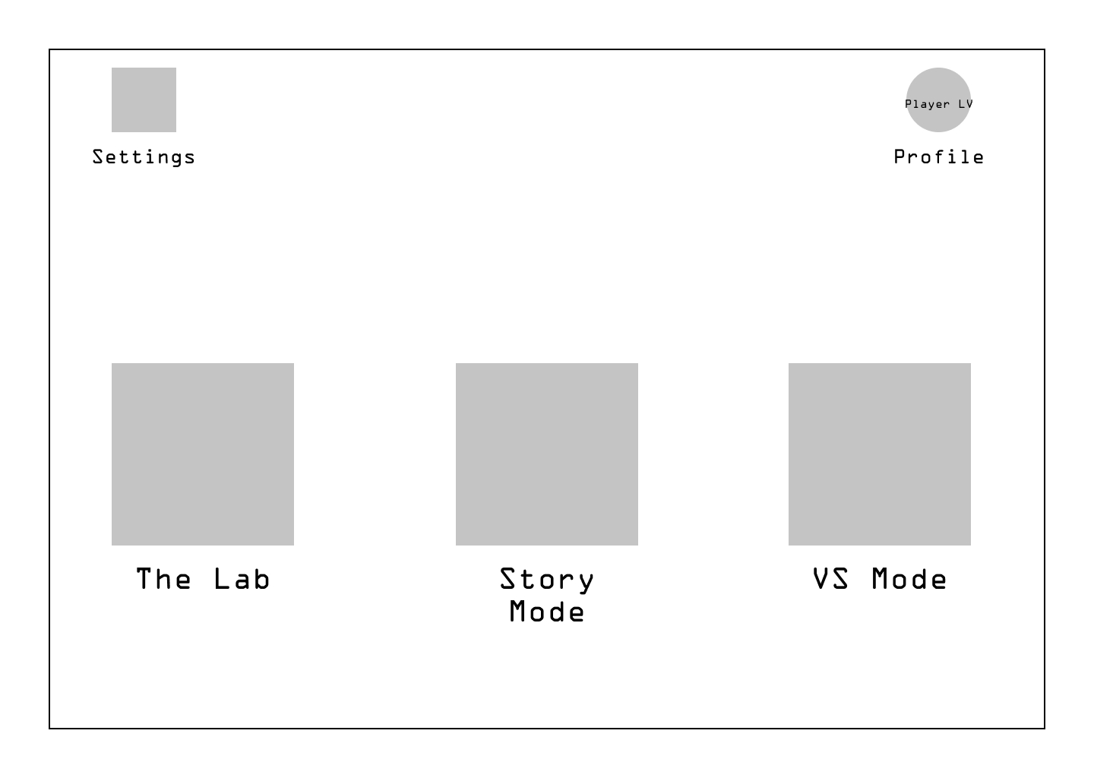

### The Lab

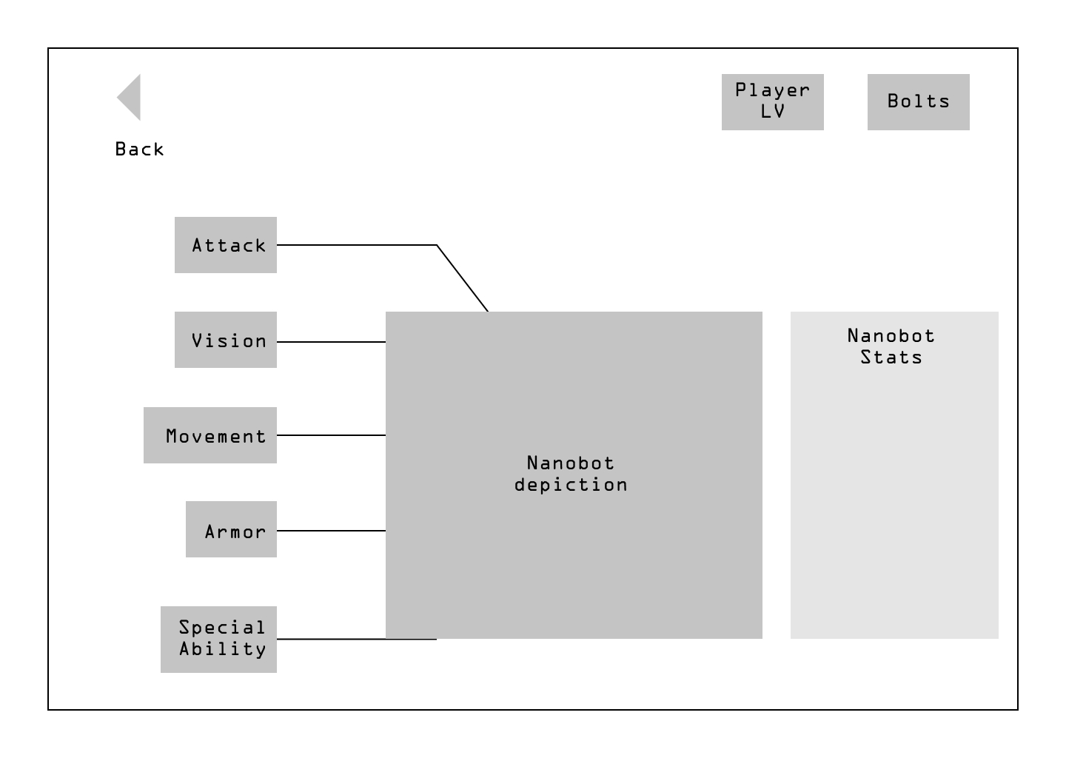

### 

### Pre Battle

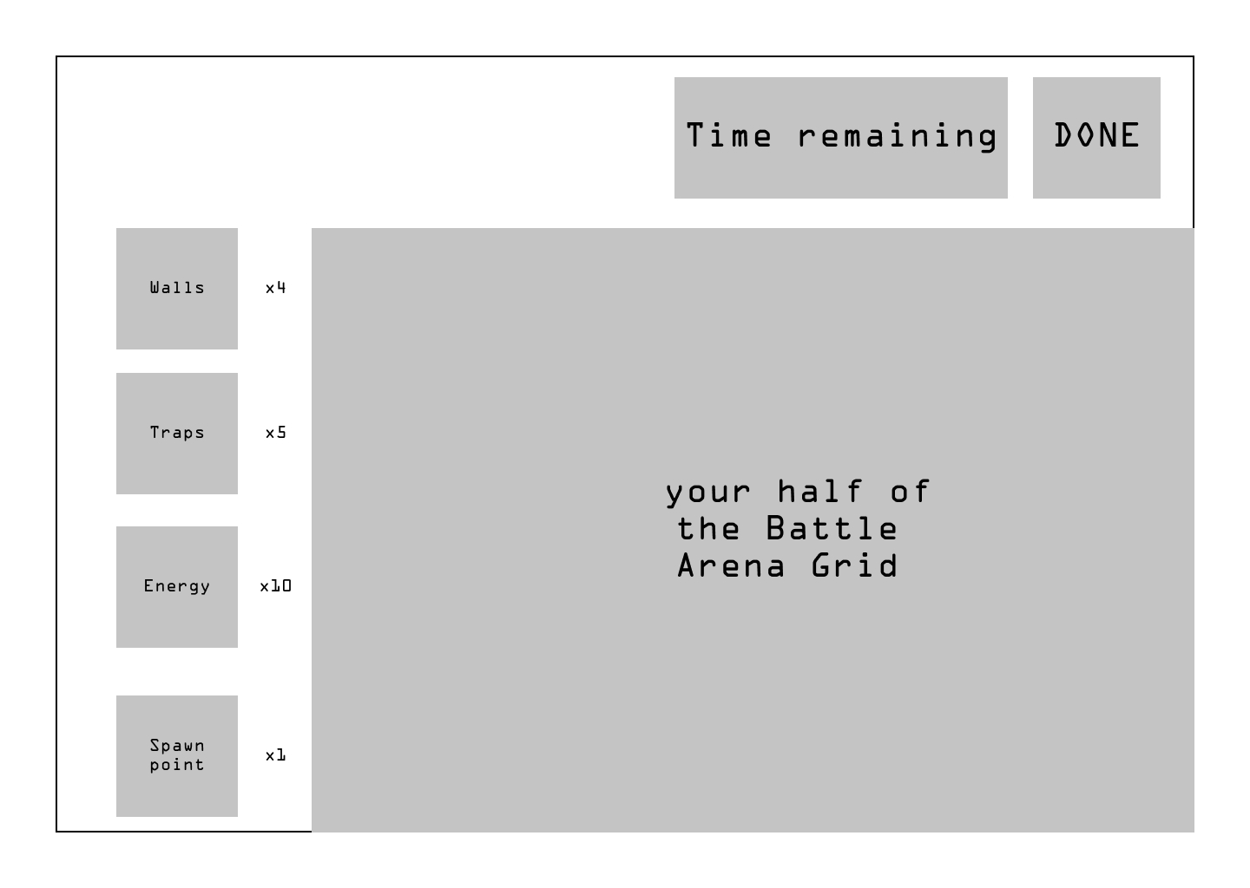

Battle

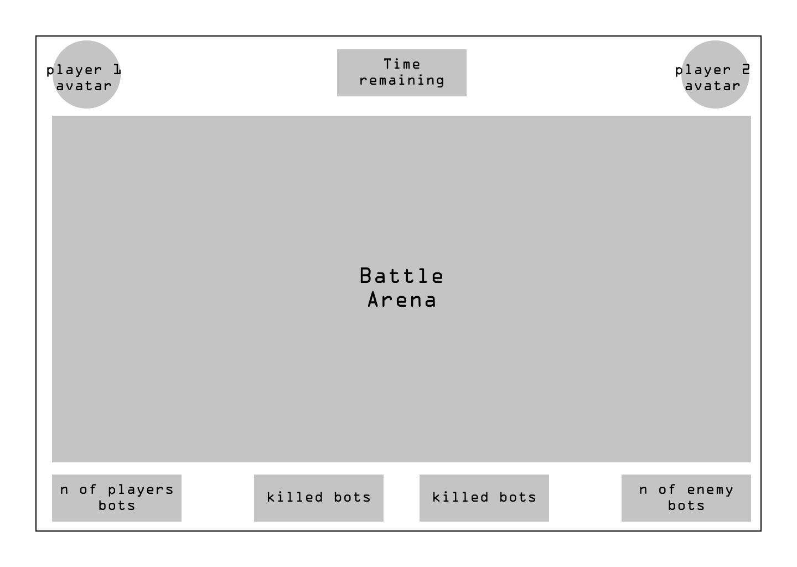

## 4.6 Resources

### Player Level

Some resources and upgrades are unlocked only after the player reaches a certain level.

The levels go from 1 to 25, and require XP to go from a level to another. As is usual, going from level to level will get increasingly difficult.

| Name | Double if Won | Bolts |
| --- | --- | --- |
| Killed Bots | ✔ | n. of enemies killed by bots |
| Remaining Bots | ✖ | n. of bots remaining |
| Time Used | ✖ | remaining seconds * 5 |
| Traps Placement | ✔ | n. of enemies killed by your traps |

### Bolts

To buy and upgrade parts for your bot at the LAB you will need “**Bolts**”. Bolts are acquired after each game, depending on how many bots get destroyed.

When the game is over, all the bots spawned during the match are converted to bolts. The winner keeps all the bots generated from his bots and also 75% of the bots generated from the adversary. The loser only gets 25% of the bolts generated by it’s bots.

## 4.7 Flowchart

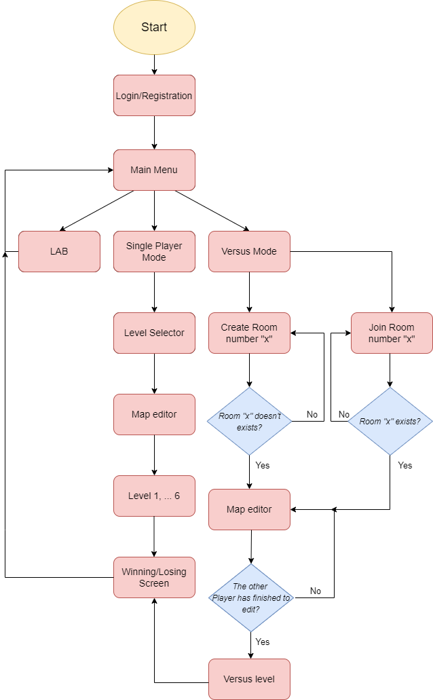

## GAME CHARACTERS 5.1 Your Bot

Your bot is the main focus of the game, upgrading and personalizing it will be the main goal. Each upgrade comes with some pros and some cons that will add up to the base stats of your bot.

Some upgrades will not just affect the stats of your bot but will also change some aspects of it’s behavior, for example how it behaves when it dies or when it receives a signal from the other bots.

### Base decision tree for the bot

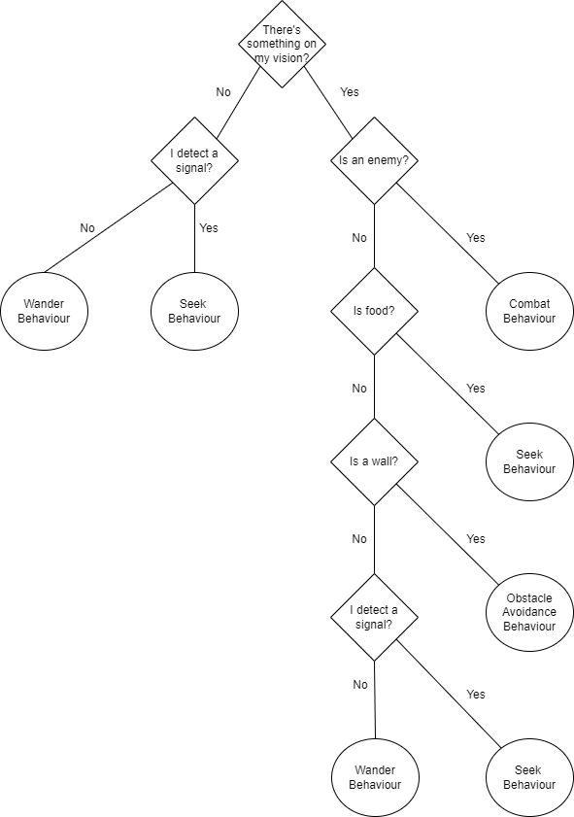

### Acquirable objects list

* Vision
  + - Long, Mid Range - High distance view with Low Fov
    - Balanced, Normal distance view with Mid Fov
    - Wide, Low distance view with High Fov
* Attack
  + - Electric - Jump between nearby bots
    - Fire - Burns enemy
    - Acid - Splash, remains on field for some seconds
* Armor
  + - Antishock Steel, resistant to acid and electric damage sources.
    - Fireproof Alloy, resistant to acid and fire damage sources.
    - Reinforced Plates, resistant to acid and trap damage sources.
    - Fireproof Rubber, resistant to electric and fire damage sources.
    - Adaptive Rubber, resistant to electric and trap damage sources.
    - Fireproof Shell, resistant to fire and trap damage sources.
* Movement
  + - Precise, Low speed High precision
    - Balanced, medium speed with medium precision
    - Fast, Hi speed, Low precision
* Special
  + Energy
    - Efficient Power, Low energy usage and leave less energy after death.
    - High capacities, Higher energy limit.
  + Attack
    - Critical hit, Chance of crit attack.
    - Bombs, Leave bomb after death.
    - First attack, First attack deals more damage.

Each purchasable item is also upgradable, each upgrade will increase the level of the part from level 1 to 5.

## STORY

Bored in a lab, some engineers decide to play a game, they want to see who can create the strongest nanobot. To choose the winner they put them in a small arena and see which one comes out victorious.

Do you, the player, have what it takes to create the most powerful nanobot and win against the others?

GAME WORLD

Each player, during the PreGame phase, can set up his own half of the map. The tools available to do so are the same for all players and consist of: Walls, Energy source and Traps. In the middle of the map there is a neutral zone that no player can modify, with an energy spawner usually at the center.

The player has to place the tools at their disposal carefully, because both nanobots can be affected by them.

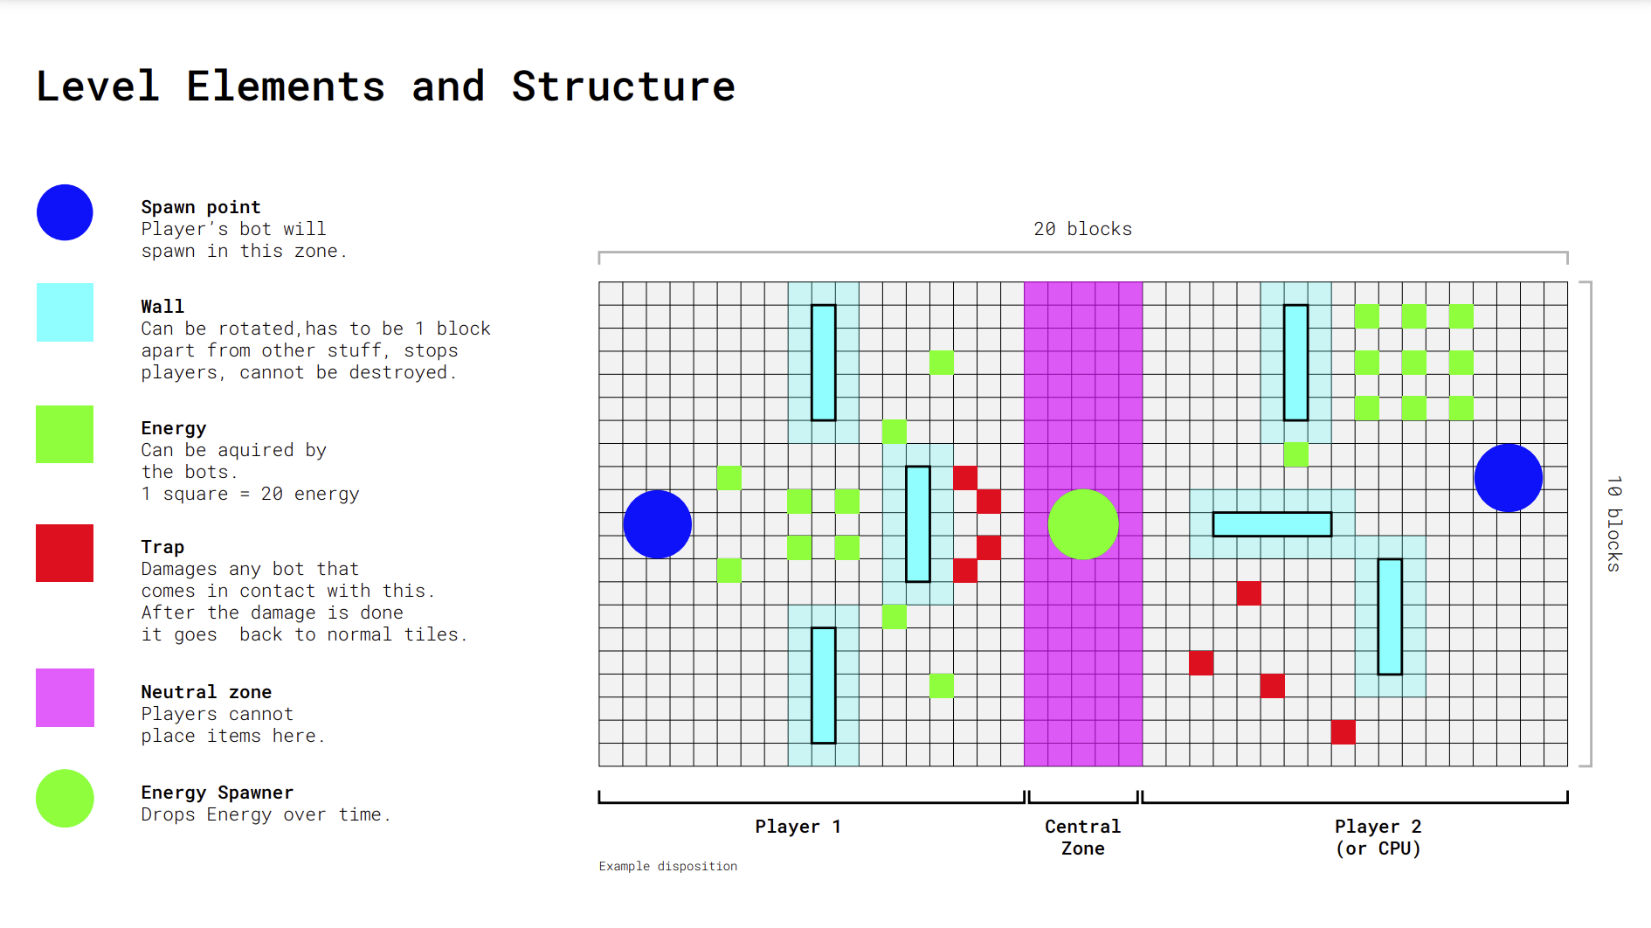

## REFERENCE ART

Here are some images that well represent the desired art style   
for the bots and the battle arena

