TDD with ASP.NET MVC
Red-Green-Refactor

TDD with ASP.NET MVC

Objectives
In this module we’ll go back and rebuild some pieces of the Movie application using unit tests. After completing the module you should understand how to:

- Refactor existing code to make it unit-testable
- Use fake objects to simulate data access

Technically we will not be doing TDD or test-first development. We already have a working application and need to add unit tests. The good news is, this process can still teach us about design.

Part I – Setup

- Open your Movies solution file (or use the one inside the before\Movies directory for this lab).

This lab builds on the solution from the MVC Models lab. If you’ve completed the MVC Models lab you can use the application you built in the AJAX lab instead of opening the solution in the before directory.

- Run all the tests in the solution (Test -> Run -> All Tests). You should have three passing tests.

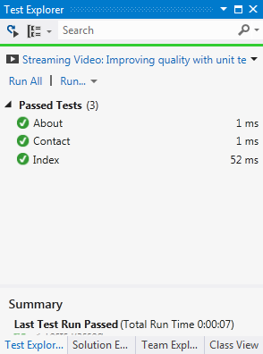

Part II – Indirection
Our first order of business will be to build a small layer of indirection between the controllers and the MovieData class. Having the controller work with an abstraction instead of the concrete type will allow us to test functionality without using a database.

- Right-click the Domain directory and select Add -> New Item. Add an interface with the name IMovieData. The interface uses the following definition.

public interface IMovieData
{
IQueryable<Review> Reviews { get; }
IQueryable<Movie> Movies { get; }

void SaveChanges();
void AddOrAttach<T>(T entity) where T : class;
}

- Go to the Infrastructure folder and open MovieData.cs. Make the MovieData class explicitly implement the IMoiveData interface (use the following code as a guide).

public class MovieData : DbContext, IMovieData
{
public DbSet<Movie> Movies { get; set; }
public DbSet<Review> Reviews { get; set; }

IQueryable<Review> IMovieData.Reviews
{
get { return Reviews; }
}

IQueryable<Movie> IMovieData.Movies
{
get { return Movies; }
}

void IMovieData.SaveChanges()
{
SaveChanges();
}

void IMovieData.AddOrAttach<T>(T entity)
{
var entry = Entry(entity);
entry.State = entry.Property<int>("Id").CurrentValue == 0 ?
EntityState.Added :
EntityState.Modified;
}
}

With an interface definition and implementation in place, let’s use it in the ReviewsController to make the controller a little more testable. We can do this one piece at a time, and eventually make the controller unaware of the concrete MovieData class and instead rely only on IMovieData. We’ll start with the Create method.

- Add a private field to the ReviewController to hold an IMovieData reference. Name the field _movieData. Add a default constructor to the controller that assigns a new MovieData object to the _movieData field. Add a second constructor to the controller that takes an IMovieData parameter and assings it to _moveData.

private readonly IMovieData _movieData;

public ReviewsController()
{
_movieData = new MovieData();
}

public ReviewsController(IMovieData movieData)
{
_movieData = movieData;
}

- Change the Create method so it uses _movieData instead of instantiating the MovieData class.

[HttpPost]
public ActionResult Create(int movieId, Review review)
{
if(ModelState.IsValid)
{
var movie = _movieData.Movies.Single(m => m.Id == movieId);
movie.Reviews.Add(review);
_movieData.SaveChanges();
return RedirectToAction("Details", "Movies",
new {id = movieId});
}
return View(review);
}

Part III – Tests

Now we can write some tests using objects to simulate data access. Let’s say there are two things we want to test about the Create method of the Reviews controller:

- Does it save changes when the data is valid?
- Does it not save changes when data is invalid?

To get started, we’ll need a test double for IMovieData. We’ll do this using Moq.

- Right-click the References node of the Test project and select Manage NuGet Packages.

- Search online for Moq, and when found click Install.

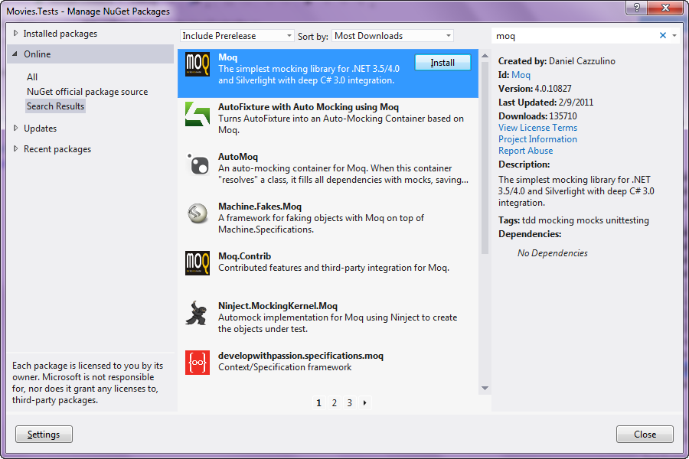

- Right click the Controllers folder in the test project and Add -> Unit Test.

- Highlight the new test file in Solution Explorer and press F2 to rename the file. Name the file ReviewsControllerTests.cs. When prompted to rename all references select “Yes”.

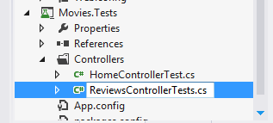
- Inside the test file, change UnitTest1 to Does_Not_Save_Changes_On_Invalid_Model

- Using Moq and the ReviewsController, see if you can figure out a test to ensure the controller doesn’t save a review in an invalid state. The code below is one way to solve the problem.

[TestClass]
public class ReviewsControllerTests
{
private Mock<IMovieData> _mockMovieData;
private Movie _movie;
private List<Movie> _movies;

[TestInitialize]
public void Initialize()
{
_mockMovieData = new Mock<IMovieData>();
_movie = new Movie() { Id = 1, Reviews = new List<Review>() };
_movies = new List<Movie> { _movie };

_mockMovieData.Setup(m => m.Movies)
.Returns(_movies.AsQueryable());
}

[TestMethod]
public void Does_Not_Save_Changes_On_Invalid_Model()
{
var controller = new ReviewsController(_mockMovieData.Object);
controller.ModelState.AddModelError("", "Error!");

controller.Create(1, new Review());

_mockMovieData.Verify(m => m.SaveChanges(), Times.Never());
}

[TestMethod]
public void Save_Changes_On_Valid_Model()
{
var controller = new ReviewsController(_mockMovieData.Object);

controller.Create(1, new Review());

_mockMovieData.Verify(m => m.SaveChanges(), Times.Once());
}
}

- Run your tests to make sure they all pass.

- For extra credit, write tests for the Edit methods, too.

Conclusion
Congratulations! In this lab you created some unit tests and learned how to fake the data access code. You can apply these same techniques on a larger scale to make any application testable.

