The WebAPI
HTTP All The Way Down

The Web API

Objectives
After completing this lab, you should understand how to do the following:

- Create a WebAPI controller
- Invoke the controller from jQuery
- Transform a JSON result into HTML using client templates

Part I – Setup
- Open the Movies solution file inside the before\Movies directory for this lab.
This lab builds on the solution from the AJAX lab. If you’ve completed the lab you can use the application you built in the previous lab instead of opening the solution in the before directory.

Part II – Movie Details
In this section we’ll load data and dynamically update the DOM when a user clicks the Details button. We’ll load in some of the movie details, including review information, and leave another link for the user to go and add a review.

- Add a new class to the Models folder named MovieDetailModel.

- Give the class properties to hold Id, Length, Director, ReviewCount, and AverageReview data.

public class MovieDetailModel
{
public int Id { get; set; }
public int Length { get; set; }
public string Director { get; set; }
public int ReviewCount { get; set; }
public double AverageReview { get; set; }
}

- Give the model class an empty default constructor, and also a constructor that takes a Movie parameter and populates all its properties with data from the movie.

public MovieDetailModel()
{

}

public MovieDetailModel(Movie movie)
{
Id = movie.Id;
Length = movie.Length;
Director = movie.Director;
ReviewCount = movie.Reviews.Count;
if(ReviewCount > 0)
{
AverageReview = Math.Round(movie.Reviews.Average(r => r.Rating), 1);
}
}

- Add a new folder to the project with the name Api.

- Right-click the Api folder and select Add -> Controller.

- Name the controller MovieDetailController. Select the Empty API Controller template.

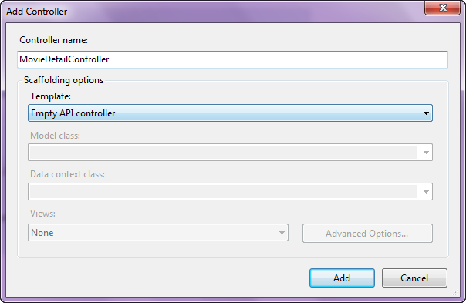

- Add a GetDetail method to the controller that takes an id parameter.

- Inside of GetDetail, find the movie matching the incoming id value, transform the object into a MovieDetailModel, and return the model from the method.

public MovieDetailModel GetDetail(int id)
{
var db = new MovieData();
var movie = db.Movies.Find(id);
var model = new MovieDetailModel(movie);
return model;
}
- Test your API by running the application and navigating to a movie detail (like api/moviedetail/2).

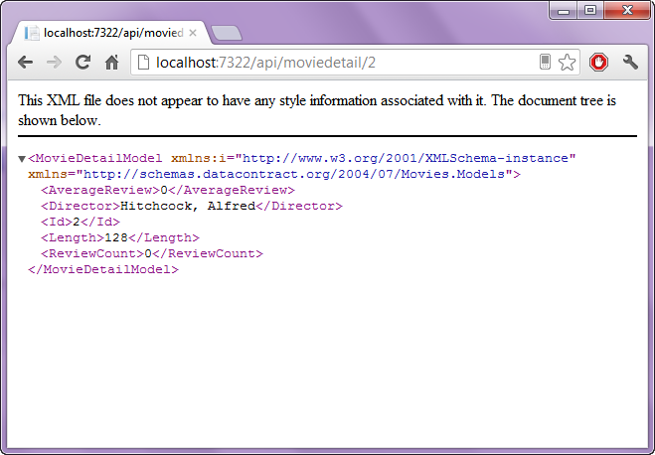

- Open the _MovieTable partial view from the Views/Movies folder.

- Remove Length and Director columns from the table.

- Wrap the display of the movie title in an anchor tag. Give the anchor tag an href that would point to the URL needed to retrieve the movie details (you can use Url.RouteUrl to generate the URL).

<a href="@Url.RouteUrl("DefaultApi",
new {
httproute="",
id=item.Id,
controller="MovieDetail"})"
class="movieLink">
@Html.DisplayFor(modelItem => item.Title)
</a>

The idea is that the user will click on the title, and we’ll bring in more details.

- In the script @section of the Index view for Movies, add some jQuery that will intercept a click on the link and prevent the browser from navigating to the URL.

$(function() {
$(".movieLink").click(function(evt) {
evt.preventDefault();

});
});

- Add additional code the the click event handler that will extract the href of the anchor tag, and use it to send a GET request to your API.

$(function() {
$(".movieLink").click(function(evt) {
evt.preventDefault();

var url = $(this).attr("href");
$.get(url, function(data) {

});

});
});

Once we have the data – what do we do with it? This is where templates come to the rescue.

- Right-click the References node of the Movie project and select Manage NuGet Packages.

- Search online for mustache.js and install mustache.

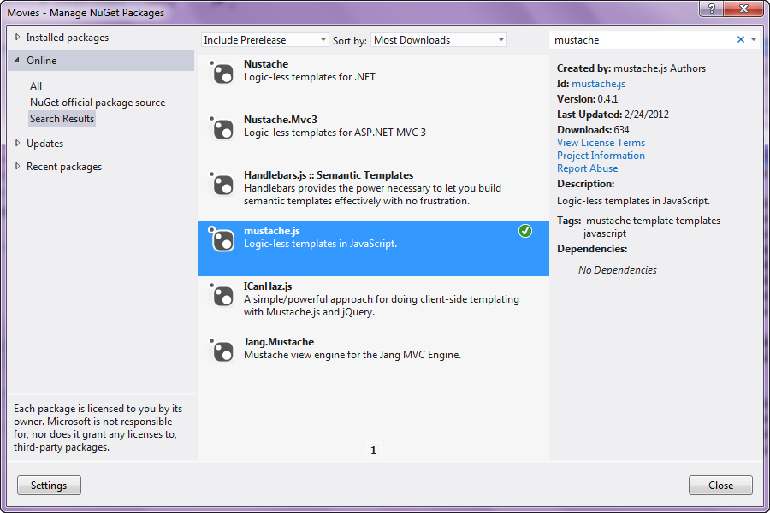

- In the BundleConfig file of App_Start, register a new bundle for mustache.

bundles.Add(new ScriptBundle("~/bundles/mustache")
.Include("~/Scripts/mustache.js"));

At some point we should optimize our scripts by adding more files into fewer bundles. One of the goals of bundling is to reduce the number of downloads.

- Return to the Index view for Movies. Inside the scripts @section, Render the mustache bundle before the script tag with your custom code inside.

@Scripts.Render("~/bundles/mustache")

- Inside the script @section, add another script tag (of type text/html) with a mustache template to render the movie detail data coming back from the WebAPI into a table. Refer to the bottom of https://github.com/janl/mustache.js for help.

- Give the new script tag an id of detailTemplate.

<script type="text/html" id="detailTemplate">
<table>
<tr>
<td>Length</td>
<td>{{Length}}</td>
</tr>
<tr>
<td>Director</td>
<td>{{Director}}</td>
</tr>
<tr>
<td>Reviews</td>
<td>{{ReviewCount}}</td>
</tr>
<tr>
<td>Average Review</td>
<td>{{AverageReview}}</td>
</tr>
</table>
</script>

- Using the Mustache.to_html method, the template you just wrote, and the data you receive from the WebAPI, render a block of HTML with the movie details and append to the table cell containing the movie title (you might need to save a reference to the cell before getting into the AJAX callback).

$(function() {
$(".movieLink").click(function(evt) {
evt.preventDefault();
var url = $(this).attr("href");
var cell = $(this).parent();
$.get(url, function(data) {
var template = $("#detailTemplate").html();
var html = Mustache.to_html(template, data);
cell.append(html);
});
});
});

- Run your application to make sure everything is working.

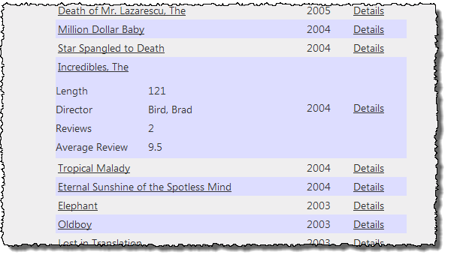

- For extra credit, remove the details if the user clicks the title a second time, and use animations to make the details slide into view (and slide out of view).

Conclusion
Congratulations! You’ve used the WebAPI and client side templates to build an application that is quick to respond to what users want to see!

