The WebAPI
HTTP All The Way Down

The Web API

Objectives
After completing this lab, you should understand how to do the following:
- Create a simple ApiController
- Bind query string data to a controller action paramter
- Unit test a controller
- Call a WebAPI from Powershell

Part I – Creating The Project
In this lab you’ll be working in the before folder where this document exists. A completed solution exists in the after folder, if you want to peak at the final product.

This assumes you are using Visual Studio 2012 with Update 1.

- Open Visual Studio and select File => New Project. Go to Templates => Visual C# => Web and select the ASP.NET MVC 4 Web Application.
- Enter AtTheMovies as the name of the solution, and select the before directory as the location for the solution.
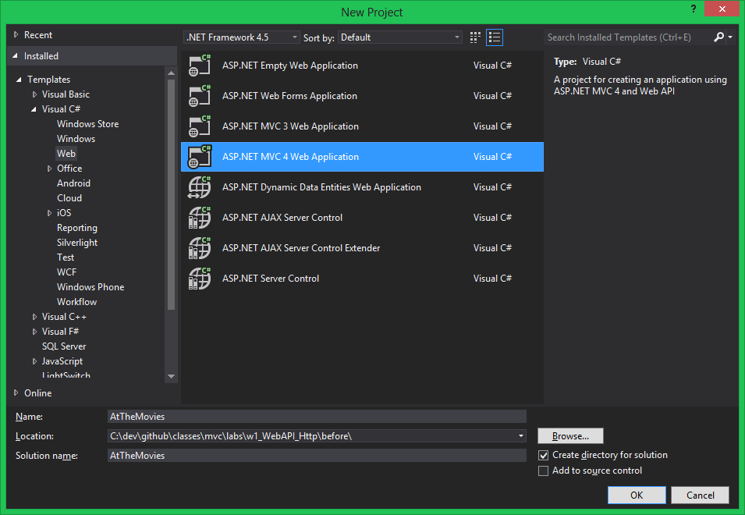
- Press OK to create the project.
- When asked to select a project template, select Empty. Make sure the Razor view engine is selected, and the Create a unit test project checkbox is selected.
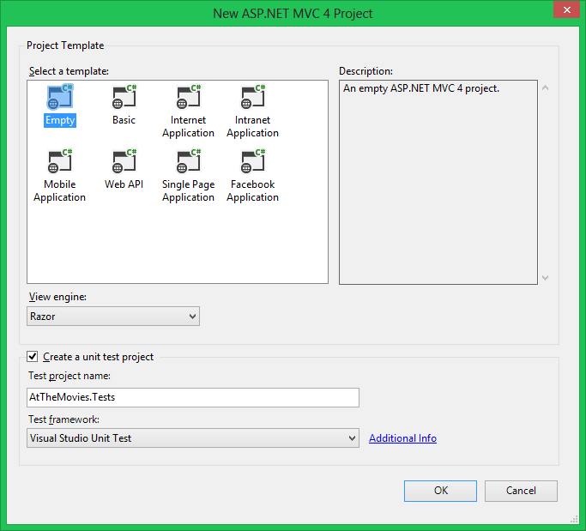

- Once the project is ready, open the Solution Explorer window (Ctrl+Alt+L), right-click the Controllers folder, and select Add -> Controller.
- In the Add Controller dialog, name the controller HelloController, and select the Empty API Controller template. Click Add.
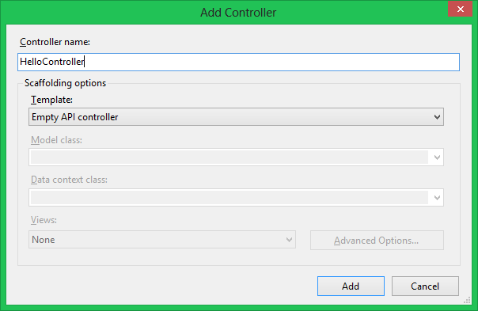
- Add a public method to the controller named GetMessage that returns the string “Hello, World!”.
public class HelloController : ApiController
{
public string GetMessage()
{
return "Hello, World!";
}
}
- Press Ctrl+F5 to run the application without a debugger, and navigate to the controller.
Your browser will probably open at the root of the new web site (‘/’) and display a 404 error message. This is normal. To reach the controller you’ll need to add api/hello to the end of the URL.
- Verify you see the “Hello, World” message.
In Internet Explorer, you might need to open a downloaded .json file to see the message.
- Return to the HelloController and add a 2nd public method named GetMessage. This overloaded GetMessage takes a string parameter named name, and return a greeting like “Hello, Scott!” when invoked (where the value Scott would be the value of the name parameter).
public string GetMessage(string name)
{
return "Hello, " + name;
}
- Refresh the browser while still referencing /api/hello.
The result of this request should still produce the string “Hello, World!”
- Add a query string to the URL like ?name=Scott
The result of this request should produce the string “Hello, Scott!”

Part II – Unit Testing A Controller
Although controllers are programmed to respond to an HTTP request, they have no runtime dependencies on web server infrastructure or a networking stack.

- In the Solution Explorer window, right-click the AtTheMovies.Tests project.
- Select Add -> UnitTest.
- Rename the UnitTest1 class to HelloController_Tests.
- Rename TestMethod1 to Produces_Personalized_Greeting
- Write a test that will instantiate the HelloController, invoke the GetMessage method passing in a name, and asserts the method returns the correct value.
[TestClass]
public class HelloController_Tests
{
[TestMethod]
public void Produces_Personalized_Greeting()
{
var controller = new HelloController();

var result = controller.GetMessage("Scott");

Assert.AreEqual("Hello, Scott!", result);
}
}
- Run the test (Ctrl+R, Ctrl+A), and make any corrections necessary to make the code pass.

Part III – Invoke the WebAPI from PowerShell

- In a PowerShell command prompt, type Get-Help Invoke-RestMethod to see if you can figure out how to call the Hello web service we created earlier.
- Hint: invoke-restmethod –Uri <your localhost address here>
Bonus: Download curl for Windows (http://curl.haxx.se/download.html) and request XML from the service, then request a JSON response.
Unfortunately, invoke-resetmethod and invoke-webrequest in PowerShell don’t allow the Accept header to be modified. curl is an easy utility for crafting requests, and the output can still pipe into a PS pipeline.

