AJAX & ASP.NET MVC
Mixing AJAX into MVC

ASP.NET MVC AJAX

Objectives
After completing this lab, you should understand how to do the following:

- Inject and manage scripts in an ASP.NET MVC applcation.
- Execute client side validation logic.
- Produce and consume JSON data from an MVC controller

Part I – Setup
- Open the Movies solution file inside the before\Movies directory for this lab.
This lab builds on the solution from the MVC Models lab. If you’ve completed the MVC Models lab you can use the application you built in the Models lab instead of opening the solution in the before directory.
- If you already have the movies database installed, skip to step 4.
- Install the movies database by executing the SQL script in the /scripts folder for this collection of labs.
- Run the application and verify you can establish a database connection to the movies database.
If you cannot establish a connection:

The connection string to the movies database for this application is the “MovieContext” connection in the web.config file. If you are comfortable changing this setting then edit the web.config file directly.

If you want some help in establishing a connection, open the Movies.edmx file in the Models directory. Right-click in the designer once the file opens, then select “Update from database”. If the Entity Framework does not connect to the database, it will guide you through the process of setting up a new connection.

Part II – Scripts

- In the Solution Explorer window, open _Layout.cshtml from the shared views directory.
- Verify the view includes a script tag for the jQuery library.
<script src="@Url.Content("~/Scripts/jquery-1.4.4.min.js")" type="text/javascript">
</script>

Adding scripts in this fashion looks slightly more complicated than it should be. Let’s create an HTML helper to make it easier to include scripts.

- Create a new folder in the solution with the name Helpers.
- Right-click the Helpers folder and select Add -> New Class. Name the class ScriptHelpers.
- Implement an extension method for HtmlHelper to generate a script tag given a file name.
It’s ok to assume the scripts will always come from the Scripts directory for now. We’ll consider it a convention. Also – don’t forget to return an MvcHtmlString – otherwise the<script> tag will be eligible for HTML encoding in the view.

public static class ScriptHelpers
{
public static MvcHtmlString Script(
this HtmlHelper helper, string name)
{
var tag = new TagBuilder("script");

tag.MergeAttribute("src",
VirtualPathUtility.ToAbsolute("~/Scripts/" + name));
tag.MergeAttribute("type", "text/javascript");

return MvcHtmlString.Create(
tag.ToString()
);
}
}

Open the web.config file in the Views directory (this is where the Razor configuration lives). Add the namespace for your new HTML helper into the default namespaces for all views.

<system.web.webPages.razor>
<host factoryType="System.Web.Mvc.MvcWebRazorHostFactory, …/>
<pages pageBaseType="System.Web.Mvc.WebViewPage">
<namespaces>
<add namespace="System.Web.Mvc" />
<add namespace="System.Web.Mvc.Ajax" />
<add namespace="System.Web.Mvc.Html" />
<add namespace="System.Web.Routing" />
<add namespace="Movies.Helpers"/>
</namespaces>
</pages>
</system.web.webPages.razor>

- Return to the _Layout.cshtml file. Remove the existing <script> tag. Use the new HTML helper to include jQuery.

<head>
<title>@ViewBag.Title</title>
...
@Html.Script("jquery-1.4.4.min.js")
</head>

- Run the application, and view the HTML source in the browser. You should see the new <script> tags appear in the HTML source code.

Part III- Client Validation
Before you begin this part you might want to run the application and observe how the edit works for a movie review (go to /Movie, click Details on a movie, then click Edit on one of the movie reviews). A review rating is restricted to the values 1 through 10. Since client-side validation is enabled, a value of 99 will show an error message when the rating textbox loses focus.

- Open the root level web.config file.
- Set ClientValidationEnabled to false.

<add key="ClientValidationEnabled" value="false" />

- Try editing a Review again – notice validation only occurs on the server.
- Open the Edit view from the Reviews folder.
- Use the EnableClientValidation helper to turn on client validation for just this view (place this call just before BeginForm).
@{ Html.EnableClientValidation(true); }
@using (Html.BeginForm()) {
...

- Open the ReviewMetadata class from the Models folder.
- Give the Rating a custom error message when the Rating value is out of range.

[Range(1,10, ErrorMessage="Rate the movie from 1 to 9")]

- Run the application and try to enter an invalid review rating (like 11). You should see the error message if you move focus out of the textbox.

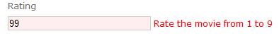

Let’s add a custom validation rule for the Summary property that will work on both the client and the server. This validation rule will make sure the Summary has at most three words in it (using a simple count of space characters in the string).

- Right click the Models directory and select Add -> New Class. Name the class MaxWordsAttribute
- Make the new class derive from the ValidationAttribute class.
- Give the class an integer properties: MaxWords. Set this property from constructor that requires a maxWords parameter.
- Override the IsValid method and use the MaxWords property to validate the incoming parameter as a string (make sure to ignore a null value).

public class MaxWordsAttribute : ValidationAttribute
{
public MaxWordsAttribute(int maxWords)
{
MaxWords = maxWords;
}
public int MaxWords { get; set; }
public override bool IsValid(object value)
{
if (value == null)
{
return true;
}
// simplistic check...
int wordCount = value.ToString().Split(' ').Count();
if (wordCount > MaxWords)
{
return false;
}
return true;
}
}

- Open the ReviewMetadata class from the Models folder.
- Add a Summary property to the class. Add validation attributes to make the field required, and contain a maximum of 3 words. Use a custom error message.

[Required]
[MaxWords(3, ErrorMessage = "Too many words!")]
public string Summary { get; set; }

- Run the application and enter a Summary of more than 3 words. Submit the review and notice the validation only occurs on the server (you can tab out of the summary input without seeing an error).

Next, we are going to add metadata we’ll need to perform client-side validation.

- Open the WordCountAttribute class and make it implement the IClientValidatable interface (from the System.Web.Mvc namespace).

public class MaxWordsAttribute : ValidationAttribute,
IClientValidatable
{

- To implement the interface, we need a GetClientValidationRules method.

public IEnumerable<ModelClientValidationRule>
GetClientValidationRules(
ModelMetadata metadata,
ControllerContext context)
{
}

- Inside the new method we need to build metadata (in the form of a ModelClientValidationRule).

public IEnumerable<ModelClientValidationRule>
GetClientValidationRules(
ModelMetadata metadata,
ControllerContext context)
{
var rule = new ModelClientValidationRule();
rule.ErrorMessage =
FormatErrorMessage(metadata.GetDisplayName());
rule.ValidationParameters["maxwords"] = MaxWords;
rule.ValidationType = "wordcount";
yield return rule;
}

Next, we need to implement some client script that takes the metadata and adapts it to jQuery validation rules.

- Right-click the Scripts folder and create a jScript file named CustomValidations.js.

- Drag and drop references to jQuery, jQuery.validate, and jQuery.validate.unobstrusive into the new script file.

/// <reference path="jquery-1.4.4-vsdoc.js" />
/// <reference path="jquery.validate-vsdoc.js" />
/// <reference path="jquery.validate.unobtrusive.js" />

- Place the following code inside the file.

jQuery.validator.unobtrusive.adapters.addSingleVal(
"wordcount", "maxwords");
jQuery.validator.addMethod("wordcount",
function (value, element, maxWords) {
if (value) {
var wordCount = value.split(' ').length;
if (wordCount <= maxWords) {
return true;
}
return false;
}
return true;
});

22. Include the CustomValidations.js script into the Edit view.

@Html.Script("CustomValidations.js")

- Run the application and verify the client-side validation works.

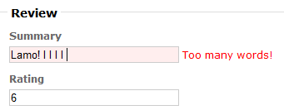

Part IV – Adding jQuery and JSON
In this section we’ll allow the user to click on a movie title to see the average review and number of reviews. To display the information we’ll make a call to the MVC application and retrieve JSON.

- Open MovieController.cs.
- Add a QuickDetails action the movie controller. The action should take an integer id parameter and return an ActionResult.
- Inside the new action, use the MovieContext to create and calculate the values for an anonymously typed object with properties AverageReview and TotalReviews.
- Return the anonymously typed object using the Json method. Set the JsonRequestBehavior to AllowGet.
The Json method will serialize the object into JSON format. By default, HTTP GET requests are disabled in ASP.NET MVC for security reasons (see http://haacked.com/archive/2009/06/25/json-hijacking.aspx). Since we are not transmitting sensitive information, we will allow the GET to take place. The full code for the controller action is shown below:

public ActionResult QuickDetails(int id)
{
var ctx = new MovieContext();
var detail =
ctx.Movies
.Where(m => m.ID == id)
.Select(m => new
{
AverageReview = m.Reviews.Average(r => r.Rating),
TotalReviews = m.Reviews.Count
})
.Single();

return Json(detail, JsonRequestBehavior.AllowGet);
}

In the next section we’ll be using jQuery templates. First, we’ll need to install the jQuery templates script.

- Right-click on the Movies project and select “Add Library Package Reference”.

- Search the NuGet official feed for “templates”.

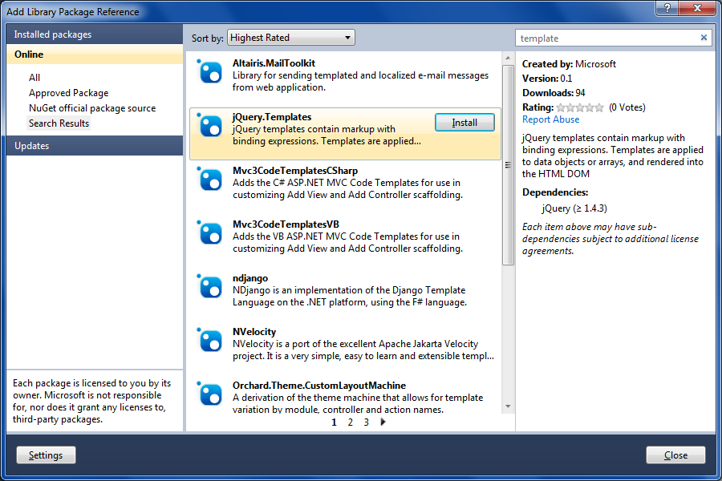

- Select jQuery.Templates and click Install.

This step should install jQuery.tmpl.* files into your scripts directory. Before we can interact with the view using script, we’ll need to add some more information to the Index view. This additional information will give us the data we need on the client side to locate movie titles and call QuickDetails action with the proper ID.

- Open the Index view for movies.
- On the <td> where a movie title appears, add a class movieTitle, and give the <td> an id attribute with the value of the movie ID.

<td class="movieTitle" id="@item.ID">
@item.Title
</td>

The class will allow jQuery to find all the elements where a movie title appears.

- At the bottom of the Index view, place the following “template” code.

<script id="detailTemplate" type="text/x-jquery-tmpl">
<span class="detail">
Rating: ${AverageReview}
Total Reviews: ${TotalReviews}
</span>
</script>

- Right-click the Scripts folder and add a new script file named MovieDetail.js.
- Add Intellisense references for jQuery, and jQuery templates to the top of the new script file.

/// <reference path="jquery-1.4.4-vsdoc.js" />
/// <reference path="jQuery.tmpl.js" />

- Use jQuery to hook the document ready event.

$(document).ready(function () {

});

- Using jQuery, add a hover effect to all elements with the movieTitle class. When hovered, set the text-decoration style to “underline”. When un-hovered, set the text-decoration style to “none”.

$(document).ready(function () {

$(".movieTitle")
.hover(
function () { $(this).css("text-decoration", "underline") },
function () { $(this).css("text-decoration", "none") });

});

- Also add a click event handler to every element with the movieTitle class. The event handler should call a function named showMovieDetail.

$(document).ready(function () {

$(".movieTitle")
.hover(
function () { $(this).css("text-decoration", "underline") },
function () { $(this).css("text-decoration", "none") })
.click(showMovieDetail);
});

- Implement showMovieDetail using the jQuery getJSON method to invoke QuickDetails. When JSON is retrieved, you can build and append additional HTML to the table cell to display the JSON data. Use the following code as a guide.
function showMovieDetail() {
var element = $(this);
var data = { id: element.attr("id") };
$.getJSON("Movie/QuickDetails", data,
function (detail) {
$("#detailTemplate").tmpl(detail)
.appendTo(element);
});
}

- Return to the Index view and inject the MovieDetail.js script, and jQuery templating script into the view (you can place these at the top of the view).

@Html.Script("jQuery.tmpl.js")
@Html.Script("MovieDetail.js")

- Run the application and test the new functionality.

- For extra credit, perform a check to prevent a second click from displaying a second result for a user.

Conclusion
In this lab we’ve looked at managing scripts, client-side validation, and making JSON requests to an ASP.NET MVC application. We’ve seen how jQuery integrates nicely with MVC on the client-side, but we’ve only scratched the surface of jQuery’s capabilities. If you have the time, find a new plugin from the jQuery website that you can use with this application, and give it a try.

