ASP.NET MVC Controllers
Putting the C in MVC

ASP.NET MVC Controllers

Objectives
After completing this lab, you should understand how to do the following:

- Create a controller derived class with actions
- Apply selector filters
- Apply action filters

Part I – Creating a GuestBook Controller
In this lab we will be working in the before directory where the lab is located. A completed version of the application exists in the after directory.

- Open Visual Studio and click File -> New Project.
- Go to the Web project type under Visual C# and click the ASP.NET MVC 3 Web Application template. Give the application the name Controllers, and select the before directory of this lab as the location.
- In the project dialog, select the “Internet Application” template.
In this application, we will focus on building controllers for a web site that uses a guestbook feature. User will be able to add their name to the guest book, and view other guests. First, we’ll need some classes to model a guestbook and its entries.

- Go to the Solution Explorer window. Right-click on the Models folder and select Add -> Class.
- Name the file GuestEntry.
- Give the file two string properties – Name and Entry.
public class GuestEntry
{
public string Name { get; set; }
public string Message { get; set; }
}

- Right-click on the Model folder and select Add -> Class.
- Name the file GuestBook.
We’ll keep the scenario simple - the guestbook we are going to build will only hold items in memory.

- Use the following code to store the guest book entries.

public class GuestBook
{
public IEnumerable<GuestEntry> Entries
{
get { return _entries; }
}

public void Add(GuestEntry entry)
{
_entries.Add(entry);
}

static List<GuestEntry> _entries = new List<GuestEntry>();
}

Note: You would not want to use a static field in a real application without making your class safe for multi-threading. In later labs, we’ll be using SQL Server to persist our data, but for now we are focused on controllers and trying to keep other areas simple.

We are ready to add some controllers and views.

- Right-click the Controllers directory and select Add -> Controller.
- Name the controller GuestEntryController. Leave the check box unchecked.
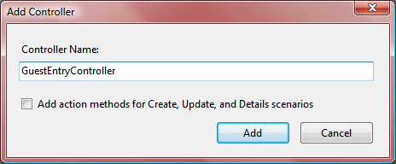
We will work in the Index action first. By default, an action will return an ActionResult object. There are a number of useful classes derived from ActionResult. For example, a JsonResult object allows us to return JSON formatted data in the request. JSON is an easy format to consume from JavaScript, and the AJAX module of this course will show you how to use JSON.

Another example is a ViewResult. A ViewResult allows us to render a view and send the resulting HTML to the client. Since we expect our Index action will only render views, we’ll change the return type of our Index action to match this expectation.

- Change the return type of the Index action to ViewResult.

public ViewResult Index()
{
return View();
}

Remember - an action method needs no special attributes or signature. Any public method on a controller class is eligible to be an action.

- Add a using statement in the file for Controllers.Models.
- Inside the Index action, use GuestBook to retrieve all entries and pass them as the model to the default view.

public ViewResult Index()
{
var book = new GuestBook();
return View(book.Entries);
}

There are overloaded versions of the View() function you can use to specify the view name the view engine should select. When we do not specify the name, the MVC framework selects the default view for this action. The default view will have the same name as the controller action.

- Build your project. (Shift+Ctrl+B).
Since we want to use a strongly-typed view, we’ll build the project to ensure the view wizard can see the new types we’ve defined in the project.

- Right-click the Views folder and select Add -> New Folder.
- Give the new folder the name GuestEntry.
- Right-click the GuestEntry folder and select Add -> View.
- Create a strongly typed view named “Index”. The Model class should be GuestEntry, the Scaffold Template should be a List.
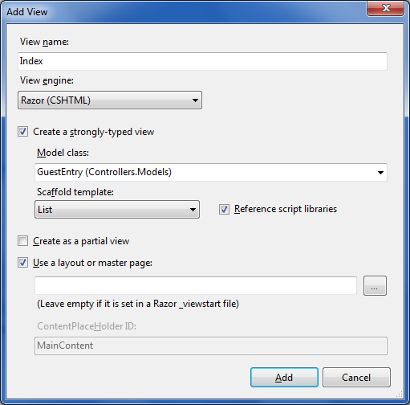

- After pressing Add, run your project (Ctrl+F5) and navigate to /GuestEntry. Verify that the GuestEntry Index view displays an empty table.
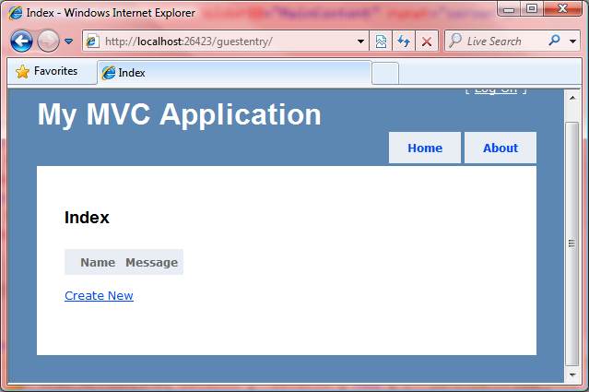

- Navigate to /GuestEntry/Index. You should still see the empty table result.
Remember the default route provided in a new MVC application will specify a default controller action of Index. In the next few steps, we’ll add a custom route for our GuestEntryController. We want to use “List” as the default controller action for our guest entries.
- Open global.asax.cs in Visual Studio.
- Inside of the RegisterRoutes method, add a new routing entry to make List the default controller action. This new route should only affect a request destined for the guest book controller.
routes.MapRoute(
"GuestEntry",
"GuestEntry/{action}/{id}",
new { controller="GuestEntry", action = "List", id = "" }
);

Keep in mind that the above route must appear before the Default route. In general, you want map specific routes before the more general “catch-all” routes like Default.
- Run the application again with Ctrl+F5.
- Navigate to /GuestEntry. This time you should see a 404 error, because the MVC framework cannot find a List action. Leave your browser open and return to Visual Studio.
- Open GuestEntryController.cs
- Add an ActionName attribute to the Index method to alias the method as the List action.

[ActionName("List")]
public ViewResult Index()
{
var book = new GuestBook();
return View(book.Entries);
}

- Build the project and refresh your browser. This time you should see an error that the view “List” could not be found.

This error is a clue that the framework calculates the default view name for a controller action using the action name and not the name of the method that implements the action.

- Fix the last error by explicitly specifying the name of the view in the ViewResult.

[ActionName("List")]
public ViewResult Index()
{
var book = new GuestBook();
return View("Index", book.Entries);
}

- Build your project and refresh the browser again. This time you should see a successful response with an empty table. Close the browser.
Let’s add a link to the home page so we can navigate directly to the list of guest book entries.

- Open Index.cshtml from the Home controller’s View directory.
- Use the ActionLink method of the Html helper to render a link at the bottom of page. The link should direct the user to the list of guest book entries.

<p>
@Html.ActionLink("View my guest book",
"List", "GuestEntry")
</p>

- Build and run the application. Click your new link to ensure it takes you to the list of guest book entries.

Part II – Signing the Guestbook
- Return to visual studio and add a public Create method to your GuestEntry controller that returns a ViewResult. The action should return the default view for itself.
public ViewResult Create()
{
return View();
}

- Right-click the GuestEntry Views folder and select Add -> View.
- In the Add View dialog set the name of the view to Create. Select the GuestEntry class as the Model class, and set the Scaffold Template to Create.
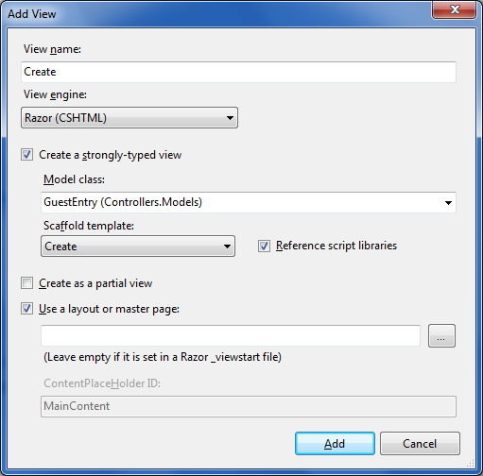

- At the bottom of the new view, you’ll find ActionLink to take the user back to the Index action. Change this ActionLink to point to List action instead.
@Html.ActionLink("Back to List", "List")

We now have a view that will allow us to post back values to the server and create a new guest book entry. What we need next is a controller action to receive the postback values and add the new entry to the guest book.

- Return to the GuestEntryController.cs and add a second Create method. This method should return an ActionResult (not a ViewResult) and take a GuestEntry object as a parameter.
- In the body of the new Create method, construct a new GuestBook object and add the incoming entry to the GuestBook.
- For the new Create method, instead of returning a view, use the RedirectToAction method to return a result that will redirect the client to the List action.

public ActionResult Create(GuestEntry entry)
{
var book = new GuestBook();
book.Add(entry);

return RedirectToAction("List");
}

There is something missing in the above code. Can you spot it?
- Build and run your application. Navigate to the Create view.
You should see an exception saying there are ambiguous action methods. The overloaded Create method is confusing the action invoker. We need to differentiate the Create method we need invoked during a GET request from the Create method we need invoked during a POST request. We can differentiate the two using action selector attributes.
- Add an [HttpPost] attribute to your latest Create method to identify the method as the destination for an HTTP POST.

[HttpPost]
public ActionResult Create(GuestEntry entry)
{
var book = new GuestBook();
book.Add(entry);
return RedirectToAction("List");
}

- Build and run your application. You should now be able to sign the guest book, and see list of all the guests.

Part III – Handling Errors with an Action Filter
- Open GuestBook.cs
- Insert the emphasized code below into the Add method.
public void Add(GuestEntry entry)
{
if (entry.Name == "Fido")
{
throw new InvalidOperationException(
"No dogs allowed");
}
_entries.Add(entry);
}

- Run the application and try to add “Fido” to the guest book. You should see an error screen like the following.
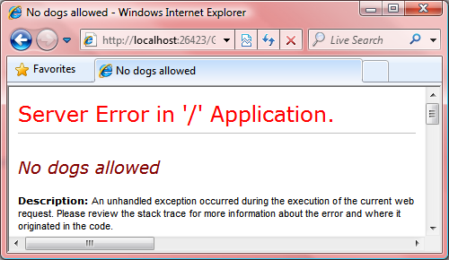

By default, the MVC framework only includes this detailed error information when the request originates from the same machine. To see the same error message our users will see, we need to change the <customErrors> configuration.

- Open the web.config file in the root of your application.
- Add a <customErrors> section inside of <system.web>
- Set the mode attribute of the <customErrors> section to “On”.

<system.web>

<customErrors mode="On" />

<!-- ... -->

- Run the application and try to enter Fido into the guest book. You should see a different error message.
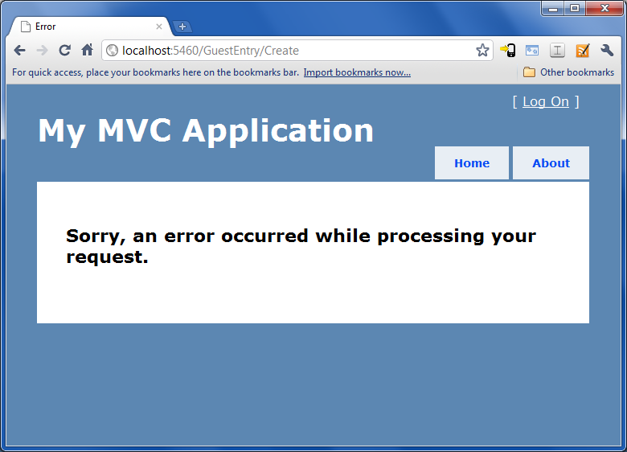

This “pretty” error view is available because the HandleError action filter is installed as a global action filter. Let’s remove it.

- Open global.asax.cs. Comment out the line of code adding HandleError to the global filters collection.

public static void RegisterGlobalFilters(
GlobalFilterCollection filters)
{
// filters.Add(new HandleErrorAttribute());
}

- Run the application again, and enter the name Fido into the guestbook. You should see a third type of error screen.

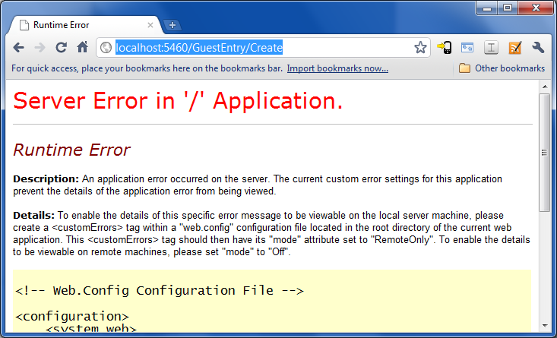

By default, ASP.NET does not show detailed information about an exception when custom errors are turned on. Detailed information would include a stack trace and exception messages. Exceptions might contain sensitive information about the location of files or the name of a database. Publishing this information during an error might give a malicious user some information they can use against you.

- Return to GuestEntryController and add a HandleError attribute to the Create action that receives an HTTP POST.

[HandleError]
[AcceptVerbs(HttpVerbs.Post)]
public ActionResult Create(GuestEntry entry)
{
var book = new GuestBook();
book.Add(entry);

return RedirectToAction("List");
}

HandleError is an action filter. We can place this attribute on individual actions, or on the controller class itself. When we place the attribute on the controller, the attribute is in effect for all actions that execute in the controller.

- Run the application and try to enter Fido into the guest book. This time you should see the custom error page again.
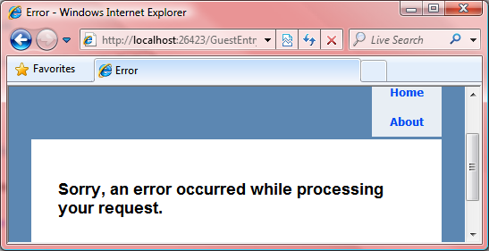

The default error view is the Error.cshtml file in the Shared views directory. You can open this file and modify the text to customize the error message. You’ll also have access to the exception information in this view.
Note the if you change the custom error mode back to “Off” or “RemoteOnly”, at this point, you’ll once again see detailed error information for local requests.
- Finished! For extra credit, create a controller action that will clear the contents of the guest book.

