ASP.NET MVC Models
Putting the M in MVC

ASP.NET MVC Models

Objectives
After completing this lab, you should understand how to do the following:

- Create an ADO.NET Entity Data Model
- Use the MVC framework to provide edit and validation logic for a basic model.
- Use model templates

Part I – Setting Up a Database
In this lab we will be working in the before directory where the lab is located. A completed version of the application exists in the after directory.

- This movie requires the moviereviews database. If you’ve already installed the database you can skip to Part II.
- To install the database, execute the SQL commands in the \Scripts\moviereviews.sql file. You can execute the script file using SQL Management Studio, sqlcmd, or any other SQL tool.

Part II – Creating an Entity Data Model
- Open Visual Studio and create a new ASP.NET MVC application in the before directory of this lab. Name the project “Movies”.
- Right-click the Models folder in Solution Explorer and select Add -> New Item.
- In the Add New Item dialog, select the ADO.NET Entity Data Model item. Give the new model the name of Movies.edmx.
- In the first screen of the Entity Data Model wizard, highlight the Generate From Database icon and click Next.
- In the next step of the wizard, you’ll need to configure a connection to the moviereviews database.
The connection may already be available if you’ve previously worked with the database, otherwise, click on the New Connection button to configure the connection. Move to the next step once the connection is ready and tested.
- In the next step (Choose Your Database Objects), check the checkbox next to the Tables entry to select all tables in the database. At the bottom of the dialog, set the Model Namespace to MovieReviewsModel, and then click Finish.
You should now see the entity designer appear. The shapes in the entity designer represent classes the entity framework will use to carry data from the database. Unfortunately, these class names will be plural because the underlying table names are plural, but each instance of the class will represent only a single entity. We’ll fix this problem, and a few others, in the designer.
- Right click on the Movies entity and select Properties to open the properties window. Change the Name property to Movie, and the Entity Set Name property to Movies.
While the Name property represents the name of the class, the Entity Set Name represents the name of a property on our entity container that we use to access all the entities. We want singular class names (because we want to work with individual Movie objects) and plural entity sets (because we’ll query for a movie from the Movies property that represents all available movies in the database).

The designer should now look like the following:
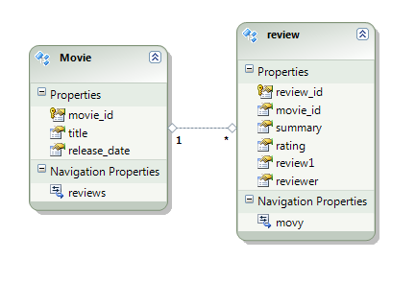
Another problem with the entity data model is how the property names for our entities match the column names in the database (the ID for a movie is move_id). These lowercase and underscored properties don’t match what we expect for properties on a CLR object, so we’ll need to make some additional changes.

- Continue using the designer to fix the names of the entities and their properties. The “Reviews” entity should be named “Review”, “movie_id” should be “ID”, and so on. When naming the “review” property of the Review entity, change the name to “Body” so it does not clash with the entity name of “Review”. Also, make sure the Entity Set Name of the Review entity is set to Reviews.
Hint: Clicking on a name inside the entity shape and pressing F2 will allow you to use inline editing. You can also click on a name and begin typing to replace the existing name entirely.

- We also need to change the name of the Navigation Properties in each entity. In the Movie entity, we want a property named Reviews to find a movie’s associated reviews. In the Review class, we want a property named Movie to find a review’s parent (this should not be plural since each review is associated with a single movie). You’ll need to make these name changes in the properties window.
After all the editing is finished, the designer should look like the following.

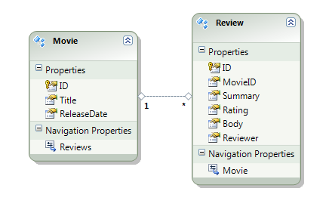
- Right-click in the white space of the designer and select Properties.
- Change the Entity Container Name property from moviereviewsEntities to MovieContext.
The entity container is the class we’ll instantiate to query for movies and reviews.
- Build the project (Shift+Ctrl+B) to ensure there are no errors.

Part II – Building the Movie List
- Right-click the Controllers folder and select Add -> Controller.
- Name the controller MovieController and leave the checkbox to add action methods unchecked.
- In the new MovieController.cs, add a using clause for Movies.Models.
- Add an Index action to the new controller. Inside, use the MovieContext class in a LINQ query to return the most recent 25 movies. Use these movies as the model for the default view.
Public ActionResult Index()
{
var ctx = new MovieContext();
var movies = ctx.Movies
.OrderByDescending(m => m.ReleaseDate)
.Take(25);
return View(movies);
}

- Right-click inside the Index action and select Add -> View.
- Name the view Index. Create a strongly-typed view for the Movie class using the List scaffold template.
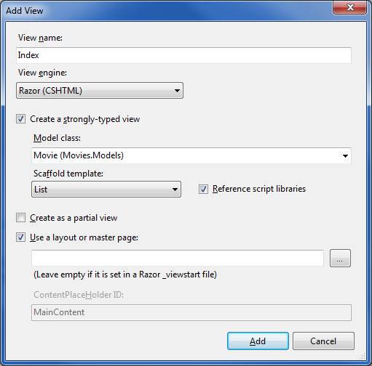
- Remove the action links for editing and deleting movies.
- At the top of the view, remove the link to create a new movie.
We’ll focus on editing and adding reviews instead of movies.

- In the table cell that displays the ReleaseDate, change the formatting string from g (date and time) to d (short date format).
@String.Format("{0:d}", item.ReleaseDate)

- Open the Views/Shared/_Layout.cshtml file.
- In the application’s menu, add a new list item to display a link the movie controller’s index action.
<li>@Html.ActionLink("Movies", "Index", "Movie")</li>

- Run the application (Ctrl+F5) and navigate to the movie list. If the application is working as expected, move on to Part III.
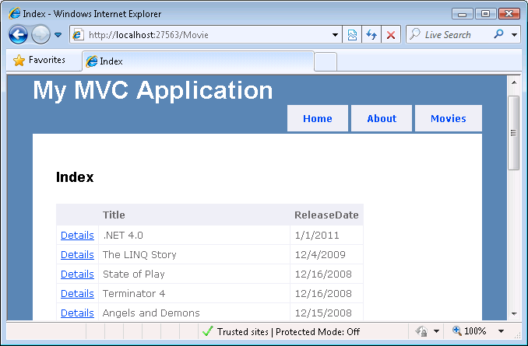

Part III – Details
- Open MovieController.cs
- Add a Detail action to the movie controller. The action will take an id parameter of type int.
- Use the MovieContext class in the Detail action to load a movie (specified by the id parameter) and eagerly load it’s associated reviews. Pass this model to the default view.
Eager loading with the ADO.NET Entity Framework is accomplished with the Include operator.
public ActionResult Details(int id)
{
var ctx = new MovieContext();
var movie = ctx.Movies
.Include(“Reviews”)
.Where(m => m.ID == id)
.First();
return View(movie);
}

- Right-click the Views\Movie folder and select Add -> View.
- Name the view Details, and make it a strongly-typed view for the Movie class. Set the Scaffold Template to Details.
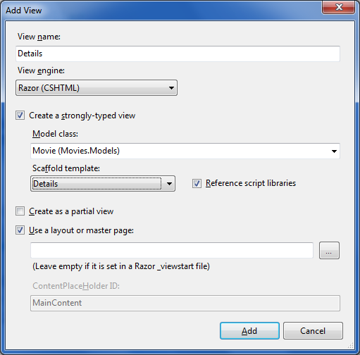
- Inside the new view, change the ReleaseDate format string from g to d.
- Remove the ActionLink used to display a link to edit the movie.
- The view code should now look like the following,

@model Movies.Models.Movie
@{
ViewBag.Title = "Details";
}
<h2>Details</h2>
<fieldset>
<legend>Movie</legend>
<div class="display-label">Title</div>
<div class="display-field">@Model.Title</div>
<div class="display-label">ReleaseDate</div>
<div class="display-field">@String.Format("{0:d}",
Model.ReleaseDate)</div>
</fieldset>
<p>
@Html.ActionLink("Back to List", "Index")
</p>

- Underneath the movie <fieldset>, displays all the reviews for a movie. One way to do this is to use the following code.
<h2>Reviews</h2>
<table>
<tr>
<th>Reviewer</th>
<th>Rating</th>
</tr>
@foreach (var review in Model.Reviews) {
<tr>
<td>@review.Reviewer</td>
<td>@review.Rating</td>
</tr>
}
</table>

- Run the application to verify the new details functionality. Move onto step 4 once the functionality is verified!

Part IV – Annotations

- Open the Details view for the Movie controller.
- Replace all the markup used inside the fieldset to display movie information with a call to Html.DisplayForModel(). The code should look like the following:

<fieldset>
<legend>Movie</legend>
@Html.DisplayForModel()
</fieldset>

- Run the application and inspect the Details view for a movie.
DisplayForModel hasn’t improved our interface (although we do have a smaller amount of markup to worry about), but by using DisplayForModel we can add fields to a Movie and have them appear without modifying every view displaying movie details. Let’s create a partial Movie class to augment the Movie class generated by the Entity Framework and add additional properties.

- Right-click the Models folder and select Add -> New Class. Name the file Movie.cs
- Add the partial modifier to the class, and make sure it is in the Movies.Models namespace.
This partial class definition will combine with the partial class definition generated by the Entity Framework to define a single Movie class.
- Add an AverageReview property to the Movie class (of type double). Implement the property by averaging the Rating property of the movie’s Reviews.

public partial class Movie
{
public double AverageReview
{
get
{
return Reviews.Average(r => r.Rating);
}
}
}

- Run the application and navigate to the details for a movie. You should see an average review.

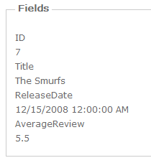
The AverageReview label shouldn’t display as a single word (neither should ReleaseDate). We’ll fix the display of the ReleaseDate label in the next step.
- Use the DisplayName attribute on the AverageReview property to generate a proper label (“Average Rating”). Use the DisplayFormat attribute so the rating will display with two digits after the decimal point (N2 format). Note: you’ll need the System.ComponentModel and System.ComponentModel.DataAnnotations namespaces in scope.

[DisplayName("Average Rating")]
[DisplayFormat(DataFormatString="{0:N2}")]
public double AverageReview
{
get
{
return Reviews.Average(r => r.Rating);
}
}

- Run the application again to verify the average rating appears with the correct format.

Next we want to fix the display of the ReleaseDate property. This fix isn’t quite as easy because the ReleaseDate property is in code generated from the Entity Data Model designer. We can add attributes to this generated code, but the next time the model changes our attributes will be erased. Fortunately, there is a solution to this problem. The MetadataType attribute allows you to define another class that will provide additional metadata for a given model. The type providing the metadata will need properties with the same name and type as the properties we want to influence on the original model class. We’ll use this approach in the next section.

- Right click on the Models folder and select Add -> New Class. Name the class MovieMetadata.
- Define a ReleaseDate property on the new class with a type of DateTime.
This property matches the definition of ReleaseDate on the Movie class.

- Decorate the ReleaseDate property with DisplayName and DisplayFormat attributes. The label when displaying the date should be “Release”, and the date should use a short date format (“d”).

public class MovieMetadata
{
[DisplayName("Release")]
[DisplayFormat(DataFormatString="{0:g}")]
public DateTime ReleaseDate { get; set; }
}

- Open the Movie.cs file we created earlier. Add the MetadataType attribute to the Movie class, and specify MovieMetadata as the metadata class type.

[MetadataType(typeof(MovieMetadata))]
public partial class Movie
{
// ...
}

- Run the application one more time to verify the latest changes.

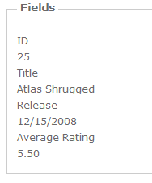

- While running the application, view the HTML source of the Movie detail view (Page -> View Source in Internet Explorer).
Notice the label div elements for the movie properties use the CSS class “display-label”, while the values display inside a div with a class of “display-field”.

- In the Solution Explorer, open the Site.css file in the Content directory.

- Modify the *-label styles to use a bold font.

/* Styles for editor and display helpers
----------------------------------------------------------*/
.display-label,
.editor-label
{
font-weight:bold;
margin: 1em 0 0 0;
}

- Run the application to verify the style change.

Part V – Templates

In this section we’ll customize the display of movie details even further by using a template.

- Create a folder with the name DisplayTemplates in the Views/Movie folder.
- Right-click the DisplayTemplates folder and select Add -> View.
- Name the view Movie. Make the view a partial view, and strongly typed the view to the Movie type.

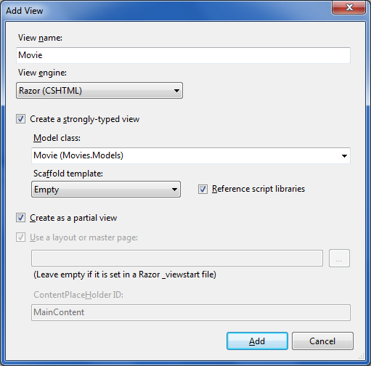

- In the template, use your own design to display the properties of a movie. Note: you can DisplayFor and LabelFor HTML helpers on individual properties to render them according to their metadata format. A sample template is shown below.

@model Movies.Models.Movie
<h3>@Model.Title</h3>
<hr />
<div>
<span class="display-label">Release: </span>
<span class="display-value">
@Html.DisplayFor(m => m.ReleaseDate)
</span>
</div>
<div>
<span class="display-label">Rating:</span>
<span class="display-value">
@Html.DisplayFor(m => m.AverageReview)
</span>
</div>

Using the above template will render the following output:

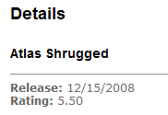

Part VI – Edit Reviews
- Return to the Details view for a movie and add a new column to the table displaying the reviews. The column should display an Edit link that will take the user to the Edit action of the ReviewController (which we’ll implement later). The link will need to pass the review’s ID as a route parameter.

<table>
<tr>
<th>Reviewer</th>
<th>Rating</th>
<th></th>
</tr>
@foreach (var review in Model.Reviews) {
<tr>
<td>@review.Reviewer</td>
<td>@review.Rating</td>
<td>@Html.ActionLink("Edit", "Edit", "Review",
new { id=review.ID }, null)
</td>
</tr>
}
</table>

Note: all the overloaded versions of ActionLink can make life difficult. Make sure you are using the correct version. It’s easy to pass a controller name parameter into a route values or html attributes parameter, because those parameters are accepted as type object.

- Right-click the Controllers folder and select Add -> Controller.
- Name the controller ReviewController and leave the checkbox for additional controller actions unchecked.
- Add a using statement for Movies.Models to ReviewController.cs.
- Remove the Index action from the new review controller.
- Add an Edit action to the controller to respond to the initial GET request for an edit action. The action will take an id parameter, and load the requested review into the default view. Eagerly load the review’s associated movie.

public ActionResult Edit(int id)
{
var ctx = new MovieContext();
var review =
ctx.Reviews
.Include("Movie")
.Where(r => r.ID == id)
.First();

return View(review);
}

- Right-click inside the Edit action and select Add -> View.
- Create a strongly-typed view for the Review class named Edit. Set the initial view content to Edit.
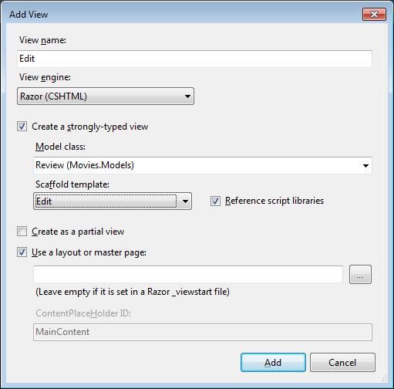
- In the new Edit view, remove the divs that allow the user to edit the MovieID.
- At the bottom of the view, change the “Back to List” action link to return to the details of the parent movie.
<div>
@Html.ActionLink("Back to " + Model.Movie.Title,
"Details", "Movie", new { id = Model.MovieID },
null)
</div>

- Return to the ReviewController and write an action that will accept a posted review. Use TryUpdateModel for moving data values into a review you retrieve from the MovieContext. Save the review and redirect back to the parent movie details if the update is successful.

[HttpPost]
public ActionResult Edit(int id, FormCollection c)
{
var ctx = new MovieContext();
var review =
ctx.Reviews
.Include("Movie")
.Single(r => r.ID == id);
TryUpdateModel(review);
if (ModelState.IsValid)
{
ctx.SaveChanges();
return RedirectToAction("Details", "Movie",
new { id = review.Movie.ID });
}
return View(review);
}

- Run the application and test your new edit functionality.
As you are testing the edit functionality, try updating a review with a rating of 99. Since we don’t have any validation for a review, the application will accept the number. Unfortunately, we only want ratings between 1 and 10.

Part VII – Validation

- Right-click the Models folder and select Add -> Class.
- Name the class ReviewMetadata.
- Add a property on the metadata class to represent the rating of a review (the type is int).
- Add data annotation attributes to indicate that rating is a required property, and the legal values are between 1 and 10.
public class ReviewMetadata
{
[Required]
[Range(1,10)]
public int Rating { get; set; }
}

- Right-click the Models folder and select Add -> Class.
- Name the class Review.
- Make the Review class a partial class.
- Decorate the Review class to send the runtime to the ReviewMetadata class when metadata is required.
[MetadataType(typeof(ReviewMetadata))]
public partial class Review
{

}

- Run the application to verify the new validation behavior.
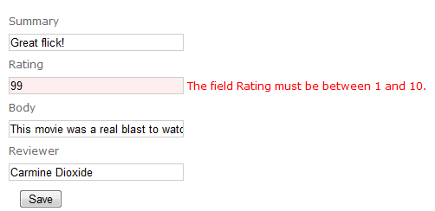

Conclusion
Congratulations! You’ve successfully built an edit screen for the movie reviews. If you are looking for an additional challenge, build functionality that will let users create and delete reviews, too.

