TDD with ASP.NET MVC
Red-Green-Refactor

TDD with ASP.NET MVC

Objectives
In this module we’ll go back and rebuild the Movie controller using unit tests. After completing the module you should understand how to:
- Create a test project
- Create and execute unit tests
- Use fake objects to simulate data access

Part I – Setup
- Open the Movies solution file inside the before\Movies directory for this lab.
This lab builds on the solution from the MVC AJAX lab. If you’ve completed the MVC AJAX lab you can use the application you built in the AJAX lab instead of opening the solution in the before directory.
- If you already have the movies database installed, skip to step 4.
- Install the movies database by executing the SQL script in the /scripts folder for this collection of labs.
- Run the application and verify you can establish a database connection to the movies database.
If you cannot establish a connection:

The connection string to the movies database for this application is the “MovieContext” connection in the web.config file. If you are comfortable changing this setting then edit the web.config file directly.

If you want some help in establishing a connection, open the Movies.edmx file in the Models directory. Right-click in the designer once the file opens, then select “Update from database”. If the Entity Framework does not connect to the database, it will guide you through the process of setting up a new connection.

Part II – Test Project
- Right-click the Movies Solution in the Solution Explorer window and select Add -> New Project
- Select Test Project under the Visual C# -> Test templates.
- Name the project Movies.Tests
- After Visual Studio creates the project, delete the UnitTest1.cs file that comes with the project by default.
- Add a reference to the Movies project from the Movies.Tests project.
- Add a reference to the System.Web.Mvc assembly from the .NET tab.
- Add a reference to the System.Data.Entity assembly (found on the .NET tab in the Add Reference dialog).

In this section we are going to revisit the MovieController and build it by first writing unit tests.

- Open MovieController.cs and delete all of the methods inside.

public class MovieController : Controller
{

}

- Right-click the Movies.Tests project and select Add -> Class. Name the file MovieControllerTests.cs and mark the new class as public.
- Add a using at the top of the file for the Microsoft.VisualStudio.TestTools.UnitTesting namespace.

Part III – The Index Action
In this lab we are going to organize our tests around specific scenarios, like testing the behavior of the Index action method. We’ll use the MovieControllerTests class as a base class for all the scenarios we test (Index, Details, QuickDetails), and write derived classes to test each specific scenario. In general, this approach leads to smaller, more focused test classes that are easier to read and maintain.

We’ll start by creating some context for our tests, then writing some tests describing the behavior of the Index action. We can think of these tests as executable specifications.

- Add a constructor to the MovieControllerTest class. Inside the constructor initialize a protected _controller field with a new instance of the MovieController.

public class MovieControllerTests
{
public MovieControllerTests()
{
_controller = new MovieController();
}

protected MovieController _controller;
}

- In the MovieControllerTests.cs file, create a class derived from MovieControllerTests. Name the class When_displaying_the_list_of_movies, and decorate the class with the [TestClass] attribute.

[TestClass]
public class When_displaying_the_list_of_movies
: MovieControllerTests
{

}

- Add a test method to the class: should_render_the_default_view.

[TestMethod]
public void should_render_the_default_view()
{

}

- Inside the new test, invoke the controller’s Index method and assert that the ViewResult it returns includes an empty ViewName property.

Note: At this time the Index action doesn’t exist, so the IDE will think you have an error.

[TestMethod]
public void should_render_the_default_view()
{
var result = _controller.Index();

Assert.IsTrue(result.ViewName == "");
}

- Movie the cursor to the Index method call and press Ctrl+., you should be able to press enter to automatically generate a method stub for Index method in the movie controller.

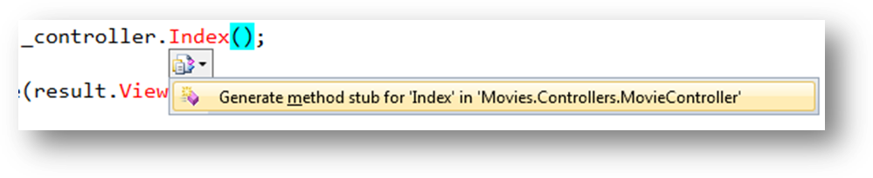
- Switch to the Index method in the movie controller and change the return type to ViewResult. Instead of throwing an exception, return null.

public ViewResult Index()
{
return null;
}

- Run all tests (Ctrl+R, A) – the new test should fail.

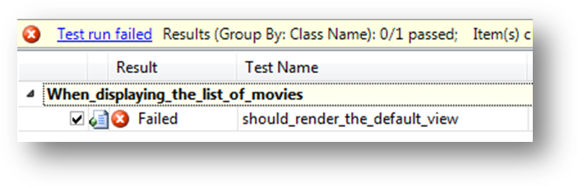

- Return to the Index action and return View() instead of null.
- Run all tests again – the new test should pass.

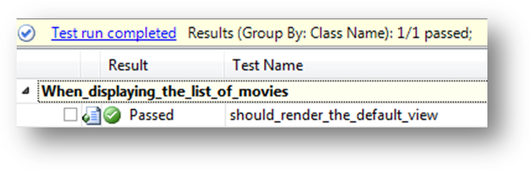
Now we’ll move on to the next test. We’re going to add paging functionality to the list of Movies, and to add paging we’ll use classes from the MvcContrib project. We’ll require data access code, which we’ll want to fake for unit test purposes.

- Right-click the test project and select Add -> Library Package Reference. Search for and install the MvcContrib package.
- Also add a package reference to MvcContrib from the Movies MVC project.
- Add a test method that invokes the Index action and asserts that the view data returned contains an IPagination of Movie.

[TestMethod]
public void should_return_paged_list_of_movies()
{
var result = _controller.Index();
Assert.IsTrue(result.ViewData.Model is IPagination<Movie>);
}

- Run the test – it should fail.
To move forward, we’ll need a fake data access layer. We’ll build the abstractions and fake layer we need in the next section.

Part IV – Fake Data Access
- Add a new, public interface to the Models folder of the Movie project. The interface name is IDbContext.
- Give the interface two readable properties – Movies and Reviews. These properties should be of type IObjectSet<T> (where T is the respective entity type).

public interface IDbContext
{
IObjectSet<Movie> Movies { get; }
IObjectSet<Review> Reviews { get; }
}

We want all of the data access code in the web application to program against this interface instead of the real ObjectContext generated by the Entity Framework designer. To do this we need the generated object context to implement this interface.

- Add a MovieContext class to the Models folder of the MVC application.
- Make the class a public, partial class that implements the IDbContext interface explicitly.

public partial class MovieContext : IDbContext
{
IObjectSet<Movie> IDbContext.Movies
{
get { return Movies; }
}

IObjectSet<Review> IDbContext.Reviews
{
get { return Reviews; }
}
}

We are simply delegating the Movies and Reviews properties to the generated code provided by the Entity Framework.

Next, we’ll need to setup the controller to use the IDbContext interface.

- Add a private IDbContext field to the MovieController class.
- Add a default constructor to the MovieController class that initializes the IDbContext field to a new instance of the real MovieContext class.
- Add a second constructor to the MovieController that takes an IDbContext parameter and assigns it to the IDbContext field.

public class MovieController : Controller
{
public MovieController()
{
_context = new MovieContext();
}

public MovieController(IDbContext context)
{
_context = context;
}

public ViewResult Index()
{
return View();
}

private IDbContext _context;
}

We now have the controller setup to use a real MovieContext, but with a constructor that allows us to pass in a fake context for testing purposes.

- Create an implementation of the Index action that will query the context and return a paginated list of movies (using AsPagination from the MvcContrib assembly, which you’ll need to reference in the MVC assembly). Use number 1 for the pageNumber parameter.

public ViewResult Index()
{
var model = _context.Movies.AsPagination(1);
return View(model);
}

Now we’ll need to provide the fake implementation for unit testing.

- Add a new folder named Fakes to the unit test project.
- Add three existing objects to the Fakes folder - the FakeObjectSet.cs file, the FakeDbContext.cs file, and the FakeData.cs file. All these files are in the lab’s helpers folder.
Take a moment to examine the fake implementations. These classes will simulate the IObjectSet<T> properties on a fake data context and make the controller think it is querying a database. In reality, we’ll have complete control over the object context inside our unit tests and populate the fake with test data.

To setup the controller with this fake data, we’ll need to add some setup code that executes before our tests execute. We’ll add this setup code in the base class for our current test so we can share the setup code across multiple scenarios.

- In the constructor for MovieControllerTests, create a new FakeDbContext and pass the content into the MovieController constructor. Also, save a reference to the context in a protected field.

public class MovieControllerTests
{
public MovieControllerTests()
{
_dbContext = new FakeDbContext();
_controller = new MovieController(_dbContext);
}

protected FakeDbContext _dbContext;
protected MovieController _controller;
}

- Run the tests again – all the tests should pass.

Part V – More Index Tests
One of the problems with the last test is the test leans towards implementation details instead of behavior. We know the index view produces an IPagination<Movie>, but do we care? It’s more important to know the controller produces the right records in the right order. Let’s finish off the tests and the controller actions in this section.

- Open MovieControllerTests.cs and rename the should_return_paged_list_of_movies method to should_return_first_page_as_default.
- Replace the existing Assert in the method with a Assert that verifies we have the first page of items (using the PageNumber property of the model).

[TestMethod]
public void should_return_first_page_as_default()
{
var result = _controller.Index();
var model = result.ViewData.Model as IPagination<Movie>;

Assert.IsTrue(model.PageNumber == 1);
}

- Run the tests - this was a refactoring and the test should still pass.
- Write a new test to verify we can retrieve the second page of items when passing the value 2 into the Index action.

[TestMethod]
public void should_return_second_page_for_page_value_2()
{
var result = _controller.Index(2);
var model = result.ViewData.Model as IPagination<Movie>;

Assert.IsTrue(model.PageNumber == 2);
}

This will require a modification to the Index action method, and to existing tests that call the method.

- Add a nullable integer parameter named page to the Index action.

public ViewResult Index(int? page)
{
var model = _context.Movies.AsPagination(1);
return View(model);
}

- Fix any tests with compiler errors by passing null as the page parameter. For example, our previous test:

[TestMethod]
public void should_return_first_page_as_default()
{
var result = _controller.Index(null);
var model = result.ViewData.Model as IPagination<Movie>;

Assert.IsTrue(model.PageNumber == 1);
}

- Run all tests, only this newest test should fail.
- Change the implementation of the Index action to use the page parameter when it is not null. Run your tests again.
If everything passes you can move on to the next step. If you have a failure, perhaps you forgot to use a default page number of 1 if the page parameter is null.

var model = _context.Movies.AsPagination(page ?? 1);

- Add another test to ensure the model has the movies sorted by release date in descending order.

[TestMethod]
public void should_order_movies_by_release_date_descending()
{
// this movie should appear first
var latestMovie = new Movie
{
ID = 0,
Title = ".NET 8.0",
ReleaseDate = new DateTime(2020, 1, 1)

};
this._dbContext.Movies.AddObject(latestMovie);

var result = _controller.Index(1);
var model = result.ViewData.Model as IPagination<Movie>;

Assert.IsTrue(model.First() == latestMovie);
}

In this test case we are specializing the context to include a new movie that we expect to see first.

- Run the test to see it fail.
- Fix the Index method.

public ViewResult Index(int? page)
{
var model = _context.Movies
.OrderByDescending(m => m.ReleaseDate)
.AsPagination(page ?? 1);
return View(model);
}

- Run all tests to see them pass.

Part VI – Details and JSON

- Implement a test class with a test method that ensures the Movie controller’s Details method will return the correct movie. Write the test first, then watch it fail, then fix the implementation. Here is what the test class might look like:

[TestClass]
public class When_displaying_a_movie_detail
: MovieControllerTests
{
[TestMethod]
public void should_return_the_correct_movie()
{
// this movie should appear first
var theMovie = new Movie { ID = 10399 };
this._dbContext.Movies.AddObject(theMovie);

var result = _controller.Details(10399);
var model = result.ViewData.Model as Movie;

Assert.IsTrue(model == theMovie);
}
}

And here is a working implementation:

public ViewResult Details(int id)
{
var model = _context.Movies.First(m => m.ID == id);
return View(model);
}

- Implement a test class with a test method to ensure the Movie controller’s QuickDetails action will compute the correct average rating for a movie, then implement the feature.
Note: When we last implemented QuickDetails we used an anonymous type to populate the JSON data. If we want to make the method easier to test we can define a MovieSummary class to hold the average rating and number of reviews. Alternatively, we could still use an anonymously typed object in the JsonResult, but use reflection to access the properties.
Example:

[TestClass]
public class When_displaying_a_quick_movie_detail
: MovieControllerTests
{
[TestMethod]
public void should_calculate_the_average_rating()
{
var theMovie = new Movie
{
ID = 10399,
Reviews = new EntityCollection<Review>
{
new Review {Rating = 2},
new Review {Rating = 10}
}
};

this._dbContext.Movies.AddObject(theMovie);

var result = _controller.QuickDetails(10399);
var model = result.Data;
var value = model.GetType()
.GetProperty("AverageReview")
.GetValue(model, null);

Assert.AreEqual((double)value, 6.0, 0.1);
}
}

And a working implementation:

public JsonResult QuickDetails(int id)
{
var detail =
_context.Movies
.Where(m => m.ID == id)
.Select(m => new
{
AverageReview =
m.Reviews.Average(r => r.Rating),
TotalReviews = m.Reviews.Count
})
.Single();

return Json(detail, JsonRequestBehavior.AllowGet);
}

Part VII – Paging the View

In this lab we added the functionality to view different pages of movie information to the controller, but not to the view. Let’s finish the paging functionality so the user can page.

- Open web.config file in the Views folder.
- In the namespaces section, add MvcContrib.UI.Pager to the included namespaces.

...
<add namespace="System.Web.Routing" />
<add namespace="Movies.Helpers"/>
<add namespace="MvcContrib.UI.Pager"/>

- Open the Index view for the Movie controller.
- Change the @model directive to the following.

@model MvcContrib.Pagination.IPagination<Movies.Models.Movie>

- Add the following markup where you want page numbers to appear:

@Html.Raw(Html.Pager(Model).ToString())

- Run the application to look at the new paging functionality.

Conclusion
Congratulations! In this lab you created a test project and unit tests. You’ve seen how to creae in-memory fakes for database work and add paging functionality to the Movie controller If you’d like to keep woring, write tests for editing a review.

