ASP.NET MVC Views
Putting the V in MVC

ASP.NET MVC Views

Objectives
After completing this lab, you should understand how to do the following:

- Create strongly-typed views to list and detail data
- Use HTML helpers to produce markup and render data
- Work with layout views and style sheets in an ASP.NET MVC view
- Create a custom HTML helper

Part I – Creating the Index View
In this lab we will be working in the before directory where the lab is located. A completed version of the application exists in the after directory. We will build an application to view and explore the population of countries around the world.

In Part I we’ll build a view that displays all of the countries available in the XML files.

- Create a new ASP.NET MVC 3.0 Web Application in the before directory named Population. Use the “Internet Application” template.
- In the Solution Explorer window, right-click the App_Data directory and select Add -> Existing Item.
- Browse to the helperfiles\data folder for this lab. Select and include the females.xml and males.xml files.
These XML files contain population numbers for countries around the world.
- In the Solution Explorer window, right-click the Models directory and select Add -> Existing Item.
- Browse to the helperfiles\code directory. Select and include the PopulationEntry.cs and PopulationStatistics.cs files.
The PopulationStatistics class can read the project’s XML files using LINQ to XML. The objects it returns are PopulationEntry objects. Each PopulationEntry objects represents the population of a country in a given year.
We plan to have a PopulationController process the requests for population information. We’ll build this controller later in the lab, but first we’ll modify the application’s navigation menu to include a link to the Index action of the population controller.
The application’s navigation menu appears on the site’s layout view. All of the views referencing this layout view will display the menu because the layout view acts as a site-wide template.
- Open the _Layout.cshtml file from the Views/Shared directory.
- In the menu list, use an ActionLink helper to create a link to the population controller’s Index action. The text of the link should display “Population”.

<ul id="menu">
<li>@Html.ActionLink("Home", "Index", "Home")</li>
<li>@Html.ActionLink("About", "About", "Home")</li>
<li>@Html.ActionLink("Population", "Index", "Population")</li>
</ul>

- Right-click the Controllers directory and select Add -> Controller.
- Name the controller PopulationController. Leave the action methods checkbox unchecked. Click OK to create the controller.
We want the Index view to display a list of available countries. It’s up to the Index action to build a distinct list of countries and pass the list to the view. The GetCountries method of the PopulationStatistics class will return an IEnumerable<string> value with the distinct list of countries inside.

- Inside the Index action, create a new instance of the PopulationStatistics class and use the GetCountries method to build a model for the Index view (you’ll need to bring the Population.Models namespace into scope).

public ActionResult Index()
{
var statistics = new PopulationStatistics();
var countries = statistics.GetCountries();

return View(countries);
}

- Right-click on the Views folder and select Add -> New Folder. Name the folder Population.
- Right click the Population folder and select Add -> View.
- In the Add View dialog, give the View the name Index. Leave only the “Use a layout or master page” checkbox checked and click Add.
Even though we will be working with a strongly-typed model of type IEnumerable<string>, we can’t use the Add View dialog box to strongly-type our view. The Add View dialog looks for public classes defined outside of the framework assemblies, and even if we entered System.String as the view data class to use, the dialog won’t know what to do. Consider this an opportunity to manually create a strongly-typed view!
- In the Index view, add a @model directive to strongly type the model against IEnumerable<string>.
@model IEnumerable<string>

- Change the title of the view to “Countries”.
@{
ViewBag.Title = "Countries";
}

- Change the h2 tag in the main content area to display the text “Countries”.
<h2>Countries</h2>

- Underneath the h2 tag, display all the countries from the Model property in an unordered list.
<ul>
@foreach (var name in Model) {
<li>@name</li>
}
</ul>

- Run the application (Ctrl+F5) and navigate to the list of countries to verify your code is working.
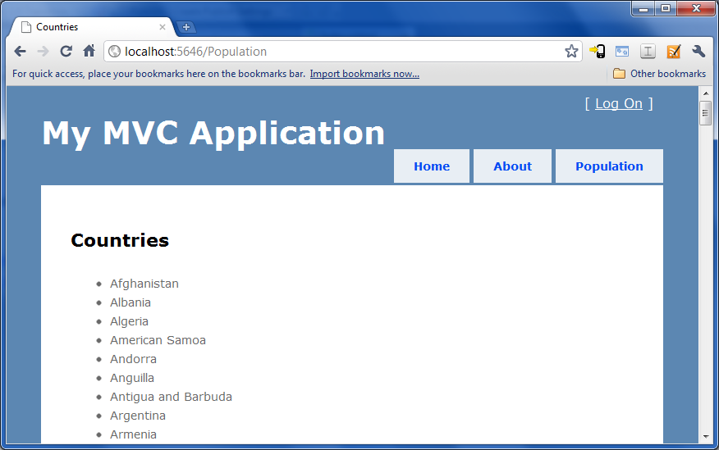
What we’ve built so far is an unattractive and long list of countries. We’ll apply some CSS styles to improve the presentation.
- Give the ul tag in the Index view an id of “countries”.
<ul id="countries">

- Underneath the closing </ul> tag, add a div with a class of “clear”.
<div class="clear"></div>

We’ll need this div to clear the floating list elements we are about to create. We’ll create the floating elements by adding styles to Site.css, which is the default style sheet provided for new MVC applications. CSS is another tool you can use to simplify your views by separating presentation from content. Your view only needs to present the content. Use CSS styles to apply colors, fonts, and formatting information to the content.

- Open Site.css from the Content directory.
The Site.css file is included by _Layout.cshtml.
- Add the following entries at the bottom of the style sheet, then save all files.
#countries
{
list-style-type: none;
}

#countries li
{
float: left;
width: 200px;
}
- Run the application again and verify your changes. The list of countries should look dramatically different.
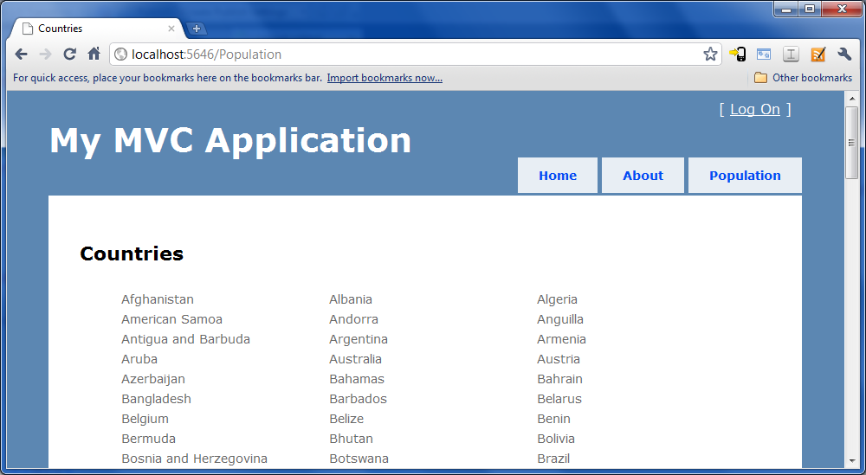

Part II: Implementing a Drill Down
In this section, we will give the user the ability to click on a country for more details. We’ll first display a drop down list of the years with available population information (not every country has population data available for every year). Once the user has selected a year, we’ll display the country’s population numbers. To carry this information into the view, we’ll need a new model object dedicated to the view.

- Right-click the Models folder and select Add -> Class.
- Name the class CountryDetails.
- Add a using statement in CountryDetails.cs for System.Web.Mvc.
- Add a string property named Name, and an IEnumerable<SelectListItem> property named AvailableYears.
public class CountryDetails
{
public string Name { get; set; }
public IEnumerable<SelectListItem>
AvailableYears { get; set; }
}

- Open PopulationController.cs and add a new action named Details. The new action will take an id parameter of type string, and a nullable int year parameter.

public ActionResult Details(string id, int? year)
{

}

- Add the following code to the Details action.
var statistics = new PopulationStatistics();
var details = new CountryDetails();
var availableYears =
statistics.GetAvailableYearsForCountry(id);
details.Name = id;
details.AvailableYears =
availableYears.Select(availableYear =>
new SelectListItem
{
Text = availableYear.ToString(),
Value = availableYear.ToString()
});
return View(details);

Here we see the controller in its typical role – transforming data from business objects into data for the view.
- Build your solution (Shift+Ctrl+B).
We are building the solution so that the CountryDetails class will appear as a candidate for a strongly-typed view class.
- Right-click on the Views\Population folder and select Add -> View.
- Name the new view Details. Select CountryDetails as the view data class, and leave the scaffold template as Empty before pressing OK.

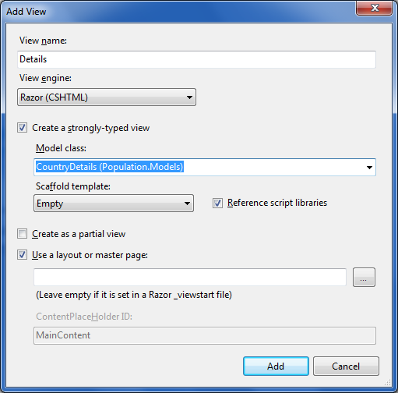
- Change the title and the h2 heading of the Details view to display the country name.
@{
ViewBag.Title = @Model.Name;
}
<h2>@Model.Name</h2>

- In the main content area, create a form with a dropdown list and a submit button. The dropdown list should contain the available years for the selected country and use the name “year”.
@using (Html.BeginForm()) {
@Html.DropDownList("year", Model.AvailableYears)
<input type="submit" value="Submit" />
}

Let’s try our dropdown list to see if it works. In order to navigate to the details, we’ll need to go back to the Index view and add some links.
- Open the Index view for the Population controller.
- Change each country list item to include a hyperlink to the Details action for the country.

<li>@Html.ActionLink(name, "Details", new { id=name })</li>

- Run the application and navigate to the details for any country. Try submitting the form with different years selected.
Notice the selected year doesn’t appear anywhere in the URL. This is because we are doing a POST, but a POST isn’t needed since we aren’t updating data. The year value is really a parameter and will ideally display in the URL. We’ll fix this now.
- Open Details.cshtml and change to form tag to use an action of “GET” instead of the default “POST” (this option is available as a FormMethod parameter).

@using (Html.BeginForm("Details", "Population", FormMethod.Get)) {
@Html.DropDownList("year", Model.AvailableYears)
<input type="submit" value="Submit" />
}

We also need to display population information in the details. We’ll add code for this functionality next.

- Open CountryDetails.cs and add the following three properties to the CountryDetails class.
public double MalePopulation { get; set; }
public double FemalePopulation { get; set; }
public double TotalPopulation { get; set; }

- Open the population controller and add the following code before the action’s return statement.
var selectedYear = year ?? availableYears.First();
details.MalePopulation = statistics.GetMalePopulation(id, selectedYear);
details.FemalePopulation = statistics.GetFemalePopulation(id, selectedYear);
details.TotalPopulation = details.MalePopulation + details.FemalePopulation;

- Open the Details view and add the following markup at the bottom of the main content area.
<div>
<p>Male Population: @Model.MalePopulation</p>
<p>Female Population: @Model.FemalePopulation</p>
<p>Total Population: @Model.TotalPopulation</p>
</div>

- Run the application and browse to the population statistics for a country. Try selecting a few different years to ensure the new functionality we implemented is working properly.
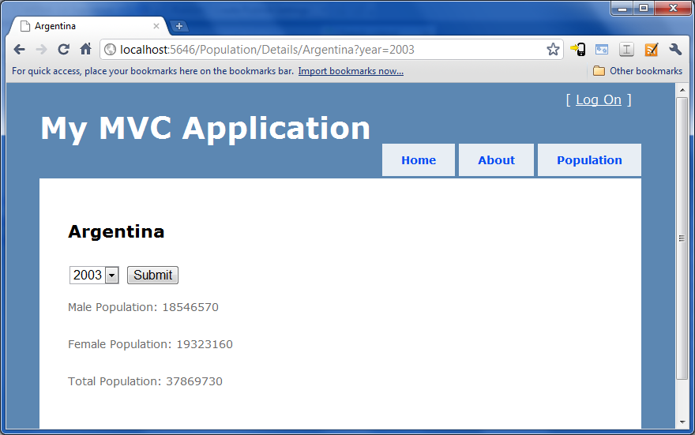
One problem you’ll notice in the display is how the population numbers are unformatted, which makes them hard to read. We’ll fix this problem in the next section.

Part III : Custom HTML Helper

There are a couple different options to fixing the number formatting in our application. One option is to use String.Format inside the view.

@String.Format("{0:n0}", Model.MalePopulation)

However, this code becomes tedious. Remember we want the view code to be simple and easy. Instead of using String.Format, we’ll provide a new Html helper so we can use the following cleaner code instead.

@Html.Number(Model.MalePopulation)

- Right-click the Population project in Solution Explorer and select Add -> New Folder.
- Name the new folder “Helpers”.
- Right-click the Helpers folder and select Add -> Class. Name the class HtmlHelpers
Note: the class should be in a Population.Helpers namespace.
- Add a using clause to the new file for System.Web.Mvc.
- Use the following code as a guide for the implementation.

public static class HtmlHelpers
{
public static string Number(this HtmlHelper helper,
double value)
{
return value.ToString("N0");
}
}

- Open the web.config file in the Views folder.
Razor view engine configuration is in the web.config in the views folder, not the root level web.config file.
- Add the Population.Helpers namespace to the <namespaces> configuration section.
<add namespace="Population.Helpers"/>

- Open the Details view and change the display of the population numbers to use the new helper method.
<div>
<p>Male Population: @Html.Number(Model.MalePopulation)</p>
<p>Female Population: @Html.Number(Model.FemalePopulation)</p>
<p>Total Population: @Html.Number(Model.TotalPopulation)</p>
</div>

- Press F5 to run the application and verify the number formatting.
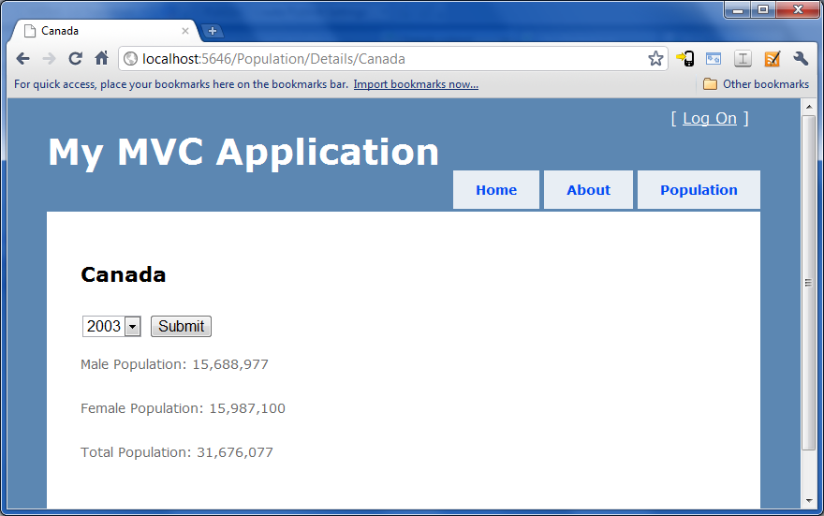

Conclusion
Congratulations! You’ve finished the MVC Views module and should now feel more comfortable creating views and using HTML helpers. If you are looking for an additional challenge, try implementing the table of population numbers as a partial view you can include in the Details view.

