Deployment & Configuration
ASP.NET MVC In Production

Deployment & Configuration with ASP.NET MVC

Objectives
After completing this lab you should understand how to:
- Deploy a web application using WebDeploy.
- Transform web.config files.

Part I – Setup
- Open the Movies solution file inside the before\Movies directory for this lab.
This lab builds on the solution from the TDD lab. If you’ve completed the TDD lab you can use the application you built in the TDD lab instead of opening the solution in the before directory.
- Make sure you have IIS installed by going to “Programs and Features” in Windows and clicking on “Turn Windows Features On and Off”.

- If IIS is not installed, select the checkbox for Internet Information Services.
  - Make sure to install the IIS Management Console under Web Management Tools
  - Also make sure ASP.NET is selected under Application Development Features.
  - Select all Common HTTP Features.

Unfortunately, SQL Server LocalDb and IIS won’t work together unless we take a number of configuration steps. To complete this lab you’ll need SQL Server Express or SQL Server installed. You can download SQL Express from http://www.microsoft.com/en-us/download/details.aspx?id=29062

After Installation:
- Open View -> SQL Server Object Explorer in Visual Studio.

- Right-click the SQL Server node in the explorer window and select “Add SQL Server”. Specify .\sqlexpress as the server name.

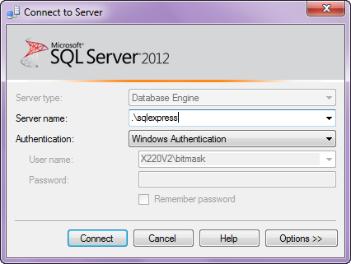

- Right-click the server and select New Query.

- Execute (Ctrl+Sift+E) the following code:

CREATE LOGIN [IIS APPPOOL\DefaultAppPool] FROM WINDOWS
EXEC sp_addsrvrolemember N'IIS APPPOOL\DefaultAppPool', dbcreator

Part II – Taking Control of EF
In this section we’ll make sure EF is using a conneciton string we specify in the web.config file. We can do this by passing a name into the DbContext constructor.

- Open the MovieData.cs file from the Infrastructure folder.
- Add a default constructor to MovieData that calls into the base class and specifies “name=DefaultConnection” as a parameter.

public MovieData() : base("name=DefaultConnection")
{

}

This tells the EntityFramework to use a connection string in the web.config file with the name of DefaultConnection. We now have control over the database used by EF.

Part II – Deployment Packages

- Open the Web.Debug.config file in the root of the project.

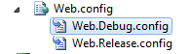

- Add a transformation that will ensure the custom error mode of the application is replaced with a new element setting the mode to off.

<system.web>
…
<customErrors mode="Off" xdt:Transform ="Replace" />

- Add a transformation that will ensure the debug attribute of the compilation section is always true (in case errors arise). This also goes under system.web.

<compilation debug="true" xdt:Transform="SetAttributes" />

- Save all files

- Right-click the Movies project and select “Publish”.

- In the Publish Web dialog, select the drop down to select a publish profile and click New.

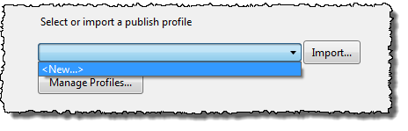

- Set the Profile name to MoviesDebug and click OK.

- On the next screen, select the publish method as Web Deploy Package.

You can publish directly to a server, but you can also create a .zip file to copy around and publish using the IIS Management Console or from the command line.

- Set the package location to a memorable place on your local file system (your Documents folder, perhaps), and name the package moviesdebug.zip.

- Set the Site/application to “Default Web Site/Movies”.

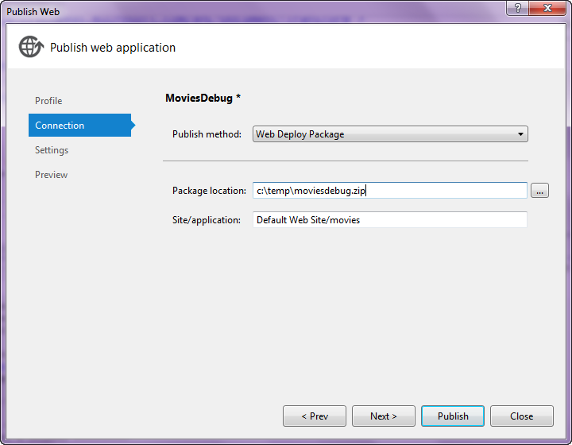

- On the next screen, select the Debug configuration. Under DefaultConnection, specify a database on your local SQL Server Express instance (data source=.;initial catalog=moviesdebug;integrated security=true).

- Select the check the box for “Execute Code First Migrations”.

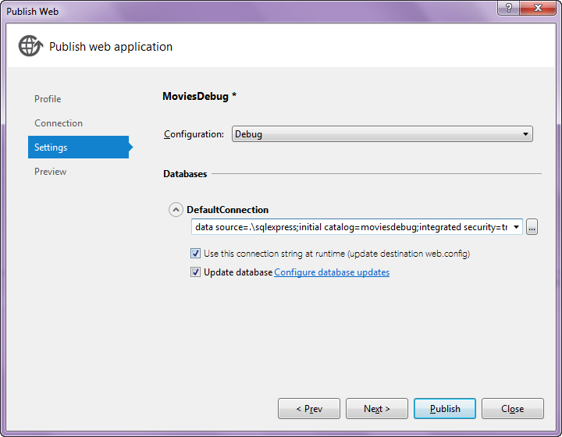

- On the next screen, click Publish. You should see a “success” message.

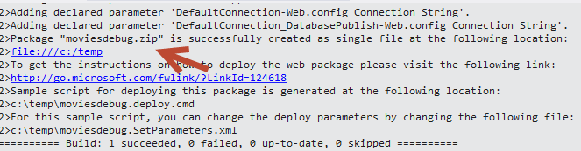

- Open a command prompt as an administrator (right-click on the cmd prompt in Windows and select Run as Administrator).

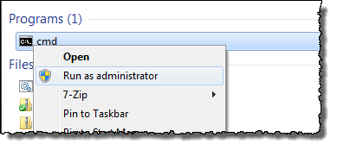
- In the command prompt, go to the location where the published package resides.

- Run moviesdebug.deploy.cmd /T (the /T means “test”).

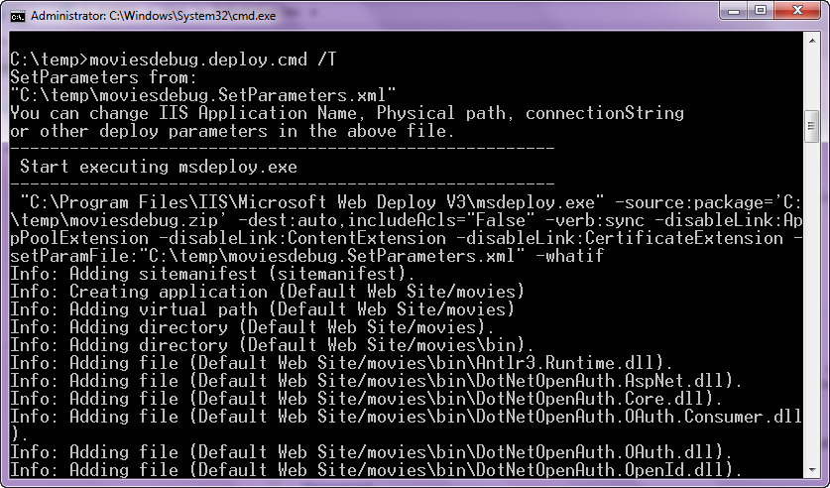

- If you don’t see any error message, you can now run moviesdebug.deploy.cmd /Y to deploy the app, or, go to the IIS console and “Import” the package.

- Browse to the movies application under IIS (http://localhost/movies) and see if the app works!

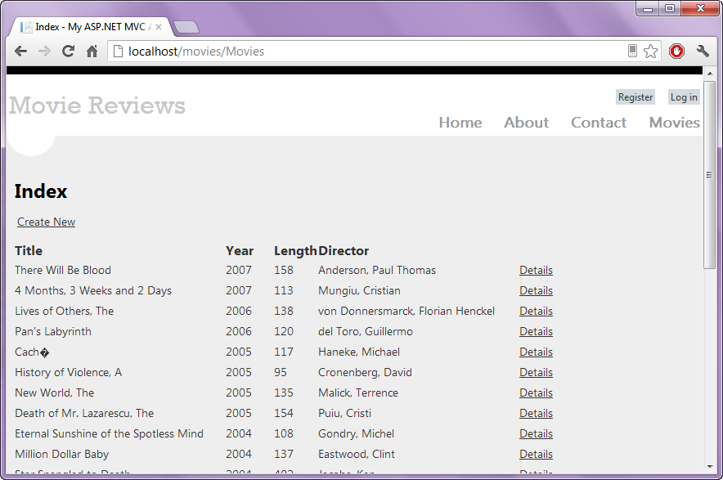

Conclusion
Congratulations! You’ve seccusfully deploy the Movie application!

