AJAX & ASP.NET MVC
Mixing AJAX into MVC

ASP.NET MVC AJAX

Objectives
After completing this lab, you should understand how to do the following:

- Inject and manage scripts in an ASP.NET MVC applcation.
- Execute client side validation logic.
- Produce and consume JSON data from an MVC controller

Part I – Setup
- Open the Movies solution file inside the before\Movies directory for this lab.
This lab builds on the solution from the jQuery lab. If you’ve completed the lab you can use the application you built in the previous lab instead of opening the solution in the before directory.

Part II – Validation – Server and Client

In this section we will implement a custom validation attribute and provide both server side and client side validation.

- Right-click the Movies project and add a new Folder named Validation.

- Right-click the Validation folder and add a class named MaxWordsAttribute.

- The new class should derive from ValidationAttribute (you’ll need using statement for System.ComponentModel.Annotations).

- Add a constructor that takes an int parameter named maxWords. Save the value into a private field named _maxWords.

public class MaxWordsAttribute : ValidationAttribute
{
private readonly int _maxWords;

public MaxWordsAttribute(int maxWords)
{
_maxWords = maxWords;
}
}
- Add a const string field to the class named DefaultErrorMessage with the string value shown after the next step.

- From the current constructor, class the base class constructor passing the DefaultErrorMessage.

public class MaxWordsAttribute : ValidationAttribute
{
private readonly int _maxWords;
const string DefaultErrorMessage = "{0} can only have {1} words";

public MaxWordsAttribute(int maxWords) : base(DefaultErrorMessage)
{
_maxWords = maxWords;
}
}

- Override the FormatErrorMessage method as shown below.

public override string FormatErrorMessage(string name)
{
return String.Format(ErrorMessageString, name, _maxWords);
}

The FormatErrorMessage allows us to produce descriptive error message with the right values, and also allows you to customize error messages at runtime by passing a different error message string to the attribute.

- Override the IsValid method (the one that returns bool), and provide the validation logic for the incoming value.

public override bool IsValid(object value)
{
if (value != null)
{
var wordCount = value.ToString().Split(' ').Length;
if (wordCount > _maxWords)
{
return false;
}
}
return true;
}

The attribute is complete, now we can try it out.

- Open the Review.cs file from the Domain folder and add the MaxWords attribute with a value of 3.

[Required]
[StringLength(255)]
[MaxWords(3)]
public virtual string Reviewer { get; set; }

- Run the application and verify the attribute works (at least on the server side).

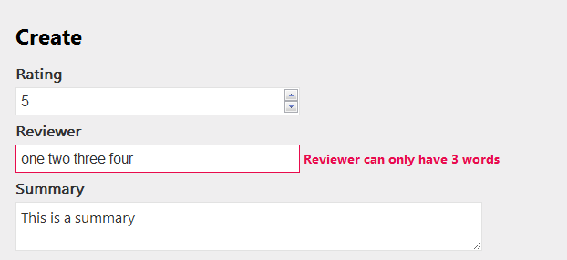

- Return to MaxWordsAttribute.cs and have the attribute implement IClientValidatable (you’ll need a using for System.Web.Mvc).

public class MaxWordsAttribute : ValidationAttribute, IClientValidatable
{
public IEnumerable<ModelClientValidationRule>
GetClientValidationRules(ModelMetadata metadata, ControllerContext context)
{
var rule = new ModelClientValidationRule();
rule.ErrorMessage = FormatErrorMessage(metadata.GetDisplayName());
rule.ValidationParameters["maxwords"] = _maxWords;
rule.ValidationType = "wordcount";
yield return rule;
}

...

- Add a new JavaScript file to the Scripts folder of the project. Name the file MovieValidations.js

- Add a “single value adapter” to the unobtrusive validation adapters.

jQuery.validator.unobtrusive.adapters.addSingleVal("wordcount", "maxwords");

- Add a method to the jQuery validator to perform the validation logic.

jQuery.validator.addMethod("wordcount", function (value, element, maxWords) {
if (value) {
var wordCount = value.split(' ').length;
if (wordCount <= maxWords) {
return true;
} return false;
} return true;
});

- Open the BundleConfig.cs file in the App_Start folder.

- Include your new MovieValidations.js file into the “jqeryval” bundle.

bundles.Add(new ScriptBundle("~/bundles/jqueryval")
.Include(
"~/Scripts/jquery.unobtrusive*",
"~/Scripts/jquery.validate*",
"~/Scripts/MovieValidations.js"));
- Run the application to verify that the client-side validations are now working

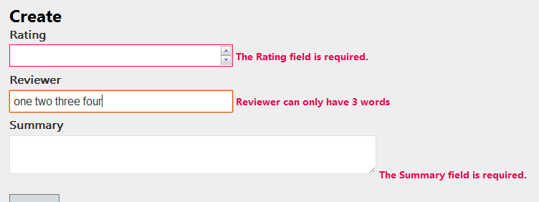

Part III – Partial Page Updates

In this section we will implement a search feature for movies that will update the display of movies without redrawing the entire page.

- Open BundleConfig in the App_Start folder.

We have to rearrange some script references to make sure the jquery.unobtrusive scripts are in place on every page.

- Cut the “unobstrusive” include from the jqueryval bundle.

- Add the unobtrusive include to the jquery bundle.

The end result should look like:

bundles.Add(new ScriptBundle("~/bundles/jquery").Include(
"~/Scripts/jquery-{version}.js",
"~/Scripts/jquery.unobtrusive*"));

bundles.Add(new ScriptBundle("~/bundles/jqueryui").Include(
"~/Scripts/jquery-ui-{version}.js"));

bundles.Add(new ScriptBundle("~/bundles/jqueryval").Include(
"~/Scripts/jquery.validate*",
"~/Scripts/MovieValidations.js"));

- Open the MovieController

- Add a parameter to the Index action of type string, named searchTerm.

- Use searchTerm in the LINQ query to only retrieve movies with searchTerm in the title (or return all movies if the searchTerm is empty).

public ActionResult Index(string searchTerm)
{
var db = new MovieData();
var movies =
from m in db.Movies
where searchTerm == null || m.Title.Contains(searchTerm)
orderby m.Year descending
select m;

return View(movies.Take(25));
}

- Run the application to make sure your search is working (you can add a searchTerm to the queryString to verify).

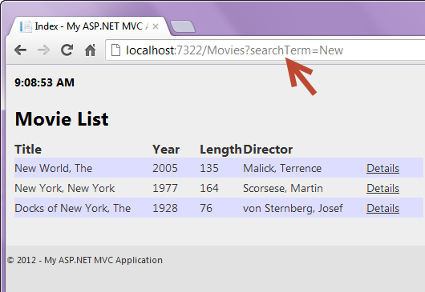

- Open the Index view for movies.

- Give the table in the Index view an id of “movieTable”

<table id="movieTable">

- Right-click the Views/Movies folder and select Add -> View.

- Name the new view _MovieTable. Make it a partial view, but do not strongly type the view (we’ll add that manually).

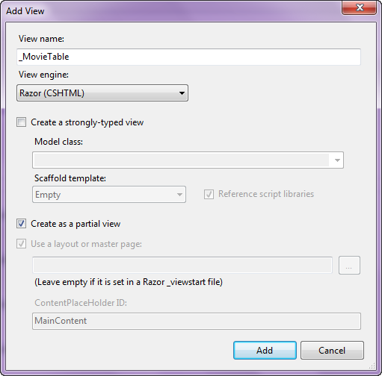

- Give the partial view a @model directive to strongly type the view to a sequence of movies.

@model IEnumerable<Movies.Domain.Movie>

- Cut the movieTable <table> from the Index view, and paste it into the partial view.

@model IEnumerable<Movies.Domain.Movie>

<table id="movieTable">
<tr>
<th>
@Html.DisplayNameFor(model => model.Title)
</th>
<th>
@Html.DisplayNameFor(model => model.Year)
</th>
...

- In the Index view, use @Html.Partial to render the movie table in the location you cut it from.

@Html.Partial("_MovieTable", Model)

- Add a form (using the Ajax BeginForm helper) that to the Index view (at the top of the view). Give the form options to use an HTTP GET request and replace “movieTable” with the response.

@using(Ajax.BeginForm(
new AjaxOptions
{
HttpMethod="GET",
InsertionMode=InsertionMode.Replace,
UpdateTargetId="movieTable"
}))
{

}

- Add two inputs into the form – one to enter the searchTerm and one to submit the form.

<input type="search" name="searchTerm"/>
<input type="submit" name="Search"/>

- In the MovieController, check the Request.IsAjaxRequest method. If the method returns true, render a partial view with the _MovieTable partial view you created. If the method returns false, render the regular view.

if(Request.IsAjaxRequest())
{
return PartialView("_MovieTable", movies.Take(25));
}

- Run the application to verify the new functionality.

Part IV – Autocomplete

In this section we’ll add some autocomplete functionality to the search. The first step will be to get the jQuery UI styles and scripts included in the application.

- Open the BundleConfig.cs file from the App_Start directory.

- Notice there are bundles configured for jQuery UI scripts (~/bundles/jqueryui) and jQuery UI styles (~/Content/themes/base/css).

- Open the _Layout view from the Views/Shared folder.

- Render the jQuery UI styles at the top of the view, just before the existing style rendering for Content.css.

@Styles.Render("~/Content/themes/base/css")

- At the bottom of the view, just after the rendering of jQuery, render the jQuery UI script bundle.

@Scripts.Render("~/bundles/jqueryui")

- Open the Index view for Movies

- Give the searchTerm input a data-autocomplete attribute that will contain the URL needed to reach the SearchAutocomplete action on the MoviesController.

<input type="search" name="searchTerm"
data-autocomplete="@Url.Action("SearchAutoComplete")" />

- At the bottom of the view you should find your section named “scripts”. Inside of here, use jQuery to setup auto complete for the searchTerm input. You’ll need to extract the data-autocomplete value to use as the source option for autocomplete.

$(function() {

var input = $("input[name='searchTerm']");
var url = input.attr("data-autocomplete");
input.autocomplete({
source: url
});
});

- Go to the MoviesController.

- Implement the SearchAutoComplete action. The action will take a parameter by the name of term (this is what the autocomplete widget will pass). Search the database using term and return JSON objects with label properties. Make sure to remember to allow JSON over HTTP GET (it is the second parameter to the JSON method).

public ActionResult SearchAutoComplete(string term)
{
var db = new MovieData();
var movies =
db.Movies.Where(m => term == null || m.Title.Contains(term))
.Take(10)
.Select(m => new {label = m.Title});

return Json(movies, JsonRequestBehavior.AllowGet);
}
- Run the application to test the functionality.

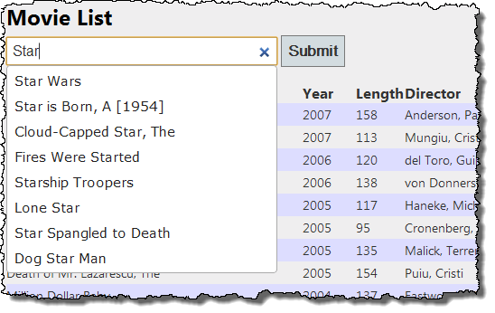

Conclusion
Congratulations! You’ve implemented custom validation logic that works on both the server and the client, and implemented partial page updates and an autocomplete control. In a future lab, we’ll look at a different approach to updating a page.

