Modern JavaScript
It’s a Test!

Modern JavaScript

Objectives
In this lab you’ll be tested in every aspect of the JavaScript language. By the end of the lab you should understand the JavaScript type system, prototypes, modules, scope, regular expressions, and more. For this lab we'll be using the JavaScript Koans created by Liam Mclennan. If you haven't heard about programming koans, see: Learning Programming Languages with Koans.

Feel free to use search engines and online references to help you complete the lab. A good online reference for JavaScript is https://developer.mozilla.org/en/JavaScript/Reference/.

Note: this lab could take 90+ minutes to complete.

Part I – How to Start
- Navigate to the before directory of this lab.
- Open the before.sln solution file.

You should see the solution open like the following:

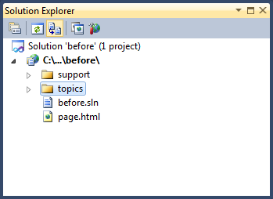

- Right-click on the page.html file and select “View In Browser”.

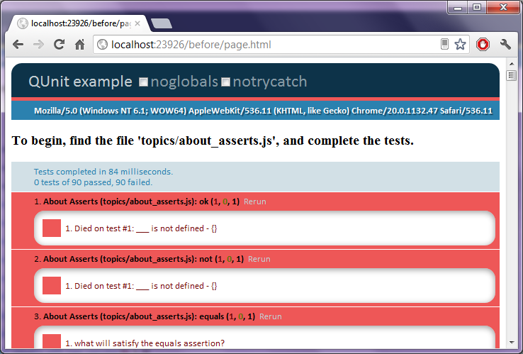

This lab relies on the qUnit unit testing JavaScript framework. Like any unit testing framework, qUnit includes a test runner and an API with asserts to test the results of an expression. What you are looking at is the result of 90 failing tests in the qUnit test runner. Let’s make the first test pass.

- Open the topics\about_asserts.js file.

The first test in the file looks like the following:

test("ok", function() {
ok(____, 'what will satisfy the ok assertion?');
});

This is the qUnit test API at work. Each test is a function you pass to the test method. The ok function is one type of assert you can use, this first test section will teach you about others.

- To make the first test pass, place a true value into the test.

test("ok", function() {
ok(true, 'what will satisfy the ok assertion?');
});

- Save the .js file and refresh the browser. You should see test #1 in a passing state.

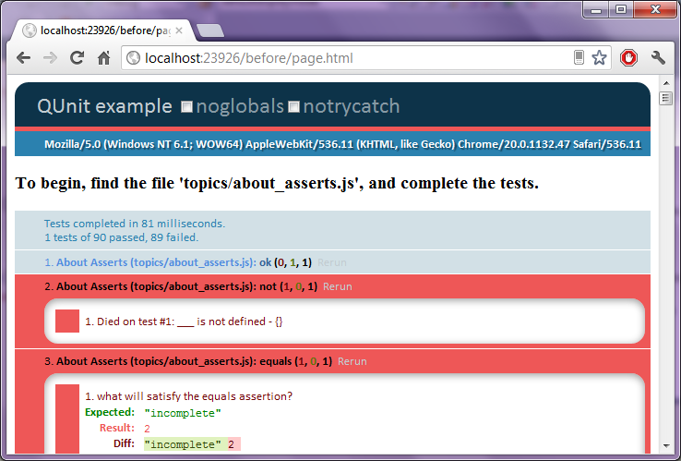
- Now make the other 89 tests pass by working through about_asserts.js and the rest of the files in the topics folder.

Conclusion
Congratulations! If you made every test pass without looking in the after folder, then you have a solid knowledge of JavaScript!

