Hosting WebAPI
A Self Hosting Movie Server

Hosting WebAPI
This lab is a continuation of the second lab. You can continue working with your AtTheMovies solution from the last lab, or you can start fresh by opening the solution in the before\AtTheMovies folder for this lab.

In this lab we’ll host the Movies WebAPI in a console mode application.

Objectives

After completing this lab, you should understand how to do the following:
- Create a self-hosted configuration
- Create a self-hosted HTTP Server
- Manage routes and controllers in a self-hosted scenario

Part I – Self Hosting In A Console App

- Right-click the AtTheMovies solution and select Add -> New Project.
- Select the Visual C# -> Windows -> Console Application template. Name the application AtTheMovies.Console and press OK.
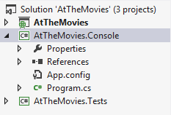
We’ll be using our existing MovieController in this host, so we’ll need a reference to the AtTheMovies ASP.NET project. We also need a reference to one System assembly.
- In Solution Explorer, right-click the References node of the console project and select Add Reference. Go to Solution, and check the box to add a reference to the AtTheMovies project. In the Assemblies -> Framework tab, search for and add a reference to System.Net.Http.
We also need to add references to some WebAPI assemblies. We can add the references with NuGet.
- Open the Package Manager Console. Set the Default Project dropdown to AtTheMovies.Console.
- Execute install-package Microsoft.AspNet.WebApi.SelfHost
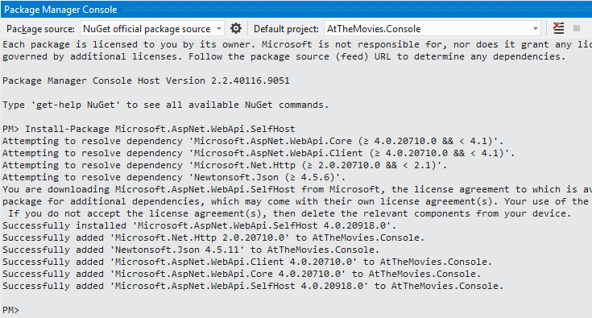
- In Program.cs, bring in the System.Web.Http and System.Web.Http.SelfHost namespaces with using statements.
- Inside the Main method, create a new instance of HttpSelfHostConfiguration. Use http://localhost:8080 as the base address.
Since this host will run with a different configuration than the ASP.NET host, we need to add routes into the configuration object.
- Use MapHttpRoutes on the configuration object’s Routes property to map requests using the URL template {controller}/{id}.
var config = new HttpSelfHostConfiguration("http://locahost:8081");

config.Routes.MapHttpRoute(
"default",
"{controller}/{id}",
new { id = RouteParameter.Optional });
- Create an instance of the HttpSelfHostServer class, passing in the configuration object. Open the server (asynchronously), write a message to the console saying the server started, and then use System.Console.ReadLine to block the program until a key is pressed.
var server = new HttpSelfHostServer(config);
server.OpenAsync();
System.Console.WriteLine("Server started");
System.Console.ReadLine();
- Right-click the AtTheMovies.Console project and select Debug -> New Instance. Make sure “Server Started” appears without error.
- Depending on the security settings of the machine, you might receive an error when the console program tries to listen on port 8080. If you have an “access denied” error, go to the command line as administrator and execute the following (where machine\username is your machine and user name):
netsh http add urlacl url=http://+:8080/ user=machine\username
- Close the running instance.
There are two more steps we need to take to make sure the MovieController can function correctly. First, in self-hosting we need to make sure the AtTheMovies assembly is loaded into memory (we’ll do this using a cheap trick). Second, we need to make sure EF has configuration information present to find the database we want to use.
- Inside Program.cs, before creating the server, add the following line of code to force the AtTheMovies assembly into memory.
Type type = typeof(MovieController);
- In Solution Explorer, Open the app.config file for the console application.
- Inside the configuration file, add a connection string with the name MovieData. The connection string should point to the movies database you created earlier (the following connection string assumes you are using LocalDb, which should be the case if you are using Visual Studio 2012 and you did not customize the connection in a previous lab).

<connectionStrings>
<add name="MovieData" connectionString="server=(localdb)\v11.0;database=AtTheMovies.Infrastructure.MovieData;Integrated Security=true" providerName="System.Data.SqlClient" />
</connectionStrings>
- Run the console application again, and connet with Fiddler to test the behavior.
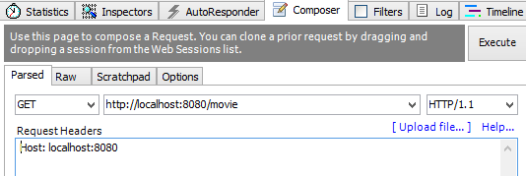
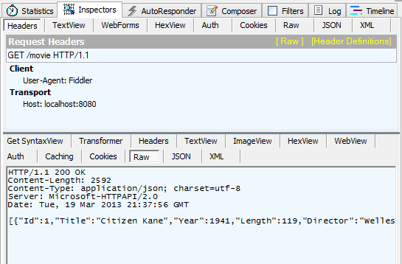

Conclusion
Congratulations! You’ve built an HTTP Web Service you can host from the command line.

