Infrastructure
Using ASP.NET Core Features

ASP.NET MVC Infrastructure

Objectives
After completing this lab you should understand how to:
- Apply output caching
- Work with localization resources

Part I – Setup

- Open the Movies solution file inside the before\Movies directory for this lab.
This lab builds on the solution from the Configuration & Deployment lab. If you’ve completed the deployment lab you can use the application you built in the lab instead of opening the solution in the before directory.

Part II - Caching

In this section we’ll explore various approaches to caching the Index action of the Movie controller.

- Go to the Index method of the Movies controller.
- Add an attribute to cache the output of the Index method.

[OutputCache(Duration=60)]
public ActionResult Index()
{
var db = new MovieData();
var movies =
from m in db.Movies
orderby m.Year descending
select m;

return View(movies.Take(25));
}

- Open the Index view for the movie controller.
- Add a timestamp to the top of the view. For example:

<h5>@DateTime.Now.ToLongTimeString()</h5>

- Run the application (Ctrl+F5) and navigate to the movie listings. Verify the cache is working as expected.

At this time we also want to move our cache configuration into a configurable caching profile. This will ensure we can easily change the settings at runtime.

- Open the web.config file.
- Add the following inside the system.web configuration section.

<caching>
<outputCacheSettings>
<outputCacheProfiles>
<add name="Regular" duration="60" location="Any" />
</outputCacheProfiles>
</outputCacheSettings>
</caching>

- Change the movie index action to use the new cache profile.

[OutputCache(CacheProfile="Regular")]

- Run the application to ensure the movie list works as expected.

Part II – i18n and l10n

In this section we’ll use a resource file to provide culture-specific resources to a controller action.

- Open web.config and add the following line inside web.config.

<globalization culture="auto" uiCulture ="auto"/>

This configuration item tells ASP.NET to automatically set current culture and current UI culture on each request thread. The culture ASP.NET chooses will be determined using the language header sent in the HTTP request from the browser.

- Add a new folder to the Movies project named Resources.
- Right-click the resources folder and select Add -> New Item. Select Resource file. Name the file Global.resx.
- Create an entry in the resource named HomeMessage. Set the value as “"Welcome to ASP.NET MVC!".
- Change the access modifier drop down to “Public”.

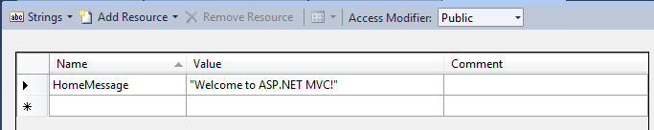

This will set the generated code we can use to access the resources in a strongly typed manner to have public visibility.

- Open Internet Explorer and use the menu option Tools -> Internet Options.
- Click on Languages.

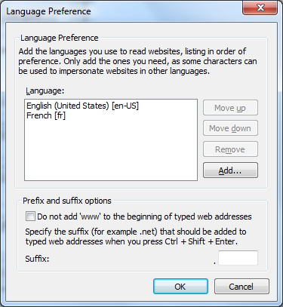

- Click on Add, and select a language you are comfortable with (other than en-US), or pick French (fr).
- Move your language selection to the top of the language preference list.
- Click OK and return to Visual Studio.
- Right-click the Resources directory and add a new resource file. This file should be named Global.xx.resx where xx represents the language ID you picked in Internet Explorer (example: Global.fr.resx).
- Make a new entry named HomeMessage in the resource file.
- Provide a translation of the Home page greeting (example: bonjour!).
- Go to the Index action of the HomeController.
- Replaced the hard coded message with a call to the resource file.

ViewBag.Message = Resources.Global.HomeMessage;

- Run the application and browse the home page using Internet Explorer. Do you see the translated message?

Conclusion
Congratulations! In this lab we looked at caching and internationalization. If you want to take the internationalization and localization work one step further, select a view (like the Movie Index view) and make it work correctly under multiple languages.

