WebAPI Extensibility
Working with HttpMessageHandler

WebAPI Extensibility
This lab is a continuation of the fourth lab. You can continue working with your AtTheMovies solution from the last lab, or you can start fresh by opening the solution in the before\AtTheMovies folder for this lab.

Objectives

After completing this lab, you should understand how to do the following:
- Register a custom HttpMessageHandler on the server
- Register a custom HttpMessageHandler on the client

Part I – A Client Console Logging Message Handler

Since we can use the component we are about to write on both the client and server, we’ll create a new class library project both sides can reference.

- Right-click the AtTheMovies solution and select Add -> New Project.
- Select the Windows -> Class Library template. Name the project AtTheMovies.Handlers.
- Delete Class1.cs from the project.
- Right-click the References folder and Add -> Reference to the framework’s System.Net.Http assembly.
- Right-click the new project and Add -> Class. Name the class ConsoleLoggingHandler.
- Derive the class from DelegatingHandler, and make sure the class is public.
- Override the SendAsync method.
- Inside SendAsync, add some code to log when a request arrives, and the first media type in the Accept header of the request (if any).
- Also inside SendAsync, add some code to log when a response is ready, and the media type in the Content-Type header of the response.

public class ConsoleLoggingHandler : DelegatingHandler
{
protected async override Task<HttpResponseMessage>
SendAsync(HttpRequestMessage request,
CancellationToken cancellationToken)
{
LogRequest(request);
var response = await base.SendAsync(request, cancellationToken);
LogResponse(response);
return response;
}

private void LogResponse(HttpResponseMessage response)
{
var contentType = response.Content.Headers.ContentType.MediaType;
Console.WriteLine("Response with {0}", contentType);
}

private void LogRequest(HttpRequestMessage request)
{
var accept = request.Headers.Accept.ToString();
Console.WriteLine("Request with {0}", accept);
}
}
- Right-click the References folder in AtTheMovies.Client. Add a reference to the AtTheMovies.Handlers project.
- In Program.cs, use the HttpClientFactory class to wire the logging handler into the HttpClient pipeline.
- Change the BaseAddress to the URL where you AtTheMovies.Console server runs (typically http://localhost:8080, if you followed the lab). Also, change the GetAsync to remove the “api” prefix (unless you configured your self-hosted server under the api path).
var client = HttpClientFactory.Create(new ConsoleLoggingHandler());
client.BaseAddress = new Uri("http://localhost:8080");
- Run both AtTheMovies.Console and AtTheMovies.Client. You should see the logging output appear in the client (as well as the list of movies).

Note: An easy way to run two projects is to right-click on the Solution and go to Common Properties -> Startup Project. Select “Multiple Startup Projects”. Move AtTheMovies.Console above AtTheMovies.Client and set them both to start running.

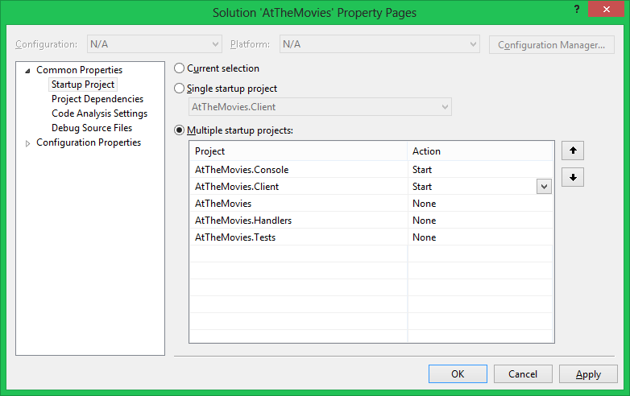

In some cases you might still lose a race condition where the client makes a request before the server is listening. As a quick fix, add a Console.ReadLine in the client to wait for a keypress before making a request.
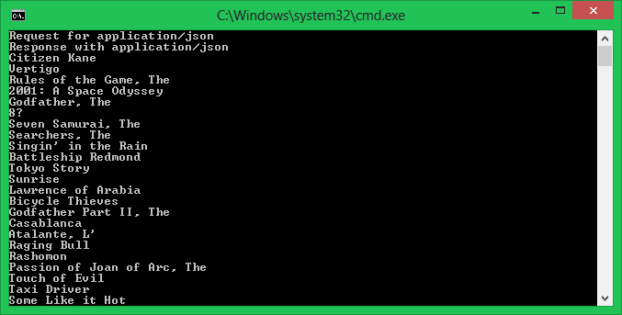

Part II – Console Logging On the Server
- Go to the AtTheMovies.Console project.
- Add a reference to AtTheMovies.Handlers
- In Program.cs, use the configuration object to add the logging message handler into the pipeline.
config.MessageHandlers.Add(new ConsoleLoggingHandler());
- Run the client and server again to see logging in both windows.
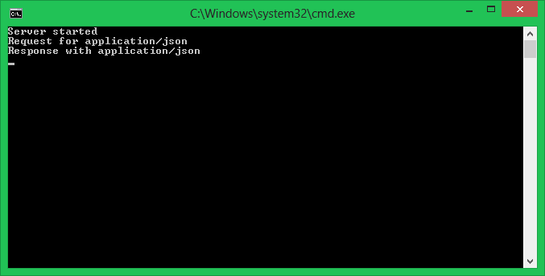

Conclusion
Congratulations! You’ve seen just how easy it is to use message handlers with the WebAPI!

