WebAPI Client
A New Client For Old Standards

WebAPI Client
This lab is a continuation of the third lab. You can continue working with your AtTheMovies solution from the last lab, or you can start fresh by opening the solution in the before\AtTheMovies folder for this lab.

In this lab we’ll use the HttpClient to call our Movie web service.

Objectives

After completing this lab, you should understand how to do the following:
- Create an HttpClient and make web requests
- Set headers in an HttpClient
- Consume both XML and JSON with an HttpClient

Part I – The Client

- Right-click the AtTheMovies solution and select Add -> New Project.
- Select the Visual C# -> Windows -> Console Application template. Name the application AtTheMovies.Client and press OK.
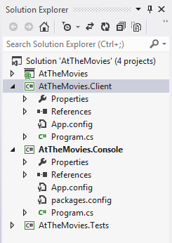
- Open the Package Manager Console.
- Ensure AtTheMovies.Client is selected in the Default Project drop down.
- Execute install-package Microsoft.AspNet.WebApi.Client.
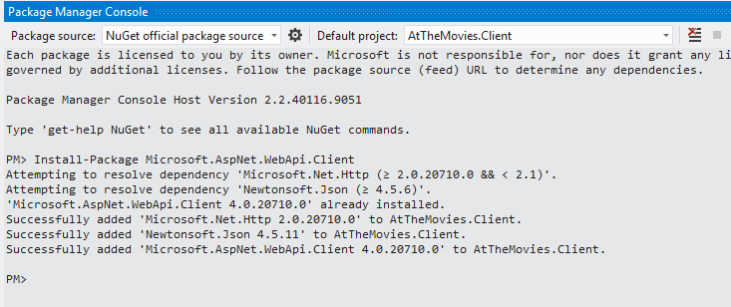

- In Solution Explorer, right-click the References node of the console project and select Add Reference. Go to the Assemblies -> Framework tab, search for and add a reference to System.Net.Http.
Note: do not add a reference to the AtTheMovies project.
- Inside the Main method in Program.cs, create a new instance of HttpClient.
- Set the client’s BaseAddress property to the address of your AtTheMovies web application.
- Add a default header for Accept that will request text/xml from the server.
var client = new HttpClient();
client.BaseAddress = new Uri("http://localhost:26544");
client.DefaultRequestHeaders.Accept.Add(
new MediaTypeWithQualityHeaderValue("text/xml"));
- Using the client, make a GET request to the movie service. Parse the response using an XDocument object and write all the movie titles to the console window.
Tip: don’t forget the XML namespace!
var response = client.GetAsync("/api/movie").Result;
var xml = response.Content.ReadAsStringAsync().Result;
var document = XDocument.Parse(xml);

XNamespace ns =
"http://schemas.datacontract.org/2004/07/AtTheMovies.Domain";

foreach (var movie in document.Descendants(ns+ "Movie"))
{
Console.WriteLine((string)movie.Element(ns + "Title"));
}

- Run the application to ensure you see the list of movies.

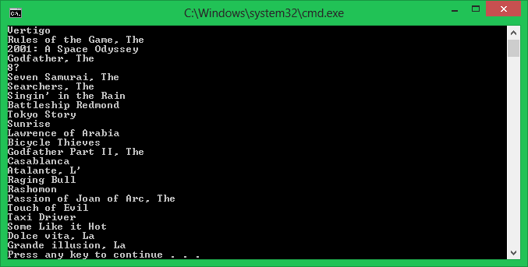

Part II – With Json
- Change the default Accept header for the client from XML to application\json.

- Using JArray and dynamic objects to parse the response and list the movies.
client.DefaultRequestHeaders.Accept.Add(
new MediaTypeWithQualityHeaderValue("application/json"));

var response = client.GetAsync("/api/movie").Result;
var movies = response.Content.ReadAsAsync<JArray>().Result;
foreach(dynamic movie in movies)
{
Console.WriteLine(movie.Title);
}
Part III – With Types
- Right-click the AtTheMovies.Client project and select Add -> Class
- Name the class Movie. Give the Movie pubic Id (int) and Title (string) properties.
public class Movie
{
public int Id { get; set; }
public string Title { get; set; }
}
- Parse the JSON response into a sequence of movie object (should only require 1 line of code to change), and show the results.

var response = client.GetAsync("/api/movie").Result;
var movies =
response.Content.ReadAsAsync<IEnumerable<Movie>>().Result;
foreach(dynamic movie in movies)
{
Console.WriteLine(movie.Title);
}

Extra Credit

- Use the HttpClient class to POST and create a new movie, then parse the response to issue a GET request for the details of the movie.

Conclusion
Congratulations! You’ve used the HttpClient class to invoke a web service and process the results!

