jQuery
Some Basics

ASP.NET MVC & jQuery

Objectives
After completing this lab you should understand how to:

- Hook up events with jQuery
- Start animations with jQuery

Part I – Setup

- Open the Movies solution file inside the before\Movies directory for this lab.
This lab builds on the solution from the Infrastructure lab. If you’ve completed the lab you can use the application you built in the lab instead of opening the solution in the before directory.

Part II – DOM Events & Manipulation
- Open the _Layout view in the Movies project (from the Views/Shared folder).
- Go to the bottom of the view and take note of the script related pieces:

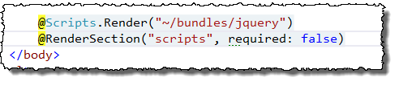
The @Scripts.Render method will essentially create a script tag to reference the jQuery library (we’ll talk more about @Scripts.Render in the next module).The call to @RenderSection allows content views to inject additional script code or libraries in that depend on jQuery

- Open the Movies Index view.
- At the bottom of the view, create a @section named scripts.

@section scripts
{

}

- Inside the scripts section, add some JavaScript code that will display an alert with the text “Ready!” during the DOM ready event.

<script>

$(function() {
alert("Ready!");
});

</script>

- Run the application and verify that the alert message appears.
- Now – remove the call to alert and try the following exercises. Remember to use the jQuery documentation at http://docs.jquery.com/Main_Page if you need help figuring out how to do some of the magic.
  - Select all the odd rows in the movie table and give them a light blue background.

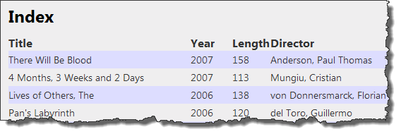

  - Change the header text to “Movie List”
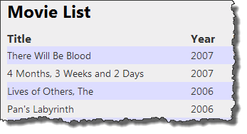
  - Using jQuery .on for delegated events, catch the click event for every table cell, and when the click occurs make the cell fade out, then fade in.
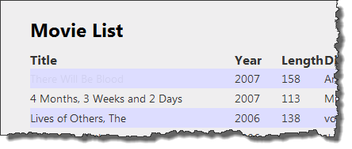

Conclusion
Congratulations! You’ve used some basic jQuery functions. We’ll start doing more advanced jQuery in the following lab.

