ASP.NET MVC Introduction
Getting Started

Introduction to ASP.NET MVC

Objectives
After completing this lab, you should understand how to do the following:

- Create an ASP.NET MVC application and test project
- Create new routes
- Create new controllers and strongly typed views

Part I – Creating the Application
In this lab we will be working in the before directory where the lab is located. A completed version of the application exists in the after directory.

- Open Visual Studio and select File -> New Project.
- Go to the Web project type under Visual C# and click the ASP.NET MVC 4 Web Application template. Give the application the name Cars, and select the before directory of this lab as the location.
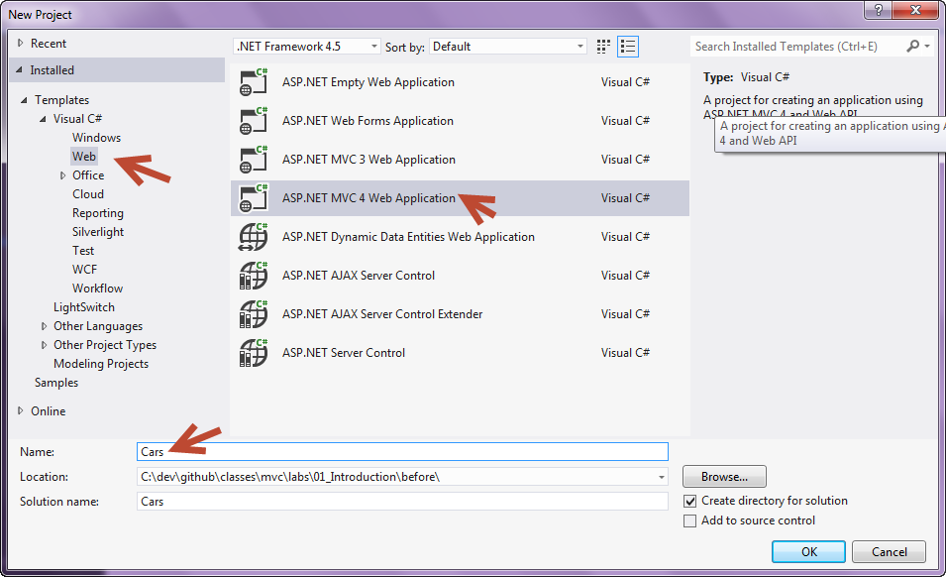
- Visual Studio will prompt you to select a project template – choose the “Internet Application” template. Ensure the Razor view engine is selected, and “Create a unit test project” is checked before
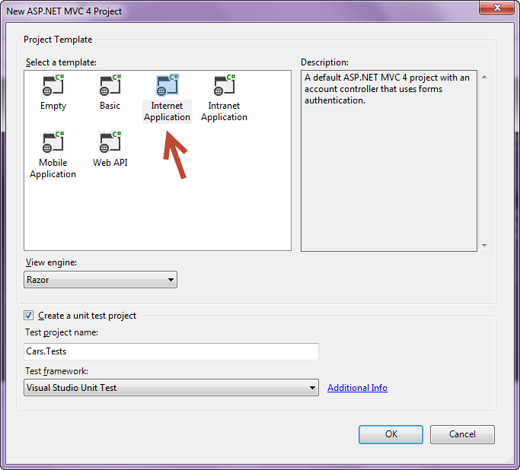

The purpose of this lab is not to focus on TDD or unit testing techniques, so we will not be implementing tests for all the features and changes in the lab. If you regularly use TDD consider this lab a “spike” you are using to learn a new technology.

- Press OK, and wait for Visual Studio to create the solution.
- Press F5 to run the new application using the debugger. Allow Visual Studio to modify web.config if prompted. Ensure the application is running without errors.
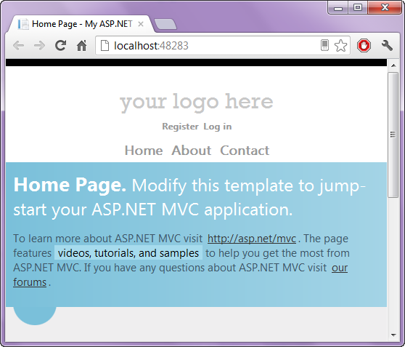
- Click on the “About” link in the application. This is where we will make our first modification, but in a later step. Close the browser and return to Visual Studio.
- Run all the unit tests in the solution (Ctrl+R,A). You should see all the unit tests pass.
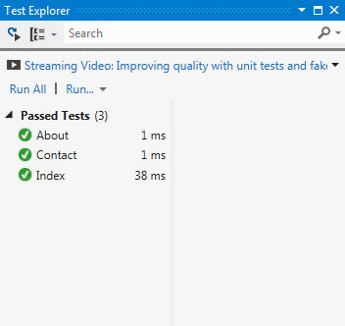

- Go to the Cars.Tests project in the Solution Explorer window (Ctrl+Alt+L). Expand the Controllers folder and open HomeControllerTests.cs file.
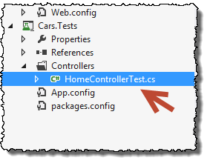
- Find the test method named About.
We’ve decided that the About view needs to display a custom Message. In the next step we’ll modify the About test to ensure the About action places this message in the ViewData collection, which is one way to get data to a view (we’ll look at better approaches later).

- Add an Assert at the bottom of the About test that ensures viewData contains data with the key of “Message”.
[TestMethod]
public void About()
{
// Arrange
HomeController controller = new HomeController();

// Act
ViewResult result = controller.About() as ViewResult;

// Assert
Assert.IsNotNull(result);
Assert.IsNotNull(result.ViewBag.Description);
}

- Run the unit tests again (Ctrl+R, A).
The About test should now fail, and we are ready to make changes to the application for the test to pass. Look how easy it is to test ASP.NET MVC controller actions!
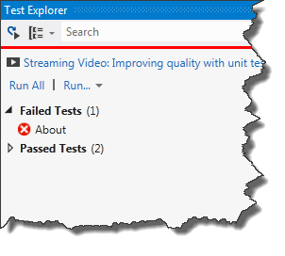
- Go to the Cars web project and open the HomeController.cs file in the Controllers directory.
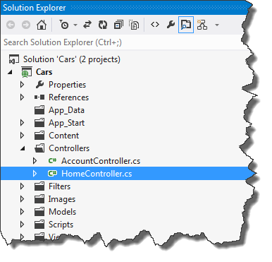
- Add code before the return statement of the About action that creates a description string. You can include information about the current operating system using Environment.OSVersion.VersionString.

- Add the greeting into the ViewBag with a key of “Message”.

public ActionResult About()
{
ViewBag.Message = "Your app description page.";

string description = String.Format("Hello, from {0}!",
Environment.OSVersion.VersionString);
ViewBag.Description = description;

return View();
}

- Run all tests in the solution again. All tests should now pass. Of course, we still must display this information in the view.
- Open the About.cshtml file in the Views/Home directory.
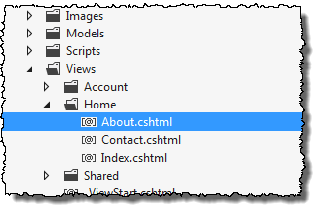
- After the hgroup and before the article, add a div with the description inside.
<div>
@ViewBag.Description
</div>

- Press F5 to run the application. Click the About link and ensure the expected message appears. Close the browser and return to Visual Studio.
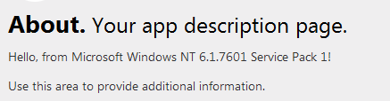

Part II – Adding New Controllers, Views, and Routes

- Right-click the App_Data folder in the Cars website and select “Add -> Existing Item”.
- Browse to the “helper_files” folder containing this Word document and select cars.csv. After adding the file to the project, open the file and explore its contents.
Cars.csv contains a comma delimited set of records about the fuel efficiency of vehicles manufactured in 2007. The fuel efficiency is measured in miles per gallon (the data comes from the US government). To read and process the data we’ll need two new classes which we will build in the following steps.

- Right-click the Models directory of the web application and select Add -> Class. Enter the name Car.cs and click OK.
- Add the following public properties to the Car class: Manufacturer (string), ModelName (string), and AverageMPG (double).
public class Car
{
public string Manufacturer { get; set; }
public string ModelName { get; set; }
public double AverageMPG { get; set; }
}

- Right-click the Models directory and select Add -> Class. Enter the name CarRepository.
We’d usually keep repositories in a different location, but for this introduction we’ll use the Models folder. Later we’ll look at a better place for infrastructure components.
- Give the CarRepository a private field named _cars of type List<Car>.
- Give the CarRepository class a public constructor that takes a string parameter named path. Use the code shown in the constructor below to load data into the repository (you’ll also need to add a using statement for System.IO).

public class CarRepository
{
public CarRepository(string path)
{
_cars = File.ReadAllLines(path)
.Skip(1) // skip the header record
.Select(line => line.Split(','))
.Select(fields =>
new Car
{
Manufacturer = fields[0],
ModelName = fields[1],
AverageMPG =
(double.Parse(fields[6]) +
double.Parse(fields[7])) / 2
}).ToList();
}

List<Car> _cars;
}

With the model in place, we will turn our attention to defining routes to reach the data. We’d like the user to visit /Cars to see a list of manufacturers, while /Cars/Show/BMW would display a list of BMW cars and /Cars/Show/BMW/Z4 would show BMW Z4 models. The default routing rules in place will not enable this type of behavior, so we will define a new route.

- Open the RouteConfig.cs file from the App_Start directory of the Cars project.
- Add the following code to the RegisterRoutes method. Make sure to place this code before the default route map entry.
routes.MapRoute(
"Cars",
"Car/{action}/{Manufacturer}/{CarModel}",
new { Controller = "Car", Action="Index",
Manufacturer = "*", CarModel = "*" }
);

RegisterRoutes is called during application startup (you can see the code calling this method in the global.asax.cs file in the project).

The routing engine evaluates routes in the order they enter the route map, this is why we need this route entry ahead of the default entry (which matches almost every request). Always place specific routes ahead of the more generic routes.

Next, we’ll add a link to the opening page of the application to make our new features easy to find.

- Open the Index.cshtml view in the Views\Home directory.
- Add the following markup after the existing h3 tag with the text “We suggest the following”.
<p>@Html.ActionLink("Go to cars", "Index", "Car")</p>

The ActionLink method emits an <a> tag that will point to the specified action (the second parameter) of the specified controller (the third parameter). There are various overloads of the ActionLink method you can take advantage of depending on the scenario.

- You can now press F5 to run the application. Try clicking on the link you created to navigate to the /Cars directory.
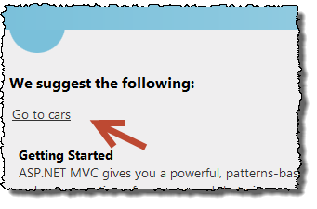
You should see a 404 error message because there is no Car controller to respond to the request. We’ll implement a controller next.
- In Solution Explorer, right-click the Controllers directory and select Add -> Controller.
- In the dialog that appears, give the controller the name of CarController. Leave the template as “Empty MVC controller”.
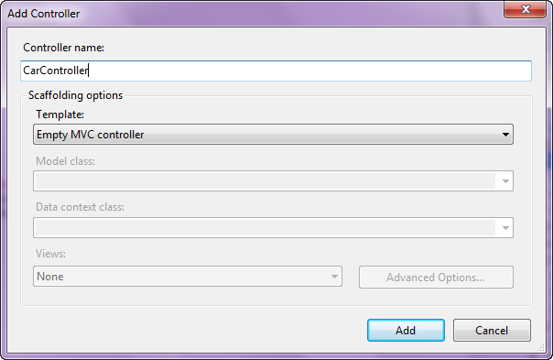

- Inside the Index method of the new file, use Server.MapPath to compute the physical path to the cars.csv file.
public ActionResult Index()
{
string path = Server.MapPath("~/App_Data/cars.csv");

return View();
}

- Next, instantiate a new CarRepository by passing the path to the csv file (you’ll need to add a using statement for Cars.Model at the beginning of the file).

var path = Server.MapPath("~/App_Data/cars.csv");
var repository = new CarRepository(path);

Before we can get any data, we’ll need a method on our repository that can return a collection of manufacturer names.

- Return to the CarRepository.cs file.
- Add a public method to CarRepository that returns IEnumerable<string> and has the name GetManufacturers.
- Inside GetManufacturers, write a LINQ query that will return an alphabetically ordered, distinct list of manufacture names.
public IEnumerable<string> GetManufacturers()
{
var result = _cars.Select(c => c.Manufacturer)
.Distinct()
.OrderBy(s => s);
return result;
}

- Return to the Index method of CarsController.cs and use the repository to retrieve the list of manufacturers. Pass the manufacturer list to the View method the controller inherits from its base class.

public ActionResult Index()
{
var path = Server.MapPath("~/App_Data/cars.csv");
var repository = new CarRepository(path);
var manufacturers = repository.GetManufacturers();
return View(manufacturers);
}

We now have all the logic in place, we just need a view to display the data.

- Build the project (F6) to make sure there are no compiler errors.
- Right-click inside the space inside the Index action and select Add View…
- In the Add View dialog, leave all the default settings (shown below) and click Add.
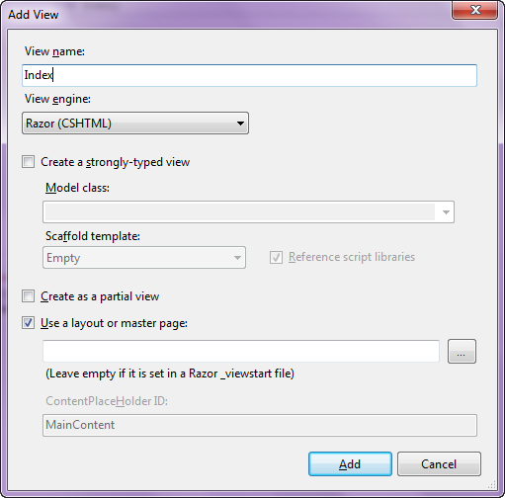

- In the new Index view, add a @model directive at the very top of the file to strongly type the view to an IEnumerable<string>.
@model IEnumerable<string>

- Just below the <h2> tag in the view, add the following code to display the manufacturer names in a list.
<ul>
@foreach (var manufacturer in Model)
{
<li>@manufacturer</li>
}
</ul>

- Press F5 to run the application. You should be able to navigate to the /Car page and see the list of manufacturers.
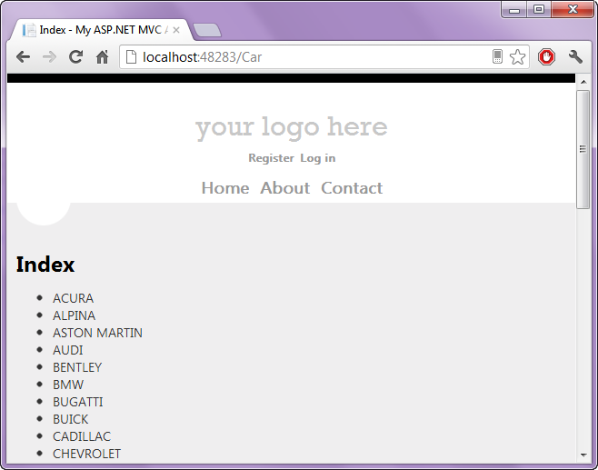

Next, we want to provide a hyperlink for each manufacture that takes the user to the next level of detail. We’ll build the detail and the hyperlink in the following steps.

- Return to CarController.cs and add a new public method that returns an ActionResult. Give the method the name of Show, and give the method two parameters named manufacturer and model, both of type string.

public ActionResult Show(string manufacturer,
string carModel)
{

}

Before we can create our list of cars, we need to add another method to our CarRepository to retrieve car information.

- Open CarRepository.cs and add a public method named GetAll. The method takes no parameters and returns an IEnumerable<Car>. Return the list of cars maintained by the repository.

public IEnumerable<Car> GetAll()
{
return _cars;
}

- Return to the Show method of CarController. Using the GetAll method of the repository, query the list of cars based on the incoming manufacturer and model parameters. Either parameter may contain a “*” value, meaning “all”, and we need to return a sequence of Car objects ordered by manufacturer then model name. Pass the results as the model for the view.

public ActionResult Show(string manufacturer, string carModel)
{
var repository =
new CarRepository(Server.MapPath("~/App_Data/cars.csv"));
var cars =
repository.GetAll()
.Where(c => manufacturer == "*" ||
manufacturer == c.Manufacturer)
.Where(c => carModel == "*" ||
c.ModelName.StartsWith(carModel));
return View(cars);
}

We can now return to our Index view and generate hyperlinks for each manufacturer that will invoke this Show action.

- Open the Index.cshtml you created earlier.
- Replace the line that displays the manufacturer inside <li> with a call to Html.ActionLink. The action link should send the user to the Show action and pass the manufacturer as a parameter.
<li>
@Html.ActionLink(manufacturer, "Show",
new { manufacturer=manufacturer})
</li>

Remember you can pass parameters as route data or query string values by passing an anonymous object with the “name/value pairs” as shown above.

We have everything in place now to navigate to the Show view. We’ll build the Show view next.

- Right-click inside the Show action and select Add -> View.
- In the Add View dialog box:
  - Select “Create a strongly-typed view”.
  - Select Cars.Model.Car as the View data class.
  - Select List as the Scaffold template.
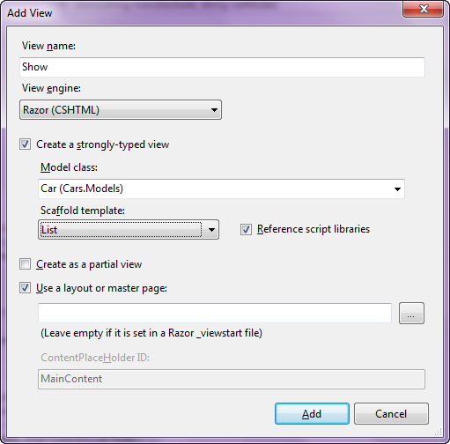

- Click Add.
- Press F5 to run the application. You should now be able to navigate to the new view by clicking on a manufacturer name from the /Cars URL.
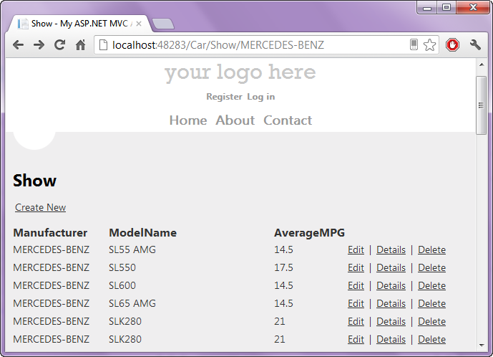

- You should also be able to navigate to a subset of a manufacturer’s cars by including the start of a model name in the URL.

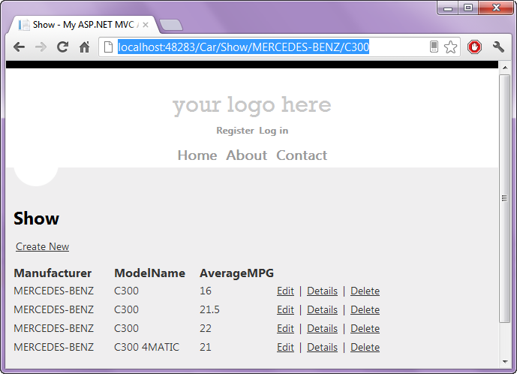

Conclusion
Congratulations! You’ve been an application with the ASP.NET MVC framework. You should now understand the relationship between routes and controllers, and have a feeling for the MVC pattern.

