Core WebAPI
Serving Movies

Core WebAPI
This lab is a continuation of the first lab. You can continue working with your AtTheMovies solution from the last lab, or you can start fresh by opening the solution in the before\AtTheMovies folder for this lab.

Objectives

After completing this lab, you should understand how to do the following:
- Create a database with the EntityFramework
- Create an API controller to read, update, create, and delete movies
- Use jQuery to invoke the web service from an HTML page

Part I – Creating The Database

In this section we will use the Entity Framework to create and populate a SQL Server LocalDb database.

- Right-click the AtTheMovies project and select Add -> New Folder.
- Set the name of the folder to Domain.
- Right-click the Domain folder and select Add -> Class. Name the class Movie. Each movies needs to store an Id, Title, Director, Length, Year, and a collection of Reviews.
public class Movie
{
public int Id { get; set; }
public string Title { get; set; }
public int Year { get; set; }
public int Length { get; set; }
public string Director { get; set; }
public ICollection<Review> Reviews { get; set; }
}

- Add another class in the Domain folder named Review. Every review needs to store an Id, Rating, Reviewer, Summary, and Movie.
public class Review
{
public int Id { get; set; }
public int Rating { get; set; }
public string Reviewer { get; set; }
public string Summary { get; set; }
public Movie Movie { get; set; }
}
The next step is to build up the persistence infrastructure with the Entity Framework. We’ll use EF Migrations to create the database schema and seed the database with some initial data.
- Open the Package Manager Console (View -> Other Windows -> Package Manager Console).
- Use the command install-package EntityFramework
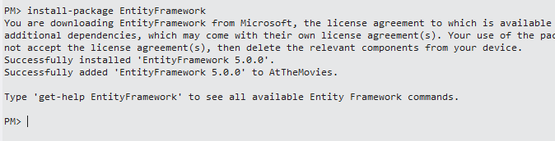
- Right click the Movie project and add a new folder named Infrastructure.
- Add a new class to the Infrastructure folder named MovieData. MovieData needs to carry DbSet properties for movies and reviews. You’ll also need a using statement for Movies.Domain at the top of the file and derive from DbContext.
public class MovieData : DbContext
{
public DbSet<Movie> Movies { get; set; }
public DbSet<Review> Reviews { get; set; }
}

- Return to the Package Manager Console
- Run the command: enable-migrations –ContextTypeName MovieData.
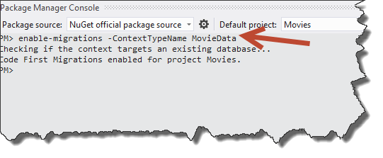
- In the new Configuration.cs file that appears in the editor, change the AutomaticMigrationsEnabled flag from false to true.
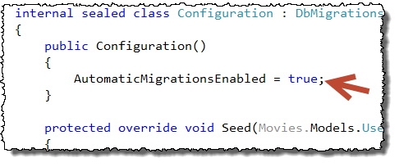
- In configuration.cs, delete the existing comments inside the Seed method.
We are going to seed the database with movies from an XML file.
The XML file is in the helperfiles folder for this lab.
- Right-click the App_Data folder and select Add -> Existing Item. Browse to the helperfiles folder for this lab and select movies.xml.
- Right-click movies.xml and set the Build Action to Embedded Resource.
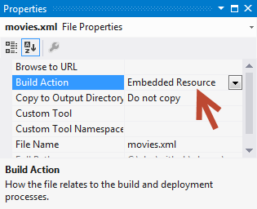
- Use the following code inside the Seed method to parse movies into the database.
var resourceName = "AtTheMovies.App_Data.movies.xml";
var assembly = Assembly.GetExecutingAssembly();
var stream = assembly.GetManifestResourceStream(resourceName);
var xml = XDocument.Load(stream);
var movies = xml.Element("Movies")
.Elements("Movie")
.Select(x => new Movie
{
Title = (string)x.Element("Title"),
Director = (string)x.Element("Director"),
Year = (int)x.Element("Year"),
Length = (int)x.Element("Length")
}).ToArray();
context.Movies.AddOrUpdate(m=>m.Title, movies);
- Return to the Package Manager Console and run update-database.
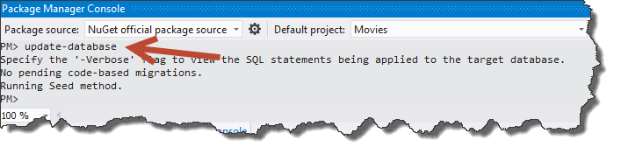
- Open SQL Server Object Explorer (View -> SQL Server Object Explorer).
- If there is no connection to LocalDb, right click the SQL Server node and select Add SQL Server…
- Use (localdb)v11.0 as a server name to connect to your LocalDb.
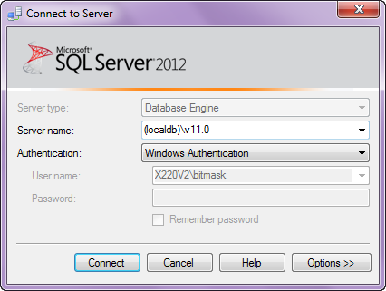
- Once connected, look for your MovieDb database (it should be AtTheMovies.Infrastructure.MovieData). Verify the tables are inside and that the Movies table has data.
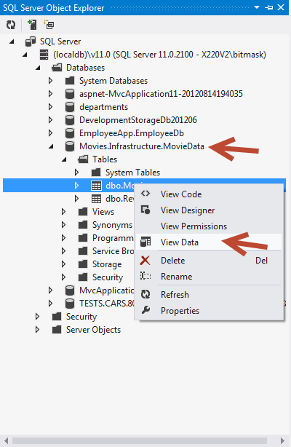
By default the Entity Framwork uses LocalDb and a database with the same name as your DbContext derived class. We can change this by giving EF an explicit conneciton string, but we’ll use LocalDb for now.

Part II – A WebAPI to Read Movies

In this section, we will add a WebAPI controller to retrieve a list of movies, or a single movie by ID.
- Right-click the controllers folder and select Add -> Controller.
- Name the controller MovieController and use the Empty API controller template.
Although tooling is available to create a controller with CRUD operations against the EntityFramework, we’ll build one from scratch.
- Give the controller a private field of type MovieData named _db.
- Add a constructor to the controller that will initialize _db to a new MovieData object.
- Override the controller’s Dispose method to dispose the _db object.
- Add a method that will response to an HTTP GET request and return the first 25 movies in the database.
The controller should now look like the following:
public class MovieController : ApiController
{
private MovieData _db;

public MovieController()
{
_db = new MovieData();
}

public IEnumerable<Movie> Get()
{
return _db.Movies.Take(25);
}

protected override void Dispose(bool disposing)
{
_db.Dispose();
}
}
- Press Ctrl+F5 to run the application in a browser, and navigate to /api/movie to test the result.

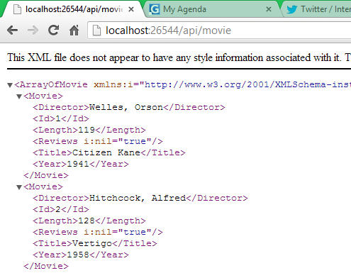
- Add another method to the controller that will respond to an HTTP GET request and return a single movie when given an id parameter in the route (the method should return type Movie). Return a 404 status code if the movie is not found in the database.
There are different techniques you can use to return a 404 status code. You can throw an HttpResponseException, or use Request.CreateErrorResponse. The difference is in the return type of the method. Do you want to return Movie, or HttpResponseMessage? Here is a version returning Movie.
public Movie Get(int id)
{
Movie movie = _db.Movies.Find(id);
if (movie == null)
{
throw new HttpResponseException(
Request.CreateResponse(
HttpStatusCode.NotFound)
);
}

return movie;
}
- In the browser, navigate to /api/movie/2 to verify you see the correct result.
- Now, change the last Get method you wrote to return an HttpResponseMessage. Do not throw an HttpResponseException object if the movie is not found (but still return a 404).
public HttpResponseMessage Get(int id)
{
Movie movie = _db.Movies.Find(id);
if (movie == null)
{
return Request.CreateErrorResponse(
HttpStatusCode.NotFound, "Movie not found");
}

return Request.CreateResponse(HttpStatusCode.OK, movie);
}
- Refresh the browser pointing to /api/movie/2 to make sure you still see the correct result.
- Navigate to /api/movie/10000 to make sure you see an error message.

Part III – A WebAPI to Create, Update, Delete Movies

- Add a method to the API controller that responds to an HTTP PUT request and updates an existing movie in the database.
Make sure to check ModelState to make sure the Movie data is valid. Use the Entity Framework Entry method to “attach” an entity that already exists in the database.
public HttpResponseMessage Put(Movie movie)
{
if (!ModelState.IsValid)
{
return Request.CreateErrorResponse(HttpStatusCode.BadRequest, ModelState);
}
try
{
_db.Entry(movie).State = EntityState.Modified;
_db.SaveChanges();
}
catch (DbUpdateConcurrencyException ex)
{
return Request.CreateErrorResponse(HttpStatusCode.Conflict, ex);
}
return Request.CreateResponse(HttpStatusCode.OK);
}
The above code is also checking to see if there is an optimistic concurrency exception. We don’t have optimistic concurrency checks enabled in EF currently, but the code is here as an example.
- Test out the Put method using Fiddler.
  - Launch Fiddler and send a GET request for movie 10. Ask for application/json content (this will give us the movie data to modify).
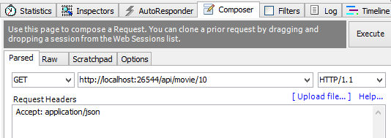
  - Copy the raw body of the response (this will give us the string to modify for the PUT operation, an easy way to see just the body is to go into “WebView”).
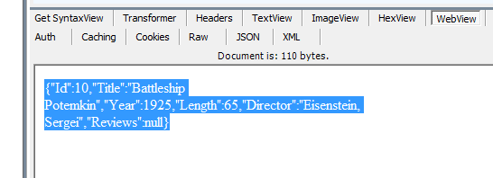
  - Return to the composer in Fiddler, and change the HTTP method to PUT.
  - Add a request header to specify the content type as application/json.
  - Paste the movie data into the request body and make some changes (like change the title).
  - Press Execute, and make sure you see a successful response (200).
- Add a method to the API controller taking an HTTP POST message to create a movie.
Make sure to include a Location header that contains a URL for the new movie, and return a 201 status code on success.
public HttpResponseMessage Post(Movie movie)
{
if (ModelState.IsValid)
{
db.Movies.Add(movie);
db.SaveChanges();

HttpResponseMessage response =
Request.CreateResponse(HttpStatusCode.Created, movie);
response.Headers.Location =
new Uri(Url.Link("DefaultApi", new { id = movie.Id }));
return response;
}
else
{
return Request.CreateErrorResponse(HttpStatusCode.BadRequest, ModelState);
}
}
- Use Fiddler to test the Post functionality.
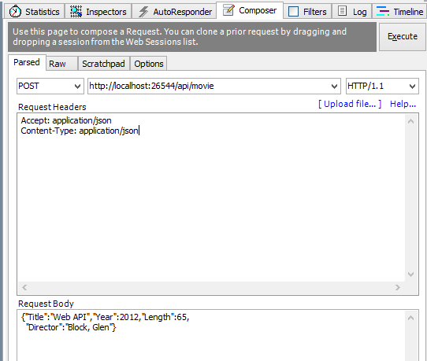
- Implement a method to DELETE a movie.

public HttpResponseMessage Delete(int id)
{
Movie movie = _db.Movies.Find(id);
if (movie == null)
{
return Request.CreateResponse(HttpStatusCode.NotFound);
}
try
{
_db.Movies.Remove(movie);
_db.SaveChanges();
}
catch (DbUpdateConcurrencyException ex)
{
return Request.CreateErrorResponse(HttpStatusCode.Conflict, ex);
}

return Request.CreateResponse(HttpStatusCode.OK, movie);
}
- Use Fiddler to test your delete and create logic.

Part IV – A Simple Web Client (With jQuery and Mustache)
In this section, we will build a web page to call the WebAPI from JavaScript and display a single page of movies.

- Right-click AtTheMovies and select Add -> HTML Page.
- Name the page default.html
- Right-click default.html and click Select as Start Page.
- Go to the Package Manager Console and install-package jQuery.
- In the console, also install-package mustache.js.
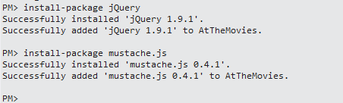
- In default.html, drag and drop the jQuery-1.9.1.js and mustache.js files from the Scripts folder into the <head> section of the page.
<head>
<title></title>
<script src="Scripts/jquery-1.9.1.js"></script>
<script src="Scripts/mustache.js"></script>
</head>
- In the body of the document, create a level 1 header with the text Movies.
- Create an unordered list with an id of movieList.
movieList is where we will place the list of movies we retrieve from the server.
<h1>Movies</h1>
<ul id="movieList">

</ul>
- Create a script tag with an id of movieTemplate and of type “text/html”.
Inside of here will be HTML markup, not a script. We don’t want the browser to try and execute or display the template, thus we give this a type the browser will ignore.
<script id="movieTemplate" type="text/html">

</script>

- Inside the template, we’ll use mustache syntax to “data-bind” movie data into HTML.
<script id="movieTemplate" type="text/html">
{{#movies}}
<li>
{{Title}}
</li>
{{/movies}}
</script>
- Create another JavaScript tag, this time for real JavaScript code. See if you can invoke the web service Get method using jQuery and display the results on the page. Here are some tips:
- Use $.get to call the Get method for all movies.
- Use Mustache.to_html to apply data to a template
- Complete code is below:
<script>
(function() {

var init = function() {
$.get("/api/movie").success(updateScreen);
};

var updateScreen = function(data) {
var template = $("#movieTemplate");
var list = $("#movieList");
var html = Mustache.to_html(template.html(), { movies: data });
list.empty().html(html);
};

$(init);

}());
</script>
- Press Ctrl+F5 to run the application and view the list of movies. Use debugging tools like a script debugger to Fiddler to find problems, if you have any.
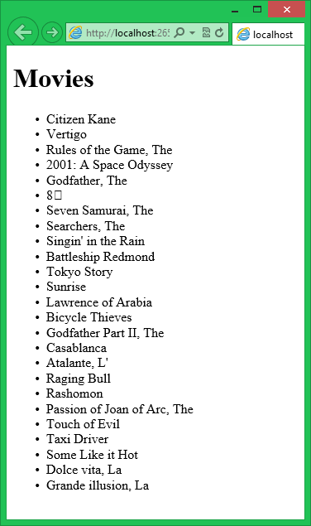

Conclusion
Congratulations! You’ve made a WebAPI that successfully encapsulates a resource!

