Supplementary Information

S1 Role of carrying capacity in the SGH patterns
We explore here the model results for each of the two mechanisms in the case where the logistic growth term is rendered inactive. This is achieved by taking the carrying capacity $k→∞$, which makes $f_{k}(B)=\left(1-B/k\right)→1$. We can now find analytical expressions for the steady-state solutions of the model described in Equations (1) in the
main paper. The nontrivial ($B≠0$) steady-state solutions $(B^{⋆},S^{⋆})$ read:
$$S^{⋆}=\frac{m}{af_{a}(d)}$$ | (S1a)
$$B^{⋆}=\frac{p-f_{r}(S^{⋆},d)-q_{s}{\left(S^{⋆}\right)}^{γ}}{e_{0}f_{e}(d)S^{⋆}}$$ |  | (S1b)
These solutions are a typical instance of the R-star rule¹, and from them we can express two important features:
- The steady-state resource level $S^{⋆}$ (generally called $R^{⋆}$ in consumer-resource modeling, therefore the name of the rule) is independent of the resource supply rate, $p$.
- The nontrivial ($B≠0$) steady-state consumer level $B^{⋆}$ is linear in the resource input rate, $p$.
Figure S1 shows the steady-state biomass $B^{⋆}$ (top panels) and relative soil water content $S^{⋆}$ (bottom panels). The left and right columns correspond to the shading mechanism and the root mechanism, respectively.
A careful examination of the steady-state solutions S1 teaches us that:
- For the shading mechanism, $0≤f_{e}(d)<f_{a}(d)<1$ for any $d>0$ (see inset in Fig. S1c). From these facts it follows that the linear function for the positive tree-density solution ($B^{⋆}(p,d>0)$) has a higher slope and a lower intercept than the no-tree solution ($B^{⋆}(p,d=0)$). Because of its lower intercept, the positive density solution surpasses the zero-tree density solution from below (lower $B$). This means that eliminating the logistic growth term from the model reverses the order of the transition described by the SGH: we have competition for $p$ below the transition point, and facilitation for $p$ above that point. Furthermore, for the parameter values we used here, the transition point occurs at extremely low values of $p$ and $B$. Looking from farther away, the interactions appear facilitative for most of the precipitation gradient (Fig. S1a).
- For the root mechanism, two straight-line solutions $B^{⋆}$ always have the same slope, regardless of their $d$ value, and therefore never intersect. The root mechanism can be either facilitative or competitive, depending on the soil water content (see inset in Fig. S1d). Figure 1b shows a scenario where the interaction is always facilitative. By changing the model parameters $m,a,d$ (see Eq. S1a), one can also find higher soil water content levels that always yield competitive interactions.
The arguments above demonstrate that, whenever tree density is constant, the introduction of an additional growth-limiting factor that strengthens with increasing precipitation is a necessary condition for the emergence of the transition described by the SGH.
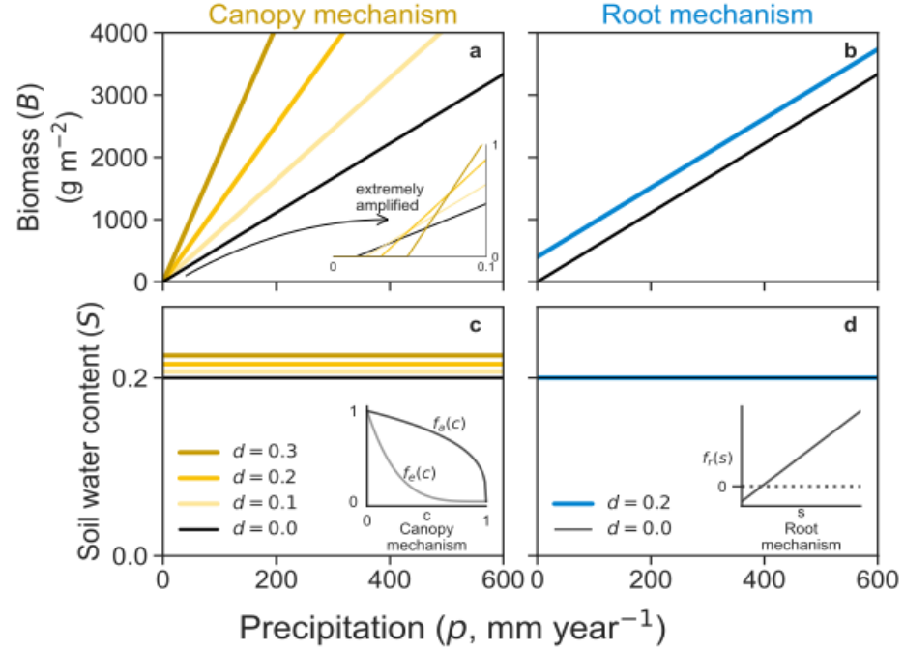
Figure S1: Steady-state biomass (panels a,b) and soil water content (panels c,d) solutions as functions of precipitation. The left column corresponds to the shading mechanism, and the right column corresponds to the root mechanism. The inset in panel a shows an extreme amplification in $p$ and $B$ of the solutions, emphasizing the intersection points between the no-tree solution ($d=0$) and the other solutions with $d>0$. The insets in panels c and d are provided as reminders of the relevant functions of each mechanism.

S2 Interaction intensity
As a rule, trees facilitate herb growth when their density is low and the system is under water stress (low $p$). Competition over water arises at high tree density values and under low water stress. Focusing on the canopy mechanism, Figure S2 shows that in the $(p,d)$ parameter space, the boundary between facilitation and competition (solid black curve) follows a negative relation: as precipitation increases, a lower tree density is sufficient to shift the balance from facilitation to competition. This border is the same for both interaction intensity definitions, since zero interaction intensity means that the biomass solution with tree density ($B_{T}$) equals the biomass solution with no tree density ($B_{0}$). The area hatched in black at the top of both panels, where tree density is very high, indicates the region in the parameter space where there are only trivial ($B=0$) vegetated solutions.
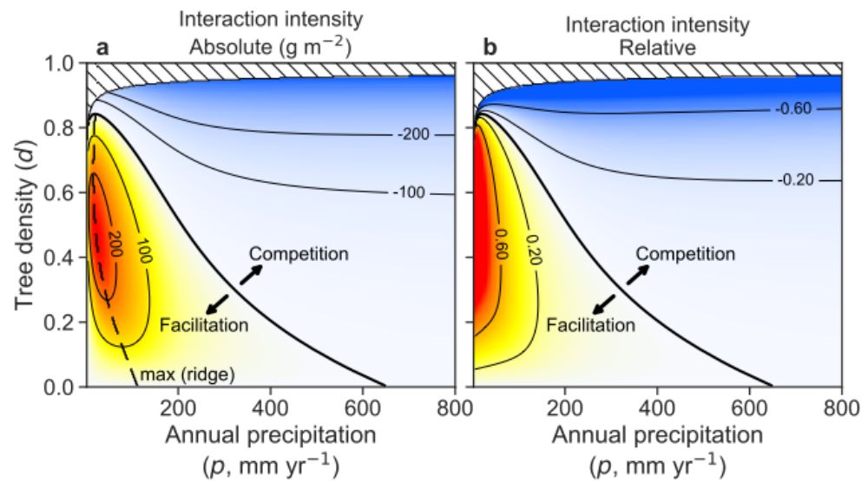
Figure S2: Interaction intensity varies jointly with precipitation and tree density. Interaction intensity in the canopy submodel is shown as a function of annual precipitation ($p$) and tree density ($d$), measured as (left) the absolute difference in herb biomass, $B_{T}-B_{0}$, and (right) the relative log response ratio, $ln(B_{T}/B_{0})$, where $B_{0}$ and $B_{T}$ denote herb biomass in the absence and presence of trees, respectively. Purple shades indicate facilitation (positive values) and orange shades indicate competition (negative values). Both metrics reveal a transition (black line) from facilitation at low rainfall and tree density to competition at high rainfall and tree density. The dashed black line on the left panel indicates the locus of maximum facilitation for a fixed tree density value $[\frac{∂}{∂p}(\text{int. intensity})=0]$, for the absolute interaction intensity.
As shown in Fig. 3a, we can get unimodal curves when using the absolute interaction intensity. The dashed black curve in , Figure S2a shows the location of the local maxima in the $(p,d)$ parameter space. To the left of this curve, the interaction intensity is positive and increases with precipitation. Once we cross this curve (from left to right), interaction intensity is still positive, but it decreases with precipitation. This ridge-like curve disappears when we use the relative interaction intensity instead: there is only monotonic decrease with precipitation.

S3 A deeper look into the model
In order to find useful ways of thinking about the model, we perform a non-dimensionalization of the equations. For our purposes, it makes more sense to describe the second equation as the rate of change of absolute soil water content $W=nz_{r}S$, instead of the equivalent $nz_{r} dS/dt$ as shown in Eq. (1). Since the active soil layer $nz_{r}$ has length dimension ($z_{r}$ is the depth of the herb rooting zone, while the porosity $n$ is non-dimensional), absolute soil water content $W$ is also a length (it is commonly called soil water depth). Finally, we note that 1 mm of water is equivalent to 1 L m⁻², so reporting $W$ as length is the same as volume per unit area. The full model equations now read:
$$\frac{dB}{dt}=a f_{a}(d) \left(1-\frac{B}{k}\right)B S-m B$$ | (S2a)
$$\frac{dW}{dt}=p-q_{s}S^{γ}-e_{0} f_{e}(d)B S-f_{r}(S,d)$$ |  | (S2b)
The independent and dependent variables of this dynamical system have the following dimensions:
Quantity | symbol | dimension | units
Biomass density | $$B$$ | density $ρ$ | kg m⁻²
Absolute soil water content | $$W$$ | length L | mm
Time | $$t$$ | time T | day
Accounting for all the model parameters that have dimensions, we have eight: $a,k,m,(nz_{r}),p,q_{s},e_{0},λ$. (Here we treat $nz_{r}$ as a single parameter.) The parameter $λ$ appears inside the function $f_{r}(S,d)$. All of these parameters have dimensions that derive from the three basic ones shown in the table. According to Buckingham’s $Π$ Theorem, when performing non-dimensionalization of the equations, the number of independent dimensionless groups is equal to the number of dimensional parameters minus the number of fundamental dimensions. Since we have 8 dimensional parameters and 3 fundamental dimensions (biomass density, length, and time), we obtain $8-3=5$. In simple terms, although the model contains eight dimensional parameters, its behavior can be fully captured by just five independent dimensionless combinations.
We start now the non-dimensionalization process by defining the following new non-dimensional variables:
$$\text{non-dimensional biomass}$$ | $$\tilde{b}=B/ξ_{1}$$ | (S3a)
$$\text{non-dimensional time}$$ | $$\tilde{t}=\frac{t}{ξ_{2}}$$ | (S3b)
$$\text{non-dimensional water}$$ | $$S=\frac{W}{ξ_{3}}$$ | (S3c)
We have many choices for $ξ_{1},ξ_{2},ξ_{3}$. A suitable choice here is:
$$ξ_{1}=\frac{1}{e_{0}/a}$$ | (S4a)
$$ξ_{2}=\frac{1}{a}$$ | (S4b)
$$ξ_{3}=nz_{r}$$ | (S4c)
Substituting Eqs. (S3) and (S4) into Eqs. (S2) yields the non-dimensional dynamical system:
$$\frac{d\tilde{b}}{d\tilde{t}}=f_{a}(d) \left(1-\frac{\tilde{b}}{\tilde{k}}\right)\tilde{b} S-\tilde{m} \tilde{b}$$ | (S5a)
$$\frac{dS}{d\tilde{t}}\&=\tilde{p}-{\tilde{q}}_{s}S^{γ}-f_{e}(d) \tilde{b}S-{\tilde{f}}_{r}(S,d)$$ | (S5b)
As we can see, this choice of $ξ_{1},ξ_{2},ξ_{3}$ leaves us a non-dimensional system, where every single variable, parameter, term or function is dimensionless. For this specific choice of $ξ$ scaling factors, we have a system with unity growth rate and unity maximum evapotranspiration rate.

The non-dimensional parameters ($Π$ parameters) for the equations above are:
$\text{non-dimensional herb growth rate },Π_{1}$ | $$\tilde{m}=\frac{m}{a}$$ | (S6a)
$\text{non-dimensional carrying capacity },Π_{2}$ | $$\tilde{k}=(e_{0}/a) k$$ | (S6b)
$$\text{non-dimensional precipitation rate },Π_{3}$$ | $$\tilde{p}=\frac{p}{anz_{r}}$$ | (S6c)
$$\text{non-dimensional sat. hyd. cond. },Π_{4}$$ | $${\tilde{q}}_{s}=\frac{q_{s}}{anz_{r}}$$ | (S6d)
$$\text{non-dimensional tree-root hydraulic rate }, Π_{5}$$ | $$\tilde{λ}=\frac{λ}{anz_{r}}$$ | (S6e)
This exercise is instrumental in shedding light on the impact of various model parameters on its behavior:
- The active soil layer $nz_{r}$ (mm), where $n$ is soil porosity (dimensionless) and $z_{r}$ is the rooting depth of herbs (mm), sets the maximum volume of water that can be stored and made available to herbs. As Eqs. (1) indicate, $nz_{r}$ can only impact the transient dynamics of $(B,S)$, never their steady-state solutions. Of course, due to the third conversion in Eq. (S3), $nz_{r}$ rescales $S$ into $W=nz_{r}S$.
- The denominator $anz_{r}$ represents a characteristic water throughput, where $a$ sets the characteristic timescale and $nz_{r}$ is the volume of water per unit area (1 mm $=$ 1 L m$​^{-2}$). It sets the scale for precipitation, drainage, and root uptake/uplift ($\tilde{p},{\tilde{q}}_{s},\tilde{λ}$): higher values correspond to processes faster than the characteristic resource throughput in the system.
- The ratio $e_{0}/a$ naturally emerges as a water-use efficiency, converting herb water uptake into biomass production. In fact, when tree density is zero ($d=0$) and herb biomass is low (so that $1-\tilde{b}/\tilde{k}≈1$), the evapotranspiration loss term in Eq. (S5b) is identical to the biomass growth term in Eq. (S5a). This symmetry highlights the direct coupling of growth and water loss. The conversion dictated by (S3a) means that whatever the non-dimensional steady state $\tilde{b}$ one gets by solving Eqs. (S5), we divide it by the water-use efficiency $e_{0}/a$ to get the dimensional biomass $B$.
- The typical growth timescale $1/a$ acts as a fundamental clock for all other remaining parameters (see (S6)).
- $\tilde{k}$ shows how the dimensional carrying capacity $k$ is rescaled by water-use efficiency $e_{0}/a$. A system with a large $k$ but low water-use efficiency is effectively constrained, while high water-use efficiency inflates the effective carrying capacity.

S4 Transient dynamics
The typical timescale for the dynamics of herb biomass ($B$) is comparable to the length of the growing season used in this study, 180 days. Figure S3 shows the time dynamics (left column) and phase space (right column) for three precipitation levels ($p=\{150,300,600\}$ mm year$​^{-1}$) and three tree conditions: no tree ($d=0$, top row), shading mechanism ($d=0.3$, middle row), and root mechanism ($d=0.3$, bottom row). Linear stability analysis of the numerically found steady-state solutions (hollow circles) reveals them to be stable nodes (real and negative eigenvalues).
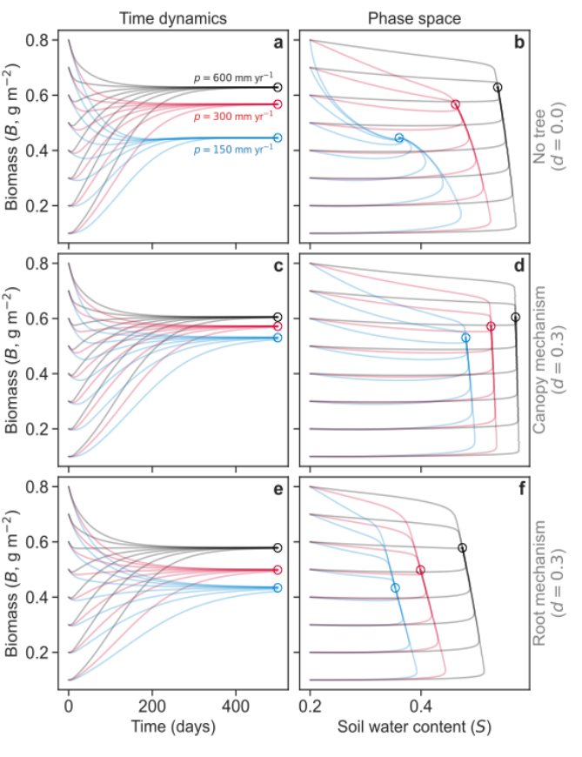
Figure S3: Time dynamics (left) and phase-space portrait (right) of $(B,S)$ solutions. Panels a,b: zero tree density. Panels c,d: Tree density $d=0.3$, shading mechanism on. Panels e,f: Tree density $d=0.3$, root mechanism on. Blue, red and black orbits denote precipitation levels of 150, 300 and 600 mm year$​^{-1}$, respectively. The same eight initial conditions were used for all cases: $S=0.2$ and $B$ ranging from 0.1 to 0.8, with 0.1 increments. Hollow circles denote the value of the solution with initial condition $(B=0.4,S=0.2)$ at time 500 days.
Crucially, the facilitation–competition switch persists when we examine transient dynamics, not only steady-state outcomes. In Fig. S4, we compare the steady-state pattern (panel a) with solutions obtained by integrating Eq. (1) in the main text for 180 days (panel b). The qualitative result is the same in both cases, with positive tree effects at low precipitation and negative effects at high precipitation. Temporal dynamics, however, alter the details: the magnitude of facilitation and competition, and the precipitation at which the switch occurs, differ between transient and steady-state results.
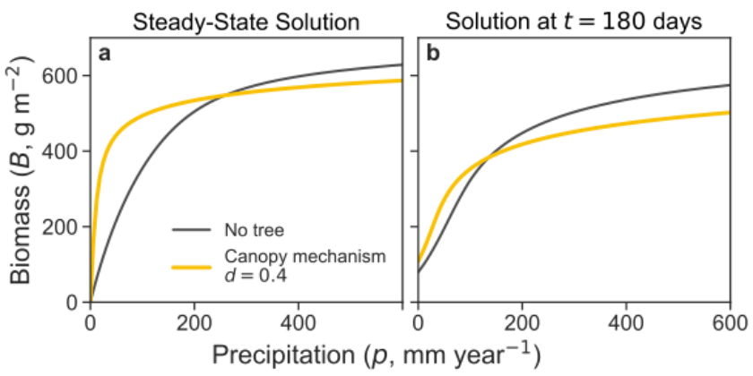
Figure S4: The transition from facilitation to competition, for steady-state solutions (panel a), and for transient solutions after 180 days (panel b). The initial conditions for the transient solutions are $(B=200 \text{g},S=0.2)$. For both panels we considered only the canopy mechanism, for tree density levels 0.0 and 0.4. Other parameters as reported in Table 1.

S5 A gradient of evaporative demand
Here, we demonstrate that our model can produce a transition from facilitation to competition, not only along a precipitation gradient but also across an evaporative demand gradient (Figure S5).
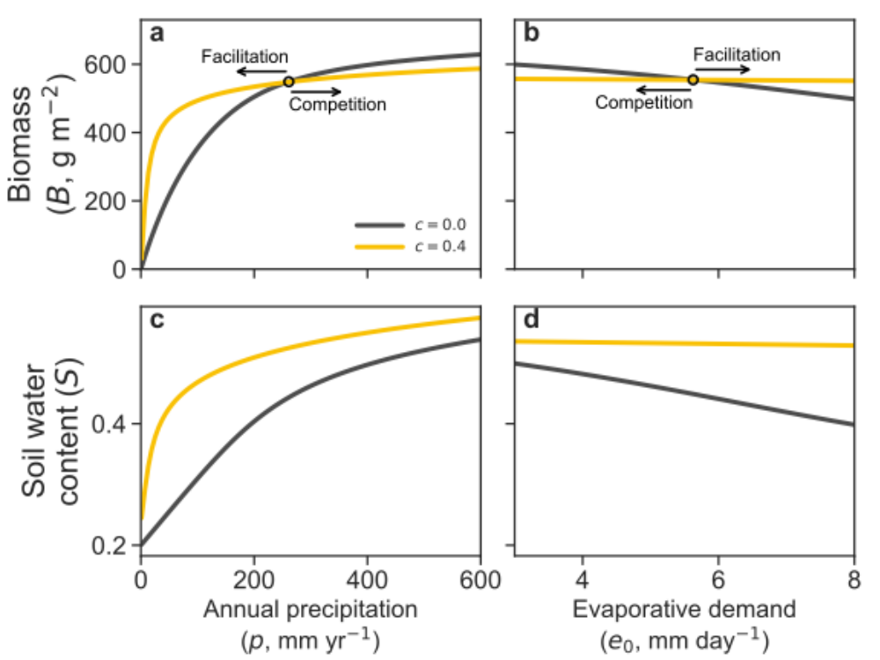
Figure S5: The facilitation–competition transition extends across different abiotic stress axes. Panels a,c: Precipitation as the stress axis reproduces the classic SGH prediction, with facilitation at low supply and competition at high supply. Panel b,d: Evaporative demand, representing atmospheric drivers of water loss, yields the same qualitative pattern but on a reversed axis (higher demand corresponds to stronger stress).

S6 Choosing the right resource metric for the SGH
The Stress Gradient Hypothesis (SGH) predicts a shift from facilitation to competition as a resource increases. A critical question is which resource metric to use: resource supply rate (like precipitation) or resource abundance (like soil water content). We demonstrate here that the resource supply rate is the appropriate metric for assessing the SGH.
When we analyze our model using precipitation as the control parameter (x-axis in a $B$ vs. $p$ plot), the results clearly demonstrate the SGH pattern. For both the shading and root mechanisms, we observe a transition from positive to negative tree–herb interactions as precipitation increases, mirroring field observations.
In contrast, if we use soil water content as the resource metric, the SGH pattern vanishes. Figure S6 shows the same herb biomass solutions as Figure 2, but plotted against soil water content.
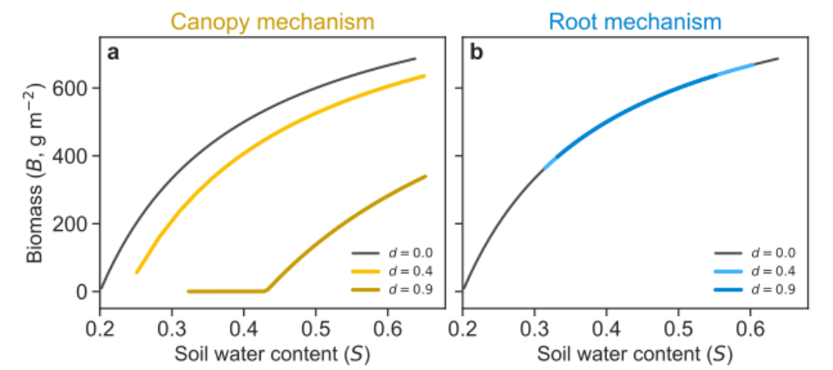
Figure S6: Using soil water content as the stress axis eliminates the facilitation–competition transition. Steady-state herb biomass solutions are shown as a function of soil water content for the canopy mechanism (panel a) and the root mechanism (panel b). In the canopy mechanism, biomass with trees ($d>0$) is always lower than the no-tree baseline, because canopy directly reduces assimilation while water conservation effects are no longer represented. In the root mechanism, biomass becomes independent of tree density when soil water is fixed, since tree effects operate only by altering soil moisture levels. Accordingly, when stress is parameterized by soil water abundance rather than supply rate, the SGH pattern disappears.
The nontrivial ($B≠0$) solutions can be readily obtained by equating Eq. (1a) to zero and solving for $B$:
$$\text{Shading mechanism: }B^{⋆}(S)=k\left(1-\frac{m}{aSf_{a}(d)}\right)$$ |  | (S7a)
$$\text{Root mechanism: } B^{⋆}(S)=k\left(1-\frac{m}{aS}\right)$$ | (S7b)
From these solutions we learn:
- Shading mechanism: Because $f_{a}(d>0)<f_{a}(d=0)$, the steady-state herb biomass with trees ($B_{T}$) is always lower than the biomass without trees ($B_{0}$). Trees always reduce light, which directly suppresses herb growth. Because the facilitative effect of water conservation is no longer a factor, the interaction intensity is always negative (competitive).
- Root mechanism: Herb biomass becomes completely independent of tree density (it lacks the variable $d$). Trees influence herbs solely by altering soil water levels, so if that level is fixed, the trees have no effect. The interaction intensity is always zero.
This result, that the SGH pattern disappears when using soil water content as the metric, occurs for a fundamental reason: soil water content, unlike precipitation, is an intrinsic property of the ecosystem, not an external force. It is the result of multiple processes such as rainfall, evapotranspiration, drainage, etc., all of which interact with the tree’s presence to determine the final soil water content. By holding soil water constant, we are artificially decoupling the very mechanisms that create the SGH pattern. Therefore, using resource abundance (soil water content) as the metric of stress renders the SGH meaningless within this mechanistic framework, as it nullifies the resource component in our consumer–resource model.
The resource supply rate (precipitation) is the external driver of the system’s state, making it the correct measure of abiotic stress for a resource-based SGH. It allows us to capture the full interplay of facilitative and competitive forces that are the core of the hypothesis.

S7 Logistic growth extension: nutrient-limited growth
To justify our choice of introducing a limiting factor to herb growth as a logistic term, we do the exercise of explicitly introducing a new essential resource, a nutrient $N$. Our model can be extended to include the nutrient dynamics as follows:
$$\frac{dB}{dt}=a f_{a}(d) B N S-m B$$ | (S8a)
$$nz_{r} \frac{dS}{dt}=p-e_{0} f_{e}(d)B S-f_{r}(S,d)-q_{s}S^{γ}$$ | (S8b)
$$\frac{dN}{dt}=N_{\text{in}}-μNB-νN.$$ | (S8c)
The first equation, (S8a), describes the herb biomass dynamics, where we have replaced our original logistic term $f_{k}(B)$ with a nutrient term, $N$. Equation (S8c) describes the nutrient’s dynamics, where it is introduced at a constant rate $N_{\text{in}}$, consumed by herbs (at a rate proportional to both herb biomass and nutrient availability, $μNB$), and lost from the system at a rate proportional to its own abundance, $νN$.
We now assume that the nutrient dynamics are much faster than those of the herb biomass ($B$) and soil water ($S$). We can therefore perform an adiabatic elimination by setting the rate of change of the nutrient to zero to find its quasi-steady-state:
$$0=N_{\text{in}}-μNB-νN$$ | (S9a)
$$⟹N^{⋆}=\frac{N_{\text{in}}}{ν} \frac{1}{\frac{μ}{ν}B+1}$$ | (S9b)

where $N^{⋆}$ denotes the quasi-steady-state nutrient concentration. Substituting $N^{⋆}$ into the herb biomass equation (S8a) gives:
$$\frac{dB}{dt}=a \frac{N_{\text{in}}}{ν}f_{a}(d) B\left(\frac{1}{\frac{μ}{ν}B+1}\right)S-m B$$ | (S10)

The term in the parenthesis acts as a saturating function of $B$. When herb biomass is low, the term is close to one, and as biomass increases, the function decreases, effectively slowing the growth rate. This plays the same role as the logistic term we assumed in the main text.
To derive the exact logistic form, we can make an additional assumption. If we assume that the herbs are highly inefficient at consuming the nutrient relative to its decay rate ($μ≪ν$), we can use a first-order Taylor series expansion:
$$\frac{1}{\frac{μ}{ν}B+1}≈1-\frac{μ}{ν}B.$$ | (S11)
Substituting this approximation into the herb biomass equation now reveals a classic logistic term:
$$\frac{dB}{dt}=a \frac{N_{\text{in}}}{ν}f_{a}(d) B\left(1-\frac{B}{k}\right)S-m B$$ | (S12)
where the carrying capacity can be identified with $k=ν/μ$. If the factor $N_{\text{in}}/ν$ is then incorporated into $a$, we get exactly Eq. (1a) in the main text.

S8 Tree density dependent on precipitation
The arguments in Supplementary Section S1 stated that there can be no SGH transition in the absence of a carrying capacity term for constant tree density. This picture changes if instead we allow for precipitation-dependent tree density (as observed in many systems). Higher precipitation supports greater tree density, which, in turn, exerts a stronger shading impact on herbaceous species. We consider here two distinct functional forms of $d(p)$:
$$d(p)=min\left(\frac{p}{1000},1\right)$$ | (S13a)
$$d(p)=\frac{p}{300+p}$$ | (S13b)
While the model internally uses $p$ in mm d⁻¹, we present the equations $d(p)$ in mm ⁻¹ for simplicity and practical relevance.
Figure S7a illustrates the transition from facilitation to competition for these two functional forms. Figure S7b shows the absolute interaction intensity in the $(p,d)$ plane, and helps us interpret the graph on the top. When a dark curve in the bottom panel crosses the border between facilitation and competition, we see in the top panel that the dark curves cross the no-tree solution. For higher values of $d$, when the dark curves in the bottom panel cross into the no-viable-biomass zone, we also see a collapse of the vegetated solutions in the top panel. Finally, Fig. S7b helps us understand, from another point of view, why there cannot be a transition from facilitation to competition in the case of no carrying capacity and constant tree density, as previously discussed. Constant density solutions (see for example the dotted line at $d=0.2$) always cross from competition to facilitation as $p$ increases, never the other way around. By changing tree density from a constant value to increasing functions of precipitation, as depicted by the solid dark lines, one can get the usual transition pattern of the SGH.
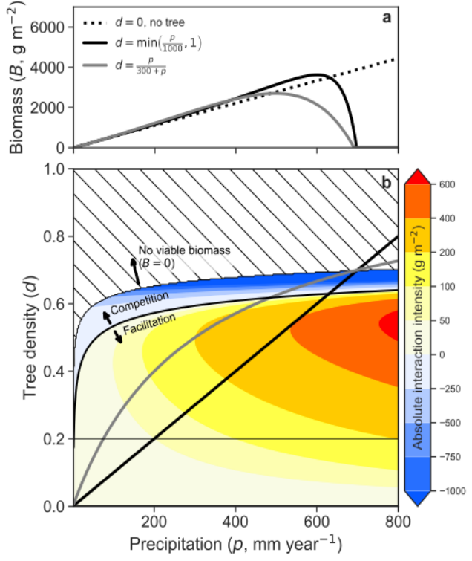
Figure S7: The precipitation-dependent tree density mechanism produces the SGH transition even without a carrying capacity term. Panel a: Steady-state herb biomass solutions (Eq. S1b) for a scenario without any tree density (dotted line) and for two possible instantiations of the tree-density dependence on precipitation (dark curves). Panel b: The absolute interaction intensity is shown in the $(p,d)$ plane: warm colors denote positive interactions (facilitation), while cold colors denote negative interactions (competition). The hashed region in the top indicates no viable herb solutions ($B=0$). The two functional forms for tree density are plotted in solid dark curves. Parameters: $β_{a}=0.9$ and $β_{e}=1.1$, and other parameters as shown in Table 1.

S9 Infiltration
The infiltration mechanism is a variation of the canopy mechanism. In both, canopy shading reduces herb assimilation through $f_{a}(d)$; here, however, the facilitative pathway is not a reduction in evapotranspiration but an increase in effective infiltration as tree density rises. The model therefore keeps the growth-side shading term and replaces the rainfall input with an infiltrated input $p f_{i}(d)$:
$$\frac{dB}{dt}=a f_{a}(d) \left(1-\frac{B}{k}\right) B S - m B$$ | (S14a)
$$nz_{r} \frac{dS}{dt}=p f_{i}(d) - q_{s} S^{γ} - e_{0} B S$$ | (S14b)

The infiltration factor $f_{i}(d)$ follows Gilad et al.²:
$$f_{i}(d) = \frac{d+i_{0} δ}{d+δ}$$ | (S15)
so that $f_{i}(0)=i_{0}$ (minimum infiltration without trees) and $f_{i}(d)→1$ as $d$ increases; see Fig. S8a. The parameter $δ$ sets the density scale at which $f_{i}$ is midway between $i_{0}$ and 1. Fig. S8b shows the SGH transition for the infiltration mechanism.
This relationship captures the idea that canopy shading can suppress biological soil crusts (biocrusts), which often form a hardened surface layer that reduces infiltration. As tree density increases, shading limits biocrust activity and allows more water to infiltrate into the soil, thereby increasing the effective water supply to herbs.
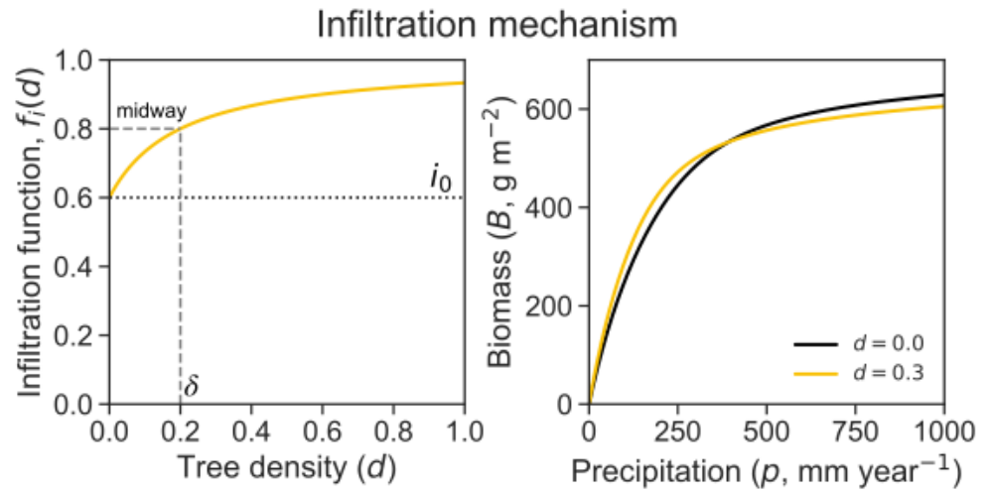
Figure S8: Infiltration mechanism as a canopy variant. (a) The infiltration factor $f_{i}(d)$ increases from $i_{0}$ at $d=0$ toward 1 as tree density rises ($δ$ controls the transition scale). (b) The transition from facilitation to competition can be obtained from the infiltration mechanism.

References
- Tilman, D. (1982). Resource Competition and Community Structure. Princeton University Press, Princeton, NJ. https://doi.org/10.2307/j.ctvx5wb72
- Gilad, E., von Hardenberg, J., Provenzale, A., Shachak, M., & Meron, E. (2004). Ecosystem engineers: from pattern formation to habitat creation. Physical Review Letters, 93(9), 098105. https://doi.org/10.1103/PhysRevLett.93.098105

Slope $σ$: for $d=0$ the slope is $σ_{0}=a/(e_{0}m)$, whereas for $d>0$ it is $σ_{d}=σ_{0}⋅\left(f_{a}(d)/f_{e}(d)\right)$. Since $f_{a}(d)>f_{e}(d)$, we have that $σ_{d}>σ_{0}$. Intercept $ω$: for $d=0$ the intercept is $ω_{0}=-(q_{s}/e_{0}) (m/a)^{γ-1}$, whereas for $d>0$ it is $ω_{d}=ω_{0} (1/f_{e}(d)) (1/f_{a}^{γ-1}(d))$. Since $f_{a}(d),f_{e}(d)<1$ and $γ>2$, each parenthesis is greater than 1, and therefore $ω_{d}<ω_{0}$ (note the minus sign in $ω_{0}$).

