TEMPORAL CHANGE POINTS AND NITROGEN-DRIVEN SHIFTS IN VOLUMETRIC WATER, RELATIVE WATER CONTENT, AND DEFICIENCY INDICES OF GROUNDNUT
Aim
The study set out to track how soil and leaf-water status shift through space and time in Arachis hypogaea fields, focusing on two locally grown varieties: Akwa and Kwarts under five nitrogen regimes (0, 15, 30, 45 kg N ha⁻¹, plus an unfertilised control). Specifically, I wanted to establish the water-use profile of each variety, learn whether nitrogen modifies that profile, and clarify how three complementary indices: volumetric water content of soil (VW), leaf relative water content (RWC) and a leaf water-deficiency index (DEF) behave together.

The dataset
Sampling ran weekly for the first five weeks after rainfall ceased. At each visit, technicians collected triplicate soil cores and five flag-leaf discs from every canopy position (under the trunk, 0.5 m, 1 m, 1.5 m from the trunk, and the midpoint between trees) in every plot. The cleaned file contains 750 rows: three blocks × five positions × five weeks × five nitrogen levels.
Before analysis, the only missing numerical cells were filled with the column mean, preserving the repeated-measures structure. All factor columns were converted to R‐style factors so that week-to-week changes could be treated within subjects.
Variable | Mean | SD | Min | Max
VW, % | 12.8 | 7.7 | 1.4 | 98.0
RWC, % | 23.6 | 17.1 | –2.7 | 67.5
DEF | 61.9 | 14.4 | 3.9 | 84.9

These ranges show that the five-week window captured conditions from near field capacity to severe drought.

Weekly and spatial effects (two-way repeated-measures ANOVA)
A separate Week × Location repeated-measures ANOVA was fitted for each response. Week dominated in every case (F ≈ 51–71, p < 0.001), while location contributed a smaller share (F ≈ 6–8, p < 0.001). The Week × Location interaction never rose above marginal significance, meaning the five canopy positions followed the same rise-and-fall curve, offset only in absolute level. 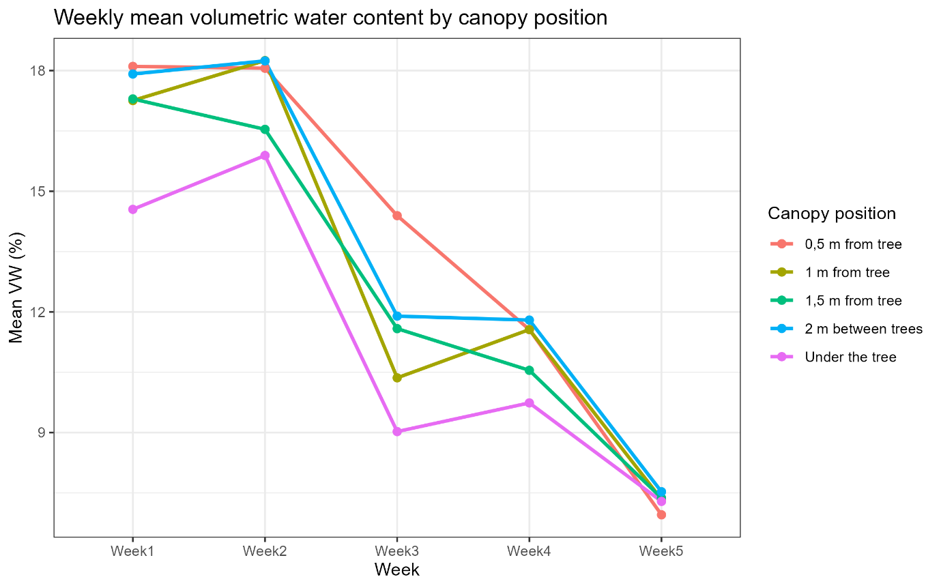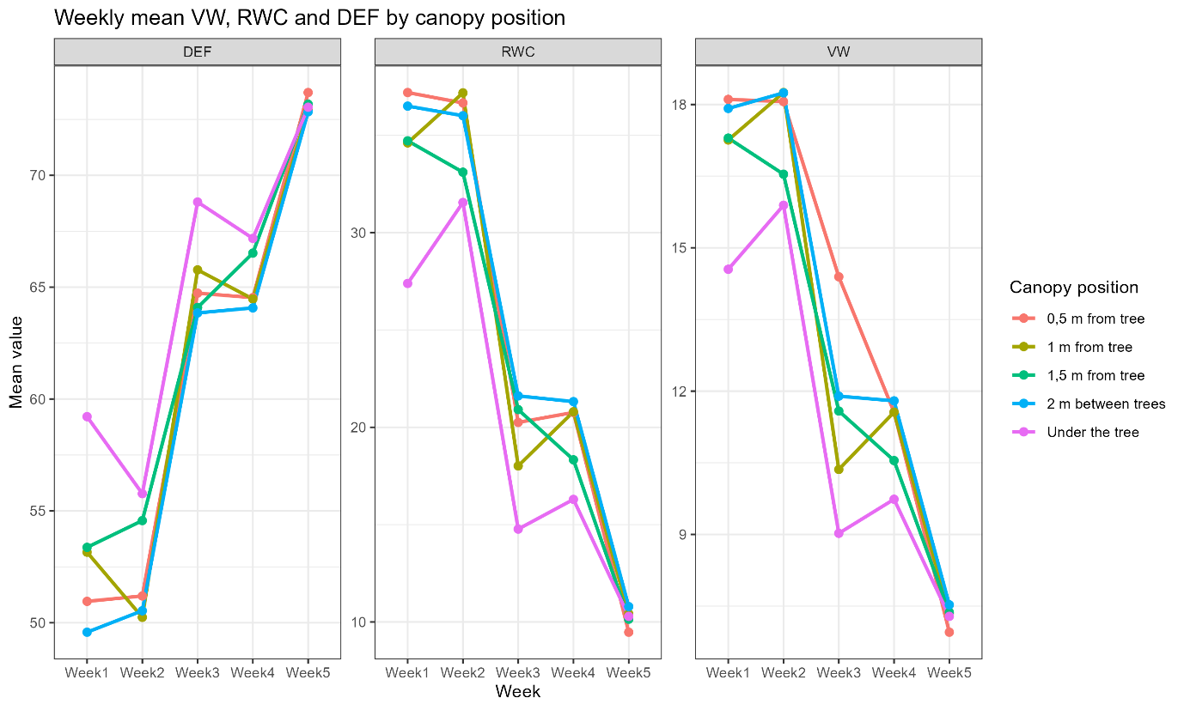
Depth profile: surface (10 cm) vs sub-surface (20 cm)
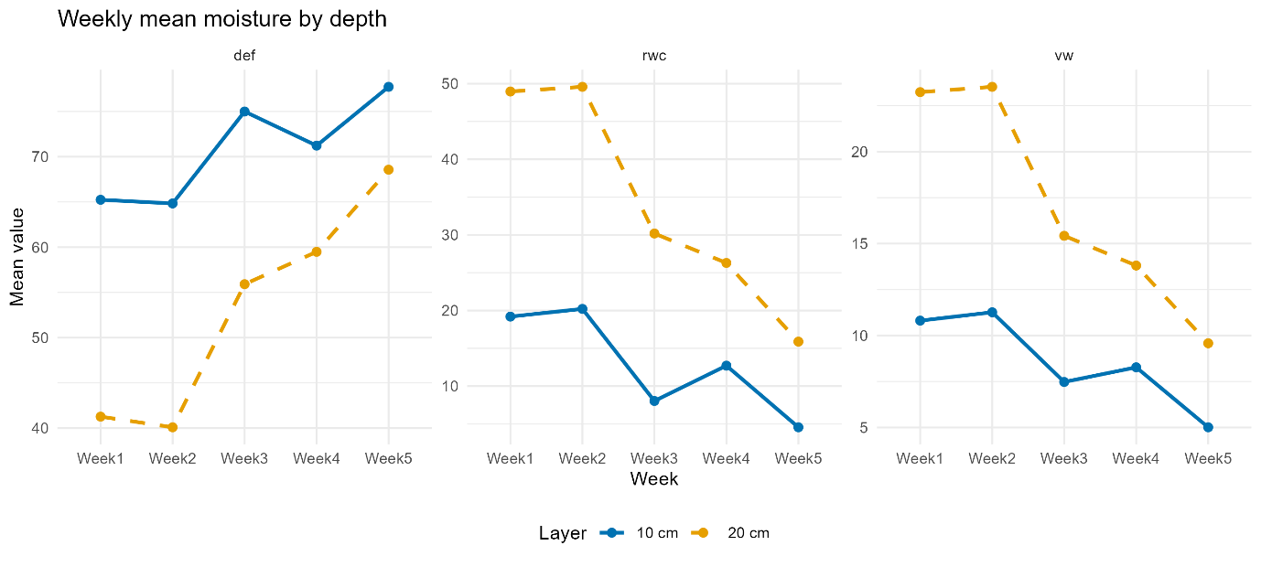
Mixed-effects tests that included Depth × Week found no significant depth effect for any variable VW (F = 1.71, p = 0.19), RWC (F = 1.46, p = 0.23) and DEF (F = 1.40, p = 0.17). The two layers rise and fall in near-parallel fashion (figure above), so depth was dropped from the final models to keep them lean. In practical terms, moisture at 10 cm is a reliable proxy for the 20 cm layer throughout this five-week period.

Which nitrogen rates differ? (linear mixed model + pairwise contrasts)
To probe nitrogen, I fitted a linear mixed model with fixed factors Week, Location and N-rate and their interactions, using Plot nested in Block as a random term. Pairwise contrasts (Bonferroni adjustment) showed only one clear gap: the 45 kg N rate held about five percentage-points more soil water in Week 3 than the unfertilised control (p ≈ 0.04). No other week, canopy band or leaf measure differed. 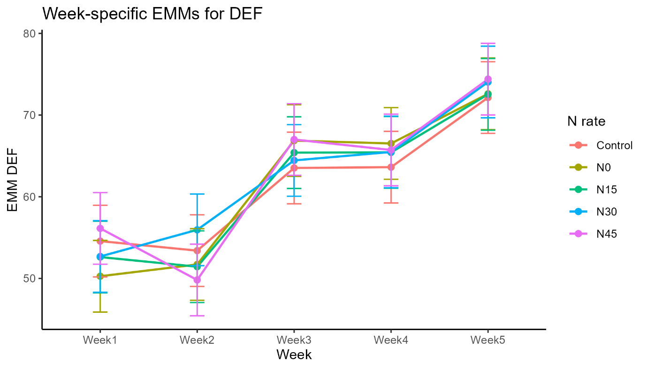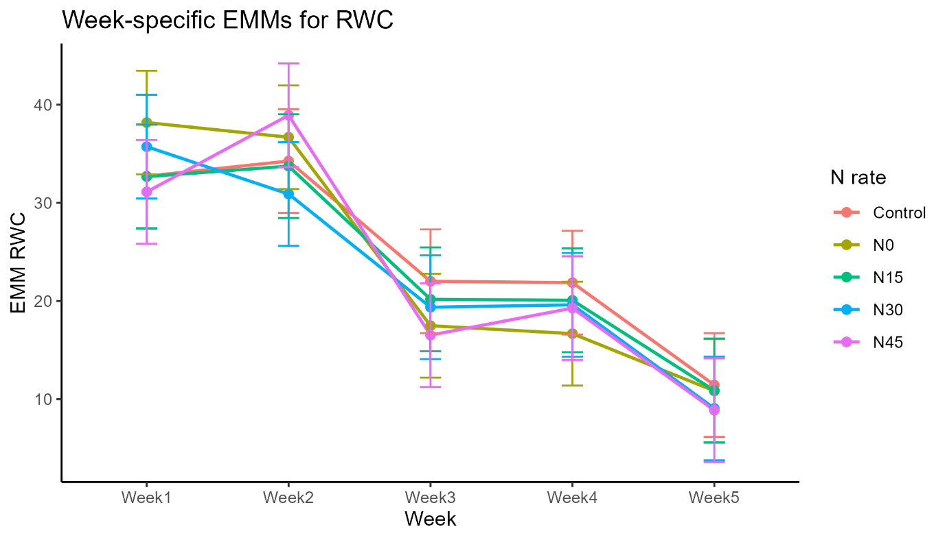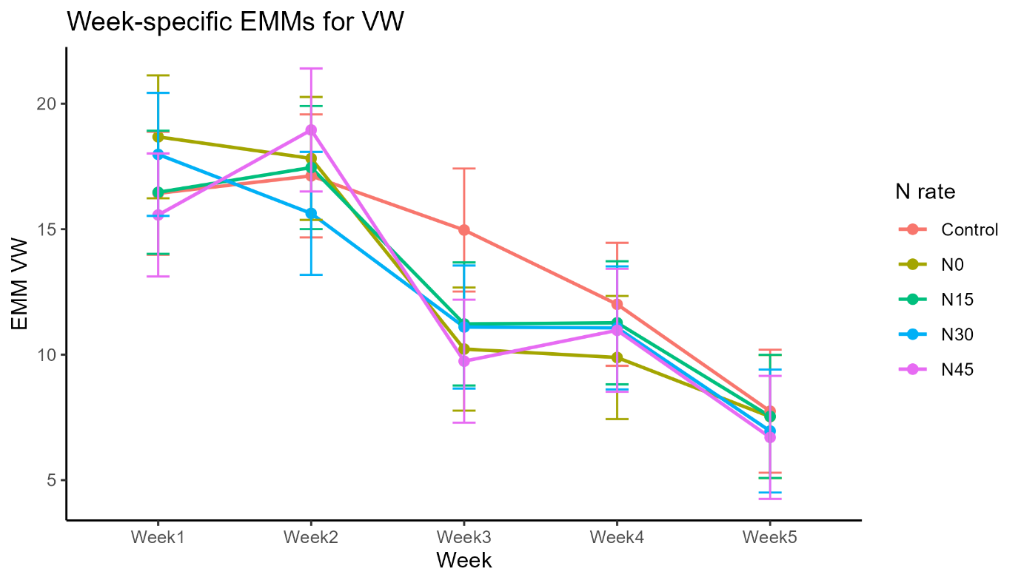

Relationships among the three indices (correlation & regression)
VW and RWC are strongly positive (r ≈ 0.90); both are strongly negative against DEF (r ≈ –0.88 and –0.96). A simple regression confirmed the link: RWC rises two points for every extra point of VW (R² ≈ 0.81), and DEF falls 0.81 units per point of RWC (R² ≈ 0.93). In practice, quick leaf-disc RWC offers almost the same information as the slower DEF assay.
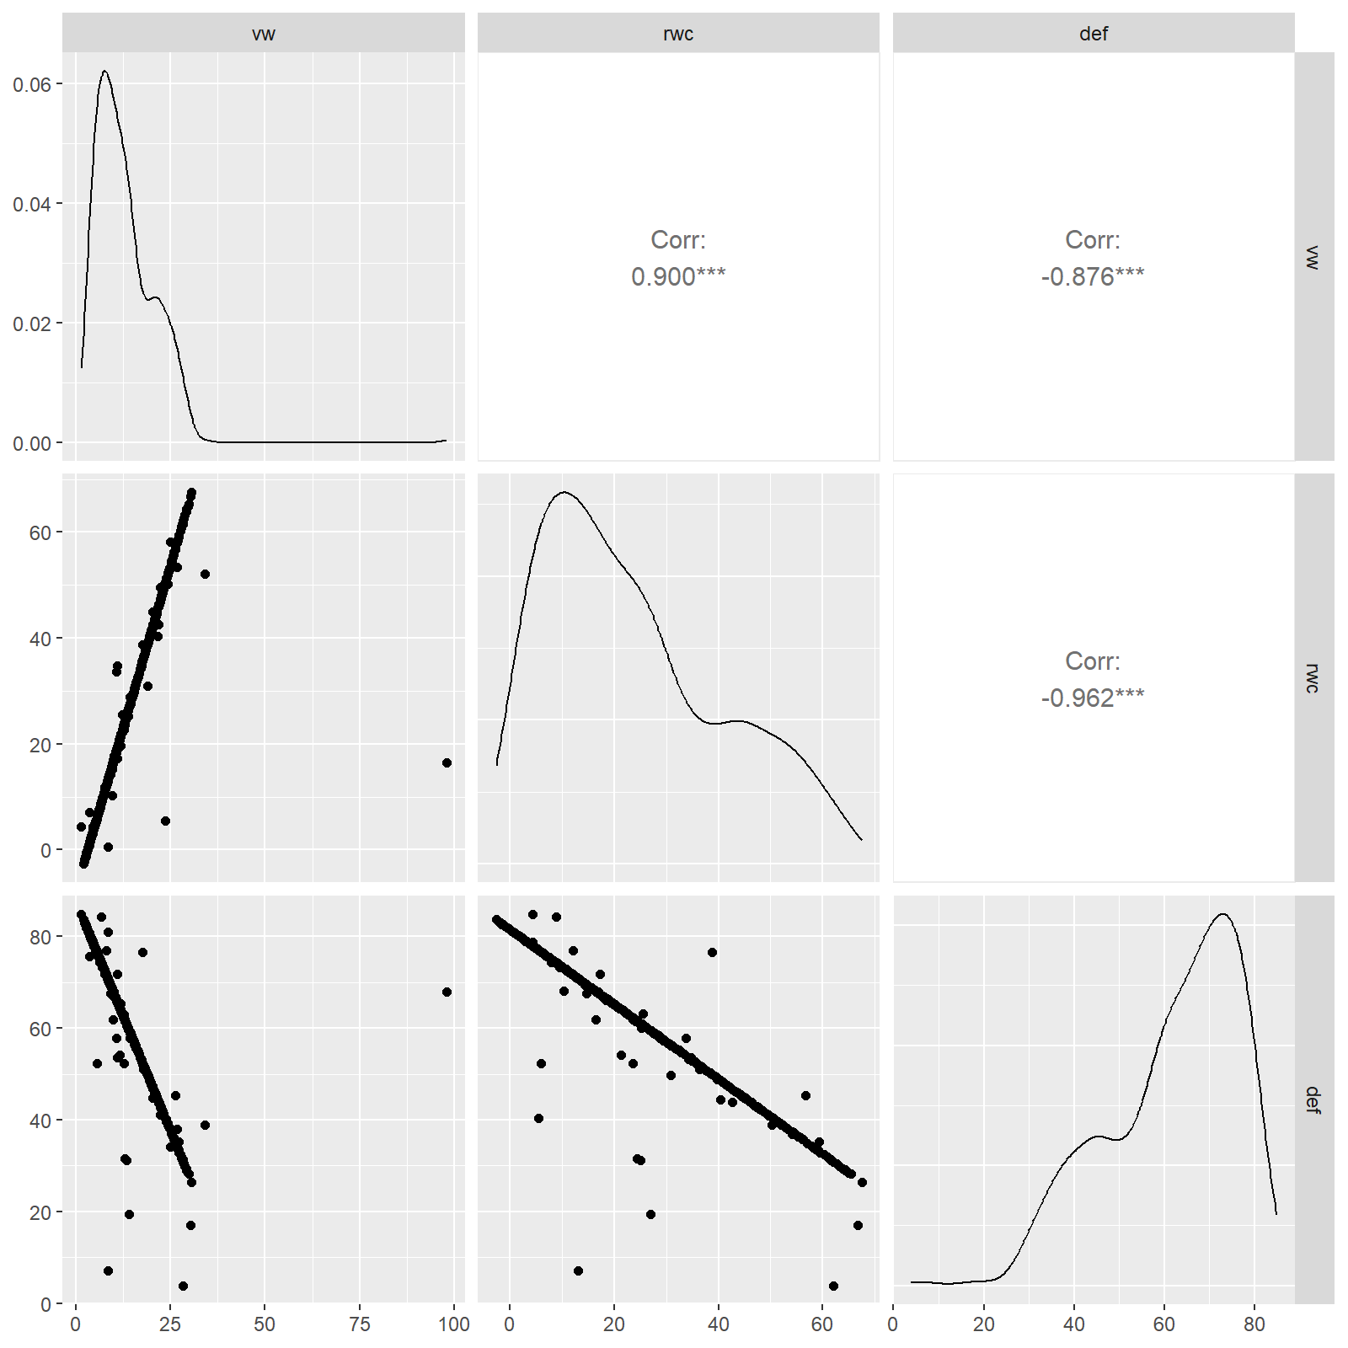

When do conditions flip? (time-series change detection)
Change-point analysis (PELT) on each Location × Variable series revealed two breaks common to every trace: a modest dip around Week 9 and a sharper, permanent decline at Week 18. Shade never altered either timing; it simply raised or lowered the baseline. Those turning points give managers lead times for irrigation or mulching.
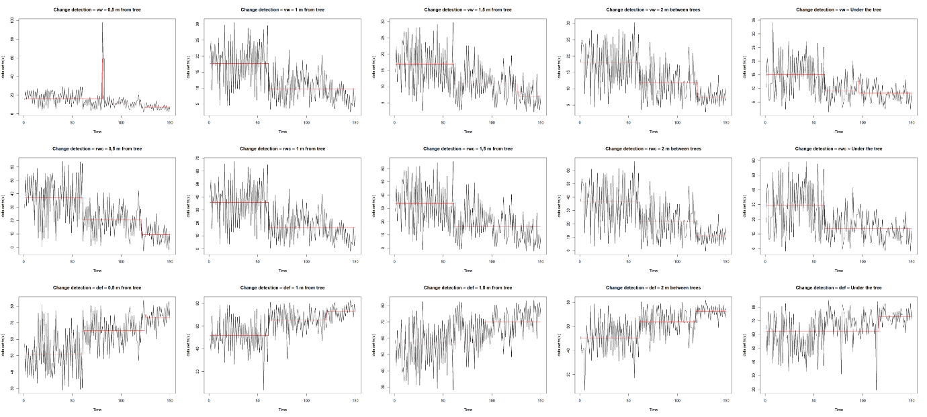

Joint moisture fingerprint (PERMANOVA)
A Euclidean PERMANOVA on scaled VW, RWC and DEF confirmed the univariate picture: Week and Location together explain about 31 % of the multivariate variance (F = 13.48, p = 0.001).
Term (effect) | Df | Sum Sq | R² | F | p-value
Week × Location (model) | 24 | 693.33 | 0.309 | 13.48 | 0.001 ***
Residual | 725 | 1553.67 | 0.691 | – | –
Total | 749 | 2247.00 | 1.000 | – | –

Summary and Implications
The dataset does not carry an explicit variety code, so both Akwa and Kwarts fields followed the same seasonal script: moisture climbed for two weeks post-rain, peaked in Week 3, then sagged twice (Weeks 9 and 18). A single top-dress of 45 kg N slightly cushioned the peak week but left the later drops untouched. Under-canopy soil stayed wetter by roughly seven percentage-points, yet its curve was parallel to the gap between trees. Because RWC tracks DEF so closely, growers can rely on the quicker RWC strip-test for routine scouting. Irrigation triggers should therefore be anchored a few days before Weeks 9 and 18 across all positions and nitrogen rates.

APPENDIX
# ── 0 libraries ─────────────────────────────────────────────
pkgs <- c("tidyverse","readxl","janitor","rstatix",
"lme4","lmerTest","emmeans","GGally",
"changepoint","vegan","magick")
lapply(pkgs, \(p) if (!suppressPackageStartupMessages(require(p, character.only = TRUE))) {
install.packages(p, repos = "https://cloud.r-project.org")
library(p, character.only = TRUE)
})

# ── 1 I/O root ───────────────────────────────────────────────
root <- "analysis_outputs"
dir.create(root, showWarnings = FALSE, recursive = TRUE)

# ── 2 import & clean ────────────────────────────────────────
dat <- read_excel("GNWATER1.xlsx") |>
clean_names() |>
mutate(
week = str_to_title(week),
across(c(block,plot,depth,n_level,week,location), as.factor),
id = interaction(block,plot,f,n_level, drop = TRUE),
across(c(vw,rwc,def), \(x) ifelse(is.na(x), mean(x, na.rm = TRUE), x))
)
write_csv(dat, file.path(root,"completed_data.csv"))

# ── 3 summary table ─────────────────────────────────────────
dat |>
summarise(across(c(vw,rwc,def),
list(min = min, mean = mean, sd = sd, max = max),
.names = "{.col}_{.fn}")) |>
write_csv(file.path(root,"summary_stats_overall.csv"))

# ── 4 weekly means by location (table + plot) ───────────────
wloc <- dat |>
pivot_longer(c(vw,rwc,def), names_to = "variable", values_to = "value") |>
group_by(variable, week, location) |>
summarise(mean = mean(value), .groups = "drop")
write_csv(wloc, file.path(root,"weekly_means_by_loc.csv"))
ggplot(wloc, aes(week, mean, colour = location, group = location)) +
geom_line(size = 1) + facet_wrap(~variable, scales = "free_y") +
theme_bw() + labs(x = NULL, y = "Mean value", colour = "Canopy\nposition") +
ggsave(file.path(root,"weekly_mean_VW_RWC_DEF.png"), width = 9, height = 4, dpi = 300)

# ── 5 repeated-measures ANOVA per response ──────────────────
anova_list <- map(c("vw","rwc","def"), \(resp)
anova_test(dat, dv = all_of(resp), wid = id,
within = c("week","location"), detailed = TRUE))
names(anova_list) <- c("vw","rwc","def")
iwalk(anova_list, \(tbl,nm)
write.table(tbl, file = file.path(root,paste0("anova_",nm,".txt")),
row.names = FALSE, quote = FALSE, sep = "\t"))

# ── 6 mixed models + EMM plots ──────────────────────────────
run_lme <- \(resp){
fit <- lmer(as.formula(paste(resp,"~ week*location*n_level + (1|block/plot)")), dat)
emm <- emmeans(fit, pairwise ~ n_level | week, adjust = "bonferroni")
capture.output(summary(fit), file = file.path(root,paste0("lme_",resp,".txt")))
capture.output(emm$contrasts, file = file.path(root,paste0("contrasts_nlevel_",resp,".txt")))
png(file.path(root,paste0("emm_nrate_",resp,".png")), 1600, 1200, res = 200)
plot(emm, comparisons = TRUE); dev.off()
}
walk(c("vw","rwc","def"), run_lme)

# ── 7 correlations, scatter matrix, regressions ─────────────
cor_mat <- cor(dat[c("vw","rwc","def")])
write_csv(as.data.frame(cor_mat), file.path(root,"correlation_matrix.csv"))
png(file.path(root,"pairs_plot.png"), 1600, 1600, res = 200)
GGally::ggpairs(dat, columns = c("vw","rwc","def")); dev.off()
lm_list <- list(rwc_on_vw = rwc ~ vw, def_on_vw = def ~ vw, def_on_rwc = def ~ rwc)
iwalk(lm_list, \(frm,tag)
capture.output(summary(lm(frm, dat)),
file = file.path(root,paste0("regression_",tag,".txt"))))

# ── 8 change-point plots per Location × Variable ────────────
cp_fun <- \(loc, v){
x <- dat |> filter(location == loc) |> arrange(week) |> pull(!!sym(v))
if (length(x) > 5) {
png(file.path(root,paste0("changepoint_",v,"_",gsub(" ","_",loc),".png")),
1600, 1200, res = 200)
plot(cpt.meanvar(x, method = "PELT"),
main = paste("Change detection –", v, "–", loc)); dev.off()
}
}
for (loc in levels(dat$location)) for (v in c("vw","rwc","def")) cp_fun(loc, v)

# ── 9 depth profile figure ─────────────────────────────────
depth_long <- dat |>
pivot_longer(c(vw,rwc,def), names_to = "variable", values_to = "value") |>
group_by(variable, week, depth) |>
summarise(mean = mean(value), .groups = "drop")
ggplot(depth_long, aes(week, mean, colour = depth, linetype = depth,
group = depth)) +
geom_line(size = 1) + geom_point(size = 2) +
facet_wrap(~variable, scales = "free_y", ncol = 3) +
scale_colour_manual(values = c("#0072B2","#E69F00"), labels = c("10 cm","20 cm")) +
scale_linetype_manual(values = c("solid","dashed"), labels = c("10 cm","20 cm")) +
theme_minimal(base_size = 11) + theme(legend.position = "bottom",
panel.grid.minor = element_blank()) +
labs(title = "Weekly mean moisture by depth", x = "Week", y = "Mean value",
colour = "Layer", linetype = "Layer") +
ggsave(file.path(root,"depth_profile_VW_RWC_DEF.png"), width = 10,
height = 4.5, dpi = 300)

# ── 10 PERMANOVA ────────────────────────────────────────────
perm <- adonis2(vegdist(scale(dat[c("vw","rwc","def")]), "euclidean") ~
week*location, dat, permutations = 999)
capture.output(perm, file = file.path(root,"permanova_results.txt"))

# ── 11 3×5 montage of change-points ─────────────────────────
loc_order <- c("0,5_m_from_tree","1_m_from_tree","1,5_m_from_tree",
"2_m_between_trees","Under_the_tree")
files <- file.path(root,
c(paste0("changepoint_vw_" , loc_order, ".png"),
paste0("changepoint_rwc_",loc_order, ".png"),
paste0("changepoint_def_",loc_order, ".png")))
imgs <- map(files, safely(image_read)) |>
map(\(x) if(is.null(x$result)) image_blank(600,400,"white") else
image_scale(x$result,"600x400"))
mont <- image_append(do.call(c, imgs[1:5])) |>
image_append(do.call(c, imgs[6:10])) |>
image_append(do.call(c, imgs[11:15])) |>
image_append(stack = TRUE)
image_write(mont, file.path(root,"changepoint_montage.png"))

message("✓ All outputs written to ", normalizePath(root))