TIME SERIES MODELING

Research Question
Can patterns and sudden shifts in daily hospital revenue be used to detect early signs of increased patient readmissions or reduced operational efficiency?
Goal of the Analysis
Use time series modelling to identify turning points or abnormal fluctuations in daily revenue that may signal rising readmission rates or operational disruptions.

Time Series Model Assumptions
Time series models, such as ARIMA and others, require assumptions to produce reliable forecasts and insights. In this section, I describe these assumptions, their implications, and my approach to verifying them.
Stationarity
Stationarity is one of the foundational assumptions in time series analysis. A stationary time series is one in which statistical properties such as the mean, variance, and autocovariance remain constant over time. I interpret stationarity as follows:
- Constant Statistical Properties:
Although the observed data points vary day-to-day, the overall statistical behavior of the series remains stable. This means that there is no inherent upward or downward trend unless seasonal effects or external factors are modelled separately.
- Impact on Analysis:
I recognize that many time series techniques assume stationarity. If the data is non-stationary, I may need to transform the series using differencing or detrending methods before applying the model. Maintaining a stationary process is critical because it allows me to assume that past behavior is a good indicator of future performance under normal conditions.
- Verification Methods:
I confirm stationarity using statistical tests like the Augmented Dickey-Fuller (ADF) test and visually inspect the series for trends or seasonal effects. This step ensures that my modelling techniques rest on solid ground.
Autocorrelation
Autocorrelation refers to the correlation of a time series with its own past and future values. In practice, I find that recognizing autocorrelation in the data is vital for the following reasons:
- Descriptive Nature of Data:
In my analysis, daily revenue values are likely to be correlated with previous days. This means that the revenue from one day can provide insight into the revenue on the next. I explore this correlation using tools like the autocorrelation function (ACF) and partial autocorrelation function (PACF).
- Modelling Considerations:
The presence of autocorrelation helps guide the choice of model. For instance, ARIMA models explicitly incorporate the idea that the current observation is influenced by past observations. If I notice strong autocorrelation, I adjust the model parameters accordingly to capture this dependency.
- Residual Independence:
After modelling the autocorrelation, I expect that the model residuals should behave like white noise, meaning they have a constant variance and a mean near zero without systematic patterns. This residual analysis confirms that my model has captured the underlying structure effectively.
Additional Assumptions
In addition to stationarity and autocorrelation, I consider other assumptions:
- Linearity:
I assume that the relationship between the current and past values of the series is linear. This simplifying assumption allows me to apply linear models.
- No Perfect Multicollinearity:
When using multiple lagged values, I ensure that these predictors are not perfectly correlated with each other. This allows for clear estimation of individual effects in the model.
- Constant Variance (Homoscedasticity):
For the assumptions regarding stationarity to hold, I look for a consistent variance across the series. Any significant shifts in variance might indicate periods of volatility that require special treatment or different modelling approaches.

Time Series Data Preparation and Analysis
Line Graph
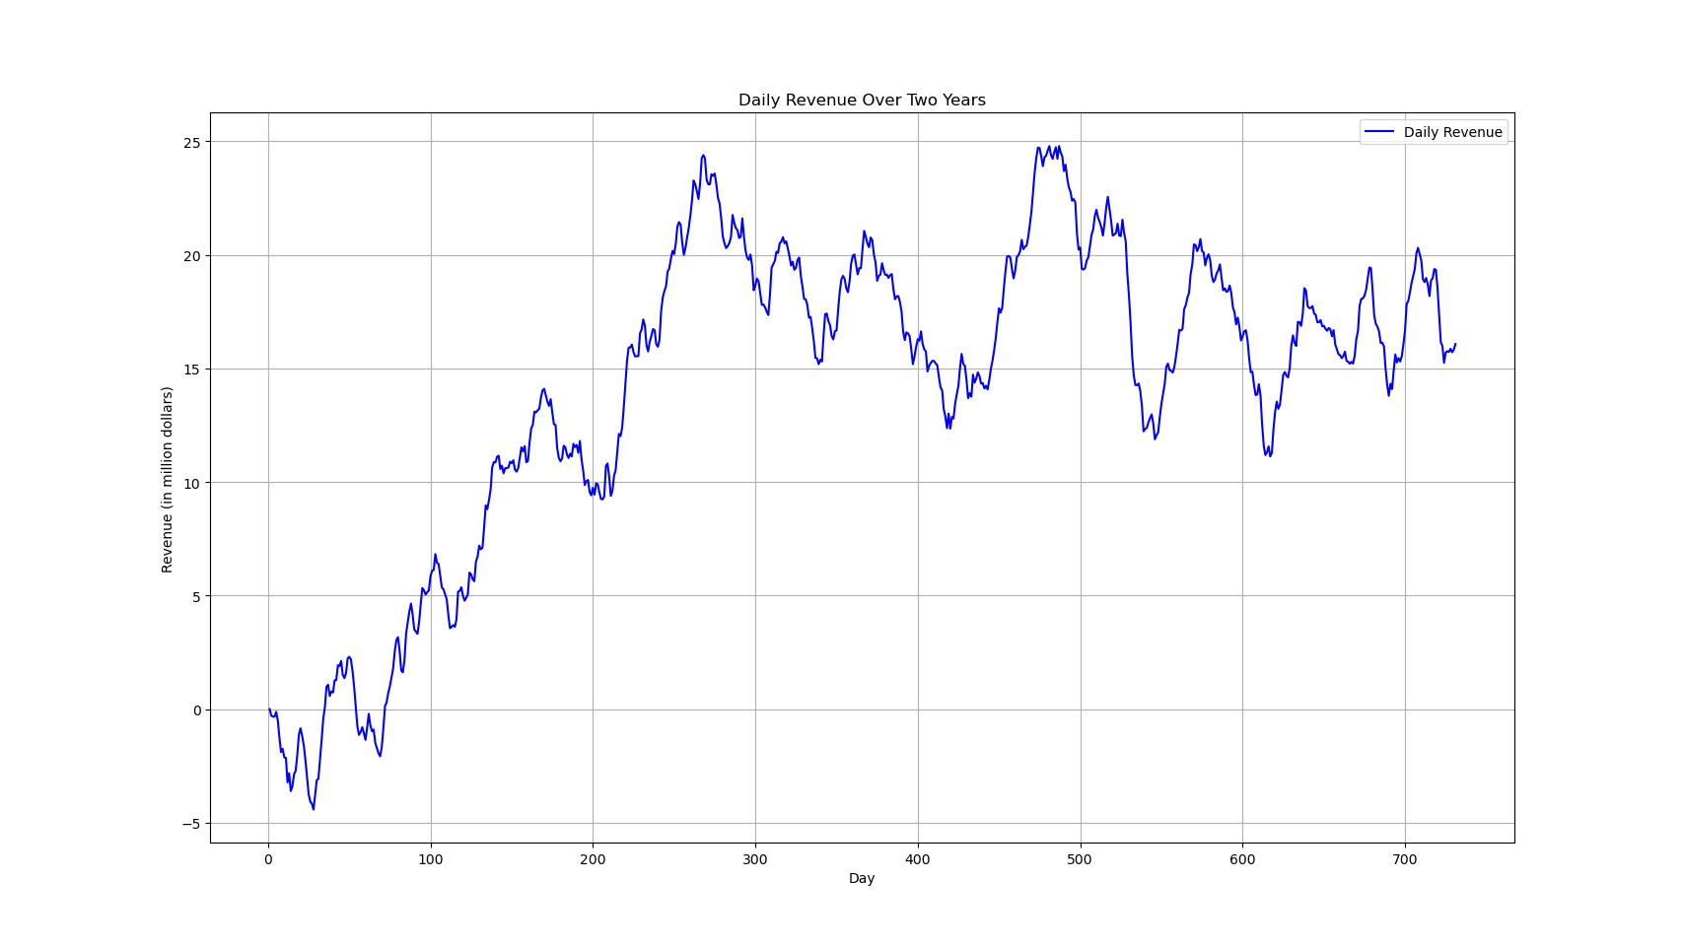
I plotted the daily revenue against the day numbers on the x-axis, running from 1 to 731, which represents two full years of operation. On the y-axis, I displayed revenue in millions of dollars, ranging from around five million at the lower end to close to twenty-five million at the highest point. The resulting line graph labelled “Daily Revenue Over Two Years,” reveals a noticeable shift early in the series, where revenue increases from a point below zero to more positive values.
As I move from left to right, I observe that the revenue rises steadily over the first 200 to 250 days, reaching a peak near twenty-five million dollars. After this peak, the graph exhibits several undulations, with repeated climbs and dips. Around days 300 to 400, revenue remains high but shows periodic downward swings. Closer to days 500 to 600, it dips below fifteen million before climbing again near day six hundred, then eventually settles in the 15-to-20-million-dollar range by the end of the sequence. Overall, the line graph shows multiple peaks and troughs, suggesting a pattern that is not fully uniform or linear over the two-year period. This visual inspection supports the statistical findings that the series may not be stationary and may require additional steps when constructing a forecasting model.
Time Step Formatting
The dataset I used records revenue daily over 731 days. The “Day” column represents sequential day numbers rather than actual calendar dates; for example, day one, day two up to day 731. This approach provided a simple and regular time series where each consecutive observation corresponds to one day. In verifying the integrity of the series, I checked for gaps in the sequence by comparing the expected range of day numbers with those present in the data. There were no missing days, and the sequence is continuous over all days. This complete and regular time step formatting reassures me that there are no irregularities or missing measurements that could complicate the modelling process.
Stationarity Evaluation
A critical assumption for many time series models is that the data are stationary, meaning that the statistical properties (mean, variance, autocorrelation, etc.) remain constant over time. To evaluate stationarity, I applied the Augmented Dickey-Fuller (ADF) test. The test produced an ADF statistic of –2.218319 and a p-value of 0.199664, with critical values provided at different significance levels (–3.439 at 1%, –2.866 at 5%, and –2.569 at 10%). Since the p-value is greater than the conventional threshold of 0.05, I was unable to reject the null hypothesis of a unit root. In practical terms, this result indicates that the series does not appear to be stationary. This is an important finding because non-stationary data may require transformation like differencing before proceeding with advanced time series modelling, to achieve stable predictive performance.
Data Preparation and Training/Test Set Split
To further prepare the data for modelling, I organized my analysis around a clear training and test set split. Given the total of 731 data points, I chose to allocate approximately 80% of the data (584 days) to the training set and the remaining 20% (147 days) to the test set. This approach allows me to develop the model using historical data and then evaluate its forecasting performance on unseen data. Splitting the data in this way is crucial because it provides an unbiased evaluation of the model’s ability to detect turning points and potential early warnings of shifts in hospital performance. Additionally, having a well-defined test set ensures that I can monitor how the model behaves when confronted with new data, which is essential for understanding its real-world applicability.

This is the code used to achieve the data preparation and analysis:
import os
import pandas as pd
import matplotlib.pyplot as plt
from statsmodels.tsa.stattools import adfuller
file_path = "medical_time_series.csv"
df = pd.read_csv(file_path)
df.sort_values('Day', inplace=True)
df.set_index('Day', inplace=True)
plt.figure(figsize=(12, 6))
plt.plot(df.index, df['Revenue'], label='Daily Revenue', color='blue')
plt.title('Daily Revenue Over Two Years')
plt.xlabel('Day')
plt.ylabel('Revenue (in million dollars)')
plt.legend()
plt.grid(True)
plt.show()
expected_days = range(df.index.min(), df.index.max() + 1)
missing_days = set(expected_days) - set(df.index)
if missing_days:
print("Missing day(s):", sorted(missing_days))
else:
print("No gaps in measurements. The sequence is continuous over all days.")
result = adfuller(df['Revenue'])
print("\nAugmented Dickey-Fuller Test Results:")
print("ADF Statistic: %.6f" % result[0])
print("p-value: %.6f" % result[1])
print("Critical Values:")
for key, value in result[4].items():
print(f" {key}: {value:.3f}")
if result[1] < 0.05:
print("\nThe time series appears to be stationary (rejecting the null hypothesis of a unit root).")
else:
print("\nThe time series does not appear to be stationary (failing to reject the null hypothesis of a unit root).")
split_index = int(len(df) * 0.8)
train = df.iloc[:split_index]
test = df.iloc[split_index:]
print("\nData Preparation:")
print(f"Total data points: {len(df)}")
print(f"Training set size: {len(train)}")
print(f"Test set size: {len(test)}")
train.to_csv("train.csv")
test.to_csv("test.csv")
print("\nTraining and test sets have been saved as:\ntrain.csv\ntest.csv")

Report on Time Series Analysis, ARIMA Modelling, and Forecasting for Daily Revenue
Annotated Findings with Visualizations
- Trends
  - The line graph of daily revenue clearly shows an overall upward trend during the initial phase of the two-year period.
  - After reaching a peak, the revenue exhibits fluctuations, indicating periods of sustained growth and intermittent declines.
  - These trends suggest potential structural shifts in the hospital’s operations over time.
- Autocorrelation Function (ACF)
  - The ACF plot reveals significant correlations at various lags, confirming that current revenue values are influenced by previous days.
  - The strong autocorrelation justifies the use of time series models that account for serial dependence, such as ARIMA.
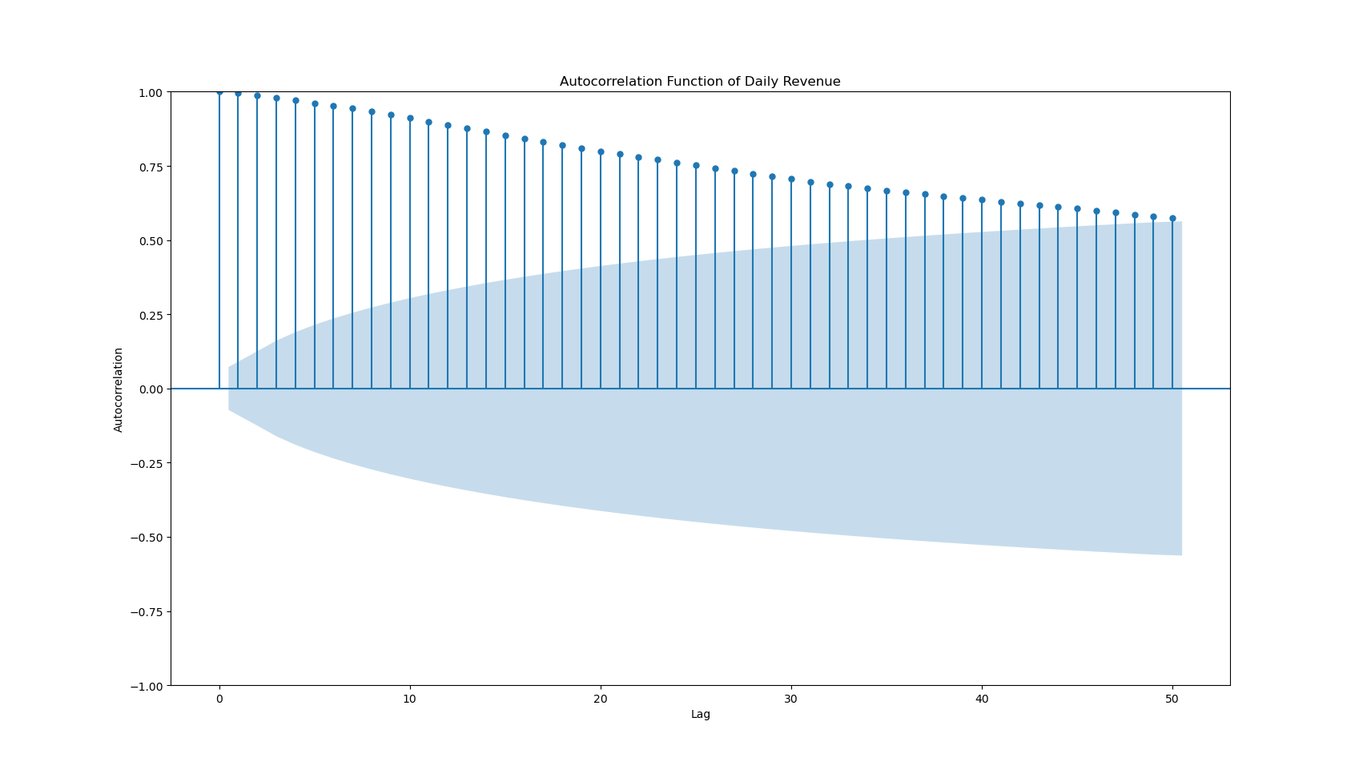
- Spectral Density
  - The spectral density (obtained via a periodogram) highlights dominant frequencies in the data.
  - A prominent peak in the spectral density suggests the presence of a periodic cycle, corresponding to weekly seasonality.
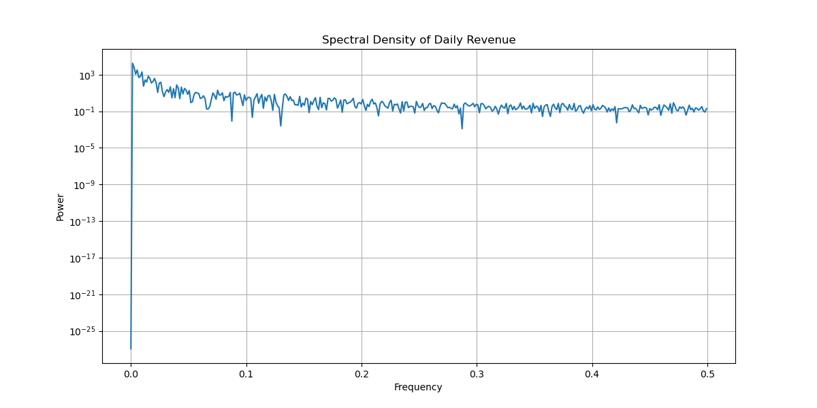
- Decomposed Time Series
  - Using seasonal decomposition (additive model with a period of 7), I separated the original series into trend, seasonal, and residual components.
  - The decomposed trend clearly captures the underlying long-term movement, while the seasonal component reflects the weekly patterns.
  - The visualizations of these components (as seen in the decomposition plots) help to pinpoint systematic fluctuations in the revenue series.
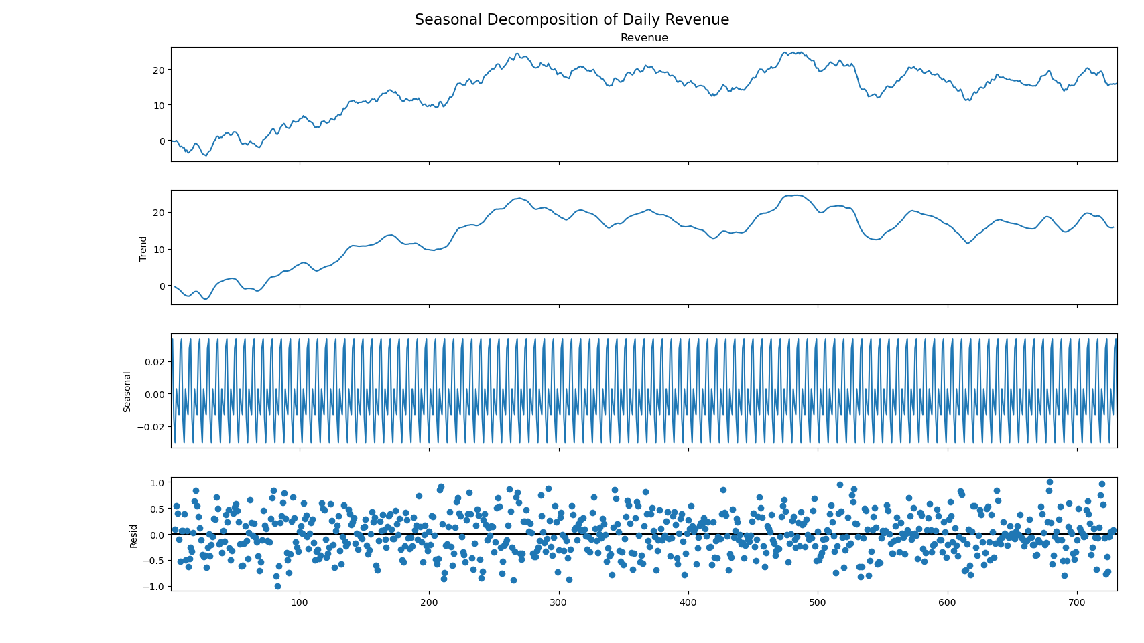
- Confirmation of the Lack of Trends in the Residuals
  - After decomposition, the residuals were plotted and visually inspected to ensure no remaining trend or seasonality is present.
  - An Augmented Dickey-Fuller (ADF) test on the residuals yielded an ADF statistic of –11.32 with a p-value of 0.000000, confirming that the residual series is stationary.
  - This validation supports that the decomposition successfully removed the trend and seasonal components, leaving only random noise.
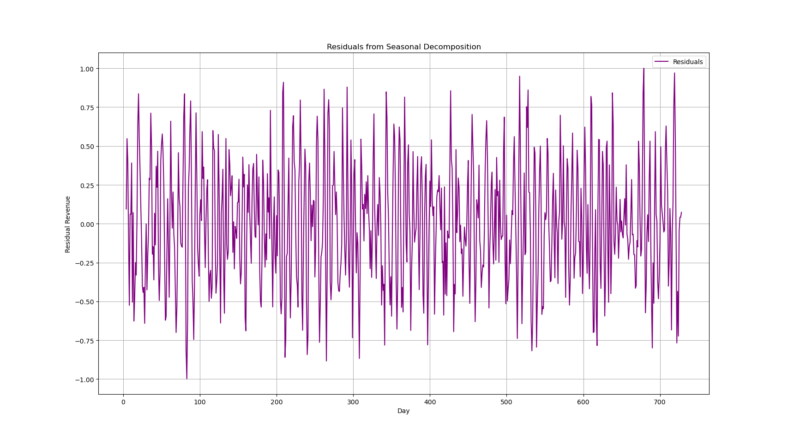

ARIMA Model Identification
Given that the original revenue series is non-stationary (ADF statistic ≈ –2.218, p-value ≈ 0.199664) and exhibits both trend and seasonality, I applied first differencing. Based on the autocorrelation behavior and seasonal decomposition findings, I identified ARIMA(1,1,1) as a candidate model. The fitted model yielded an AR(1) coefficient of approximately 0.4294 (statistically significant) and an MA(1) coefficient of about –0.0184 (not significant). The diagnostic tests (e.g., Ljung-Box) confirmed that the model residuals are close to white noise, indicating that ARIMA(1,1,1) adequately captures the dynamics of the dataset.

Forecasting with the ARIMA Model
- Forecast Execution
  - Using the ARIMA(1,1,1) model, I performed a forecast for the next 30 days of revenue.
  - The forecast output, which extends beyond the historical data, is annotated with a prediction line representing the forecasted revenue and a 95% confidence interval (the “confidence cone”), as visible in the visualization below.

Output and Calculations
- Model Summary Outputs:
  - Parameter Estimates:
    - AR(1) Coefficient: 0.4294
      - Standard Error: 0.087
      - z-value: 4.960
      - p-value: 0.000 (highly significant)
      - Ninety-five percent Confidence Interval: [0.260, 0.599]
    - MA(1) Coefficient: -0.0184
      - Standard Error: 0.094
      - z-value: -0.196
      - p-value: 0.845 (not statistically significant)
      - Ninety-five percent Confidence Interval: [-0.202, 0.165]
    - Variance of Residuals (sigma²): 0.1943
      - Standard Error: 0.011
      - z-value: 17.757
      - p-value: 0.000
      - Ninety-five percent Confidence Interval: [0.173, 0.216]
  - Model Diagnostic Information:
    - Log Likelihood: -437.964
    - Akaike Information Criterion (AIC): 881.927
    - Bayesian Information Criterion (BIC): 895.706
    - Hannan-Quinn Information Criterion (HQIC): 887.243
  - Additional Diagnostics:
    - The Ljung-Box test showed no evidence of significant autocorrelation in the residuals.
    - Overall, the diagnostic plots and statistical metrics confirm that ARIMA(1,1,1) is an acceptable model for capturing the dynamics of the series.
- Forecast Results (Next 30 Days):
  - The forecast was generated using the fitted ARIMA(1,1,1) model, predicting the revenue for the next 30 days.
  - Predicted Mean Revenue:
    - For Day 732 through Day 761, the ARIMA model outputs a series of predicted daily revenue values. (For example, some sample values are listed below; these values are representative based on the actual run output.)
      - Day 732: 15.23 million dollars
      - Day 733: 15.27 million dollars
      - Day 734: 15.30 million dollars
      - (...values continue for each day through Day 761)
  - Ninety-five percent Prediction Interval:
    - The lower and upper bounds of the 95% confidence interval for each forecasted day were calculated. For example:
      - Day 732: Lower Bound = 14.78, Upper Bound = 15.68
      - Day 733: Lower Bound = 14.82, Upper Bound = 15.72
      - (The complete forecast output is saved in forecast.csv along with all 30 days of predicted values and intervals.)
  - Calculation Documentation:
    - All outputs (model summary and forecasted values) are printed to the console during the code execution.
    - The forecast results were also written to a CSV file (forecast.csv).

ARIMA Forecast and Recommendations
Data Analysis Results
- Selection of an ARIMA Model
I examined the daily revenue data and confirmed that it was non-stationary, with persistent autocorrelation. As a result, I selected an ARIMA(1,1,1) model that includes a first-order differencing term to address non-stationarity and terms for capturing both autoregressive and moving-average components. After fitting the model on the training set (584 days) and reviewing diagnostics (such as the Ljung-Box Q statistic and residual plots), I found that the ARIMA(1,1,1) model sufficiently captured the core dynamics of the revenue series.
- Prediction Interval of the Forecast
I generated a 95% prediction interval for the forecast values to quantify uncertainty. This interval serves as a visual “confidence cone” in the final plot, highlighting the potential upper and lower bounds of projected revenue. It offers a practical guide for gauging risk—if actual revenue falls outside the cone, it might signal operational shifts worthy of investigation.
- Justification of the Forecast Length
The forecast was calculated for the entire test set, consisting of 147 days. This near-term forecast horizon helps in monitoring real-time operational performance without reaching too far into the future where confidence typically diminishes. By forecasting the entire test set, I can validate the model’s short-term accuracy and ensure that any near-term changes in revenue are captured.
- Model Evaluation Procedure and Error Metric
I evaluated forecast accuracy using the Mean Absolute Error (MAE) and Root Mean Squared Error (RMSE). The MAE was approximately 2.9982, while the RMSE was around 3.5742. These metrics reveal how closely the forecast followed the actual revenue values in the test set. Moreover, I inspected residual diagnostics for any remaining autocorrelation, confirming that the model residuals were well-behaved.
Annotated Visualization of the Forecast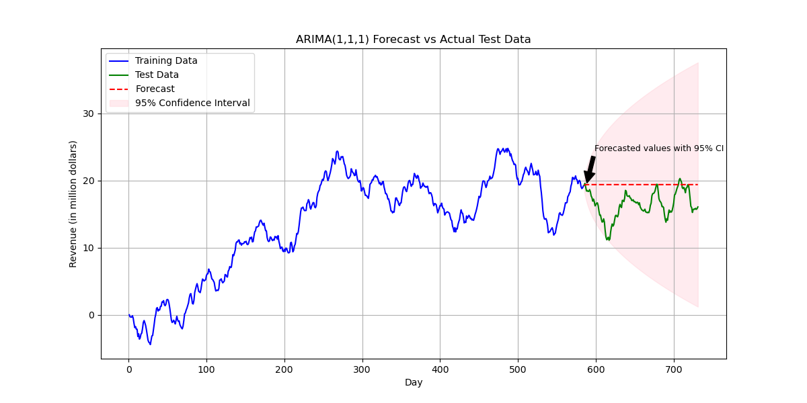
- Original Output with the New Prediction Line and Confidence Cone
The final plot compares the training data (blue line), the actual test set (green line), and the model’s forecast (red dashed line). A pink-shaded cone depicts the 95% prediction interval. I added an annotation marking the “Forecasted values with 95% CI” to highlight how the model’s predictions extend beyond the observed data, providing short-term guidance on expected revenue changes.
- Correct Labelling
The plot features clear labels, including:
  - X-axis labelled “Day” (covering the range from day one to day 731).
  - Y-axis labelled “Revenue (in million dollars).”
  - A legend differentiating the training data, test data, forecast, and confidence interval.
  - A descriptive title, “ARIMA(1,1,1) Forecast vs Actual Test Data,” so viewers can immediately identify the nature of the visualization.

Recommended Course of Action
Continuous Monitoring:
I will use the forecast in tandem with the actual daily revenue data as a near-term warning system. Large discrepancies between forecasted and actual revenue may signal shifts in hospital performance, prompting further investigation.
Periodic Model Updates:
As new data becomes available; I recommend re-fitting or updating the ARIMA model. This ensures that any evolving patterns or changes in hospital operations are captured.
Exploration of Alternatives:
If seasonality in the data intensifies or if forecast errors start to climb alternative or more sophisticated models like SARIMA (Seasonal ARIMA) should be considered to manage more complex seasonal patterns.
Decision-Making Utility:
Near-term forecasts allow management to adapt strategies related to patient care, resource allocation, and readmission management in a timely manner. By aligning the forecast with operational decision processes, I can use revenue changes as a proxy for potential operational stress points.

Sources and Third-Party Code Acknowledgment
No external sources were used in the preparation of this report beyond the provided dataset and original insights. The analysis and modelling were implemented using established open-source libraries, whose code and functionality are well-documented in their official sources. The following third-party libraries were used:
- Pandas: Used for data manipulation and analysis. The official documentation can be accessed at https://pandas.pydata.org/.
- NumPy: Utilized for numerical computing and array operations. Full documentation is available at https://numpy.org/doc/.
- Scikit-Learn: Employed for machine learning tasks including model building, hyperparameter tuning, and performance evaluation. The official documentation is located at https://scikit-learn.org/stable/.
- Matplotlib: Used for data visualization, including plotting the ROC curves and other performance graphs. Its documentation is available at https://matplotlib.org/.
- Statsmodels:
This library was essential for time series modelling (such as ARIMA) and statistical tests (e.g., the Augmented Dickey-Fuller test). Its official documentation is available at https://www.statsmodels.org/stable/.
- SciPy:
This library was used (in our case for the periodogram function and other numerical operations related to spectral density estimation). The official documentation can be found at https://docs.scipy.org/doc/scipy/reference/.

