Open Router: is an API gateway that allows access to hundreds of different AI models (e.g. GPT-4, Gemini, Claude, etc.).
For all these projects I used the free open router models: (LLM_MODEL=openrouter/free)
For each project I changed the system prompt to make the model act as the role it was needed to be. For the first and second projects, it was a friendly teacher. For the third project it takes an image reads it in binary mode and answers the user’s questions based on the extracted data from the image. For the fourth project, it was an extraction assistant extracts data from input. And lastly the fifth project, it was an AI Agent the code had functions and if the model needs a specific function to perform a specific task it asks to use that function by tool-calling.
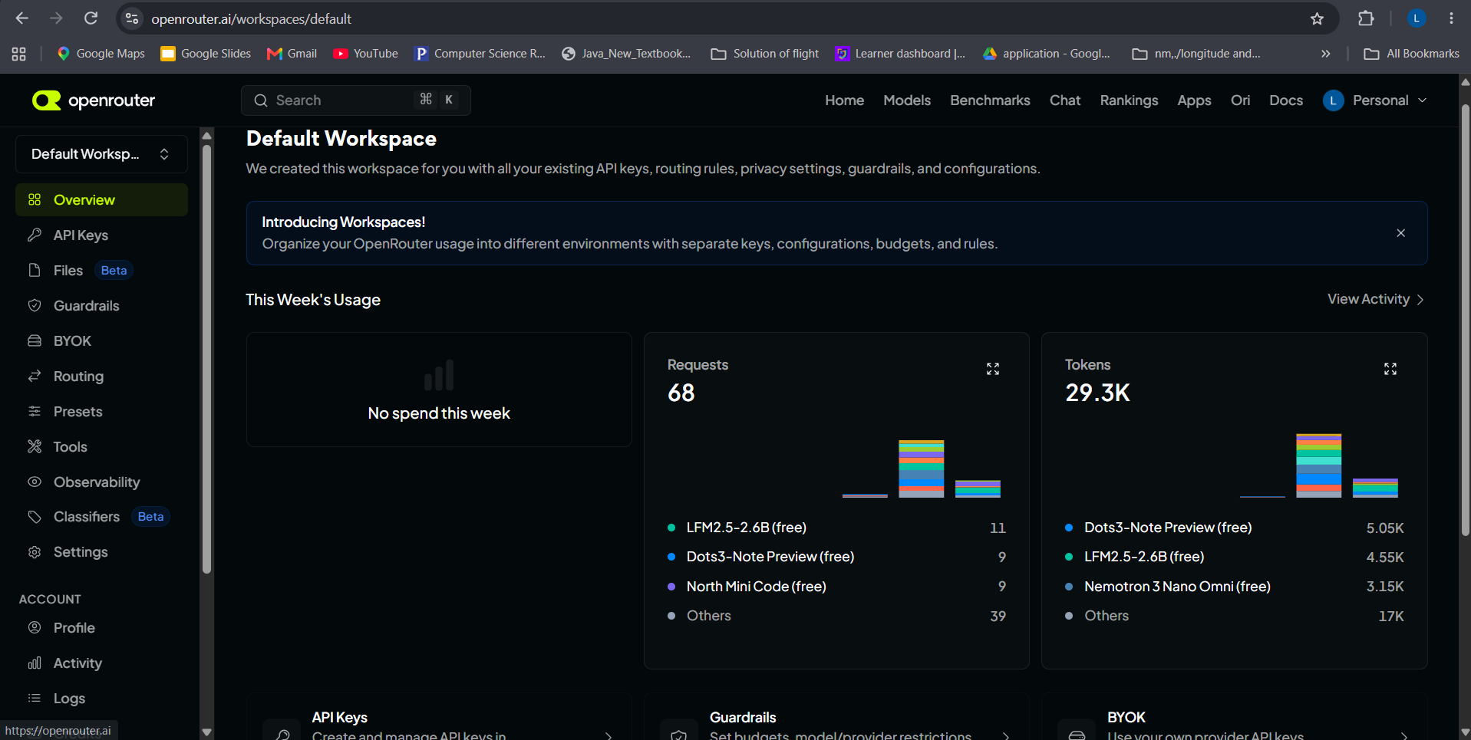
Project 1:
Before prompt:
For the first project I created a simple prompt that tells the model to act as a friendly teacher as the system role and take input from the user answers it in a friendly tone. Below I copied two answers from the terminal the first one was before giving the friendly teach prompt and the second one is after we can clearly see the difference in the model’s answers.
Enter your message: Why is the sky blue?
Response from the model:
The sky appears blue because of how sunlight interacts with the Earth's atmosphere. Sunlight seems white, but it actually contains all the colors of the visible spectrum. When this light enters the atmosphere, it collides with tiny molecules of air, primarily nitrogen and oxygen. These particles scatter the shorter, smaller wavelengths of light—blue and violet—much more effectively than the longer wavelengths, like red and orange. This scattered blue light travels in all directions, including to our eyes, making the sky
After prompt:
Re-running the code and giving the same question gives us a new tone of the same answer.
Enter your message: Why is the sky blue?
Response from the model:
The sky is blue because sunlight contains all colors, and when it hits the air in our atmosphere, blue light is scattered more than other colors. This happens because blue light has a shorter wavelength, so it bounces around in all directions across the sky. That scattered blue light is what you see when you look up!

Project 2:
The first project was stateless meaning when the model returns the answer it finished its task and stops it does not remember anything. For this project I was asked to modify the first project and make it stateful meaning it must remember what was asked from it in the previous message and answer. I made it stateful by appending the new message to the history of message. Now when a new message comes the model appends it to the history of messages and gives the answer.
Enter your message: My favorite color is green
Response from the model:
User Safety: safe
Enter your message (or type 'exit' to quit, 'reset' to start over): What is my favorite color?
Response from the model:
Your favorite color is green, as you mentioned in your previous message.
Enter your message (or type 'exit' to quit, 'reset' to start over): exit
Project 3:
For this project I was asked to make an LLM with vision capabilities meaning it takes an image read it in binary mode extracts information from it and answers the user based on the extracted information. At first, I made it to read the image and output all its contents then I added the user input feature.

Enter your message: What kind of document is this? Also, what is the invoice number and total?
Response from the model:
This is an invoice. The invoice number is INV-2026-104, and the total is SAR 2,300.00.

I rotated the invoice screenshot and the output:
Enter your message: What is the invoice Date and total and number?
Response from the model:
Invoice number: **INV-2026-104**
Invoice date: **18 September 2026**
Total: **SAR 2,300.00**
Project 4:
Before removing the currency:
For this project I was asked to read a json file and extract document_type, document_number, organization, document_date, currency. The model reads the value of input key from json file and extract the data I want from it.
Analyzing text: "Invoice 2837 from Example Trading, dated 12 September 2026. Total: SAR 4,820.00."
Raw Response from the model:
```json
{
"document_type": "Invoice",
"document_number": "2837",
"organization": "Example Trading",
"document_date": "12 September 2026",
"currency": "SAR",
"total": "4,820.00"
}
```
After removing the currency (SAR)
Analyzing text: "Invoice 2837 from Example Trading, dated 12 September 2026. Total: 4,820.00."
Raw Response from the model:
{"document_type":"Invoice","document_number":"2837","organization":"Example Trading","document_date":"2026-09-12","currency":null,"total":"4,820.00"}

Parsed JSON Response:
{
"document_type": "Invoice",
"document_number": "2837",
"organization": "Example Trading",
"document_date": "2026-09-12",
"currency": null,
"total": "4,820.00"
}
Project 5:
In this project I started with part 1 first tried to make the model a helpful assistant that can lookup shipments and find out where are they going.
In this project I learnt about function calling (tool-calling) and how a model if it can’t find the answer to specific information it asks to use tools that may help it give accurate answers to specific.

Part 1:
Enter your message: Where is shipment SHP-1001 going?
[AI Agent requested tool call: lookup_shipment]

[Tool Response: {"status": "in_transit", "origin": "Riyadh", "destination": "Dammam"}]
[Final Response from the model: ]
Shipment SHP-1001 is going to Dammam.

Enter your message: where is shimpent 100 going?
[AI Agent requested tool call: lookup_shipment]
[Tool Response: {"error": "Shipment ID not found."}]
[Final Response from the model: ]
I’m sorry—I couldn’t locate any shipment with ID 100 in our system (the lookup returned “Shipment ID not found”). Please double‑check the shipment ID and try again, or let me know if you have any other details (such as a tracking number or destination) that might help me locate the correct record.
Part 2:
I added the second part of the project to my code and
Enter your message: What is the return policy?
[AI Agent requested tool call: list_file with arguments: {}]
[Tool Response: ['about.md', 'hours.md', 'returns.md']]
[Tool Response: ['about.md', 'hours.md', 'returns.md']]
[AI Agent requested tool call: read_file with arguments: {'file_name': 'returns.md'}]
[Tool Response: {'content': '# Return Policy\n\nBright Paper accepts unused items within 14 days of purchase. The customer must have\nthe receipt. Opened printer ink cannot be returned.\n\n'}]
[Tool Response: {'content': '# Return Policy\n\nBright Paper accepts unused items within 14 days of purchase. The customer must have\nthe receipt. Opened printer ink cannot be returned.\n\n'}]
[Final Response from the model: ]
Based on the **returns.md** file, here is Bright Paper's return policy:
**Return Policy:**
- Unused items can be accepted within **14 days** of purchase.
- The customer must have the **receipt**.
- **Opened printer ink** cannot be returned.
If you need more details or have specific questions about your order, feel free to ask!

Enter your message: Does it sell laptops?
[AI Agent requested tool call: list_file with arguments: {}]
[Tool Response: ['about.md', 'hours.md', 'returns.md']]

[AI Agent requested tool call: read_file with arguments: {'file_name': 'about.md'}]
[Tool Response: {'content': '# Bright Paper\n\nBright Paper sells notebooks, printer paper, pens, folders, and other office supplies.\n\nThe shop is located in Riyadh. Its support email is help@example.invalid.\n'}]
[AI Agent requested tool call: read_file with arguments: {'file_name': 'hours.md'}]
[Tool Response: {'content': '# Opening Hours\n\nBright Paper is open from Sunday to Thursday, 9:00 AM to 5:00 PM.\n\nIt is closed on Friday and Saturday.\n\n'}]
[AI Agent requested tool call: read_file with arguments: {'file_name': 'returns.md'}]

[Tool Response: {'content': '# Return Policy\n\nBright Paper accepts unused items within 14 days of purchase. The customer must have\nthe receipt. Opened printer ink cannot be returned.\n\n'}]

[Final Response from the model: ]

Based on the available information, Bright Paper sells office supplies such as notebooks, printer paper, pens, and folders. There is no mention of laptops in the provided files, so I cannot confirm whether they sell laptops or not.

