**About the dataset**

The dataset is a fictional student score for 3 assignments. It contains a total of 10 students. I calculated the total score, average and grade for each student.

**Inbuilt excel formula used**

I used the SUM and AVERAGE inbuilt formulas.

The sum formula combined the total for assignment 1,2 and 3.

Total score =SUM(B2:D2)

Average =AVERAGE(B2:D2)

Grade=IF(F2>=90,"A",IF(F2>=80,"B",IF(F2>=70,"C",IF(F2>=60,"D","F"))))

**Relative referencing**

Relative referencing was used to comment on the score of the student. This is the formulae used.

=IF(F11>=$N$4,"Excellent",IF(F11>=$N$5,"Good",IF(F11>=$N$6,"Average",IF(F11>=$N$7,"Fail","Fail"))))

**Chart**

The bar chart was the best visualization of the student average scores. It shows the average score of the 10 students. The bar chart has title, labelled x and y axis and a legend.

The average score ranges from 0(minimum) to 100(maximum).

*Figure 1: bar graph average score of students*

**Data Insights**

The bar chart clearly visualized the average score of each student. The chart shows that Isaac has the average highest score while David has the lowest average score. This graph makes it easy to identify the top and bottom performing students.

**Final data and Graph visualization**

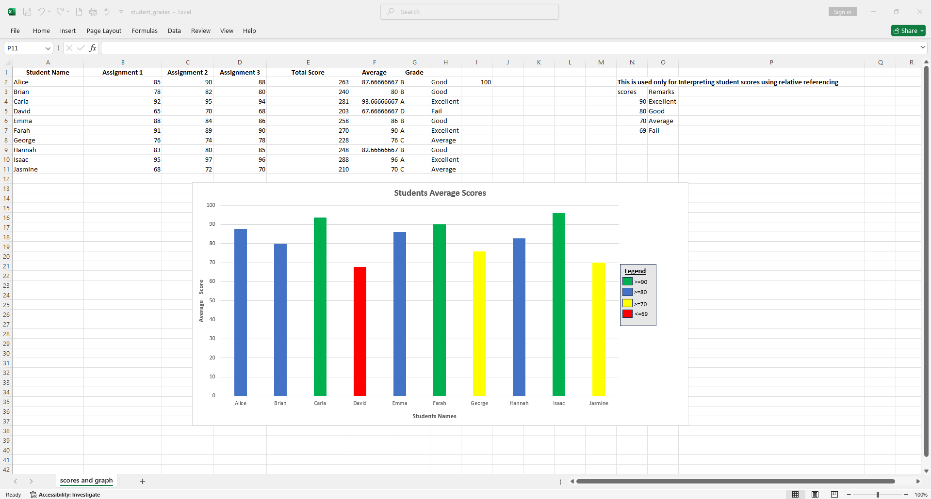

*Figure 2: Final data and graph visualization in excel*