Résultats

On cherche un lien entre srh et actpro en ajustant sur age, sexe, educ, csp, seul.

n = 10 001

**Age**

> median(dataClean$age0)

[1] 59.11

> mean(dataClean$age0)

[1] 59.61245

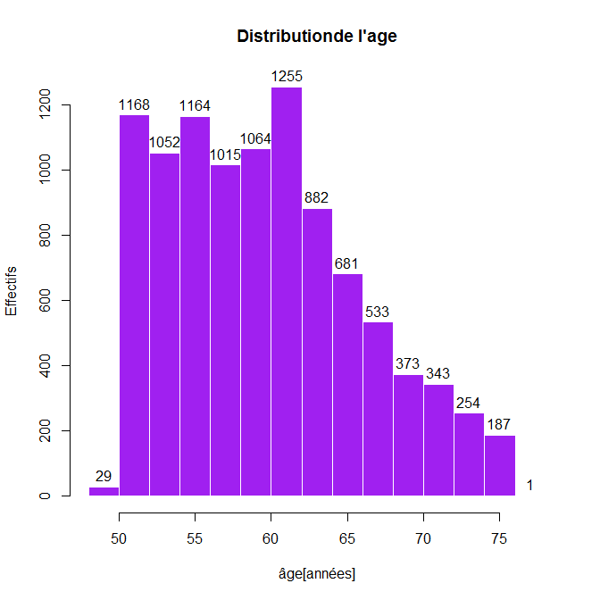

**La distribution de l’âge ne semble pas normale. Le test de Shapiro étant limité à 5000 individus, on va considérer la variable age0 comme non Gaussienne.**

**Santé perçue**

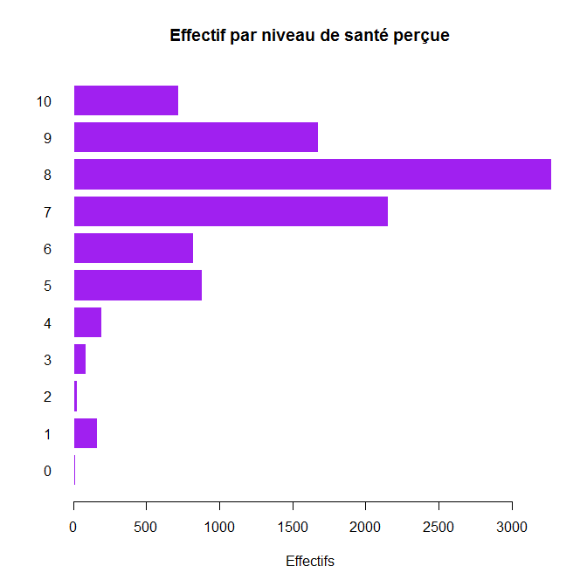

> cumsum(summary(dataClean$srh))

0 1 2 3 4 5 6 7 8 9 10

11 174 202 287 479 1362 2182 4336 7608 9282 10001

**On fixe median = 7**

**Sexe**

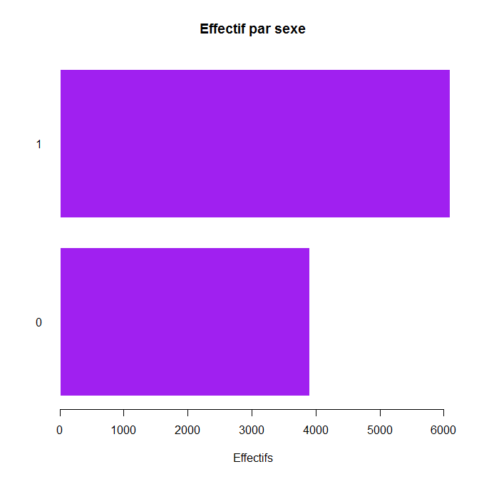

**Plus d’hommes que de femmes**

**Seul**

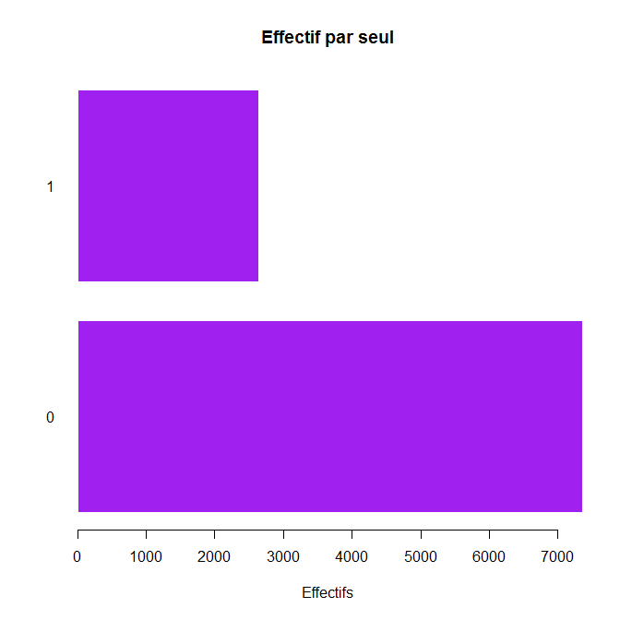

> summary(dataClean$seul)

0 1

7361 2640

73.60 26.40

**Plus de 73% des effectifs sont en couple.**

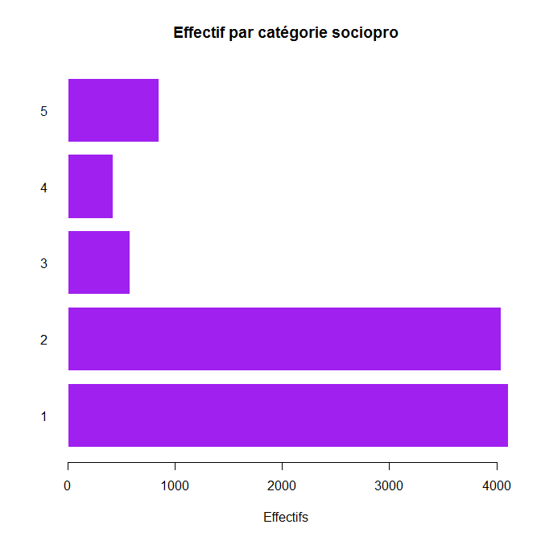

> cumsum(summary(dataClean$csp))

1 2 3 4 5

4109 8151 8732 9154 10001

**Educ**

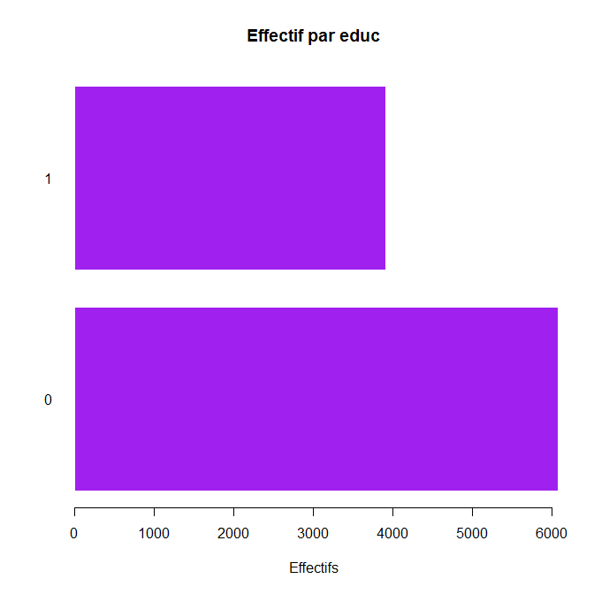

**Lien srh actpro**

**Actpro: 0 = travaille, 1 = ne travaille plus, 5 = n’a jamais travaillé**

> table(dataClean$srh,dataClean$actpro)

0 1 5

0 7 4 0

1 109 53 1

2 14 14 0

3 50 34 1

4 117 75 0

5 504 371 8

6 465 348 7

7 1258 886 10

8 1870 1390 12

9 992 671 11

10 406 311 2

round(prop.table(table(dataClean$srh,dataClean$actpro))*100,2)

0 1 5

0 0.07 0.04 0.00

1 1.09 0.53 0.01

2 0.14 0.14 0.00

3 0.50 0.34 0.01

4 1.17 0.75 0.00

5 5.04 3.71 0.08

6 4.65 3.48 0.07

7 12.58 8.86 0.10

8 18.70 13.90 0.12

9 9.92 6.71 0.11

10 4.06 3.11 0.02

table(dataClean$srh_bin,dataClean$actpro)

0 1 5

0 2524 1785 27

1 3268 2372 25

round(prop.table(table(dataClean$srh_bin,dataClean$actpro))*100,2)

0 1 5

0 25.24 17.85 0.27

1 32.68 23.72 0.25

chisq.test(dataClean$srh_bin,dataClean$actpro)

Pearson's Chi-squared test

data: dataClean$srh_bin and dataClean$actpro

X-squared = 1.9631, df = 2, **p-value = 0.3747**

**Sur les 52 sujets n’ayant jamais travaillé (actpro = 5), 7 sont des hommes (sexe = 1) et 45 sont des femmes (sexe = 0)**

**Stratification sur le sexe + on retire les 52 sujets n’ayant jamais travaillé**

**Hommes**

table(data2_H$srh_bin, data2_H$actpro)

0 1 5

0 1504 888 0

1 2299 1399 0

round(prop.table(table(data2_H$srh_bin, data2_H$actpro))*100,2)

0 1 5

0 24.70 14.58 0.00

1 37.75 22.97 0.00

chisq.test(data2_H$srh_bin,data2_H$actpro)

Pearson's Chi-squared test with Yates' continuity correction

data: data2_H$srh_bin and data2_H$actpro

X-squared = 0.28061, df = 1, **p-value = 0.5963**

**Donc les différences de santé perçue entre les hommes qui travaillent et ceux qui ne travaillent pas n’est pas significative.**

**Femmes**

table(data2_F$srh_bin, data2_F$actpro)

0 1 5

0 1020 897 0

1 969 973 0

round(prop.table(table(data2_F$srh_bin, data2_F$actpro))*100,2)

0 1 5

0 26.43 23.24 0.00

1 25.11 25.21 0.00

chisq.test(data2_F$srh_bin, data2_F$actpro)

Pearson's Chi-squared test with Yates' continuity correction

data: data2_F$srh_bin and data2_F$actpro

X-squared = 4.1031, df = 1, **p-value = 0.0428**

**Il y a une différence significative entre la santé perçue des femmes à la retraite et des femmes qui travaillent**

**Stratification sur l’âge**

summary(dataClean$age0)

Min. 1st Qu. Median Mean 3rd Qu. Max.

48.53 54.47 59.11 59.61 63.65 76.45

data_retraite = data2[data2$actpro == 1,]

> summary(data_retraite$age0)

Min. 1st Qu. **Median** Mean 3rd Qu. Max.

49.98 60.77 **63.73** 64.05 67.97 76.45

**On a l’age median et moyen des retraités mais pas l’âge moyen de départ à la retraite.**

**On catégorise l’âge en 10 classes  et on retire actpro = 5**

> summary(age_cut)

[48.5,51.7] (51.7,53.5] (53.5,55.3] (55.3,57.1] (57.1,59.1] (59.1,60.9]

1001 994 1006 993 995 1002

1 2 3 4 5 6

(60.9,62.5] (62.5,65] (65,68.8] (68.8,76.5]

992 986 990 990

7 8 9 10

**Classe d’âge 1** [48.5,51.7]

table(data_age1$srh_bin, data_age1$actpro)

0 1 5

0 390 53 0

1 523 35 0

round(prop.table(table(data_age1$srh_bin, data_age1$actpro))*100,2)

0 1 5

0 38.96 5.29 0.00

1 52.25 3.50 0.00

chisq.test(data_age1$srh_bin, data_age1$actpro)

Pearson's Chi-squared test with Yates' continuity correction

data: data_age1$srh_bin and data_age1$actpro

X-squared = 9.2791, df = 1, **p-value = 0.002318**

**Chez les sujets qui ont entre 48.5 et 51.7 ans, il y a une différence significative de la santé perçue entre ceux qui travaillent et ceux qui sont à la retraite.**

**Attention la différence d’effectifs entre ceux qui travaillent (913)et ceux qui ne travaillent pas(88) dans la première classe d’âge peut fausser l’interprétation.**

**Classe d’age 2** (51.7,53.5]

table(data_age2$srh_bin, data_age2$actpro)

0 1 5

0 380 62 0

1 487 65 0

round(prop.table(table(data_age2$srh_bin, data_age2$actpro))*100,2)

0 1 5

0 38.23 6.24 0.00

1 48.99 6.54 0.00

chisq.test(data_age2$srh_bin, data_age2$actpro)

Pearson's Chi-squared test with Yates' continuity correction

data: data_age2$srh_bin and data_age2$actpro

X-squared = 0.92389, df = 1, **p-value = 0.3365**

**Non significatif**

**Classe d’âge 3 :** (53.5,55.3]

table(data_age3$srh_bin, data_age3$actpro)

0 1 5

0 409 58 0

1 488 51 0

round(prop.table(table(data_age3$srh_bin, data_age3$actpro))*100,2)

0 1 5

0 40.66 5.77 0.00

1 48.51 5.07 0.00

chisq.test(data_age3$srh_bin, data_age3$actpro)

Pearson's Chi-squared test with Yates' continuity correction

data: data_age3$srh_bin and data_age3$actpro

X-squared = 1.9699, df = 1, **p-value = 0.1605**

**Significatif ( 0.16, ok jusqu’à 20 % cf Marie-Cecile, a checker on the internet !!!)**

**Classe d’âge 4 :** (55.3,57.1]

table(data_age4$srh_bin, data_age4$actpro)

0 1 5

0 358 69 0

1 476 90 0

round(prop.table(table(data_age4$srh_bin, data_age4$actpro))*100,2)

0 1 5

0 36.05 6.95 0.00

1 47.94 9.06 0.00

chisq.test(data_age4$srh_bin, data_age4$actpro)

Pearson's Chi-squared test with Yates' continuity correction

data: data_age4$srh_bin and data_age4$actpro

X-squared = 0.00050369, df = 1, **p-value = 0.9821**

**Classe d’âge 5 :**(55.3,57.1]

table(data_age5$srh_bin, data_age5$actpro)

0 1 5

0 359 102 0

1 416 118 0

round(prop.table(table(data_age5$srh_bin, data_age5$actpro))*100,2)

0 1 5

0 36.08 10.25 0.00

1 41.81 11.86 0.00

|  |
| --- |
| chisq.test(data_age5$srh_bin, data_age5$actpro)  Pearson's Chi-squared test with Yates' continuity correction  data: data_age5$srh_bin and data_age5$actpro  X-squared = 1.4767e-29, df = 1, **p-value = 1** |
|  |
| |  | | --- | |  | |

**Classe d’âge 6 :** (59.1,60.9]

table(data_age6$srh_bin, data_age6$actpro)

0 1 5

0 260 174 0

1 359 209 0

round(prop.table(table(data_age6$srh_bin, data_age6$actpro))*100,2)

0 1 5

0 25.95 17.37 0.00

1 35.83 20.86 0.00

chisq.test(data_age6$srh_bin, data_age6$actpro)

Pearson's Chi-squared test with Yates' continuity correction

data: data_age6$srh_bin and data_age6$actpro

X-squared = 0.99683, df = 1, **p-value = 0.3181**

**Classe d’âge 7** (60.9,62.5]

table(data_age7$srh_bin, data_age7$actpro)

0 1 5

0 156 250 0

1 213 373 0

round(prop.table(table(data_age7$srh_bin, data_age7$actpro))*100,2)

0 1 5

0 15.73 25.20 0.00

1 21.47 37.60 0.00

chisq.test(data_age7$srh_bin, data_age7$actpro)

Pearson's Chi-squared test with Yates' continuity correction

data: data_age7$srh_bin and data_age7$actpro

X-squared = 0.35787, df = 1, **p-value = 0.5497**

**Classe d’âge 8**(62.5,65]

table(data_age8$srh_bin, data_age8$actpro)

0 1 5

0 113 265 0

1 172 436 0

> round(prop.table(table(data_age8$srh_bin, data_age8$actpro))*100,2)

0 1 5

0 11.46 26.88 0.00

1 17.44 44.22 0.00

> chisq.test(data_age8$srh_bin, data_age8$actpro)

Pearson's Chi-squared test with Yates' continuity correction

data: data_age8$srh_bin and data_age8$actpro

X-squared = 0.21921, df = 1, **p-value = 0.6396**

**Classe d’âge 9**(65,68.8]

table(data_age9$srh_bin, data_age9$actpro)

0 1 5

0 62 353 0

1 84 491 0

> round(prop.table(table(data_age9$srh_bin, data_age9$actpro))*100,2)

0 1 5

0 6.26 35.66 0.00

1 8.48 49.60 0.00

> chisq.test(data_age9$srh_bin, data_age9$actpro)

Pearson's Chi-squared test with Yates' continuity correction

data: data_age9$srh_bin and data_age9$actpro

X-squared = 0.00293, df = 1, **p-value = 0.9568**

**Classe d’âge 10**(68.8,76.5]

table(data_age10$srh_bin, data_age10$actpro)

0 1 5

0 37 399 0

1 50 504 0

> round(prop.table(table(data_age10$srh_bin, data_age10$actpro))*100,2)

0 1 5

0 3.74 40.30 0.00

1 5.05 50.91 0.00

> chisq.test(data_age10$srh_bin, data_age10$actpro)

Pearson's Chi-squared test with Yates' continuity correction

data: data_age10$srh_bin and data_age10$actpro

X-squared = 0.033977, df = 1, **p-value = 0.8538**

**Model1:**

**srh_bin ~ actpro** sur dataClean

Deviance Residuals:

Min 1Q Median 3Q Max

-1.300 -1.289 1.059 1.070 1.210

Coefficients:

Estimate Std. Error z value Pr(>|z|)

(Intercept) 0.25833 0.02650 9.749 <2e-16 ***

actpro1 0.02598 0.04104 0.633 **0.527**

actpro5 -0.33529 0.27882 -1.203 **0.229**

---

Signif. codes: 0 ‘***’ 0.001 ‘**’ 0.01 ‘*’ 0.05 ‘.’ 0.1 ‘ ’ 1

(Dispersion parameter for binomial family taken to be 1)

Null deviance: 13687 on 10000 degrees of freedom

Residual deviance: 13685 on 9998 degrees of freedom

**AIC: 13691**

Number of Fisher Scoring iterations: 4

**odds.ratio(model1)**

OR 2.5 % 97.5 % p

(Intercept) 1.29477 1.22931 1.3639 <2e-16 ***

actpro1 1.02632 0.94703 1.1123 **0.5266**

actpro5 0.71513 0.41189 1.2369 **0.2291**

---

Signif. codes: 0 ‘***’ 0.001 ‘**’ 0.01 ‘*’ 0.05 ‘.’ 0.1 ‘ ’ 1

**On prend comme reference actpro0**

**Log(srh_bin) = beta0 + beta1(actpro1) + beta2(actpro5) + epsilon**

**avec : beta0 = 0.26**

**beta1 = 0.03**

**beta2 = -0.34**

**Les test de wald nous indique qu’il n’y a pas de lien significatif entre srh_bin et actpro.**

**On a OR(actpro1, actpro0) = 1.03 et OR(actpro5, actpro0) = 0.72**

**Model11**

srh_bin ~ actpro

Call:

glm(formula = srh_bin ~ actpro, family = "binomial", data = data2)

Deviance Residuals:

Min 1Q Median 3Q Max

-1.300 -1.289 1.059 1.070 1.070

Coefficients:

Estimate Std. Error z value Pr(>|z|)

(Intercept) 0.25833 0.02650 9.749 <2e-16 ***

actpro1 0.02598 0.04104 0.633 0.527

---

Signif. codes: 0 ‘***’ 0.001 ‘**’ 0.01 ‘*’ 0.05 ‘.’ 0.1 ‘ ’ 1

(Dispersion parameter for binomial family taken to be 1)

Null deviance: 13614 on 9948 degrees of freedom

Residual deviance: 13613 on 9947 degrees of freedom

AIC: 13617

Number of Fisher Scoring iterations: 4

**Lien srh et sexe**

table(dataClean$srh, dataClean$sexe)

0 1

0 7 4

1 47 116

2 9 19

3 43 42

4 87 105

5 443 440

6 403 417

7 901 1253

8 1159 2113

9 568 1106

10 237 482

round(prop.table(table(dataClean$srh, dataClean$sexe)),2)

0 1

0 0.07 0.04

1 0.47 1.16

2 0.09 0.19

3 0.43 0.42

4 0.87 1.05

5 4.43 4.40

6 4.03 4.17

7 9.01 12.53

8 11.59 21.13

9 5.68 11.06

10 2.37 4.82

**On binarise :**

table(dataClean$srh_bin,dataClean$sexe)

0 1

0 1940 2396

1 1964 3701

round(prop.table(table(dataClean$srh_bin,dataClean$sexe)),2)

0 1

0 19.40 23.96

1 19.64 37.01

chisq.test(dataClean$srh_bin,dataClean$sexe)

Pearson's Chi-squared test with Yates' continuity correction

data: dataClean$srh_bin and dataClean$sexe

X-squared = 104.29, df = 1, **p-value < 2.2e-16**

Model2

**srh_bin ~ sexe**

Call:

glm(formula = srh_bin ~ sexe, family = "binomial", data = dataClean)

Deviance Residuals:

Min 1Q Median 3Q Max

-1.3667 -1.1826 0.9992 0.9992 1.1722

Coefficients:

Estimate Std. Error z value Pr(>|z|)

(Intercept) 0.01230 0.03201 0.384 0.701

sexe1 0.42251 0.04138 10.211 **<2e-16** ***

---

Signif. codes: 0 ‘***’ 0.001 ‘**’ 0.01 ‘*’ 0.05 ‘.’ 0.1 ‘ ’ 1

(Dispersion parameter for binomial family taken to be 1)

Null deviance: 13687 on 10000 degrees of freedom

Residual deviance: 13583 on 9999 degrees of freedom

**AIC: 13587**

Number of Fisher Scoring iterations: 4

**Log(srh_bin) = 0.012 + 0.423(sexe1) =epsilon**

OR 2.5 % 97.5 % p

(Intercept) 1.01237 0.95081 1.0779 0.7009

sexe1 1.52578 1.40697 1.6547 <2e-16 ***

**Model3**

**srh_bin ~ actpro + sexe**

Deviance Residuals:

Min 1Q Median 3Q Max

-1.3870 -1.1993 0.9814 1.0098 1.2351

Coefficients:

Estimate Std. Error z value Pr(>|z|)

(Intercept) -0.02112 0.03794 -0.557 0.5778

actpro1 0.07249 0.04152 1.746 **0.0808 .**

actpro5 -0.11345 0.28039 -0.405 0.6858

sexe1 0.42899 0.04175 10.276 **<2e-16** ***

---

Signif. codes: 0 ‘***’ 0.001 ‘**’ 0.01 ‘*’ 0.05 ‘.’ 0.1 ‘ ’ 1

(Dispersion parameter for binomial family taken to be 1)

Null deviance: 13687 on 10000 degrees of freedom

Residual deviance: 13579 on 9997 degrees of freedom

**AIC: 13587**

**Model4**

**Avec une interaction entre actpro et sexe**

**srh_bin ~ actpro + sexe + actpro*sexe**

Call:

glm(formula = srh_bin ~ actpro + sexe + actpro * sexe, family = "binomial",

data = dataClean)

Deviance Residuals:

Min 1Q Median 3Q Max

-1.3755 -1.2121 0.9915 1.0033 1.3018

Coefficients:

Estimate Std. Error z value Pr(>|z|)

(Intercept) -0.051293 0.044860 -1.143 0.2529

actpro1 0.132622 0.064459 2.057 **0.0396** *

actpro5 0.006842 0.301571 0.023 0.9819

sexe1 0.475639 0.055788 8.526 **<2e-16** ***

actpro1:sexe1 -0.102426 0.084236 -1.216 0.2240

actpro5:sexe1 -0.718870 0.821814 -0.875 0.3817

---

(Dispersion parameter for binomial family taken to be 1)

Null deviance: 13687 on 10000 degrees of freedom

Residual deviance: 13577 on 9995 degrees of freedom

**AIC: 13589**

Number of Fisher Scoring iterations: 4

**Lien srh et age_cut**

table(data2$srh_bin, data2$age_cut)

1 2 3 4 5 6 7 8 9 10

0 443 442 467 427 461 434 406 378 415 436

1 558 552 539 566 534 568 586 608 575 55

round(prop.table(table(data2$srh_bin, data2$age_cut))*100,2)

1 2 3 4 5 6 7 8 9 10

0 4.45 4.44 4.69 4.29 4.63 4.36 4.08 3.80 4.17 4.38

1 5.61 5.55 5.42 5.69 5.37 5.71 5.89 6.11 5.78 5.57

chisq.test(data2$srh_bin, data2$age_cut)

Pearson's Chi-squared test

data: data2$srh_bin and data2$age_cut

X-squared = 21.833, df = 9, **p-value = 0.009423**

**Model10**

srh_bin ~ age_cut

Call:

glm(formula = srh_bin ~ age_cut, family = "binomial", data = data2)

Deviance Residuals:

Min 1Q Median 3Q Max

-1.385 -1.281 1.026 1.078 1.117

Coefficients:

Estimate Std. Error z value Pr(>|z|)

(Intercept) 0.230789 0.063635 3.627 0.000287 ***

age_cut2 -0.008551 0.090130 -0.095 0.924415

age_cut3 -0.087403 0.089700 -0.974 0.329862

age_cut4 0.051021 0.090323 0.565 0.572159

age_cut5 -0.083791 0.089952 -0.932 0.351587

age_cut6 0.038288 0.090079 0.425 0.670802

age_cut7 0.136177 0.090659 1.502 0.133074

age_cut8 0.244491 0.091322 2.677 0.007423 ** (62.5,65],

age_cut9 0.095302 0.090544 1.053 0.292546

age_cut10 0.008733 0.090267 0.097 0.922925

---

Signif. codes: 0 ‘***’ 0.001 ‘**’ 0.01 ‘*’ 0.05 ‘.’ 0.1 ‘ ’ 1

(Dispersion parameter for binomial family taken to be 1)

Null deviance: 13614 on 9948 degrees of freedom

Residual deviance: 13592 on 9939 degrees of freedom

AIC: 13612

Number of Fisher Scoring iterations: 4

Min. 1st Qu. **Median** Mean 3rd Qu. Max.

49.98 60.77 **63.73** 64.05 67.97 76.45

**Model9**

srh_bin ~ actpro + age_cut + sexe + actpro*sexe + actpro*age_cut

Call:

glm(formula = srh_bin ~ actpro + age_cut + sexe + actpro * sexe +

actpro * age_cut, family = "binomial", data = data2)

Deviance Residuals:

Min 1Q Median 3Q Max

-1.4738 -1.2655 0.9746 1.0350 1.4800

Coefficients:

Estimate Std. Error z value Pr(>|z|)

(Intercept) -0.05048 0.07827 -0.645 0.51899

actpro1 -0.63762 0.23658 -2.695 0.00704 **

age_cut2 -0.03303 0.09629 -0.343 0.73158

age_cut3 -0.08486 0.09537 -0.890 0.37353

age_cut4 0.02299 0.09747 0.236 0.81353

age_cut5 -0.09611 0.09910 -0.970 0.33214

age_cut6 0.06576 0.10614 0.620 0.53555

age_cut7 0.06109 0.12573 0.486 0.62705

age_cut8 0.19133 0.13948 1.372 0.17013

age_cut9 0.08190 0.18173 0.451 0.65222

age_cut10 0.12422 0.22894 0.543 0.58740

sexe1 0.48005 0.05609 8.559 < 2e-16 ***

actpro1:sexe1 -0.09124 0.08476 -1.076 0.28175

actpro1:age_cut2 0.52974 0.29816 1.777 0.07562 .

actpro1:age_cut3 0.41109 0.30679 1.340 0.18025

actpro1:age_cut4 0.71057 0.28849 2.463 0.01377 *

actpro1:age_cut5 0.72622 0.27607 2.631 0.00852 **

actpro1:age_cut6 0.60323 0.26428 2.283 0.02246 *

actpro1:age_cut7 0.83175 0.26559 3.132 0.00174 **

actpro1:age_cut8 0.78225 0.27110 2.885 0.00391 **

actpro1:age_cut9 0.71514 0.29296 2.441 0.01464 *

actpro1:age_cut10 0.59337 0.32386 1.832 0.06693 .

---

Signif. codes: 0 ‘***’ 0.001 ‘**’ 0.01 ‘*’ 0.05 ‘.’ 0.1 ‘ ’ 1

(Dispersion parameter for binomial family taken to be 1)

Null deviance: 13614 on 9948 degrees of freedom

Residual deviance: 13465 on 9927 degrees of freedom

AIC: 13509

Number of Fisher Scoring iterations: 4

**Lien srh et educ**

table(dataClean$srh,dataClean$educ)

0 1

0 9 2

1 83 80

2 21 7

3 64 21

4 136 56

5 637 246

6 562 258

7 1326 828

8 1923 1349

9 914 760

10 410 309

round(prop.table(table(dataClean$srh,dataClean$educ))*100,2)

0 1

0 0.09 0.02

1 0.83 0.80

2 0.21 0.07

3 0.64 0.21

4 1.36 0.56

5 6.37 2.46

6 5.62 2.58

7 13.26 8.28

8 19.23 13.49

9 9.14 7.60

10 4.10 3.09

table(dataClean$srh_bin, dataClean$educ)

0 1

0 2838 1498

1 3247 2418

round(prop.table(table(dataClean$srh_bin,dataClean$educ))*100,2)

0 1

0 28.38 14.98

1 32.47 24.18

Pearson's Chi-squared test with Yates' continuity correction

data: dataClean$srh_bin and dataClean$educ

X-squared = 67.887, df = 1, p-value **< 2.2e-16**

**Model5**

**srh_bin ~ educ**

glm(formula = srh_bin ~ educ, family = "binomial", data = **dataClean**)

Deviance Residuals:

Min 1Q Median 3Q Max

-1.386 -1.235 0.982 1.121 1.121

Coefficients:

Estimate Std. Error z value Pr(>|z|)

(Intercept) 0.13463 0.02570 5.239 1.61e-07 ***

educ1 0.34418 0.04173 8.248 **< 2e-16 \*\*\***

---

Signif. codes: 0 ‘***’ 0.001 ‘**’ 0.01 ‘*’ 0.05 ‘.’ 0.1 ‘ ’ 1

(Dispersion parameter for binomial family taken to be 1)

Null deviance: 13687 on 10000 degrees of freedom

Residual deviance: 13619 on 9999 degrees of freedom

**AIC: 13623**

Number of Fisher Scoring iterations: 4

OR 2.5 % 97.5 % p

(Intercept) 1.1441 1.0879 1.2033 1.613e-07 ***

educ1 1.4108 1.3001 1.5312 < 2.2e-16 ***

model6

srh_bin ~ actpro + sexe + educ

Deviance Residuals:

Min 1Q Median 3Q Max

-1.4621 -1.2911 0.9505 1.0639 1.2565

Coefficients:

Estimate Std. Error z value Pr(>|z|)

(Intercept) -0.11179 0.04031 -2.773 0.00555 **

actpro1 0.08768 0.04168 2.104 0.03540 *

actpro5 -0.07229 0.28071 -0.258 0.79676

sexe1 0.38475 0.04231 9.094 < 2e-16 ***

educ1 0.28746 0.04249 6.765 1.34e-11 ***

---

Signif. codes: 0 ‘***’ 0.001 ‘**’ 0.01 ‘*’ 0.05 ‘.’ 0.1 ‘ ’ 1

(Dispersion parameter for binomial family taken to be 1)

Null deviance: 13687 on 10000 degrees of freedom

Residual deviance: 13533 on 9996 degrees of freedom

AIC: 13543

Number of Fisher Scoring iterations: 4

**Lien srh et seul**

> table(dataClean$srh_bin,dataClean$seul)

0 1

0 3034 1302

1 4327 1338

> round(prop.table(table(dataClean$srh_bin,dataClean$seul))*100,2)

0 1

0 30.34 13.02

1 43.27 13.38

> chisq.test(dataClean$srh_bin,dataClean$seul)

Pearson's Chi-squared test with Yates' continuity correction

data: dataClean$srh_bin and dataClean$seul

X-squared = 51.595, df = 1**, p-value = 6.823e-13**

Model7

**srh_bin ~ seul**

Call:

glm(formula = srh_bin ~ seul, family = "binomial", data = dataClean)

Deviance Residuals:

Min 1Q Median 3Q Max

-1.331 -1.331 1.031 1.031 1.166

Coefficients:

Estimate Std. Error z value Pr(>|z|)

(Intercept) 0.35499 0.02368 14.992 < 2e-16 ***

seul1 -0.32772 0.04556 -7.192 **6.37e-13 \*\*\***

---

Signif. codes: 0 ‘***’ 0.001 ‘**’ 0.01 ‘*’ 0.05 ‘.’ 0.1 ‘ ’ 1

(Dispersion parameter for binomial family taken to be 1)

Null deviance: 13687 on 10000 degrees of freedom

Residual deviance: 13636 on 9999 degrees of freedom

**AIC: 13640**

Number of Fisher Scoring iterations: 4

**Lien srh et age**

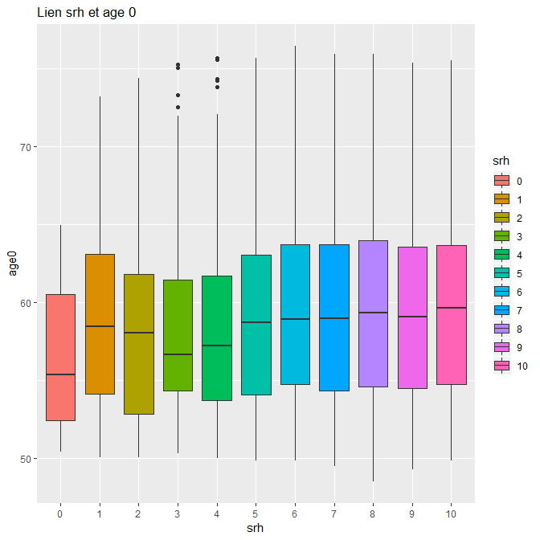

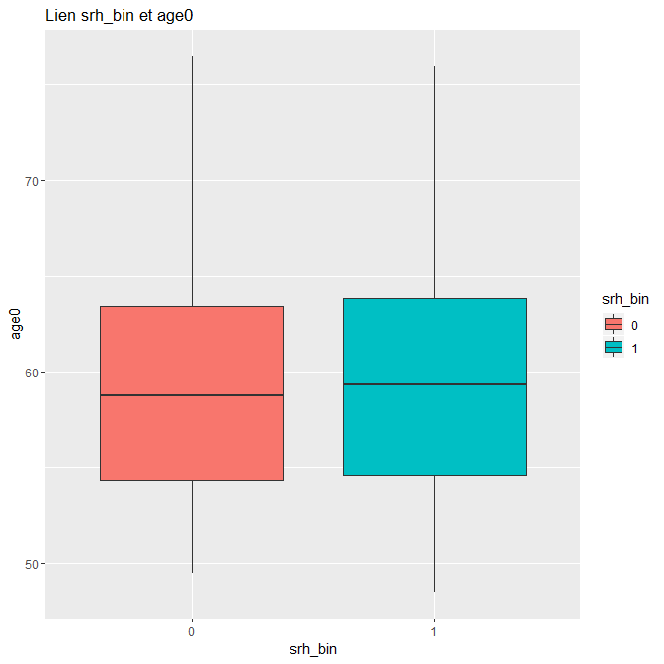

Model12

srh_bin ~ actpro + age_cut + sexe + actpro*sexe + actpro*age_cut + seul + educ

Call:

glm(formula = srh_bin ~ actpro + age_cut + sexe + actpro * sexe +

actpro * age_cut + seul + educ, family = "binomial", data = data2)

Deviance Residuals:

Min 1Q Median 3Q Max

-1.5571 -1.2543 0.9199 1.0523 1.4575

Coefficients:

Estimate Std. Error z value Pr(>|z|)

(Intercept) -0.05085 0.08198 -0.620 0.53506

actpro1 -0.58714 0.23707 -2.477 0.01326 *

age_cut2 -0.04226 0.09657 -0.438 0.66170

age_cut3 -0.08426 0.09567 -0.881 0.37847

age_cut4 0.02515 0.09780 0.257 0.79709

age_cut5 -0.10168 0.09942 -1.023 0.30642

age_cut6 0.05787 0.10649 0.543 0.58682

age_cut7 0.03435 0.12628 0.272 0.78558

age_cut8 0.17349 0.14015 1.238 0.21576

age_cut9 0.08884 0.18262 0.486 0.62665

age_cut10 0.13192 0.22984 0.574 0.56599

sexe1 0.39472 0.05743 6.873 6.29e-12 ***

seul1 -0.20749 0.04753 -4.365 1.27e-05 ***

educ1 0.27205 0.04288 6.345 2.22e-10 ***

actpro1:sexe1 -0.09137 0.08502 -1.075 0.28255

actpro1:age_cut2 0.52677 0.29864 1.764 0.07775 .

actpro1:age_cut3 0.38375 0.30732 1.249 0.21178

actpro1:age_cut4 0.70205 0.28896 2.430 0.01512 *

actpro1:age_cut5 0.68447 0.27675 2.473 0.01339 *

actpro1:age_cut6 0.58357 0.26493 2.203 0.02762 *

actpro1:age_cut7 0.82675 0.26645 3.103 0.00192 **

actpro1:age_cut8 0.74832 0.27212 2.750 0.00596 **

actpro1:age_cut9 0.65158 0.29414 2.215 0.02675 *

actpro1:age_cut10 0.55777 0.32495 1.716 0.08608 .

---

Signif. codes: 0 ‘***’ 0.001 ‘**’ 0.01 ‘*’ 0.05 ‘.’ 0.1 ‘ ’ 1

(Dispersion parameter for binomial family taken to be 1)

Null deviance: 13614 on 9948 degrees of freedom

Residual deviance: 13403 on 9925 degrees of freedom

AIC: 13451

Number of Fisher Scoring iterations: 4

**On peut aussi ajouter la catégotie socio pro au modele et anticiper une interaction entre csp et educ:**

**Model13**

glm(srh_bin ~ actpro + age_cut + sexe + actpro*sexe + actpro*age_cut + seul + educ + csp, data = data2, family = "binomial")

Call:

glm(formula = srh_bin ~ actpro + age_cut + sexe + actpro * sexe +

actpro * age_cut + seul + educ + csp, family = "binomial",

data = data2)

Deviance Residuals:

Min 1Q Median 3Q Max

-1.6122 -1.2307 0.8961 1.0582 1.4545

Coefficients:

Estimate Std. Error z value Pr(>|z|)

(Intercept) 0.14977 0.08973 1.669 0.095074 .

actpro1 -0.35392 0.25179 -1.406 0.159836

age_cut2 -0.03664 0.09687 -0.378 0.705238

age_cut3 -0.07824 0.09597 -0.815 0.414979

age_cut4 0.02667 0.09811 0.272 0.785733

age_cut5 -0.09958 0.09974 -0.998 0.318098

age_cut6 0.05948 0.10681 0.557 0.577650

age_cut7 0.02506 0.12665 0.198 0.843135

age_cut8 0.18323 0.14069 1.302 0.192797

age_cut9 0.10058 0.18340 0.548 0.583408

age_cut10 0.14971 0.23108 0.648 0.517081

sexe1 0.35996 0.05908 6.093 1.11e-09 ***

seul1 -0.19646 0.04815 -4.080 4.50e-05 ***

educ1 0.16873 0.04694 3.595 0.000325 ***

csp2 -0.24833 0.05172 -4.802 1.57e-06 ***

csp3 -0.42150 0.09393 -4.487 7.21e-06 ***

csp4 -0.42717 0.11860 -3.602 0.000316 ***

csp5 -0.38629 0.10485 -3.684 0.000229 ***

actpro1:sexe1 -0.08284 0.08617 -0.961 0.336380

actpro1:age_cut2 0.51731 0.29852 1.733 0.083110 .

actpro1:age_cut3 0.37177 0.30737 1.210 0.226463

actpro1:age_cut4 0.66862 0.28987 2.307 0.021075 *

actpro1:age_cut5 0.65846 0.27738 2.374 0.017604 *

actpro1:age_cut6 0.46670 0.27075 1.724 0.084757 .

actpro1:age_cut7 0.64284 0.27761 2.316 0.020576 *

actpro1:age_cut8 0.55627 0.28327 1.964 0.049561 *

actpro1:age_cut9 0.43592 0.30702 1.420 0.155657

actpro1:age_cut10 0.32834 0.33724 0.974 0.330247

---

Signif. codes: 0 ‘***’ 0.001 ‘**’ 0.01 ‘*’ 0.05 ‘.’ 0.1 ‘ ’ 1

(Dispersion parameter for binomial family taken to be 1)

Null deviance: 13614 on 9948 degrees of freedom

Residual deviance: 13361 on 9921 degrees of freedom

AIC: 13417

Number of Fisher Scoring iterations: 4

**Model14**

glm(srh_bin ~ actpro + age_cut + sexe + actpro*sexe + actpro*age_cut + seul + educ + csp + csp*educ, data = data2, family = "binomial")

Call:

glm(formula = srh_bin ~ actpro + age_cut + sexe + actpro * sexe +

actpro * age_cut + seul + educ + csp + csp * educ, family = "binomial",

data = data2)

Deviance Residuals:

Min 1Q Median 3Q Max

-1.5978 -1.2406 0.9041 1.0578 1.6269

Coefficients:

Estimate Std. Error z value Pr(>|z|)

(Intercept) 0.18841 0.09456 1.992 0.0463 *

actpro1 -0.34196 0.25245 -1.355 0.1756

age_cut2 -0.03302 0.09691 -0.341 0.7333

age_cut3 -0.07838 0.09597 -0.817 0.4141

age_cut4 0.02929 0.09815 0.298 0.7654

age_cut5 -0.10034 0.09973 -1.006 0.3143

age_cut6 0.05920 0.10684 0.554 0.5795

age_cut7 0.02696 0.12664 0.213 0.8314

age_cut8 0.18520 0.14071 1.316 0.1881

age_cut9 0.10459 0.18353 0.570 0.5688

age_cut10 0.14000 0.23120 0.606 0.5448

sexe1 0.36364 0.05914 6.148 7.83e-10 ***

seul1 -0.19538 0.04819 -4.055 5.02e-05 ***

educ1 0.10223 0.06715 1.522 0.1279

csp2 -0.29181 0.06493 -4.494 6.98e-06 ***

csp3 -0.43402 0.10090 -4.301 1.70e-05 ***

csp4 -0.55805 0.14279 -3.908 9.30e-05 ***

csp5 -0.51256 0.12766 -4.015 5.94e-05 ***

actpro1:sexe1 -0.09004 0.08633 -1.043 0.2970

actpro1:age_cut2 0.50425 0.29936 1.684 0.0921 .

actpro1:age_cut3 0.36303 0.30824 1.178 0.2389

actpro1:age_cut4 0.66991 0.29063 2.305 0.0212 *

actpro1:age_cut5 0.64975 0.27816 2.336 0.0195 *

actpro1:age_cut6 0.45738 0.27142 1.685 0.0920 .

actpro1:age_cut7 0.62542 0.27832 2.247 0.0246 *

actpro1:age_cut8 0.54180 0.28391 1.908 0.0563 .

actpro1:age_cut9 0.42036 0.30766 1.366 0.1718

actpro1:age_cut10 0.32726 0.33776 0.969 0.3326

educ1:csp2 0.08578 0.10424 0.823 0.4105

educ1:csp3 -0.64211 0.43280 -1.484 0.1379

educ1:csp4 0.36251 0.23574 1.538 0.1241

educ1:csp5 0.26859 0.15712 1.709 0.0874 .

---

Signif. codes: 0 ‘***’ 0.001 ‘**’ 0.01 ‘*’ 0.05 ‘.’ 0.1 ‘ ’ 1

(Dispersion parameter for binomial family taken to be 1)

Null deviance: 13614 on 9948 degrees of freedom

Residual deviance: 13353 on 9917 degrees of freedom

AIC: 13417

Number of Fisher Scoring iterations: 4

**L’interaction n’est pas significative.**

**Meilleur model = 13 ??**

glm(srh_bin ~ actpro + age_cut + sexe + actpro*sexe + actpro*age_cut + seul

+ educ + csp, data = data2, family = "binomial")

**On peut regarger les effets des variables de notre model13.**

