Weka Immidiatly after loading in the data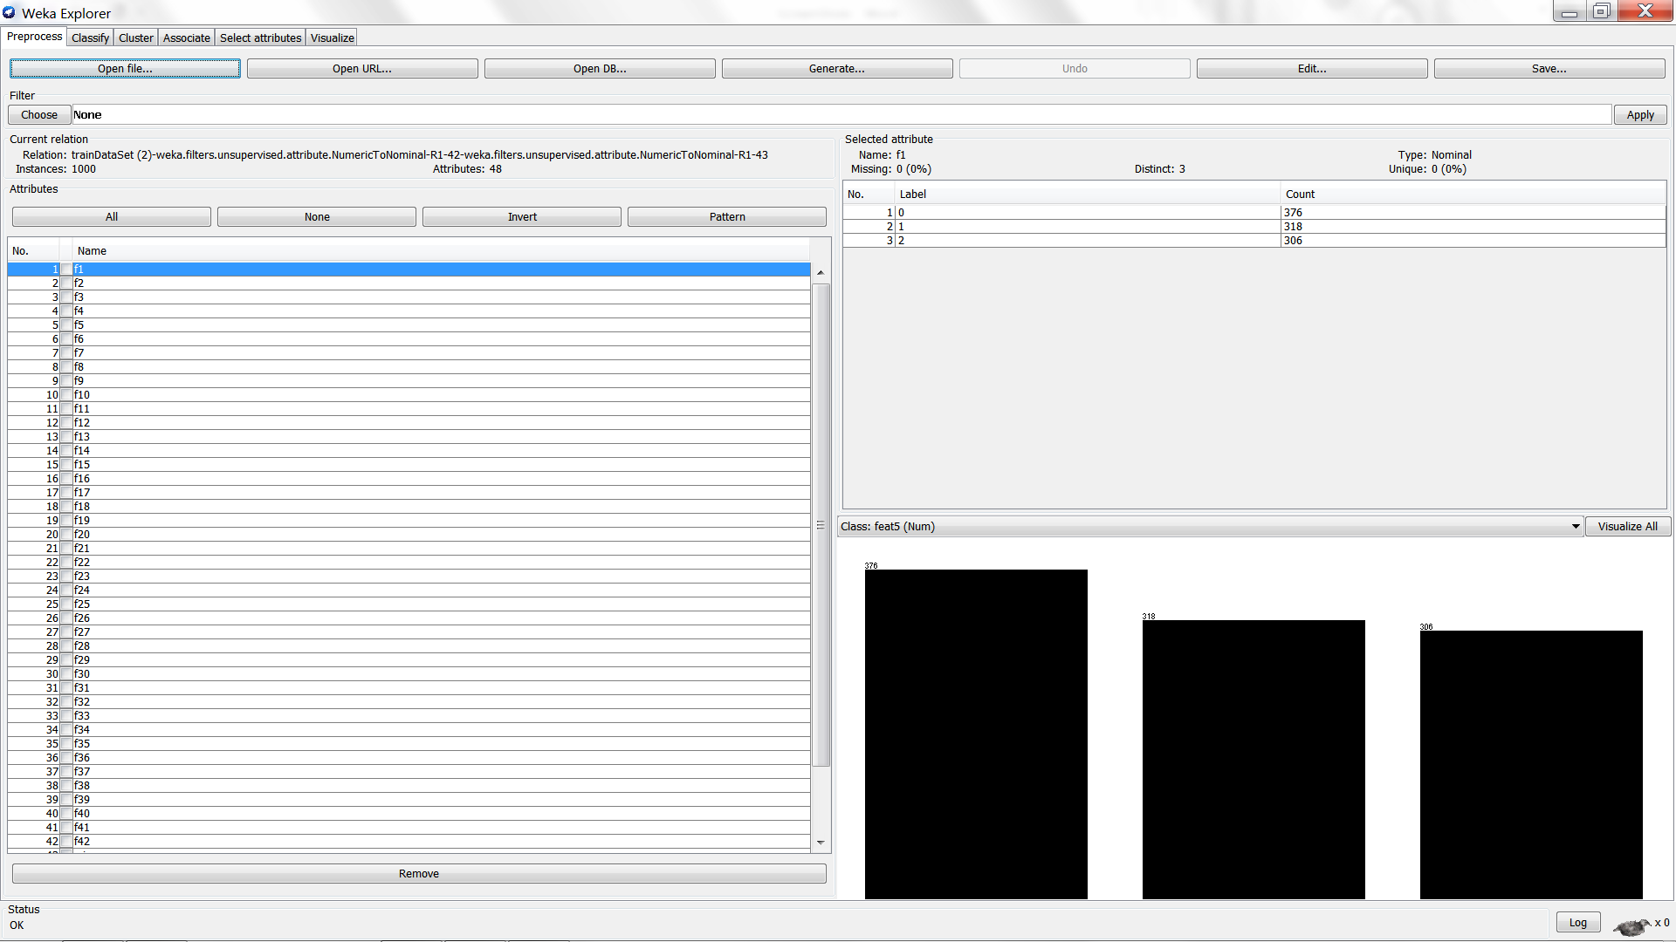

Weka classify screen after selecting j48 as the classifier, using the training set, and selecting the winner column as the class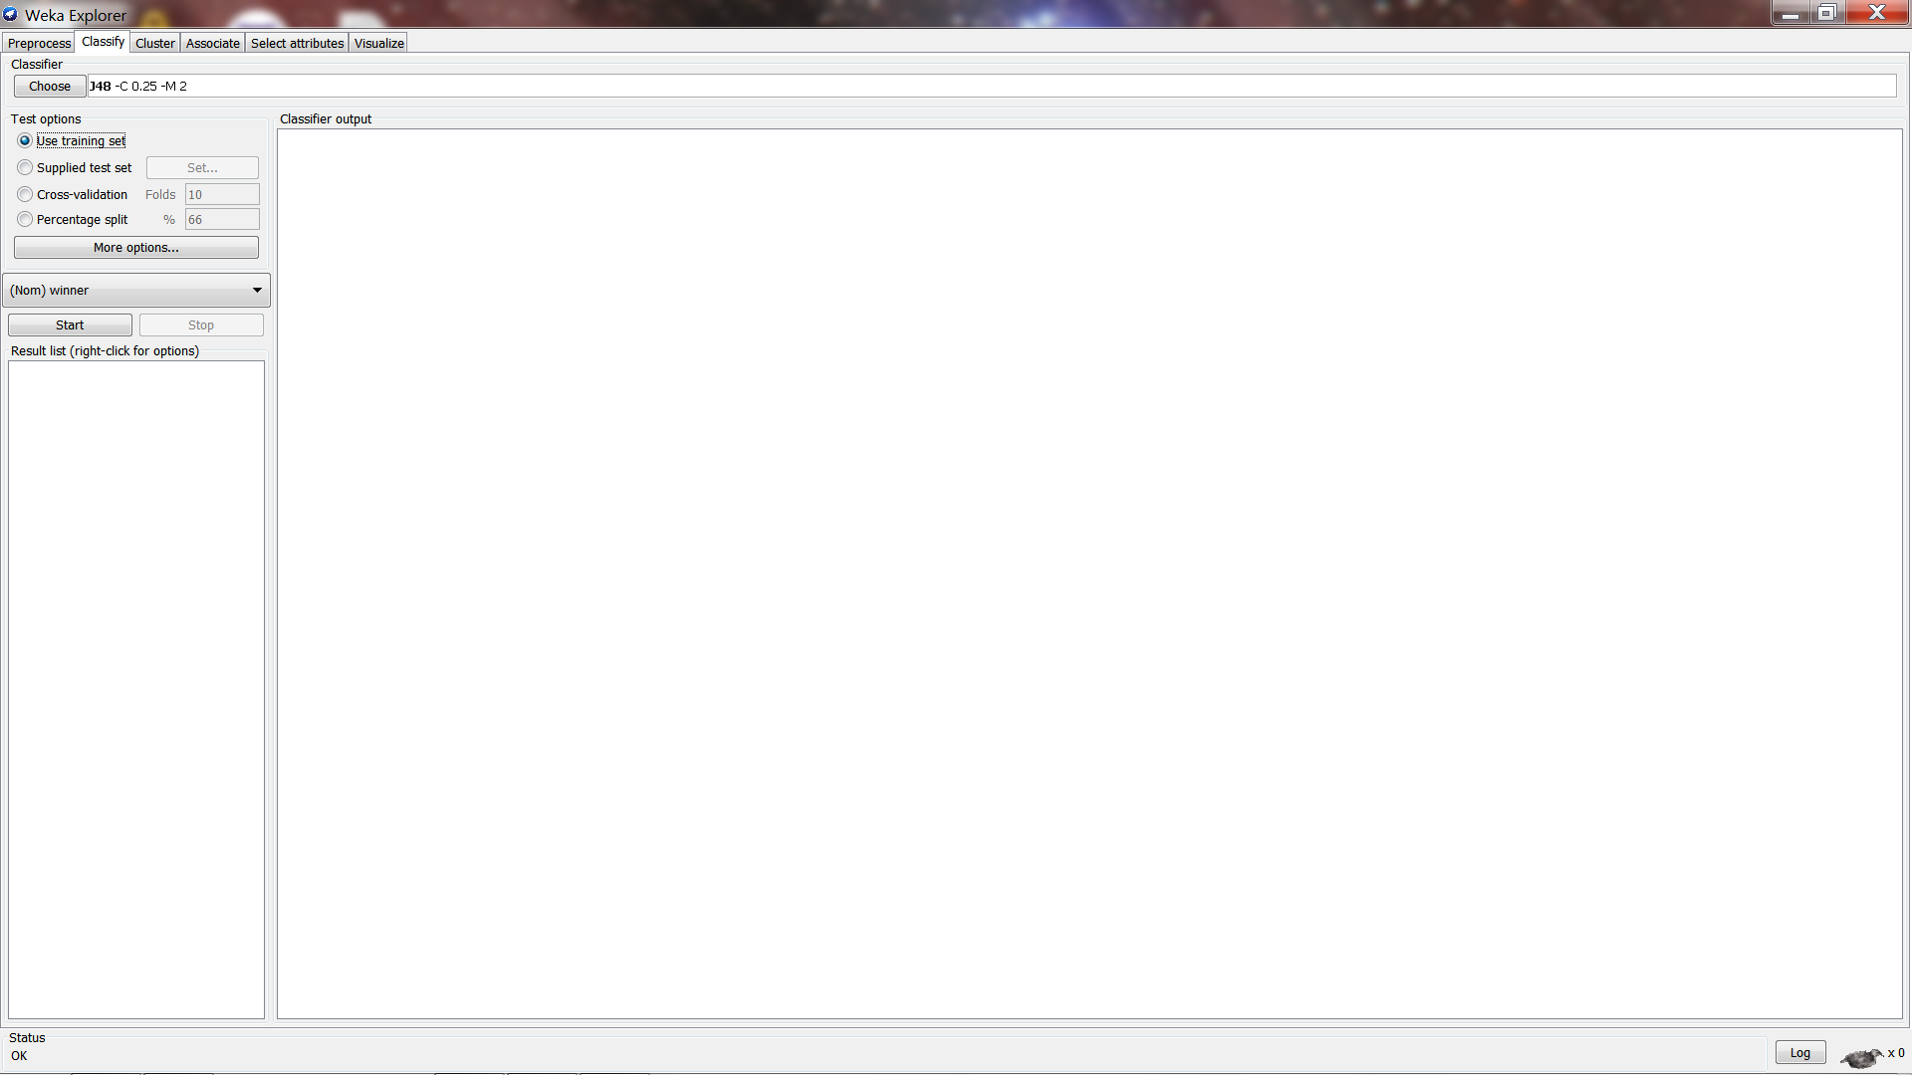

Weka created decision tree using the training set with no cross validation or hold out data.

