**Big Techs versus Big Banks: A Detailed Analysis**

**By**

# Introduction

## Background of the study

The battle or ongoing discussion of big banks versus big tech has been unending for many reasons that are obvious even to the blind. Big tech companies, with their vast resources, technological expertise, and extensive user data, have increasingly ventured into financial services. They offer digital payment solutions, peerto-peer lending platforms, robo-advisors, and other fintech innovations, challenging traditional banks’ market share and revenue streams. Both big techs and big banks are driving innovation and digital transformation within the financial industry. Big techs bring agile development practices, user-centric design, and advanced analytics capabilities, while big banks leverage their experience, regulatory compliance, and established customer bases. In the last decade, large technology companies, also known as big techs, have moved into the provision of financial services. Big techs have become substantial players in payments in several advanced and emerging market economies. Both big techs and big banks are driving innovation and digital transformation within the financial industry. Big techs bring agile development practices, user-centric design, and advanced analytics capabilities, while big banks leverage their experience, regulatory compliance, and established customer bases Selwyn et al.(2020). Big techs refers to large technology companies that dominate their respective sectors or have significant influence in the tech industry and broader economy. These companies are characterized by their substantial market capitalization, global reach, innovative products and services, and often by their disruptive impact on traditional industries. Some of the most well-known big tech companies include: Apple, Google,Amazon, Facebook. Big banks typically refer to large, multinational financial institutions that play a dominant role in the banking industry, often characterized by significant assets, market capitalization, and global reach. These institutions offer a wide range of financial services, including commercial banking, investment banking, asset management, and wealth management. Some of the most well-known big banks include: Bank of America Corporation, Wells Fargo and Company.

Apple Inc. Known for its iconic hardware products like the iPhone, iPad

## Purpose of the study

The purpose of this study is to comprehensively investigate the dynamic relationship between big technology companies (big techs) and big banks within the contemporary financial landscape. By examining the competitive forces, collaborative opportunities, regulatory challenges, and societal implications inherent in this complex interaction, the study seeks to shed light on the evolving dynamics shaping the future of financial services.

## Overview of Big techs and Big banks

Big techs are large technology companies known for their innovation, global reach, and influence across various sectors. They include companies like Apple, Google, Amazon, Facebook (Meta), and Microsoft. Big techs offer a wide range of digital products and services, including hardware, software, cloud computing, ecommerce, social media, and entertainment platforms Birch et al. (2022). They often leverage advanced technologies such as artificial intelligence, data analytics, and blockchain to drive growth, disrupt traditional industries, and shape consumer behavior. Big banks, on the other hand, are large financial institutions that play a central role in the banking and financial services industry Gianmaria et al. (2020). They provide a diverse array of banking services, including retail banking, commercial banking, investment banking, wealth management, and asset management. Examples of big banks include JPMorgan Chase, Bank of America, Wells Fargo, Citigroup, HSBC, and others. Big banks typically have extensive networks, global operations, and significant market share, making them key players in the global economy. Both sides have strengths and weaknesses. Big Tech excels at digital platforms and user data, while banks have experience in managing finances and regulations. Collaboration could see them leverage each other’s strengths for mutual benefit Bethlendi et al. (2022). Big tech agility and tech expertise could revolutionize financial services, offering faster, more accessible products and personalized experiences. This could benefit consumers but potentially leave traditional banks behind. Concerns exist about uneven regulations, potentially giving Big Tech an unfair advantage due to their existing user base and data. Calls for stricter regulations or even breaking up dominant tech companies are emerging Miditomo et al. (2023).

# Literature Review

The intersection of technology and finance has become increasingly prominent in recent years, with the emergence of big techs challenging the traditional dominance of big banks in the financial services industry. This literature review aims to provide a comprehensive overview of existing research and scholarly discourse on the competition, collaboration, and implications of big techs and big banks in the contemporary financial landscape. Researchers have extensively examined the competitive dynamics between big techs and big banks, highlighting the disruptive impact of big techs on traditional banking models. Studies by have shown how big techs leverage their technological prowess, data analytics capabilities, and customer-centric approach to gain market share in key areas such as payments, lending, and wealth management. The literature also explores the responses of big banks to the competitive threat posed by big techs, including digital transformation initiatives, strategic partnerships, and investments in fintech startups. Research by examines the strategies adopted by big banks to adapt to changing market dynamics and retain their competitive edge in the digital age. Scholars have investigated the potential for collaboration and partnerships between big techs and big banks to leverage complementary strengths and address shared challenges. Studies by Pascoli et al. (2022) explore innovative intercestions of cooperation in areas such as digital payments infrastructure, data sharing, and ecosystem integration. The literature highlights the emergence of strategic alliances, joint ventures, and open banking initiatives as avenues for big techs and big banks to collaborate and co-create value for customers. Research by Asem et al. (2010) examines the motivations, benefits, and challenges of collaboration in the evolving financial ecosystem using quantitative analysis. Regulatory considerations are a central theme in the literature on big techs versus big banks, with researchers analyzing the implications of big tech entry into financial services for market competition, consumer protection, and systemic risk. Studies by Asem et al . (2010) assess the regulatory frameworks governing big techs and big banks, highlighting gaps, inconsistencies, and potential areas for reform.

# Discussion/Analysis

## Historical Evolution

The roots of big techs can be traced back to the early 20th century with foundational inventions such as the transistor, integrated circuit, and microprocessor. These technological breakthroughs laid the groundwork for the development of computers, telecommunications, and digital electronics, setting the stage for the information age. The San Francisco Bay Area, particularly Silicon Valley, emerged as a hub of innovation in the 1960s and 1970s, fueled by the pioneering work of companies like Fairchild Semiconductor, Intel, and Hewlett-Packard Fernholz et al. (2016). These companies played a pivotal role in the commercialization of semiconductor technology and the birth of the modern computer industry. The 2000s witnessed the rise of social media platforms like Facebook, founded by Mark Zuckerberg, and Twitter, founded by Jack Dorsey, as well as the emergence of Web 2.0 technologies that enabled user-generated content, social networking, and collaborative online platforms. These developments transformed the way people interacted, communicated, and consumed information online Hendrikse et al (2022).

Banking traces its origins back to ancient civilizations such as Mesopotamia, Egypt, and Greece, where rudimentary forms of banking and financial intermediation emerged Fernholz et al. (2016). In the Middle Ages, Italian city-states like Venice and Florence became centers of banking activity, with prominent families like the Medici establishing early banking institutions. During the Renaissance and Early Modern Period, merchant banking emerged as a prominent form of banking, with merchant bankers providing financing, trade facilitation, and advisory services to merchants and governments. European banking centers like Amsterdam, London, and Geneva became hubs of merchant banking activity, financing international trade and colonial ventures Baron et al (2023). Survival of the Biggest: Large Banks and Financial Crises. In Survival of the Biggest: Large Banks and Financial Crises: Baron. The global financial crisis of 2008 exposed vulnerabilities in the banking sector and prompted regulatory reforms aimed at enhancing financial stability and consumer protection. Big banks faced increased scrutiny, regulatory compliance costs, and capital requirements, leading to restructuring, divestitures, and changes in business models. The era also witnessed the emergence of fintech startups challenging traditional banking practices and the rise of digital banking platforms offering innovative financial services.

Technology has enabled significant innovation in financial services, leading to the emergence of new products, platforms, and business models. From mobile banking apps and digital wallets to robo-advisors and peer-to-peer lending platforms, technology-driven innovations have transformed the way individuals and businesses manage their finances, access credit, and invest their savings. Established financial institutions are undergoing digital transformation to remain competitive in the digital age Shaw et al. (1988). Banks are investing in technology infrastructure, data analytics, and customer experience enhancements to deliver seamless, personalized services across digital channels. This includes offering online banking, mobile apps, chatbots, and digital advisory services to meet evolving customer expectations. Blockchain and distributed ledger technology (DLT) have the potential to revolutionize financial transactions, record-keeping, and trust mechanisms. These technologies enable secure, transparent, and tamper-resistant transactions without the need for intermediaries, potentially reducing costs and increasing efficiency in areas such as cross-border payments, trade finance, and securities settlement Cuiting et al. (2021). The intersection of technology and finance has enabled the collection, analysis, and utilization of vast amounts of data to inform decision-making, risk management, and customer insights. Big data analytics, machine learning, and predictive modeling are being used to assess creditworthiness, detect fraud, optimize investment strategies, and personalize financial services offerings. Emerging technologies such as artificial intelligence, quantum computing, and Internet of Things (IoT) are poised to further reshape the intersection of technology and finance in the future. These technologies have the potential to unlock new possibilities in areas such as predictive analytics, autonomous finance, smart contracts, and decentralized finance, driving further innovation and disruption in the financial industry Pascoli et al (2022).

## Financial Inclusion and Access

Financial inclusion refers to the accessibility and availability of financial services to all segments of society, particularly those who are underserved or excluded from the traditional banking system. This is crucial for promoting economic development, reducing poverty, and fostering social inclusion. Big tech companies have emerged as key players in advancing financial inclusion through their innovative digital platforms and services. By leveraging technology and data analytics, big techs have been able to reach underserved populations, provide them with access to financial products and services, and empower them to participate in the formal economy Muralidhar et al (2019). The stock chart of amazon below makes it obvious that big techs like amazon and Tesla, often experiences upward trends in terms of growth over the years.

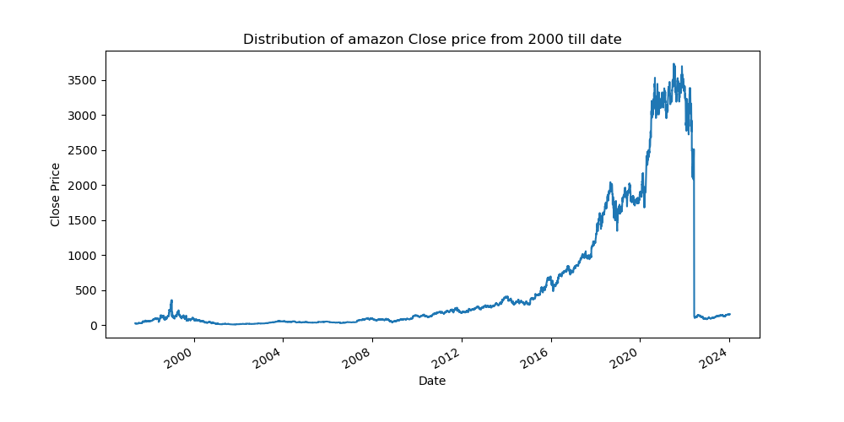

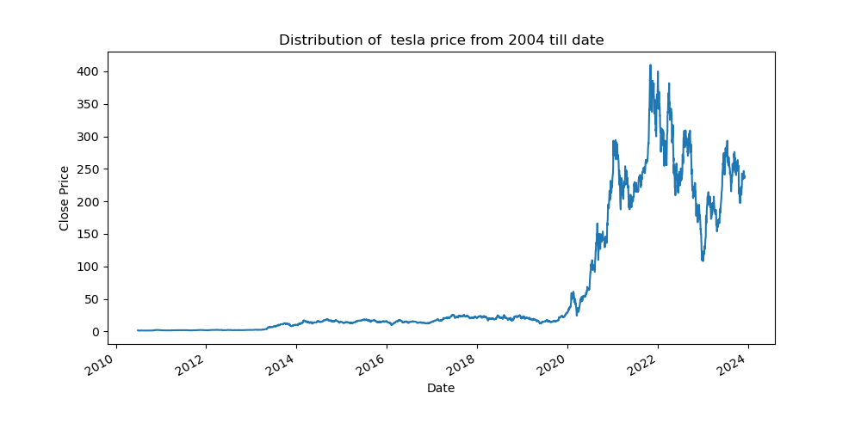

* Digital payments platforms such as PayPal, Square, and Alipay have facili-tated convenient and affordable money transfers, enabling individuals without access to traditional banking services to send and receive funds electronically.
* Big techs are also exploring initiatives such as microfinance, digital lending,and financial education programs to further promote financial inclusion and empower marginalized communities to build assets and improve their livelihoods.

Traditional banks have also recognized the importance of financial inclusion and have implemented various initiatives to expand access to banking services and promote financial literacy among underserved populations.

* Offering microfinance and small-scale lending programs to support entrepreneur-ship and economic development in underserved areas.
* Partnering with fintech companies, community organizations, and government agencies to develop innovative solutions for addressing the specific financial needs of underserved populations.
* Investing in financial education and literacy programs to empower individuals with the knowledge and skills needed to make informed financial decisions and improve their financial well-being Birkenmaier at al. (2019).

## Economic Impact

Big techs and big banks play a significant role in driving economic growth and contributing to gross domestic product (GDP) in their respective sectors and the broader economy. Big techs contribute to GDP through innovation, productivity gains, and the creation of new industries and business models. They invest in research and development, infrastructure, and human capital, leading to the development of cutting-edge technologies, job creation, and increased productivity across sectors Siegfried at al. (2007). Big banks contribute to GDP by facilitating capital formation, financing economic activities, and providing essential financial services to individuals, businesses, and governments. They mobilize savings, allocate capital efficiently, and facilitate investments in productive assets, infrastructure, and innovation, thereby stimulating economic growth and development. The size, interconnectedness, and complexity of big techs and big banks can pose systemic risks to the financial system and broader economy Hammond at al (2010). Big techs may pose systemic risks through their extensive data holdings, network effects, and market dominance, which could lead to concentration of economic power, data privacy breaches, and cybersecurity vulnerabilities. Big banks are traditionally considered systemically important institutions (SIFIs) due to their size, interconnectedness, and role in the financial system. Big banks are traditionally considered systemically important institutions (SIFIs) due to their size, interconnectedness, and role in the financial system. They can pose systemic risks through their exposure to credit, market, liquidity, and operational risks, as well as through interconnectedness with other financial institutions and counterparties. Regulators and policymakers closely monitor big techs and big banks to mitigate systemic risks and ensure financial stability. This includes implementing prudential regulations, conducting stress tests, and enhancing supervision and oversight to safeguard the resilience and stability of the financial system.

## Market Dynamics

Big techs and big banks compete in various segments of the financial services market, including payments, lending, wealth management, and insurance. They leverage their respective strengths in technology, customer relationships, and brand recognition to gain market share and differentiate their offerings. Competition between big techs and big banks has intensified with the entry of big techs into financial services, challenging traditional banking models and disrupting established industry dynamics. Big techs often focus on providing seamless digital experiences, leveraging data analytics, and offering innovative products and services to attract customers Michael at al (2003). Despite competition, big techs and big banks also engage in strategic collaborations and partnerships to capitalize on synergies and address common challenges. Collaborations may involve integrating banking services into digital platforms, co-developing new products, or leveraging data-sharing agreements to enhance customer experiences and drive growth. Market share trends in the financial services industry reflect shifting consumer preferences, technological advancements, and regulatory developments. Big techs have made significant inroads into traditional banking domains, particularly in areas such as digital payments, where platforms like Apple Pay, Google Pay, and PayPal have gained substantial market share Asem et al. (2010). Big banks continue to dominate certain segments of the financial services market, particularly in areas requiring extensive regulatory compliance, risk management, and capital-intensive operations. However, their market share is increasingly being challenged by nimble fintech startups and innovative offerings from big techs. Fintech startups, while still relatively small in terms of market share compared to big banks and big techs, are rapidly gaining traction in niche markets and segments. They offer specialized solutions, targeted at addressing specific pain points or underserved customer needs, and often leverage technology and datadriven approaches to compete effectively against incumbents. Fintech startups play a disruptive role in the financial services industry by introducing innovative business models, technologies, and customer experiences. They offer solutions ranging from peer-to-peer lending, robo-advisory services, and digital banking to blockchain-based payments and decentralized finance (DeFi). Fintech startups often target underserved or overlooked market segments, such as small and medium-sized enterprises (SMEs), millennials, and unbanked populations, by offering more accessible, affordable, and user-friendly financial products and services. While fintech startups pose a competitive threat to traditional incumbents, they also present collaboration opportunities. Many big banks and big techs partner with fintech startups to access new technologies, tap into innovative ideas, and expand their service offerings. Collaborations may involve investment, acquisition, or strategic alliances to capitalize on fintech innovation and enhance competitiveness Asem at al (2010).

## Future Trends and Scenarios

Looking ahead, several future trends and scenarios are likely to shape the market dynamics of the financial services industry, driven by technological innovations, regulatory trends, and evolving consumer preferences. Big tech companies are expected to expand their presence in financial services, leveraging their massive user bases, data analytics capabilities, and technological prowess to offer a wide range of innovative financial products and services. This could lead to increased competition with traditional banks and fintech startups, as well as further consolidation within the industry. The integration of financial services into non-financial products and platforms, known as embedded finance, is expected to accelerate Kochergin et al. (2022). This trend could lead to new revenue streams for big techs, as they embed financial functionalities into their existing products and ecosystems, blurring the lines between banking, commerce, and technology. The fintech sector is likely to undergo consolidation as larger players acquire smaller startups to expand their capabilities and market reach. This consolidation could result in the emergence of fewer, more dominant players, capable of competing with big techs and traditional banks on a global scale. Regulators are expected to closely monitor the activities of big techs in financial services, imposing stricter regulations to address concerns related to data privacy, consumer protection, and systemic risk. Regulatory frameworks may need to evolve to keep pace with technological advancements and ensure a level playing field for all market participants Omarini et al (2020). AI and machine learning technologies are expected to play a transformative role in financial services, enabling personalized customer experiences, more accurate risk assessment, and automation of routine tasks. However, concerns about algorithmic bias, data privacy, and ethical use of AI will need to be addressed. Blockchain and DLT have the potential to streamline financial transactions, reduce costs, and enhance transparency and security. These technologies could revolutionize areas such as cross-border payments, trade finance, and securities settlement, but regulatory challenges and scalability issues remain. Advances in digital identity verification and biometric authentication are likely to improve security and reduce fraud in financial transactions. Digital identity solutions could facilitate financial inclusion by providing individuals with secure and portable identities, enabling access to banking services and credit Mehdiabadi et al (2020).

# Conclusions

The intersection of big techs and big banks represents a pivotal juncture in the evolution of the financial services industry, characterized by dynamic competition, collaboration, and innovation. Throughout this research, we have explored the multifaceted relationship between these two sectors, examining their respective roles, contributions, and implications for the economy, society, and regulatory landscape.

Big techs, with their unparalleled technological expertise, global reach, and customercentric approach, have emerged as formidable competitors to traditional banking institutions. Leveraging advanced technologies such as artificial intelligence, blockchain, and cloud computing, big techs have disrupted traditional banking models, offering innovative financial products and services that challenge established industry norms and reshape consumer behaviors.

Simultaneously, big banks, with their deep domain expertise, regulatory compliance, and extensive networks, continue to play a vital role in the financial ecosystem. Despite facing pressure from big techs and fintech startups, big banks have demonstrated resilience and adaptability, embracing digital transformation, enhancing customer experiences, and exploring strategic collaborations to remain competitive in the digital age. The rise of fintech startups further complicates the competitive landscape, introducing disruptive innovations and agile business models that challenge incumbents and drive industry-wide transformation. Fintech startups offer specialized solutions, targeted at addressing specific customer needs or pain points, and often collaborate with big techs and big banks to leverage their resources, expertise, and distribution channels. Looking ahead, the future of big techs and big banks will be shaped by a combination of technological advancements, regulatory developments, and shifting consumer preferences. Collaboration between big techs, big banks, and fintech startups will be essential for driving innovation, expanding access to financial services, and addressing complex societal challenges such as financial inclusion, data privacy, and systemic risk. The convergence of big techs and big banks represents both opportunities and challenges for the financial services industry. By embracing technological innovation, fostering collaboration, and prioritizing consumer welfare, stakeholders can harness the transformative potential of this intersection to create a more inclusive, resilient, and sustainable financial ecosystem for the benefit of all.

# References

Arvanitakis et al.(2019)Arvanitakis, Z., Shah, R., C., Bennett, & D. A.]

Arvanitakis, Z., Shah, R. C., Bennett, & D. A. (2019). Diagnosis and management of dementia. *Jama*, *332*(16),1589-1599

Hammond at al.(2010)Hammond, R. A., Levine, & R.] Hammond, R. A., Levine, & R (2010). The economic impact of obesity in the United States. Diabetes, metabolic syndrome and obesity: targets and therapy, 285-295.

Muralidha at al.(2019)Muralidha, S. H., Bossen, C., O’neill, & J.] Muralidha, S. H., Bossen, C., O’neill, & J (2019) Rethinking financial inclusion: From access to autonomy. Computer Supported Cooperative Work (CSCW), *28*,511-547.

Pascoli et al.(2022)Pascoli, D. U., Aui, A., Frank, J., Therasme, O., Dixon, K., Gustafson, R., Wright, &

Pascoli, D. U., Aui, A., Frank, J., Therasme, O., Dixon, K., Gustafson, R.,

Wright, & M (2022) The US bioeconomy at the intersection of technology, policy, and education. Biofuels, bioproducts and biorefining, *16(1)*,9-26.

Asem et al.(2010)Asem, E., Tian, G. & Y. ] Asem, E., Tian, G. & Y. (2010). Market dynamics and momentum profits. Journal of Financial and Quantitative Analysis, *45*(6),1549-1562.

Baron et al.(2023)Baron, M., Schularick, M., Zimmermann, & K.] Baron, M., Schularick, M.,Zimmermann, & K. (2023). Survival of the Biggest: Large

Banks and Financial Crises. In Survival of the Biggest: Large Banks and Financial Crises: Baron, Matthew— uSchularick, Moritz— uZimmermann, Kaspar. [Sl]: SSRN.

Muditomo et al.(2023)Muditomo,A., Setyawati, & N. ] Muditomo, A.,Setyawati, & N. (2023). REDEFINING THE MARKET POSITION OF BANKS IN THE AGE OF FINTECH AND BIG TECH. In Perbanas International Seminar on Economics, Business, Management, Accounting and IT (PROFICIENT) (Vol. 1, No. 1, pp. 181-188).

Bethlendi at al.(2022)Bethlendi, A., Szocs,&˝ A.] Bethlendi,´ A., Szocs,˝ & A.´ (2022). How the Fintech ecosystem changes with the entry of Big Tech companies. Investment Management and Financial Innovations, *19*(3), 38-48.

Cuiting at al.(2021)Cuiting, H. U. A. N. G., Fan, Z. H. A. N. G., Xiaochao, S. U. N.,Yang, B. I. A. Cuiting, H. U. A. N. G., Fan, Z. H. A. N. G., Xiaochao, S. U. N.,Yang, B. I. A. & N. (2021). A survey of private set intersection technology and finance practice. Information and Communications Technology and Policy, *47*(6), 50.

Birch et al.(2022)Birch, K.,Bronson, &K] Birch, K., Bronson, & K. (2022). Big tech. Science as Culture, *31*(1), 1-14.

Michael et al.(2003)Michael, F., Johnson, & M. D. ] Michael, F.,Johnson, & M. D. (2003). Financial market dynamics. Physica A: Statistical Mechanics and its Applications, *320*, 525-534.

Selwyn et al.(2020)Selwyn, N., Hillman, T., Eynon, R., Ferreira, G., Knox, J., Macgilchrist, F., Sa

Selwyn, N., Hillman, T., Eynon, R., Ferreira, G., Knox, J., Macgilchrist, F.,Sancho-Gil, & J. M. (2020). What’s next for Ed-Tech? Critical hopes and concerns for the 2020s. Learning, Media and Technology, *45*(1), 1-6. [Kochergin et al.(2022)Kochergin,D. ., Sheshukova, & E. S. ] Kochergin, D. .,Sheshukova, & E. S. (2022). Bigtech-Companies Ecosystems Prospects in the Payment Sector. FINANCE: THEORY AND PRACTICE, 32.