1.GET

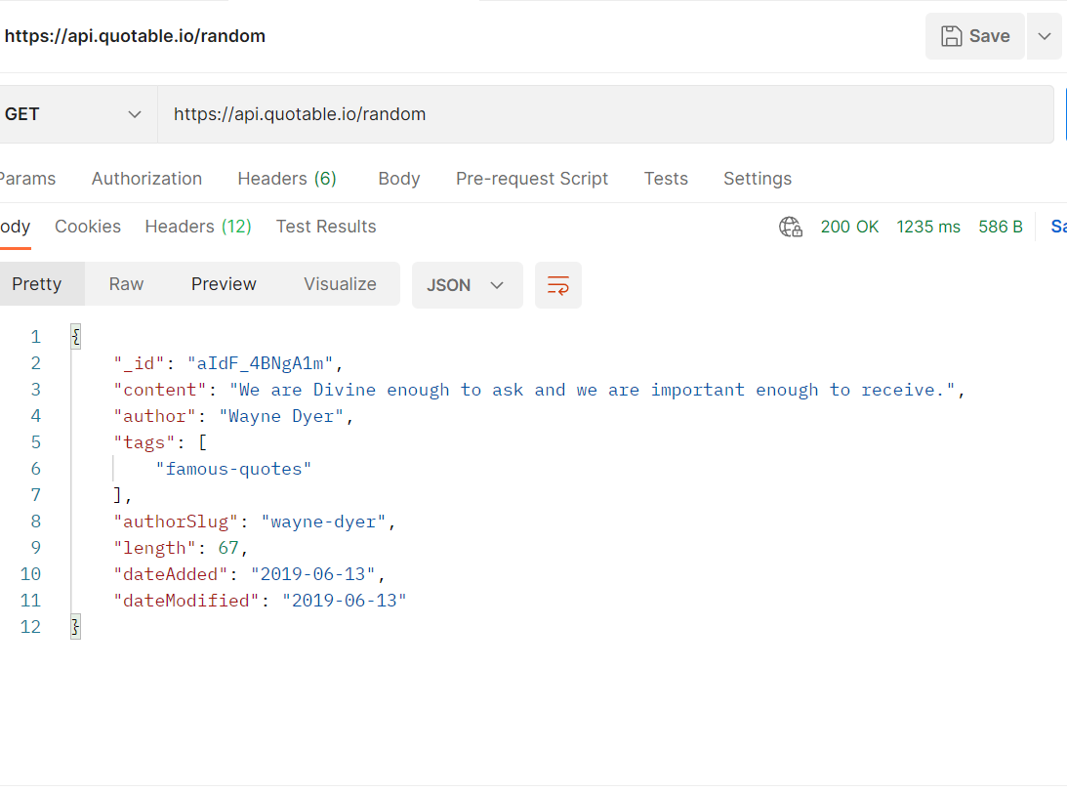

2.GET

3.GET

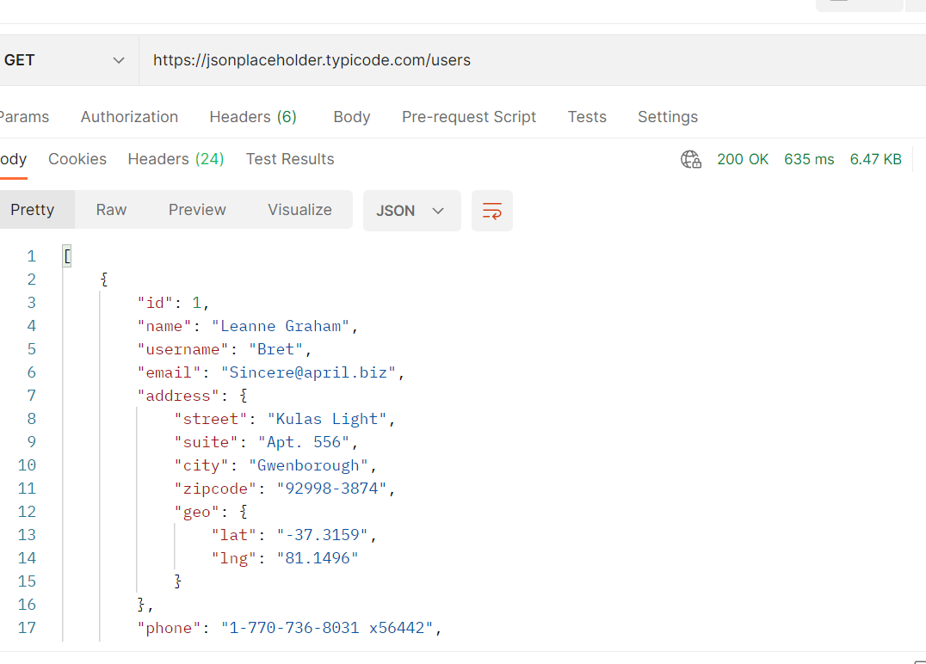

4.POST

5.POST

