**PROJECT TITLE: INTERACTIVE WEBMAP USING PYTHON**

**CASE STUDY: CORN YIELD PRODUCTION IN THE BELT OF USA.**

Agriculture is the foundation of civilization --- Allan Savory

Hello GSSA TUK, I’m George Odero BTech. Geo student at Technical University of Kenya. I’m currently in year 3.4. I’m writing this proposal to book a room so that I can showcase my python skills in mapping corn yield production in the Belts of United states of Georgia. We know that if we invest more in Agriculture, we will reduce hunger thus, we will have enough food in store to feed high population in the world that is targeted by 2050. This will help in addressing sustainable goal number two; **hunger.**

The main objective of this project is to Map Spatiotemporal trend yield of corn in the United States using open-source python packages to build interactive webmaps and publishing it in a beautiful format. This will enable us to explore how the corn yield in the United States increased over the past decade. Corn yield is the final output after harvesting maize crops from the field. Below is the sample of the project: 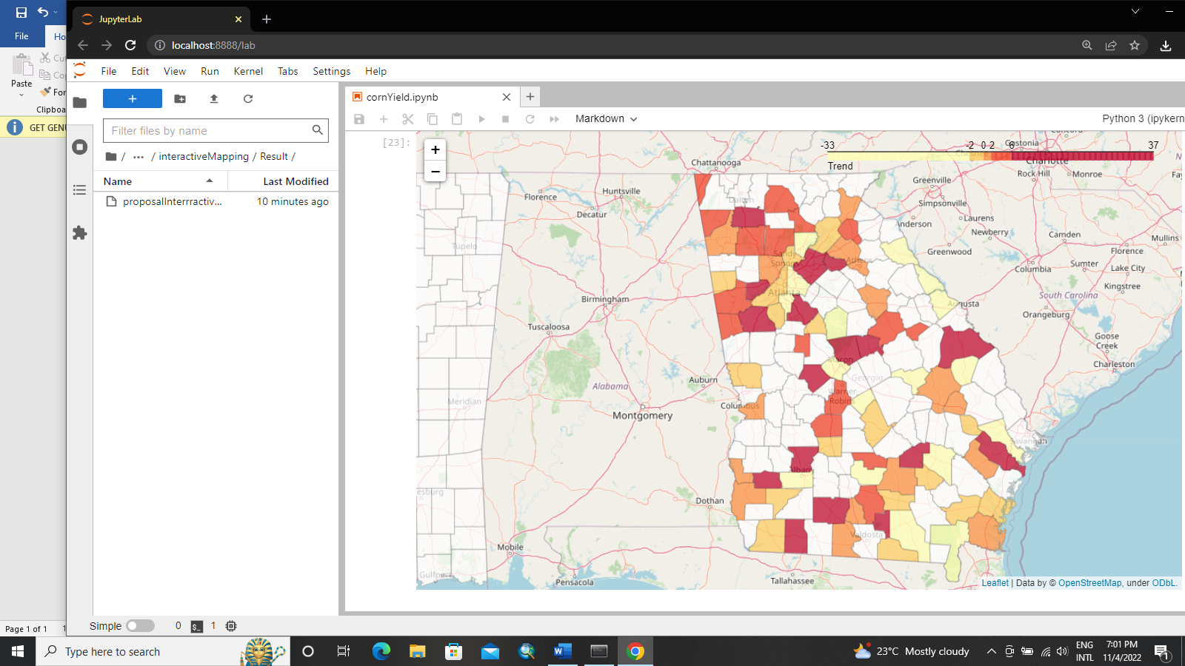fig: **Choropleth Map of Corn Yield in Georgia state**

Best regards, George Odero

Geospatial Data Scientist.