**Part A**

**I**

**A**

**B**

**C**

**D**

**E**

**F**

**G**

**Objective** : Name and decribe each component

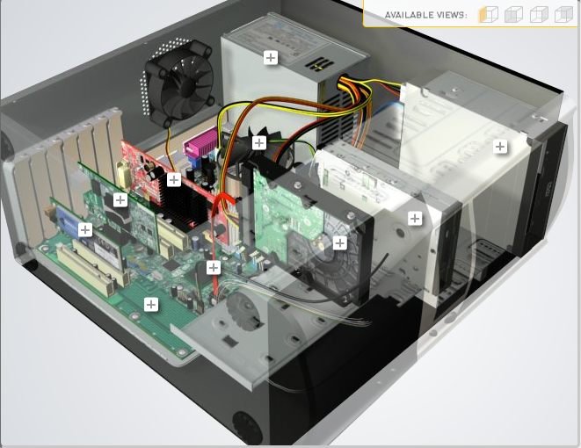

**H**

|  |  |  |
| --- | --- | --- |
| Download [**http://tinyurl.com/CW208-CAG-SIM**](http://tinyurl.com/CW208-CAG-SIM) PC Build Simulator.  Go through steps of building a PC, as you complete the simulation find and describe in detail components A to I. To run simulator first install <http://www.swffileplayer.com/> and open ***RootMovie.swf*** using SWF player. Alternatively install [Macromedia Flashplayer](https://fpdownload.macromedia.com/pub/flashplayer/updaters/32/flashplayer_32_sa.exe) . Ideally use a simulator as listed in class. | | |
| Label | Name each component | Description |
| A | Wireless NIC | Enables use of wifi for system |
| B | GPU | System graphics processor |
| C | CPU | System Central processing unit and cooling solution |
| D | PSU | System power supply unit |
| E | CDD | Read/write to CD |
| F | FDD | Read/Write to FD |
| G | HDD | System mass storage |
| H | SATA Cable | Cable for HDD |
| I | Motherboard | Motherboard |

**Part B**

**Objective**

Compare a pre-assembled system and the components that could be assembled to build a comparable system. After completing this practical, you should be able to:

1. Identify the components of a pre-assembled system
2. Locate prices for components needed to assemble a comparable system
3. Compare the cost of a pre-assembled system and a self-assembled system.

If you can’t find exact match for components, find the closest possible substitute. Use the Internet and available computer-related publications as your sources for information. Examples of websites for computer parts [www.komplett.ie](http://www.komplett.ie), [www.dell.ie](http://www.dell.ie), [www.custompc.ie](http://www.custompc.ie) [www.amazon.de](http://www.amazon.de)

MAKE SURE TO INCLUDE VALID LINKS TO WEB REFERENCES

|  |  |  |
| --- | --- | --- |
|  | **Pre-Assembled Computer Package** | **Computer Package**  **Components** |
| **CPU** | * AMD Ryzen 3 3250U | AMD Ryzen 3 1200 |
| **Storage / Memory** | | |
| |  | | --- | |  | | RAM | | Hard Drive | |  | | |  | | --- | |  | | 8 GB 2400 MHz DDR4 | |  | |  |   256 GB SSD | Kingston ValueRAM 8 GB - PC4-21300 – DIMM  WD Blue SSD - 250 GB |
| **Input/Output** | | |
| |  | | --- | | Keyboard | | Pointing Device | | Monitor | | Speakers | | Network Adapter | |  | |  | | None  None  None  None  Dual-band WiFi (802.11a/b/g/n/ac) + Bluetooth 5.0 | None  None  None  None  ASUS PCE-AX3000(Wireless up to 3000 Mbit/s  Dual-band 2,4 GHz / 5 GHz  Bluetooth 5.0) |
| **Bundled Software**  (Including Operating System) | Windows 10 Home | Microsoft Windows 10 Home - English - DVD |
| **Total Cost** | 349 | 405.83 |

**Part C**

**Objective**

You have been asked by a family friend to assist them with a computer purchase. They’re unfamiliar with technology and the terms used and have presented you with two alternatives machine choices. They would like to be able to write word documents, surf internet and play Minecraft © Mojang and Half-Life © Valve Software. They are considering playing Fortnight but are not sure yet, as it depends on machine cost and if they can extract some money from their Bitcoin wallet.

Compare Personal Computer Option A and B in relation to each of the side headings and recommend a system and any alterations.

|  |  |  |
| --- | --- | --- |
|  | Personal Computer  Option A | Personal Computer  Option B |
| CPU | 2.2 GHz Intel Celeron 450 | 3.2 GHz Intel Core i5 |
| Memory |  |  |
| |  | | --- | | Cache | | RAM | | Hard Drive | | CD-ROM/DVD | | |  | | --- | | 512 KB Cache | | 4 GB RAM | | 320 GB Hard Drive | | DVD+/-RW drive | | |  | | --- | | 4 MB Cache | | 8 GB RAM | | 1 TB Hard Drive | | DVD+/-RW drive | |
| Input/Output |  |  |
| |  | | --- | | Keyboard | | Pointing Device | | Screen | | Speakers | | Network Adapter | | |  | | --- | | USB multifunction keyboard | | USB optical mouse | | 20’’ HD flatscreen monitor | | Multimedia Speaker System | | Integrated 10/100/1000 Ethernet | | |  | | --- | | wireless multifunction keyboard | | wireless optical mouse | | 25’’ HD flatscreen monitor | | Dolby Surround Sound Speakers | | Integrated 10/100/1000 Ethernet | |

|  |
| --- |
| **Recommendations** |
| For your required use I would recommend Option B to you, this option gives you enough memory to play Minecraft and half life the cpu will allow you speedy operation on your PC which will help you with writing word docs and internet surfing the wireless options for keyboard and mouse will also allow more comfort in use the extra HDD space will afford you plenty of leeway should you go on a download spree. |

**Your Recommend System**

|  |  |
| --- | --- |
|  | Personal Computer  Recommendation |
| **CPU** | Ryzen 5 1600 |
| **Memory** | |
| |  | | --- | |  | | RAM | | Hard Drive | | SSD Drive | | |  | | --- | | 16 gb 3600 | | 1tb WD blue | | 256 gb wd bluee | |  | |
| **Input/Output** | |
| |  | | --- | | Keyboard | | Pointing Device | | Screen | | Speakers | | Network Adapter  GPU | | |  | | --- | | Wireless multi function keyboard  Wireless optical mouse | | 25’’ HD flatscreen monitor | | Dolby Surround Sound Speakers | | Integrated 10/100/1000 Ethernet  Gtx 1050 ti | |  | |

Hand up this practical report at the end of session and ensure it has been checked

|  |  |  |  |
| --- | --- | --- | --- |
| **Student Name** | **Odhran butler** | **Student Number** | **C00263565** |
| **Date** | **27/10/2021** | **Checked** |  |
| **Group** | **A** |  |  |