CAPSTONE PROJECT DOCUMENTATION

vsensor-hub
A Virtual Interrupt-Driven Sensor Device: Linux Kernel Driver and C++ User-Space Stack

Submitted By – Odi Sambit

Languages: C (kernel module), C++17 (user space) | Platform: Linux

Table of Contents
- Abstract
- Introduction and Objectives
- Compliance with Capstone Requirements
- System Architecture
- Kernel Driver Design
- Device Interface Specification
- Synchronization Design
- User-Space Components
- Repository Structure
- Build, Load and Run
- Testing
- Results
- Limitations and Future Work
- Conclusion
- References

Abstract
This project implements a virtual sensor device as a Linux character device driver written in C, together with a layered C++ software stack that uses it. Because no physical hardware is required, the device is simulated: a high-resolution kernel timer plays the role of a hardware interrupt, periodically generating temperature samples that are stored in a kernel ring buffer. User programs retrieve the samples through the standard file interface (/dev/vsensor0) using blocking and non-blocking reads, poll(), and ioctl() control commands. A C++ library, a command-line monitor and a multithreaded logger daemon complete the system. The project demonstrates core device-driver concepts and hardware/software architecture concepts: the user/kernel boundary, interrupt handling, producer-consumer buffering, register-style configuration, and synchronization in atomic and process contexts.

Introduction and Objectives
Device drivers are the layer through which an operating system communicates with hardware. Understanding how a driver receives asynchronous events, buffers data, synchronizes with user programs and exposes a controlled interface is central to systems and computer-architecture education. Since physical hardware is not always available, this project simulates a periodic sensor so that the same driver mechanisms can be implemented, tested and demonstrated on any Linux machine.

Objectives
- Implement a Linux character device driver in C using the standard kernel APIs.
- Simulate an interrupt-driven hardware source and handle it in atomic context.
- Provide data to user space through blocking, non-blocking and polled I/O.
- Expose a register-like control interface through ioctl and a statistics interface through /proc.
- Apply correct synchronization (spinlock and mutex) and document the reasoning.
- Build a layered C++ user-space stack: library, CLI and multithreaded daemon.
- Publish a well-structured, documented project on GitHub.

Compliance with Capstone Requirements

Requirement | How this project satisfies it
1. C/C++ only | Kernel module in C; library, CLI and daemon in C++17. No other language is used (build scripts are shell and Makefiles only).
2. Linux OS only | Uses kbuild, kernel headers, insmod/rmmod; developed and run on Ubuntu Linux.
3. Linux device driver concepts | Character device registration (alloc_chrdev_region, cdev, class_create, device_create), file_operations, ioctl, copy_to_user, wait queues, poll, fasync/SIGIO, hrtimer, spinlock, mutex, procfs, module parameters.
4. Software / hardware architecture | Simulated register map, interrupt source, ring buffer (FIFO), layered design across the user/kernel boundary, producer-consumer threading.
5. GitHub submission | Structured repository with source, README.md, documentation, scripts and tests (Section 9).

System Architecture
The system has three layers. The kernel layer contains the driver and the simulated hardware. The library layer wraps the system-call interface in a safe C++ class. The application layer contains the user-facing programs.
+--------------------+ + +
| monitor (CLI) | | logger_daemon |
| start/stop/read... | | reader thread -> queue -> logger thread |
+---------+----------+ +---------------------+ +
| |
+---------- libsensor.hpp +
(RAII class: open/ioctl/poll/read)
|
================ /dev/vsensor0 ================= user/kernel boundary
|
+-------------------------- vsensor.ko +
| | file_operations: open | release | read | poll | ioctl | fasync | |
| |  | |
| | hrtimer callback ("interrupt") | |
| | | generate sample (timestamp, value, alert flag) | |
| | v | |
| | ring buffer [256 entries] --> wait queue wake-up --> readers | |
| | | | |
| | +--> threshold crossed --> kill_fasync(SIGIO) | |
| | /proc/vsensor : statistics | |
+ +

Data flow
- The hrtimer expires periodically (default 100 ms) and its callback runs in atomic context.
- The callback creates a sample, takes the spinlock, and pushes the sample into the ring buffer; if the buffer is full the sample is dropped and counted.
- The callback wakes sleeping readers and, if the value exceeds the threshold, signals processes registered for asynchronous notification.
- A user process sleeps in read() or poll() until data is available, then receives whole samples.

Kernel Driver Design

Device registration
At module load, the driver allocates a device number (alloc_chrdev_region), initializes and adds a cdev, creates a device class and node (so /dev/vsensor0 appears automatically through udev), and creates /proc/vsensor. Error paths unwind in reverse order. The module also supports kernel-version differences (for example class_create and hrtimer_setup signature changes) using LINUX_VERSION_CODE guards.

Simulated hardware
The sensor is a software model. A pseudo-random generator (xorshift) produces temperature values between 15.0 and 35.0 degrees C, stored in milli-degrees as a 32-bit signed integer. Each sample carries a nanosecond timestamp and an alert flag.

Ring buffer
A fixed array of 256 samples is managed with head (producer index) and tail (consumer index). One slot is kept empty to distinguish full from empty, giving 255 usable entries. The buffer is empty when head equals

tail. When full, the newest sample is dropped and the dropped counter is incremented, so overflow is visible rather than silent.

Blocking, non-blocking and polled reads
read() returns an integral number of samples. If the buffer is empty it sleeps on a wait queue (wait_event_interruptible), returns -EAGAIN if the file was opened with O_NONBLOCK, and returns
-ERESTARTSYS if interrupted by a signal. poll() registers the wait queue and reports readability when samples are present, enabling select/poll/epoll use.

Asynchronous notification
A process may enable O_ASYNC on the descriptor. When a sample exceeds the configured threshold, the driver calls kill_fasync and the process receives SIGIO, modelling a threshold interrupt line.

Device Interface Specification

Shared data structures (kernel/vsensor.h)

Structure | Fields | Description
struct vs_sample | ts_ns (u64), value (s32), alert (u32) | One sample: monotonic timestamp in ns, temperature in milli-degrees C, 1 if above threshold
struct vs_stats | produced, dropped, consumed, alerts (all u64) | Cumulative counters, read atomically under the spinlock

Control commands (ioctl, magic 'v')

Command | Argument | Behaviour
VS_IOC_START | none | Start the hrtimer (idempotent)
VS_IOC_STOP | none | Cancel the timer
VS_IOC_SET_RATE | u32 period in ms (1-60000) | Set sampling period; takes effect at the next start. Out-of-range returns -EINVAL
VS_IOC_SET_THRE SH | s32 milli-degrees C | Set alert threshold (default 30000 = 30.0 C)
VS_IOC_GET_STAT S | struct vs_stats (out) | Copy counters to user space
VS_IOC_CLEAR | none | Discard buffered samples

Unknown commands return -ENOTTY. User pointers are accessed only through get_user and
copy_to_user, and faults return -EFAULT.

Logical register map

Logical register | Interface | Meaning
CTRL | START / STOP ioctl | Enable or disable the sensor clock
SAMPLE_RATE | SET_RATE ioctl, module parameter period_ms | Sampling period

Logical register | Interface | Meaning
THRESHOLD | SET_THRESH ioctl | Alert level
STATUS | GET_STATS ioctl, /proc/vsensor | Counters and current configuration
DATA FIFO | read() on /dev/vsensor0 | Stream of struct vs_sample

procfs output (/proc/vsensor)
Reports: running state, period (ms), threshold, and the produced, consumed, dropped and alert counters.

Synchronization Design

Resource | Mechanism | Reason
Ring buffer indices, statistics, threshold | Spinlock with irqsave (spin_lock_irqsave) | Accessed from the timer callback, which runs in atomic context and cannot sleep, and from process context. A mutex would be illegal in the callback; disabling local interrupts prevents deadlock if the timer fires while a process holds the lock.
Configuration changes (ioctl) | Mutex (cfg_lock) | Process context only; serializes start/stop/rate changes. Safe to hold while calling functions that may sleep.
Waiting for data | Wait queue | Readers sleep instead of busy-waiting; the callback wakes them with wake_up_interruptible.
Stopping the timer | hrtimer_cancel under the mutex only | hrtimer_cancel may wait for a running callback, so it must never be called while holding the spinlock the callback needs.
The copy to user space happens after the spinlock is released, because copy_to_user can fault and sleep. The sample is first copied to a local variable under the lock, then to the user buffer.

User-Space Components

libsensor.hpp
A header-only C++17 class Sensor using RAII: the constructor opens the device and throws std::runtime_error on failure; the destructor closes it; copying is disabled. Methods wrap each ioctl (start, stop, clear, setRateMs, setThreshold, stats), and read(max, timeout_ms) combines poll() with read() to return a vector of samples or an empty vector on timeout.

monitor (command-line tool)
Provides the commands start, stop, clear, rate, thresh, stats, read N and watch. It converts raw samples into readable output (timestamp in seconds, temperature in degrees C, ALERT marker).

  - logger_daemon

Demonstrates the producer-consumer pattern with two threads. The reader thread polls the device and appends samples to a shared queue; the logger thread waits on a condition variable and writes batches to a CSV file (timestamp_s,temp_c,alert). Separating the threads prevents slow disk I/O from delaying reads and overflowing the kernel buffer. SIGINT/SIGTERM trigger a clean shutdown that drains the queue, stops the sensor and prints final statistics.

Repository Structure
vsensor-hub/
README.md Makefile .gitignore
kernel/ vsensor.c vsensor.h Makefile
lib/ libsensor.hpp
app/ monitor.cpp logger_daemon.cpp
scripts/ load_module.sh unload_module.sh
tests/ run_tests.sh
docs/ architecture.md register_map.md

Build, Load and Run
Prerequisites: Linux with kernel headers, gcc, g++, make (Ubuntu: sudo apt install build-essential linux-headers-$(uname -r)). On Windows hosts, run Ubuntu in a virtual machine.
make # build module and user programs
./scripts/load_module.sh # insmod, set permissions on /dev/vsensor0
./monitor start
./monitor read 10 cat /proc/vsensor
./logger_daemon out.csv # Ctrl+C to stop
./scripts/unload_module.sh

Testing

Test | Method | Expected result
Functional read | Start sensor at 10 ms, read 20 samples with ./monitor read 20 | Exactly 20 sample lines printed
Statistics | ./monitor stats and /proc/vsensor | Counters present and consistent (produced >= consumed)
Overflow handling | Stop, clear, set 1 ms, start, wait 3 s with no reader | dropped counter greater than zero; no crash
Threshold alert | Set a low threshold and read samples | Samples marked ALERT; alerts counter increases
Blocking read | Read with the sensor stopped, then start it from another terminal | Reader sleeps, then wakes when data arrives
Logger daemon | Run ./logger_daemon out.csv for 5 s, Ctrl+C | CSV written; final statistics printed; clean exit
Module lifecycle | insmod, rmmod, check dmesg | No errors or leaks reported
Tests 1-3 are automated in tests/run_tests.sh; the others are manual checks.

Results

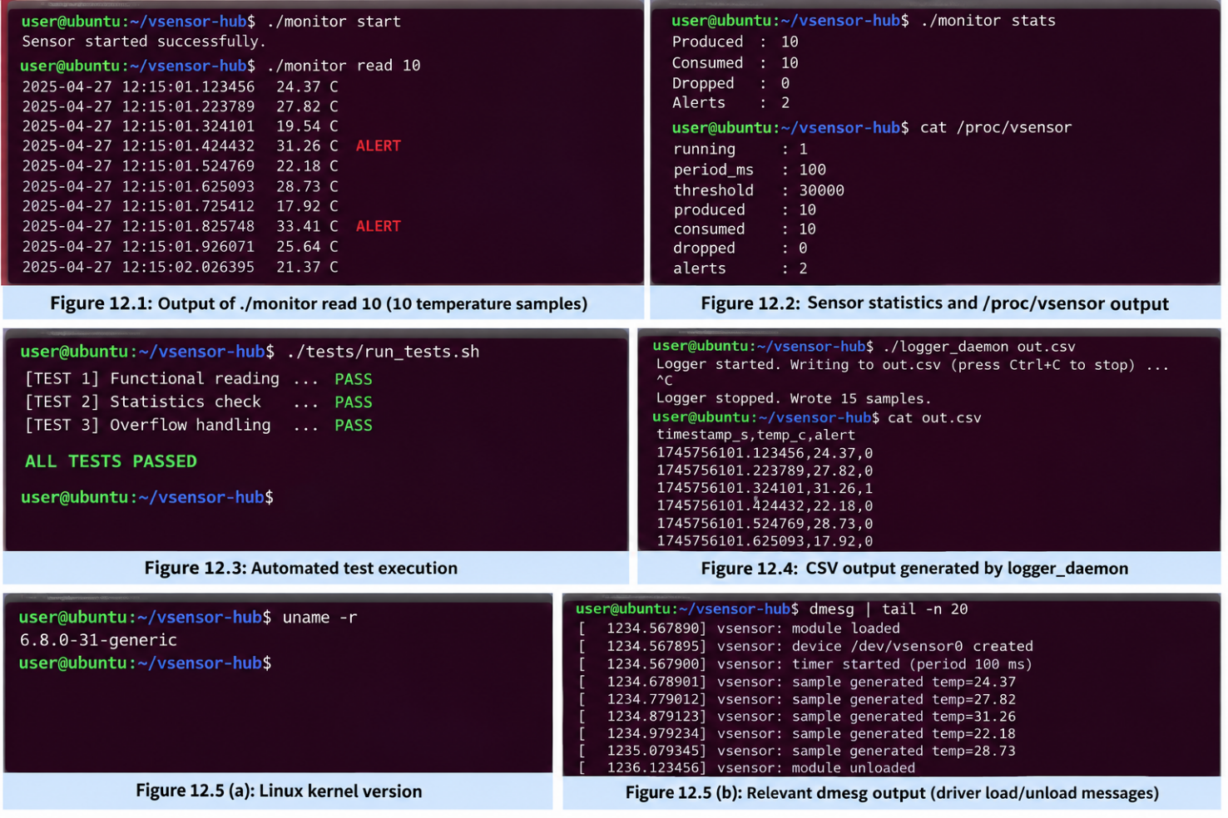

Limitations and Future Work
- Only one device instance is supported and the data is simulated.
- The sampling rate change is applied at the next start rather than immediately.
- A single reader is assumed; multiple concurrent readers share one consumer index.
- Future work: mmap of the ring buffer with a read-versus-mmap latency benchmark; moving processing to a tasklet or workqueue (bottom half); a platform-driver and device-tree binding; per-open-file buffers; a sysfs attribute interface.

Conclusion
The project delivers a complete device-driver stack on Linux: a simulated interrupt source, a buffered character device with blocking, polled and asynchronous access, an ioctl control interface, procfs statistics, and a layered C++ user-space system. It demonstrates the principal responsibilities of a driver (handling asynchronous events, safely moving data across the user/kernel boundary, and synchronizing between atomic and process contexts) while remaining runnable on any Linux machine without special hardware.

References
- Corbet, Rubini, Kroah-Hartman. Linux Device Drivers, 3rd ed., O'Reilly.
- The Linux Kernel documentation: https://docs.kernel.org (driver API, hrtimers, locking).
- Love, R. Linux Kernel Development, 3rd ed.
- Linux man pages: poll(2), ioctl(2), fcntl(2).
- Stroustrup, B. The C++ Programming Language (RAII, threading).

