Dirigenti PA 17 giugno 2009
Segmentazione binaria
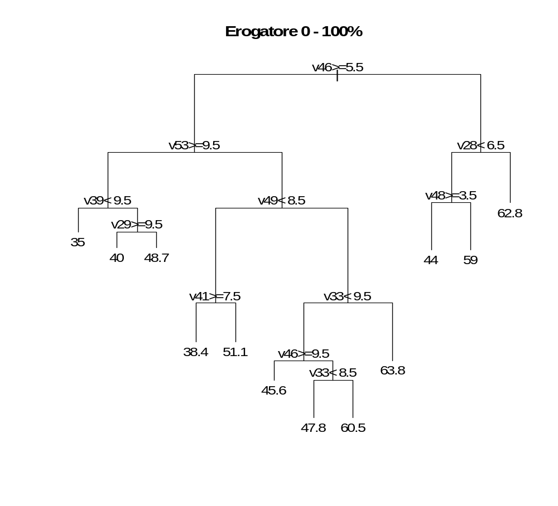
> # segmentazione binaria su erogatore 0 - 100
> mod<-rpart(v57~v28+v29+v30+v31+v32+v33+v34+v35+v36+v37
+ +v38+v39+v40+v41+v42+v43+v44+v45+v46+v47
+ +v48+v49+v50+v51+v52+v53+v60+v61+v63
+ +v621+v622+v623+v624+v642, data=dati)
> print(mod$cptable)
CP nsplit rel error xerror xstd
1 0.05907263 0 1.0000000 1.004388 0.1299107
2 0.05742191 1 0.9409274 1.141123 0.1497081
3 0.04348548 3 0.8260835 1.187622 0.1533792
4 0.03842975 4 0.7825981 1.140717 0.1434504
5 0.03588014 5 0.7441683 1.136300 0.1414415
6 0.02898619 6 0.7082882 1.161761 0.1460494
7 0.02150434 7 0.6793020 1.199394 0.1456850
8 0.01804410 9 0.6362933 1.192741 0.1451719
9 0.01193399 10 0.6182492 1.231726 0.1522291
10 0.01000000 11 0.6063152 1.240105 0.1549612
> # plot(moderog, uniform=TRUE, margin=0.1, branch=0.5, compress=TRUE)
> plot(mod, main="Erogatore 0 - 100%")
> text(mod,digits=3)
> mod
n= 134
node), split, n, deviance, yval * denotes terminal node
1) root 134 31354.4000 50.93284
2) v46>=5.5 96 21881.1600 48.59375
4) v53>=9.5 28 4556.7140 42.78571
8) v39< 9.5 7 2150.0000 35.00000 *
9) v39>=9.5 21 1840.9520 45.38095
18) v29>=9.5 8 200.0000 40.00000 *
19) v29< 9.5 13 1266.7690 48.69231 *
5) v53< 9.5 68 15990.9900 50.98529
10) v49< 8.5 24 3545.3330 43.16667
20) v41>=7.5 15 1947.6000 38.40000 *
21) v41< 7.5 9 688.8889 51.11111 *
11) v49>=8.5 44 10178.2500 55.25000
22) v33< 9.5 31 5107.0970 51.64516
44) v46>=9.5 9 1022.2220 45.55556 *
45) v46< 9.5 22 3614.5910 54.13636
90) v33< 8.5 11 1113.6360 47.81818 *
91) v33>=8.5 11 1622.7270 60.45455 *
23) v33>=9.5 13 3707.6920 63.84615 *
3) v46< 5.5 38 7621.0530 56.84211
6) v28< 6.5 20 4455.0000 51.50000
12) v48>=3.5 10 1840.0000 44.00000 *
13) v48< 3.5 10 1490.0000 59.00000 *
7) v28>=6.5 18 1961.1110 62.77778 *

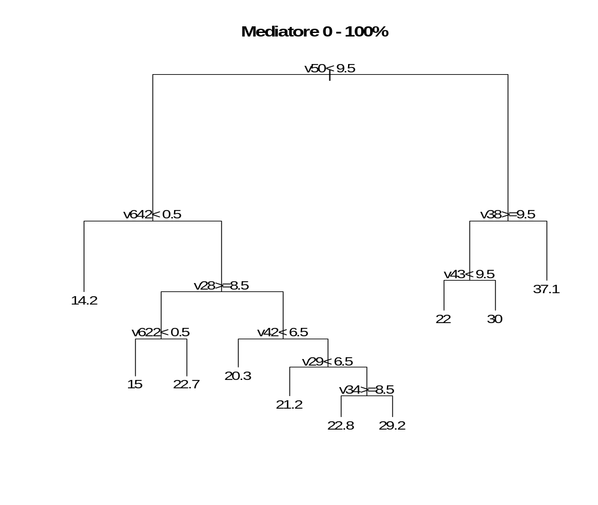

> # segmentazione binaria su mediatore 0 - 100
> mod<-rpart(v58~v28+v29+v30+v31+v32+v33+v34+v35+v36+v37
+ +v38+v39+v40+v41+v42+v43+v44+v45+v46+v47
+ +v48+v49+v50+v51+v52+v53+v60+v61+v63
+ +v621+v622+v623+v624+v642, data=dati)
> print(mod$cptable)
CP nsplit rel error xerror xstd
1 0.10936995 0 1.0000000 1.015021 0.1434611
2 0.05342951 1 0.8906301 1.005348 0.1393915
3 0.04444534 2 0.8372005 1.059986 0.1386769
4 0.03478720 3 0.7927552 1.157581 0.1477090
5 0.02776380 4 0.7579680 1.166584 0.1412153
6 0.02283698 5 0.7302042 1.186773 0.1417308
7 0.02151859 6 0.7073672 1.221475 0.1489519
8 0.01537149 8 0.6643300 1.200207 0.1497280
9 0.01000000 9 0.6489586 1.192771 0.1480909
> # plot(moderog, uniform=TRUE, margin=0.1, branch=0.5, compress=TRUE)
> plot(mod, main="Mediatore 0 - 100%")
> text(mod,digits=3)
> mod
n= 134 node), split, n, deviance, yval * denotes terminal node
1) root 134 15286.2100 22.65672
2) v50< 9.5 104 9002.9900 20.75962
4) v642< 0.5 16 878.4375 14.18750 *
5) v642>=0.5 88 7307.8180 21.95455
10) v28>=8.5 29 1755.1720 18.44828
20) v622< 0.5 16 800.0000 15.00000 *
21) v622>=0.5 13 530.7692 22.69231 *
11) v28< 8.5 59 5020.8810 23.67797
22) v42< 6.5 19 1723.6840 20.26316 *
23) v42>=6.5 40 2970.4000 25.30000
46) v29< 6.5 13 1207.6920 21.15385 *
47) v29>=6.5 27 1431.6300 27.29630
94) v34>=8.5 8 183.5000 22.75000 *
95) v34< 8.5 19 1013.1580 29.21053 *
3) v50>=9.5 30 4611.3670 29.23333
6) v38>=9.5 22 1909.0910 26.36364
12) v43< 9.5 10 560.0000 22.00000 *
13) v43>=9.5 12 1000.0000 30.00000 *
7) v38< 9.5 8 2022.8750 37.12500 *
# Promotore
> # segmentazione binaria su promotore 0 - 100
> mod<-rpart(v59~v28+v29+v30+v31+v32+v33+v34+v35+v36+v37
+ +v38+v39+v40+v41+v42+v43+v44+v45+v46+v47
+ +v48+v49+v50+v51+v52+v53+v60+v61+v63
+ +v621+v622+v623+v624+v642, data=dati)
> print(mod$cptable)
CP nsplit rel error xerror xstd
1 0.05981284 0 1.0000000 1.015947 0.1468361
2 0.04226695 2 0.8803743 1.160770 0.1623968
3 0.03624746 4 0.7958404 1.198710 0.1716759
4 0.02790625 7 0.6870980 1.313889 0.1999596
5 0.01983372 8 0.6591918 1.440392 0.2182697
6 0.01727068 9 0.6393581 1.462977 0.2206682
7 0.01660394 11 0.6048167 1.467682 0.2215664
8 0.01000000 12 0.5882128 1.463262 0.2216066
> # plot(moderog, uniform=TRUE, margin=0.1, branch=0.5, compress=TRUE)
> plot(mod, main="Promotore 0 - 100%")
> text(mod,digits=3)
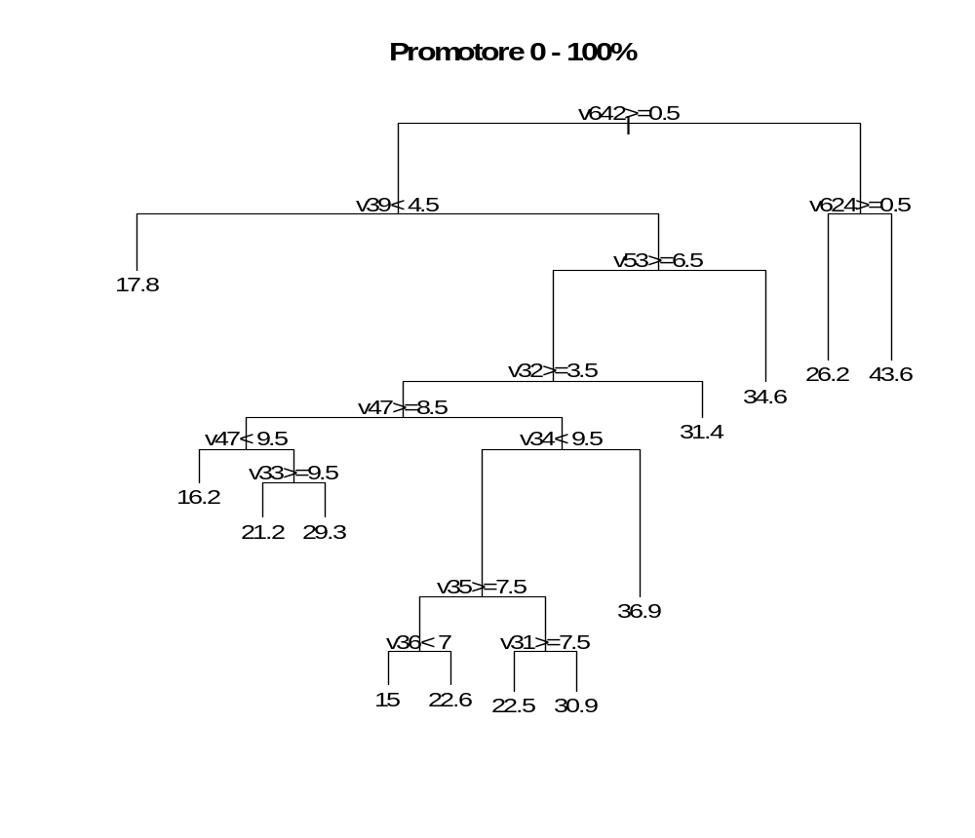
> mod n= 134 node), split, n, deviance, yval * denotes terminal node
1) root 134 18675.2800 26.22388
2) v642>=0.5 114 13549.8300 25.16667
4) v39< 4.5 9 805.5556 17.77778 *
5) v39>=4.5 105 12210.8000 25.80000
10) v53>=6.5 93 10042.6700 24.66667
20) v32>=3.5 86 9460.8370 24.11628
40) v47>=8.5 32 2880.4690 21.71875
80) v47< 9.5 8 587.5000 16.25000 *
81) v47>=9.5 24 1973.9580 23.54167
162) v33>=9.5 17 1426.4710 21.17647 *
163) v33< 9.5 7 221.4286 29.28571 *
41) v47< 8.5 54 6287.4260 25.53704
82) v34< 9.5 45 4098.8000 23.26667
164) v35>=7.5 24 1753.8330 20.08333
328) v36< 7 8 350.0000 15.00000 *
329) v36>=7 16 1093.7500 22.62500 *
165) v35< 7.5 21 1823.8100 26.90476
330) v31>=7.5 10 312.5000 22.50000 *
331) v31< 7.5 11 1140.9090 30.90909 *
83) v34>=9.5 9 796.8889 36.88889 *
21) v32< 3.5 7 235.7143 31.42857 *
11) v53< 6.5 12 1122.9170 34.58333 *
3) v642< 0.5 20 4271.7500 32.25000
6) v624>=0.5 13 1255.6920 26.15385 *
7) v624< 0.5 7 1635.7140 43.57143 *

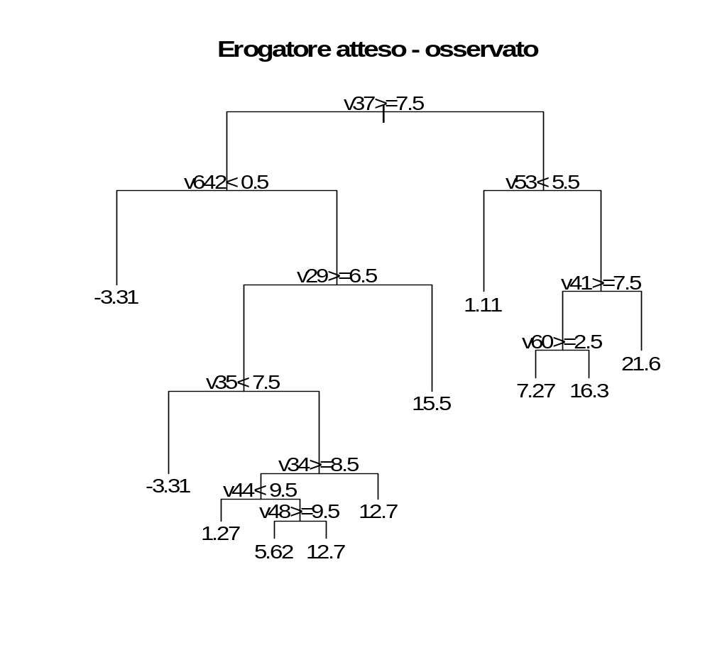
> # segmentazione binaria su erogatore atteso - osservato
> mod<-rpart((v57-v54)~v28+v29+v30+v31+v32+v33+v34+v35+v36+v37
+ +v38+v39+v40+v41+v42+v43+v44+v45+v46+v47
+ +v48+v49+v50+v51+v52+v53+v60+v61+v63
+ +v621+v622+v623+v624+v642, data=dati)
> print(mod$cptable)
CP nsplit rel error xerror xstd
1 0.05886186 0 1.0000000 1.023747 0.1346057
2 0.05085685 4 0.7645526 1.116496 0.1547465
3 0.03657466 5 0.7136957 1.214991 0.1861945
4 0.01693130 6 0.6771211 1.222629 0.1855890
5 0.01573631 7 0.6601897 1.230966 0.1904027
6 0.01338158 8 0.6444534 1.243907 0.1906632
7 0.01124493 9 0.6310719 1.240177 0.1908193
8 0.01000000 10 0.6198269 1.254468 0.1960390
> # plot(moderog, uniform=TRUE, margin=0.1, branch=0.5, compress=TRUE)
> plot(mod, main="Erogatore atteso - osservato")
> text(mod,digits=3)
> mod
n= 134 node), split, n, deviance, yval * denotes terminal node
1) root 134 23824.7300 8.266940
2) v37>=7.5 91 16092.4800 6.245824
4) v642< 0.5 13 1986.7690 -3.307692 *
5) v642>=0.5 78 12721.4500 7.838077
10) v29>=6.5 58 9197.4900 5.196034
20) v35< 7.5 13 1406.7690 -3.307692 *
21) v35>=7.5 45 6579.0700 7.652667
42) v34>=8.5 34 2935.9750 6.010882
84) v44< 9.5 10 744.4760 1.267000 *
85) v44>=9.5 24 1872.6860 7.987500
170) v48>=9.5 16 793.7500 5.625000 *
171) v48< 9.5 8 811.0288 12.712500 *
43) v34< 8.5 11 3268.1820 12.727270 *
11) v29< 6.5 20 1945.0000 15.500000 *
3) v37< 7.5 43 6573.8460 12.544190
6) v53< 5.5 9 1288.8890 1.111111 *
7) v53>=5.5 34 3797.1110 15.570590
14) v41>=7.5 20 1809.2450 11.335000
28) v60>=2.5 11 618.1818 7.272727 *
29) v60< 2.5 9 787.6800 16.300000 *
15) v41< 7.5 14 1116.4840 21.621430 *

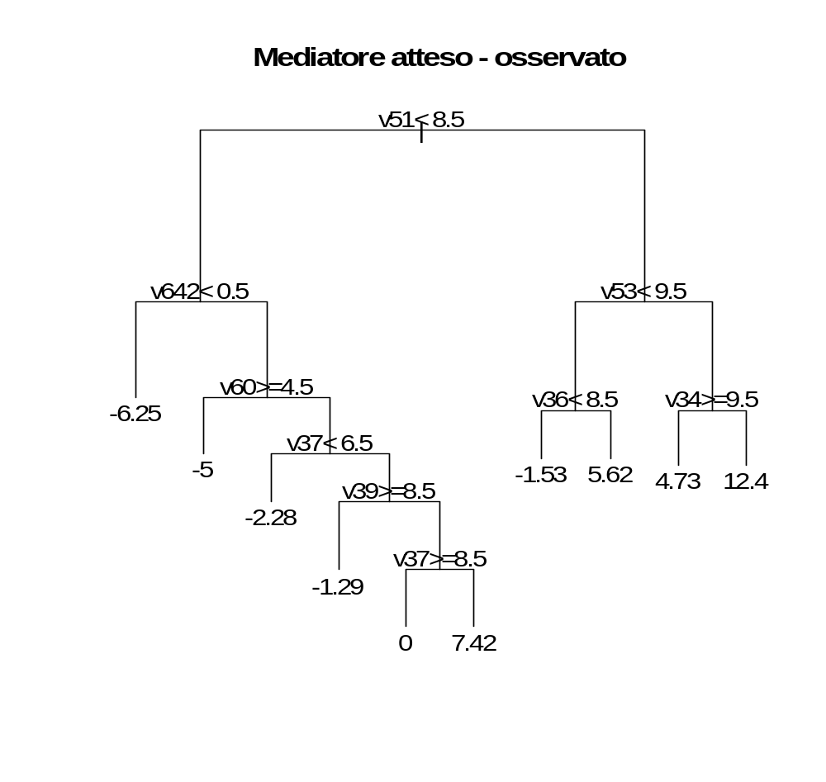
> # segmentazione binaria su mediatore atteso - osservato
> mod<-rpart((v58-v55)~v28+v29+v30+v31+v32+v33+v34+v35+v36+v37
+ +v38+v39+v40+v41+v42+v43+v44+v45+v46+v47
+ +v48+v49+v50+v51+v52+v53+v60+v61+v63
+ +v621+v622+v623+v624+v642, data=dati)
> print(mod$cptable)
CP nsplit rel error xerror xstd
1 0.08430705 0 1.0000000 1.025035 0.1666073
2 0.05287672 1 0.9156930 1.075022 0.1666644
3 0.04651021 2 0.8628162 1.078950 0.1638277
4 0.02816824 3 0.8163060 1.063327 0.1638612
5 0.02768905 6 0.7318013 1.138265 0.1720147
6 0.02694738 7 0.7041122 1.138265 0.1720147
7 0.02336259 8 0.6771649 1.135064 0.1682275
8 0.01000000 9 0.6538023 1.128650 0.1660849
> # plot(moderog, uniform=TRUE, margin=0.1, branch=0.5, compress=TRUE)
> plot(mod, main="Mediatore atteso - osservato")
> text(mod,digits=3)
> mod
n= 134
node), split, n, deviance, yval
* denotes terminal node
1) root 134 11443.4300 0.66246270
2) v51< 8.5 90 6775.6700 -1.21366700
4) v642< 0.5 17 1362.0020 -6.25294100 *
5) v642>=0.5 73 4881.4310 -0.04013699
10) v60>=4.5 11 300.0000 -5.00000000 *
11) v60< 4.5 62 4262.8180 0.83983870
22) v37< 6.5 19 1712.2120 -2.27894700 *
23) v37>=6.5 43 2284.1370 2.21790700
46) v39>=8.5 18 563.7294 -1.29444400 *
47) v39< 8.5 25 1338.4660 4.74680000
94) v37>=8.5 9 150.0000 0.00000000 *
95) v37< 8.5 16 871.6083 7.41687500 *
3) v51>=8.5 44 3703.0000 4.50000000
6) v53< 9.5 23 1262.9570 0.95652170
12) v36< 8.5 15 773.7333 -1.53333300 *
13) v36>=8.5 8 221.8750 5.62500000 *
7) v53>=9.5 21 1834.9520 8.38095200
14) v34>=9.5 11 488.1818 4.72727300 *
15) v34< 9.5 10 1038.4000 12.40000000 *
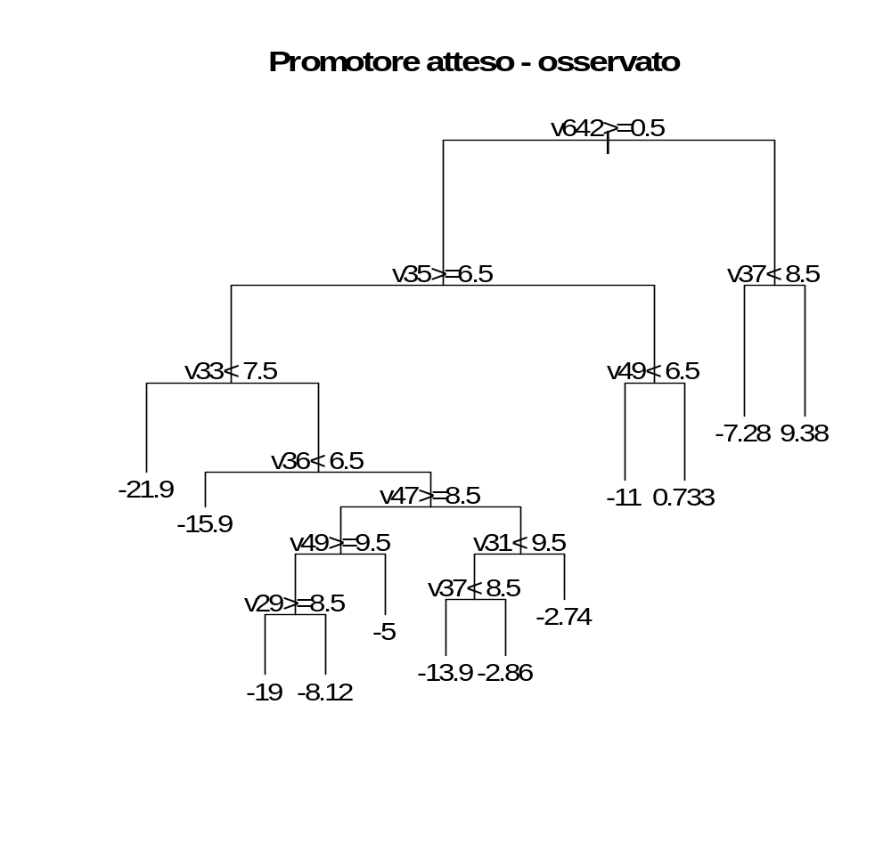
> # segmentazione binaria su promotore atteso - osservato
> mod<-rpart((v59-v56)~v28+v29+v30+v31+v32+v33+v34+v35+v36+v37
+ +v38+v39+v40+v41+v42+v43+v44+v45+v46+v47
+ +v48+v49+v50+v51+v52+v53+v60+v61+v63
+ +v621+v622+v623+v624+v642, data=dati)
> print(mod$cptable)
CP nsplit rel error xerror xstd
1 0.07767842 0 1.0000000 1.018755 0.1419927
2 0.06967609 1 0.9223216 1.078667 0.1419846
3 0.05187638 2 0.8526455 1.052509 0.1409069
4 0.05176157 3 0.8007691 1.060885 0.1383176
5 0.04805661 4 0.7490075 1.058387 0.1381218
6 0.02532000 5 0.7009509 1.008440 0.1295485
7 0.01000000 11 0.5384879 1.132104 0.1480873
> # plot(moderog, uniform=TRUE, margin=0.1, branch=0.5, compress=TRUE)
> plot(mod, main="Promotore atteso - osservato")
> text(mod,digits=3)
> mod
n= 134

node), split, n, deviance, yval
* denotes terminal node

1) root 134 19105.5600 -8.5623880
2) v642>=0.5 114 13699.4900 -9.9563160
4) v35>=6.5 85 10298.0500 -11.6785900
8) v33< 7.5 8 996.8750 -21.8750000 *
9) v33>=7.5 77 8383.0270 -10.6192200
18) v36< 6.5 11 1340.9090 -15.9090900 *
19) v36>=6.5 66 6683.0060 -9.7375760
38) v47>=8.5 31 3793.5480 -12.5806500
76) v49>=9.5 23 2873.9130 -15.2173900
152) v29>=8.5 15 1510.0000 -19.0000000 *
153) v29< 8.5 8 746.8750 -8.1250000 *
77) v49< 9.5 8 300.0000 -5.0000000 *
39) v47< 8.5 35 2416.9460 -7.2194290
78) v31< 9.5 21 1677.8990 -10.2066700
156) v37< 8.5 14 967.8788 -13.8814300 *
157) v37>=8.5 7 142.8571 -2.8571430 *
79) v31>=9.5 14 270.5588 -2.7385710 *
5) v35< 6.5 29 2410.3120 -4.9082760
10) v49< 6.5 14 748.4445 -10.9528600 *
11) v49>=6.5 15 672.9333 0.7333333 *
3) v642< 0.5 20 3921.9820 -0.6170000
6) v37< 8.5 12 1368.9060 -7.2783330 *
7) v37>=8.5 8 1221.8750 9.3750000 *

