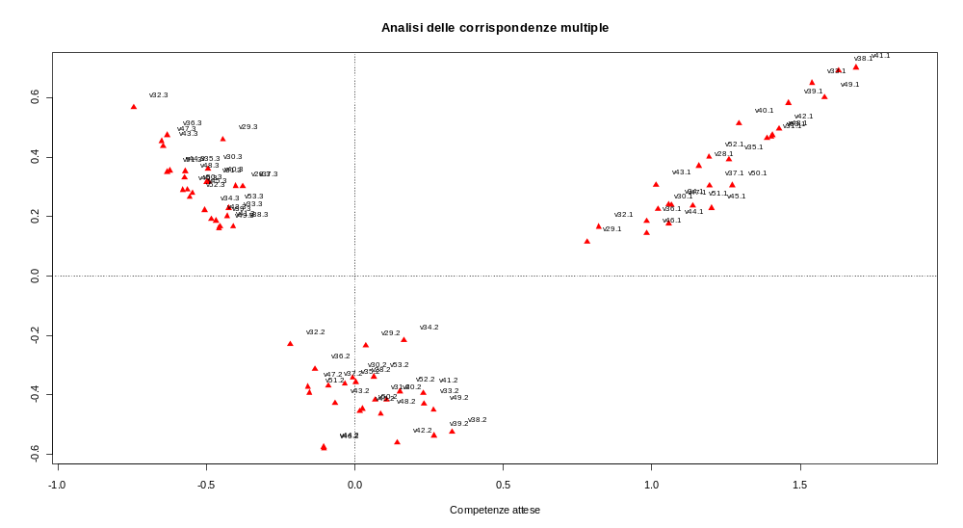
Principal inertias (eigenvalues):
dim value % cum% scree plot
[1,] 1 0.083744 54.9 54.9 *************************
[2,] 2 0.033428 21.9 76.8 **********
[3,] 3 0.009994 6.5 83.3 ***
6 aprile 2009
