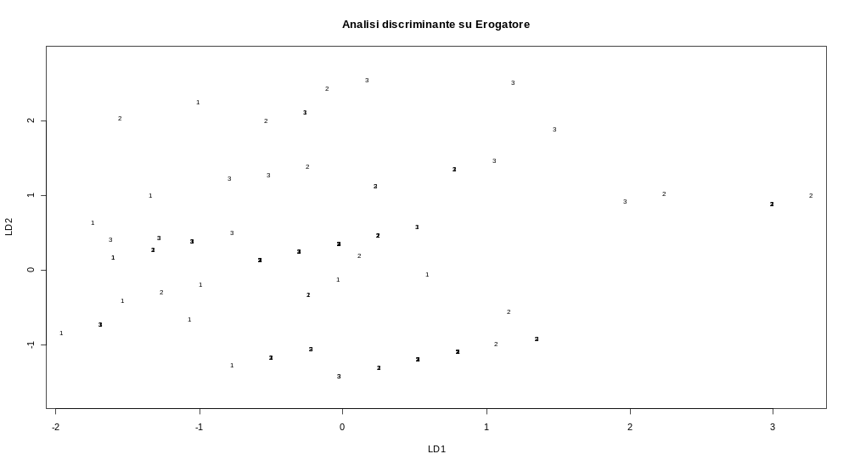
12 maggio 2009
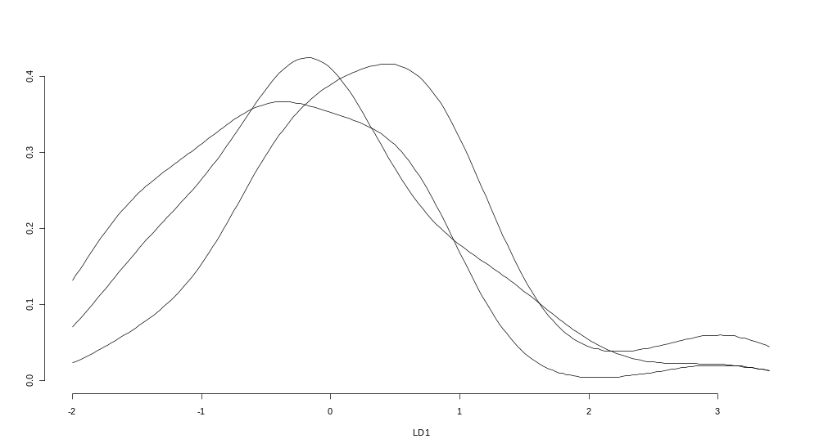

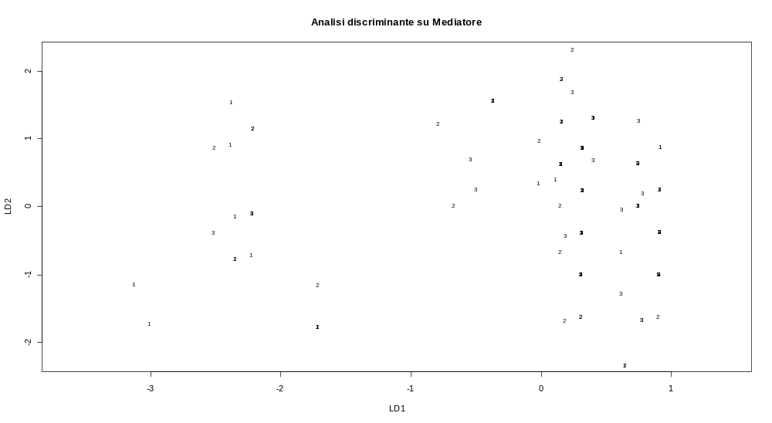

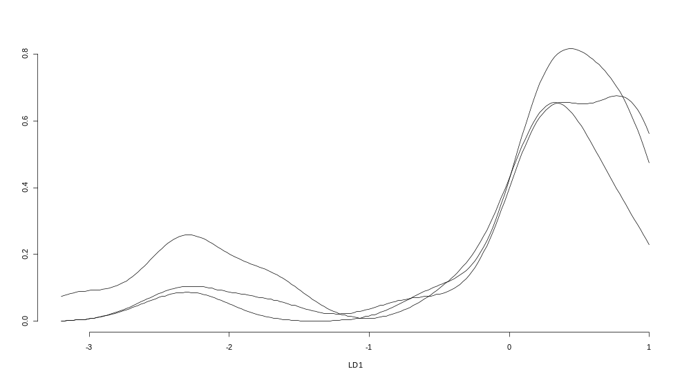

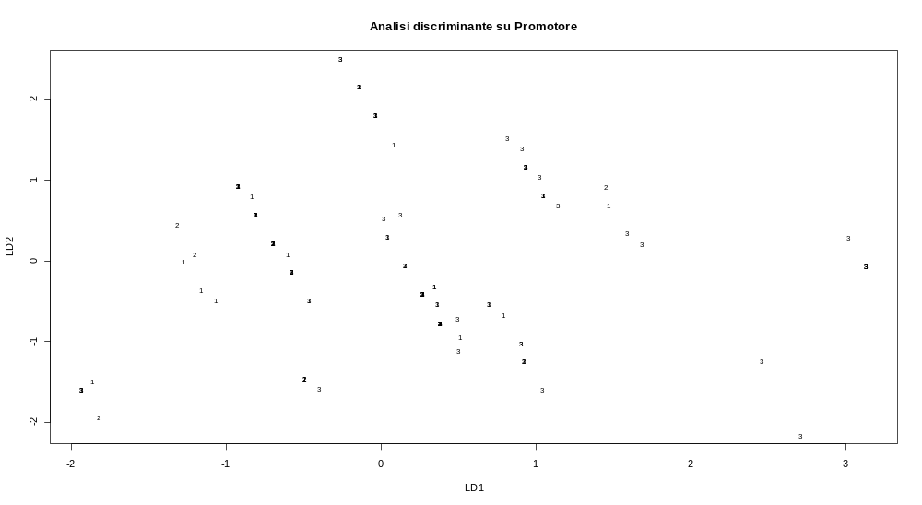

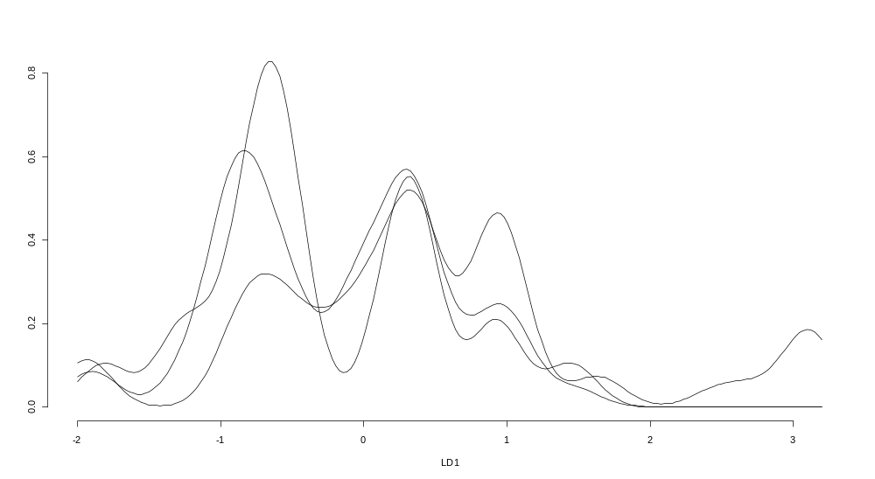

> (discr1<-lda(y57~dati$v60+dati$v61+v621+v622+v623+dati$v63+v642))
Call:
lda(y57 ~ dati$v60 + dati$v61 + v621 + v622 + v623 + dati$v63 +
v642)

Prior probabilities of groups:
1 2 3
0.3283582 0.3432836 0.3283582

Group means:
dati$v60 dati$v61 v621 v622 v623 dati$v63 v642
1 3.068182 1.318182 0.3863636 0.4545455 0.06818182 2.772727 0.8409091
2 2.891304 1.217391 0.2826087 0.4130435 0.08695652 2.847826 0.8913043
3 2.954545 1.295455 0.3863636 0.3181818 0.06818182 2.727273 0.8181818

Coefficients of linear discriminants:
LD1 LD2
dati$v60 -0.2746092 -0.10851011
dati$v61 -1.0208761 0.03046239
v621 -3.0167546 -0.52696312
v622 -2.4655637 -2.08033848
v623 -1.0858091 -1.58328989
dati$v63 1.0380823 -0.75812911
v642 2.4856286 -0.35744060

Proportion of trace:
LD1 LD2
0.8155 0.1845
> plot(discr1, main="Analisi discriminante su Erogatore")
> eqscplot(predict(discr1)$x, main="Rispondenti su scale equispaziate")
> plot(discr1, type="density", dimen=1)
>
> (discr2<-lda(y58~dati$v60+dati$v61+v621+v622+v623+dati$v63+v642))
Call:
lda(y58 ~ dati$v60 + dati$v61 + v621 + v622 + v623 + dati$v63 +
v642)

Prior probabilities of groups:
1 2 3
0.2611940 0.4029851 0.3358209

Group means:
dati$v60 dati$v61 v621 v622 v623 dati$v63 v642
1 2.914286 1.285714 0.3142857 0.2857143 0.11428571 2.742857 0.6857143
2 2.851852 1.240741 0.3518519 0.4629630 0.05555556 2.777778 0.8888889
3 3.155556 1.311111 0.3777778 0.4000000 0.06666667 2.822222 0.9333333

Coefficients of linear discriminants:
LD1 LD2
dati$v60 0.002440044 0.6245911
dati$v61 -0.160983840 1.0110031
v621 -0.092347377 -1.6881638
v622 0.502604595 -1.6823025
v623 -0.781547989 -1.0022641
dati$v63 0.130357013 0.6748193
v642 2.625118505 0.7760840

Proportion of trace:
LD1 LD2
0.7885 0.2115
> plot(discr2, main="Analisi discriminante su Mediatore")
> # eqscplot(discr2)
> plot(discr2, type="density", dimen=1)
> # predict(discr2)
>
> (discr3<-lda(y59~dati$v60+dati$v61+v621+v622+v623+dati$v63+v642))
Call:
lda(y59 ~ dati$v60 + dati$v61 + v621 + v622 + v623 + dati$v63 +
v642)

Prior probabilities of groups:
1 2 3
0.3880597 0.1641791 0.4477612

Group means:
dati$v60 dati$v61 v621 v622 v623 dati$v63 v642
1 3.134615 1.288462 0.4423077 0.3269231 0.05769231 2.788462 0.9230769
2 3.000000 1.181818 0.3636364 0.3181818 0.09090909 2.772727 0.9090909
3 2.816667 1.300000 0.2666667 0.4833333 0.08333333 2.783333 0.7666667

Coefficients of linear discriminants:
LD1 LD2
dati$v60 -0.11516635 0.3540407
dati$v61 0.66211167 1.5812871
v621 1.24064827 1.8095937
v622 2.20356801 1.1776285
v623 1.66935437 -0.5764708
dati$v63 0.02124615 -0.2248893
v642 -2.74483058 -0.7006558

Proportion of trace:
LD1 LD2
0.8714 0.1286
> plot(discr3, main="Analisi discriminante su Promotore")
> # eqscplot(discr3)
> plot(discr3, type="density", dimen=1)
> # predict(discr2)
>

